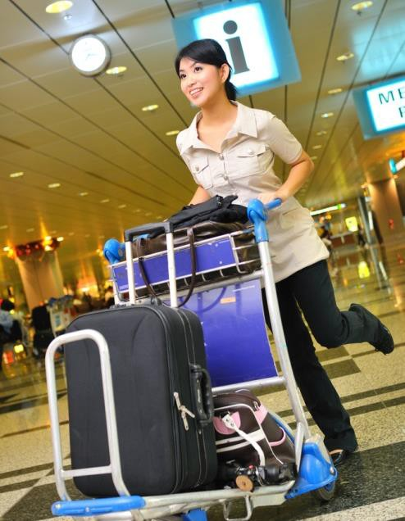
Provide camp site catering
D2.TTO.CL4.18
Trainer Guide

Provide camp site catering

D2.TTO.CL4.18

Trainer Guide





Project Base
William Angliss Institute of TAFE
555 La Trobe Street
Melbourne 3000 Victoria
Telephone: | (03) 9606 2111
Facsimile: | (03) 9670 1330
Acknowledgements
Project Director: | Wayne Crosbie
Project Manager | Jim Irwin
Chief Writer: | Alan Hickman
Subject Writer: | Alan Hickman
Editor: | Jim Irwin
DTP/Production: | Daniel Chee, Mai Vu, Cindy Curran

The Association of Southeast Asian Nations (ASEAN) was established on 8 August 1967. The Member States of the Association are Brunei Darussalam, Cambodia, Indonesia, Lao PDR, Malaysia, Myanmar, Philippines, Singapore, Thailand and Viet Nam.
The ASEAN Secretariat is based in Jakarta, Indonesia.
General Information on ASEAN appears online at the ASEAN Website: www.asean.org.
All text is produced by William Angliss Institute of TAFE for the ASEAN Project on “Toolbox Development for Tourism Labour Divisions for Travel Agencies and Tour Operations”.
This publication is supported by the Australian Government’s aid program through the ASEAN- Australia Development Cooperation Program Phase II (AADCP II).
Copyright: Association of Southeast Asian Nations (ASEAN) 2015. All rights reserved.
Disclaimer
Every effort has been made to ensure that this publication is free from errors or omissions. However, you should conduct your own enquiries and seek professional advice before relying on any fact, statement or matter contained in this book. The ASEAN Secretariat and William Angliss Institute of TAFE are not responsible for any injury, loss or damage as a result of material included or omitted from this course. Information in this module is current at the time of publication. Time of publication is indicated in the date stamp at the bottom of each page.
Some images appearing in this resource have been purchased from stock photography suppliers Shutterstock and iStockphoto and other third party copyright owners and as such are non-transferable and non-exclusive. Clip arts, font images and illustrations used are from the Microsoft Office Clip Art and Media Library. Some images have been provided by and are the property of William Angliss Institute.
Additional images have been sourced from Flickr and SXC and are used under Creative Commons licence: http://creativecommons.org/licenses/by/2.0/deed.en
File name: TG_Provide_camp_site_catering_240715



Table of contents
Competency Based Training (CBT) and assessment – An introduction for trainers 1
Competency standard 11
Notes and PowerPoint slides 25
Recommended training equipment 327
Instructions for Trainers for using PowerPoint – Presenter View 331
Appendix – ASEAN acronyms 333

© ASEAN 2015
Trainer Guide Provide camp site catering

© ASEAN 2015
Trainer Guide
Provide camp site catering

Competency Based Training (CBT) and assessment – An introduction for trainers
Competency
Competency refers to the ability to perform particular tasks and duties to the standard of performance expected in the workplace.
Competency requires the application of specified knowledge, skills and attitudes relevant to effective participation, consistently over time and in the workplace environment.
The essential skills and knowledge are either identified separately or combined.
Knowledge identifies what a person needs to know to perform the work in an informed and effective manner.
Skills describe the application of knowledge to situations where understanding is converted into a workplace outcome.
Attitude describes the founding reasons behind the need for certain knowledge or why skills are performed in a specified manner.
Competency covers all aspects of workplace performance and involves:
- Performing individual tasks
- Managing a range of different tasks
- Responding to contingencies or breakdowns
- Dealing with the responsibilities of the workplace
- Working with others.

Unit of competency

Like with any training qualification or program, a range of subject topics are identified that focus on the ability in a certain work area, responsibility or function.
Each manual focuses on a specific unit of competency that applies in the hospitality workplace.
In this manual a unit of competency is identified as a ‘unit’.
Each unit of competency identifies a discrete workplace requirement and includes:
- Knowledge and skills that underpin competency
- Language, literacy and numeracy
- Occupational safety and health requirements.
Each unit of competency must be adhered to in training and assessment to ensure consistency of outcomes.

Element of competency
An element of competency describes the essential outcomes within a unit of competency. The elements of competency are the basic building blocks of the unit of competency.
They describe in terms of outcomes the significant functions and tasks that make up the competency.
In this manual elements of competency are identified as an ‘element’.

Performance criteria

Performance criteria indicate the standard of performance that is required to demonstrate achievement within an element of competency. The standards reflect identified industry skill needs.
Performance criteria will be made up of certain specified skills, knowledge and attitudes.

Learning

For the purpose of this manual learning incorporates two key activities:
- Training
- Assessment.
Both of these activities will be discussed in detail in this introduction.
Today training and assessment can be delivered in a variety of ways. It may be provided to participants:
- On-the-job – in the workplace
- Off-the-job – at an educational institution or dedicated training environment
- As a combination of these two options.
No longer is it necessary for learners to be absent from the workplace for long periods of time in order to obtain recognised and accredited qualifications.

Learning approaches

This manual will identify two avenues to facilitate learning: Competency Based Training (CBT)
This is the strategy of developing a participant’s competency.
Educational institutions utilise a range of training strategies to ensure that participants are able to gain the knowledge and skills required for successful:
- Completion of the training program or qualification
- Implementation in the workplace.
The strategies selected should be chosen based on suitability and the learning styles of participants.

Competency Based Assessment (CBA)

This is the strategy of assessing competency of a participant.
Educational institutions utilise a range of assessment strategies to ensure that participants are assessed in a manner that demonstrates validity, fairness, reliability, flexibility and fairness of assessment processes.

Flexibility in learning

It is important to note that flexibility in training and assessment strategies is required to meet the needs of participants who may have learning difficulties. The strategies used will vary, taking into account the needs of individual participants with learning difficulties.
However they will be applied in a manner which does not discriminate against the participant or the participant body as a whole.
Catering for participant diversity
Participants have diverse backgrounds, needs and interests. When planning training and assessment activities to cater for individual differences, trainers and assessors should:
- Consider individuals’ experiences, learning styles and interests
- Develop questions and activities that are aimed at different levels of ability
- Modify the expectations for some participants
- Provide opportunities for a variety of forms of participation, such as individual, pair and small group activities
- Assess participants based on individual progress and outcomes.
The diversity among participants also provides a good reason for building up a learning community in which participants support each other’s learning.
Participant centred learning
This involves taking into account structuring training and assessment that:
- Builds on strengths – Training environments need to demonstrate the many positive features of local participants (such as the attribution of academic success to effort, and the social nature of achievement motivation) and of their trainers (such as a strong emphasis on subject disciplines and moral responsibility). These strengths and uniqueness of local participants and trainers should be acknowledged and treasured
- Acknowledges prior knowledge and experience – The learning activities should be planned with participants’ prior knowledge and experience in mind
- Understands learning objectives – Each learning activity should have clear learning objectives and participants should be informed of them at the outset. Trainers should also be clear about the purpose of assignments and explain their significance to participants
- Teaches for understanding – The pedagogies chosen should aim at enabling participants to act and think flexibly with what they know
- Teaches for independent learning – Generic skills and reflection should be nurtured through learning activities in appropriate contexts of the curriculum. Participants should be encouraged to take responsibility for their own learning

- Enhances motivation – Learning is most effective when participants are motivated. Various strategies should be used to arouse the interest of participants
- Makes effective use of resources – A variety of teaching resources can be employed as tools for learning
- Maximises engagement – In conducting learning activities, it is important for the minds of participants to be actively engaged
- Aligns assessment with learning and teaching – Feedback and assessment should be an integral part of learning and teaching
- Caters for learner diversity – Trainers should be aware that participants have different characteristics and strengths and try to nurture these rather than impose a standard set of expectations.
Active learning
The goal of nurturing independent learning in participants does not imply that they always have to work in isolation or solely in a classroom. On the contrary, the construction of knowledge in tourism and hospitality studies can often best be carried out in collaboration with others in the field. Sharing experiences, insights and views on issues of common concern, and working together to collect information through conducting investigative studies in the field (active learning) can contribute a lot to their eventual success.
Active learning has an important part to play in fostering a sense of community in the class. First, to operate successfully, a learning community requires an ethos of acceptance and a sense of trust among participants, and between them and their trainers. Trainers can help to foster acceptance and trust through encouragement and personal example, and by allowing participants to take risks as they explore and articulate their views, however immature these may appear to be. Participants also come to realise that their classmates (and their trainers) are partners in learning and solving.
Trainers can also encourage cooperative learning by designing appropriate group learning tasks, which include, for example, collecting background information, conducting small-scale surveys, or producing media presentations on certain issues and themes.
Participants need to be reminded that, while they should work towards successful completion of the field tasks, developing positive peer relationships in the process is an important objective of all group work.

Competency Based Training (CBT)

Principle of Competency Based Training
Competency based training is aimed at developing the knowledge, skills and attitudes of participants, through a variety of training tools.

Training strategies
The aims of this curriculum are to enable participants to:
- Undertake a variety of subject courses that are relevant to industry in the current environment
- Learn current industry skills, information and trends relevant to industry
- Learn through a range of practical and theoretical approaches
- Be able to identify, explore and solve issues in a productive manner

- Be able to become confident, equipped and flexible managers of the future
- Be ‘job ready’ and a valuable employee in the industry upon graduation of any qualification level.
To ensure participants are able to gain the knowledge and skills required to meet competency in each unit of competency in the qualification, a range of training delivery modes are used.

Types of training
In choosing learning and teaching strategies, trainers should take into account the practical, complex and multi-disciplinary nature of the subject area, as well as their participant’s prior knowledge, learning styles and abilities.
Training outcomes can be attained by utilising one or more delivery methods:
Lecture/tutorial
This is a common method of training involving transfer of information from the trainer to the participants. It is an effective approach to introduce new concepts or information to the learners and also to build upon the existing knowledge. The listener is expected to reflect on the subject and seek clarifications on the doubts.
Demonstration
Demonstration is a very effective training method that involves a trainer showing a participant how to perform a task or activity. Through a visual demonstration, trainers may also explain reasoning behind certain actions or provide supplementary information to help facilitate understanding.
Group discussions
Brainstorming in which all the members in a group express their ideas, views and opinions on a given topic. It is a free flow and exchange of knowledge among the participants and the trainer. The discussion is carried out by the group on the basis of their own experience, perceptions and values. This will facilitate acquiring new knowledge. When everybody is expected to participate in the group discussion, even the introverted persons will also get stimulated and try to articulate their feelings.
The ideas that emerge in the discussions should be noted down and presentations are to be made by the groups. Sometimes consensus needs to be arrived at on a given topic.
Group discussions are to be held under the moderation of a leader guided by the trainer. Group discussion technique triggers thinking process, encourages interactions and enhances communication skills.
Role play
This is a common and very effective method of bringing into the classroom real life situations, which may not otherwise be possible. Participants are made to enact a particular role so as to give a real feel of the roles they may be called upon to play. This enables participants to understand the behaviour of others as well as their own emotions and feelings. The instructor must brief the role players on what is expected of them. The role player may either be given a ready-made script, which they can memorize and enact, or they may be required to develop their own scripts around a given situation. This technique is extremely useful in understanding creative selling techniques and human relations. It can be entertaining and energizing and it helps the reserved and less literate to express their feelings.

Simulation games
When trainees need to become aware of something that they have not been conscious of, simulations can be a useful mechanism. Simulation games are a method based on "here and now" experience shared by all the participants. The games focus on the participation of the trainees and their willingness to share their ideas with others. A "near real life" situation is created providing an opportunity to which they apply themselves by adopting certain behaviour. They then experience the impact of their behaviour on the situation. It is carried out to generate responses and reactions based on the real feelings of the participants, which are subsequently analysed by the trainer.
While use of simulation games can result in very effective learning, it needs considerable trainer competence to analyse the situations.
Individual /group exercises
Exercises are often introduced to find out how much the participant has assimilated. This method involves imparting instructions to participants on a particular subject through use of written exercises. In the group exercises, the entire class is divided into small groups, and members are asked to collaborate to arrive at a consensus or solution to a problem.
Case study
This is a training method that enables the trainer and the participant to experience a real life situation. It may be on account of events in the past or situations in the present, in which there may be one or more problems to be solved and decisions to be taken. The basic objective of a case study is to help participants diagnose, analyse and/or solve a particular problem and to make them internalize the critical inputs delivered in the training. Questions are generally given at the end of the case study to direct the participants and to stimulate their thinking towards possible solutions. Studies may be presented in written or verbal form.
Field visit
This involves a carefully planned visit or tour to a place of learning or interest. The idea is to give first-hand knowledge by personal observation of field situations, and to relate theory with practice. The emphasis is on observing, exploring, asking questions and understanding. The trainer should remember to brief the participants about what they should observe and about the customs and norms that need to be respected.
Group presentation
The participants are asked to work in groups and produce the results and findings of their group work to the members of another sub-group. By this method participants get a good picture of each other's views and perceptions on the topic and they are able to compare them with their own point of view. The pooling and sharing of findings enriches the discussion and learning process.
Practice sessions
This method is of paramount importance for skills training. Participants are provided with an opportunity to practice in a controlled situation what they have learnt. It could be real life or through a make-believe situation.

Games
This is a group process and includes those methods that involve usually fun-based activity, aimed at conveying feelings and experiences, which are everyday in nature, and applying them within the game being played. A game has set rules and regulations, and may or may not include a competitive element. After the game is played, it is essential that the participants be debriefed and their lessons and experiences consolidated by the trainer.
Research
Trainers may require learners to undertake research activities, including online research, to gather information or further understanding about a specific subject area.

Competency Based Assessment (CBA)

Principle of Competency Based Assessment
Competency based assessment is aimed at compiling a list of evidence that shows that a person is competent in a particular unit of competency.
Competencies are gained through a multitude of ways including:
- Training and development programs
- Formal education
- Life experience
- Apprenticeships
- On-the-job experience
- Self-help programs.
All of these together contribute to job competence in a person. Ultimately, assessors and participants work together, through the ‘collection of evidence’ in determining overall competence.
This evidence can be collected:
- Using different formats
- Using different people
- Collected over a period of time.
The assessor who is ideally someone with considerable experience in the area being assessed, reviews the evidence and verifies the person as being competent or not.

Flexibility in assessment
Whilst allocated assessment tools have been identified for this subject, all attempts are made to determine competency and suitable alternate assessment tools may be used, according to the requirements of the participant.
The assessment needs to be equitable for all participants, taking into account their cultural and linguistic needs.

Competency must be proven regardless of:
- Language
- Delivery Method
- Assessment Method.

Assessment objectives
The assessment tools used for subjects are designed to determine competency against the ‘elements of competency’ and their associated ‘performance criteria’.
The assessment tools are used to identify sufficient:
- Knowledge, including underpinning knowledge
- Skills
- Attitudes
Assessment tools are activities that trainees are required to undertake to prove participant competency in this subject.
All assessments must be completed satisfactorily for participants to obtain competence in this subject. There are no exceptions to this requirement, however, it is possible that in some cases several assessment items may be combined and assessed together.

Types of assessment
Allocated Assessment Tools
There are a number of assessment tools that are used to determine competency in this subject:
- Work projects
- Written questions
- Oral questions
- Third Party Report
- Observation Checklist.
Instructions on how assessors should conduct these assessment methods are explained in the Assessment Manuals.
Alternative assessment tools
Whilst this subject has identified assessment tools, as indicated above, this does not restrict the assessor from using different assessment methods to measure the competency of a participant.
Evidence is simply proof that the assessor gathers to show participants can actually do what they are required to do.
Whilst there is a distinct requirement for participants to demonstrate competency, there are many and diverse sources of evidence available to the assessor.
Ongoing performance at work, as verified by a supervisor or physical evidence, can count towards assessment. Additionally, the assessor can talk to customers or work colleagues to gather evidence about performance.

A range of assessment methods to assess competency include:
- Practical demonstrations
- Practical demonstrations in simulated work conditions
- Problem solving
- Portfolios of evidence
- Critical incident reports
- Journals
- Oral presentations
- Interviews
- Videos
- Visuals: slides, audio tapes
- Case studies
- Log books
- Projects
- Role plays
- Group projects
- Group discussions
- Examinations.

Recognition of Prior Learning
Recognition of Prior Learning is the process that gives current industry professionals who do not have a formal qualification, the opportunity to benchmark their extensive skills and experience against the standards set out in each unit of competency/subject.
Also known as a Skills Recognition Audit (SRA), this process is a learning and assessment pathway which encompasses:
- Recognition of Current Competencies (RCC)
- Skills auditing
- Gap analysis and training
- Credit transfer.

Assessing competency
As mentioned, assessment is the process of identifying a participant’s current knowledge, skills and attitudes sets against all elements of competency within a unit of competency. Traditionally in education, grades or marks were given to participants, dependent on how many questions the participant successfully answered in an assessment tool.
Competency based assessment does not award grades, but simply identifies if the participant has the knowledge, skills and attitudes to undertake the required task to the specified standard.

10
© ASEAN 2015
Trainer Guide
Therefore, when assessing competency, an assessor has two possible results that can be awarded:
- Pass Competent (PC)
- Not Yet Competent (NYC).
Pass Competent (PC)
If the participant is able to successfully answer or demonstrate what is required, to the expected standards of the performance criteria, they will be deemed as ‘Pass Competent’ (PC).
The assessor will award a ‘Pass Competent’ (PC) if they feel the participant has the necessary knowledge, skills and attitudes in all assessment tasks for a unit.
Not Yet Competent’ (NYC)
If the participant is unable to answer or demonstrate competency to the desired standard, they will be deemed to be ‘Not Yet Competent’ (NYC).
This does not mean the participant will need to complete all the assessment tasks again. The focus will be on the specific assessment tasks that were not performed to the expected standards.
The participant may be required to:
- Undertake further training or instruction
- Undertake the assessment task again until they are deemed to be ‘Pass Competent’.

Competency standard

UNIT TITLE: PROVIDE CAMP SITE CATERING |  | NOMINAL HOURS: 90
UNIT NUMBER: D2.TTO.CL4.18
UNIT DESCRIPTOR: This unit deals with skills and knowledge required to provide food and beverages to tour group members in a camp site setting
ELEMENTS AND PERFORMANCE CRITERIA | UNIT VARIABLE AND ASSESSMENT GUIDE
Element 1: Determine camp site catering needs  - Identify tour group requirements  - Develop menus for the tour itinerary  - Verify planned menus with management or tour group members  - Identify equipment and resources required to support menus  - Stow equipment, resources and supplies for transportation to camp site  Element 2: Prepare the catering area  - Establish the catering area  - Store food and beverages  - Establish safe water supply  - Position catering and dining equipment  - Position cooking and dining utensils and ancillary items | Unit Variables  The Unit Variables provide advice to interpret the scope and context of this unit of competence, allowing for differences between enterprises and workplaces. It relates to the unit as a whole and facilitates holistic assessment.  This unit applies to organisations that provide camp site catering within the labour divisions of the hotel and travel industries and may include:  1. Tour Operation  Tour group requirements may be related to:  - Destination, including multiple destinations during the one tour  - Transport available to move equipment, resources and supplies  - Facilities available at the camp site(s)  - Equipment available for the safe storage of perishable food, including refrigerated and frozen storage  - Staffing levels for the preparation and service of food  - Duration of the tour or camp site stay  - Number of tour group members and numbers of support staff who have to be fed

Element 3: Produce food  - Apply food preparation techniques  - Apply food production techniques  - Confirm requirements of itinerary, as advertised  Element 4: Serve meals  - Prepare the dining area for service  - Plate meals for service according to standard food presentation requirements  - Display food for self-service as required  - Serve beverages to accompany meals  - Replenish items throughout service  - Establish rapport with tour group members  Element 5: Clear food and beverage items  5.1 Clear tables being used by tour group members  5.2 Clear communal food and beverage service points  - Tidy food production and service areas throughout service  - Maintain on-going interaction with tour group members  - Dispose of unwanted items and materials throughout service  Element 6: Finalise service session  - Dispose of unwanted items  - Clean and sanitise equipment and utensils used in the storage, preparation, production and service of food and beverages | - Age and gender of tour group members  - Previous history of the group, where applicable.  Develop menus will include consideration of:  - Budget  - Climate  - Timing of meals, including matching meals to scheduled itinerary  - Ensuring variety of food and beverages  - Special dietary requirements, including vegetarian meals, catering for those with allergies and those with cultural dietary requirements and other dietetic requirements  - Special requests, including requests from tour group members for special celebrations  - Nutritional balance  - Availability of supplies en route, or at the camp site destination  - Beverage requirements while at the camp site, including alcoholic and non-alcoholic beverages  - Number of meals to be prepared at the camp site for transport to other destinations, including the carriage of meals by vehicle and on foot as part of short and day tours from the camp site  - Food storage capacity.  Equipment and resources may be related to:  - Facilities and equipment available at the camp site  - Calculating quantities of supplies required to support identified menus for known numbers of tour group members  - Acquiring equipment and resources to enable the production of identified menus, including food storage, preparation and service items  - Checking cleanliness and operational efficiency of all equipment and utensils  - Food and beverage supplies including:  - Fresh

- Clean and tidy the food production and dining area  - Disassemble food related equipment for transport or later use  - Stow equipment, resources and supplies for transport or later use | - Frozen  - Dehydrated  - Canned  - Convenience  - Vacuum packed  - Long-life.  Stow equipment, resources and supplies should include:  - Ensuring initial food safety of items prior to packing  - Using checklists to ensure all items are packed  - Protecting food integrity and safety during transportation  - Separating foodstuffs from contaminants  - Stowing items in accordance with projected usage while on tour  - Labelling equipment and supplies to facilitate future location and use  - Ensuring the physical security of equipment and supplies  - Locating equipment and supplies in accordance with identified future service and usage needs  - Identifying supplies and equipment that need to be obtained to replenish used and/or damaged stock.  Establish the catering area will relate to:  - Determining the layout for food storage, preparation and service equipment  - Assembling equipment  - Testing equipment  - Connecting power sources  - Stowing supplies on-site  - Ensuring safe food handling conditions

  - Utilising existing on-site facilities
  - Cleaning and sanitising equipment and facilities
  - Identifying suitable food preparation and serving area within campsite.
Store food and beverages may include:
  - Storing food into appropriate dry, refrigerated or frozen equipment
  - Verifying temperatures of food, where appropriate
  - Conducting visual inspection of food to ensure food safety
  - Locating food to facilitate its retrieval in accordance with set menu planning
  - Recording information as required to verify/monitor food safety.
Establish safe water supply may include:
  - Verifying safety of water brought into the camp site as part of the food supplies
  - Testing local water sources
  - Treating water to ensure its safety and freedom from contamination
  - Communicating safety of water to tour group members.
Position catering and dining equipment may include:
  - Enabling the smooth flow of food preparation, production and service
  - Allowing safe working spaces
  - Protecting food preparation and production areas from prevailing conditions
  - Establishing conditions to ensure food safety and freedom from contamination during preparation, production and service.

Cooking and dining utensils and ancillary items may include:
  - Food handling and service utensils
  - Crockery, cutlery and glassware, including single serve items

  - Serviettes and drinking straws
  - Portion control packs for communal use
  - Communal use items presented or used in bulk form, including condiments, proprietary sauces, sugar, tea and coffee.
Food preparation techniques may apply to all types of hot and cold food and beverages and may include:
  - Unpacking and unwrapping
  - Washing and peeling
  - Opening cans, bottles and other containers
  - Cutting, slicing and dicing
  - Mixing
  - Thawing
  - Re-constituting
  - Applying safe food handling practices
  - Maintaining food safety.
Food production techniques may apply to all types of hot and cold food and beverages and may include:
  - Barbecuing
  - Roasting
  - Frying
  - Grilling
  - Boiling
  - Any other cooking or preparation technique required to produce the food and beverage items identified for the tour
  - Applying safe food handling practices

  - Maintaining food safety
  - Following standard recipes as designated by the host enterprise.
Confirm requirements of itinerary must include:
  - Ensuring that advertised items and meals are provided when and in the quantities advertised
  - Ensuring that special event meals are served at the times and in the styles advertised.
Prepare the dining area may include:
  - Ensuring the cleanliness and hygiene of the dining and service areas
  - Setting tables
  - Providing seating
  - Providing service items, including cutlery, crockery, glassware, single serve items and serviettes
  - Notifying tour group members that the meal is served.
Plate meals for service may include:
  - Adhering to tour standards regarding the quantity of food supplied
  - Maintaining safe food handling conditions throughout the plating process
  - Positioning food on plates in an attractive and standardised manner
  - Wiping plates prior to service to enhance presentation
  - Modifying standard serve requirements on the basis of special requests
  - Ensuring equality in serve sizes
  - Matching plating with demand to enhance food quality, presentation and maintenance of required temperatures.

Display food for self-service may include:
  - Preparing bain maries, cold service and display equipment
  - Filling service and display equipment

  - Monitoring and maintaining safe food temperatures
  - Protecting food from contamination
  - Ensuring the integrity of food displayed for self-service
  - Providing sufficient and suitable food service implements to facilitate self-service of food.
Serve beverages may relate to alcoholic and non-alcoholic beverages and/or hot and cold beverages and may include:
  - Setting up communal use beverages for group use/self-service
  - Preparing and presenting glassware and other requirements, including cups, spoons, milk, tea and coffee
  - Ensuring beverages are served at the appropriate temperature
  - Opening bottles and cans
  - Mixing drinks and decanting bulk beverages into jugs and/or glasses
  - Pouring beverages, including table service and service point service which may include service from bottles and jugs
  - Allocating nominated beverages by type and quantity to individual tables
  - Identifying contents of beverages to tour group members.
Replenish items relates to food, beverages and all other items required to support the service and consumption of meals and may include:
  - Greeting tour group members and welcoming them to the meal
  - Monitoring levels of food, beverage and other service requirements
  - Adding supplies to service points as required in accordance with usage levels and estimated future usage
  - Preparing additional food and beverage items in response to demand and in accordance with budget and food production targets for each meal
  - Rotating stock to ensure food safety
  - Implementing safe food handling practices.

Establish rapport may include:
  - Explaining food and beverage items to tour group members
  - Encouraging tour group members to try something new or different
  - Advising tour group members
  - Recommending beverages to accompany meals
  - Sharing experiences of tour group members
  - Seeking feedback on the food, beverages and service
  - Reminding tour group members not to feed local fauna.
Clear tables may include:
  - Removing unused and unwanted items from table settings
  - Removing used and dirty crockery, cutlery and glassware from guests on completion of courses and/or meals
  - Returning unused food to the service area or kitchen for disposal or storage
  - Cleaning up spills
  - Picking up dropped items, including food
  - Wiping down and sanitising tables.
Clear communal food and beverage service points may include:
  - Returning unused items, including food to the service area or kitchen for disposal or storage
  - Cleaning up spills
  - Picking up dropped items, including food
  - Wiping down and sanitising service areas and equipment.
Tidy food production and service areas may include:
  - Cleaning up in-service spills to facilitate later cleaning, enhance operational safety and limit pests
  - Picking up dropped items, including food

  - Wiping down and sanitising service areas and equipment
  - Removing food debris and other rubbish to designated rubbish containers or areas
  - Maintaining hygienic conditions in food production and service areas
  - Maintaining an attractive and acceptable visual appearance of the kitchen and service areas
  - Ensuring food production and service takes precedence over non-essential cleaning and tidying duties.
Dispose of unwanted items may include:
  - Removing used, dirty or damaged items to waste area
  - Disposing of all items in an environmentally-sensitive manner
  - Conforming to local requirements and restrictions that apply to the disposal of food and non- food items
  - Packing and stowing waste for later disposal at an approved waste disposal area, where no facilities exist on-site
  - Protecting food from contamination by waste
  - Not feeding the local fauna.
Clean and sanitise equipment and utensils may include:
  - Cleaning and sanitising food storage equipment
  - Cleaning and sanitising food preparation equipment and utensils
  - Cleaning and sanitising food production equipment and utensils, including large and small equipment
  - Cleaning and sanitising food service equipment and utensils
  - Cleaning and sanitising dining equipment, including crockery, cutlery and glassware
  - Adhering to cleaning and sanitising that will ensure the elimination of bacteria or their reduction to a safe level
  - Storing cleaned and sanitised equipment and utensils to protect them from re-contamination.

Clean and tidy the food production and dining area may include:
  - Cleaning and sanitising tables
  - Cleaning chairs and other seating arrangements
  - Picking up litter
  - Cleaning up spills
  - Returning the areas to original or improved condition to the greatest extent possible
  - Disposing of rubbish and litter in an environmentally-sensitive manner
  - Conducting a final visual inspection
  - Confirming with site owners, where applicable, that the areas have been cleaned to their satisfaction.
Disassemble food related equipment may include:
  - Ensuring component parts are cleaned and sanitised as part of the disassembling process
  - Observing appropriate manual handling techniques
  - Maintaining the hygiene of cleaned and sanitised items after their cleaning and disassembly.
Assessment Guide
The following skills and knowledge must be assessed as part of this unit:
  - Enterprise policies and procedures in regard to the provision of camp site catering, safe food handling protocols and the implementation of a food safety program, where applicable
  - Principles of nutrition and food energy
  - Knowledge of the legislated safe food handling requirements of the host country
  - Knowledge and ability to enable compliance with the safe food handling requirements of the host country
  - Ability to use camp site food storage, preparation, production and service techniques

  - Knowledge of problems and challenges commonly encountered when providing camp site catering services
  - Ability to apply interpersonal skills with tour group members during service.
Linkages To Other Units
  - Operate tours in remote areas
  - Set up and operate a camp site
  - Comply with workplace hygiene procedures
  - Implement occupational health and safety procedures
  - Plan and manage menu-based catering
  - Prepare and store food in a safe and hygienic manner
  - Design meals to meet specific dietary or cultural needs
  - Manage responsible service of alcohol
  - Identify and prepare various meats
  - Apply basic techniques of commercial cookery
  - Establish and maintain quality control in food production
  - Organise and prepare food products and services
  - Provide advice to patrons on food and beverage services
  - Provide food and beverage services
  - Serve a range of wine products.

Critical Aspects of Assessment
Evidence of the following is essential:
  - Understanding of host enterprise policies and procedures in regard to the provision of camp site catering, safe food handling protocols and the implementation of a food safety program, where applicable
  - Demonstrated ability to identify the equipment and supplies required to provide catering services to a nominated tour group, including the development of menus to cater for given tour group needs and the requirements of a designated itinerary
  - Demonstrated ability to set up catering and dining areas and to provide catering services, including the service and clearing of food and beverages to a given tour group at a nominated camp site to comply with the stated requirements of tour group members and a supplied itinerary
  - Demonstrated ability to finalise camp site catering services at a designated camp site, including the cleaning of equipment, utensils and facilities and the safe and secure stowing of equipment and supplies for transport from the site.
Context of Assessment
Assessment must ensure:
  - Actual or simulated workplace application of on tour camp site catering which must include the outdoor provision of food storage, preparation, production and service.
Resource Implications
Training and assessment must include an outdoor camp site setting reflecting realistic tour conditions and using real food, real equipment and real people; and access to workplace standards, procedures, policies, guidelines, tools and equipment.
Assessment Methods
The following methods may be used to assess competency for this unit:
  - Observation of practical candidate performance
  - Analysis of menus
  - Evaluation of equipment checklists

- Feedback from tour group members who received the camp site catering
- Taste testing of food and beverage items
- Oral and written questions
- Third party reports completed by a supervisor
- Project and assignment work
- Simulation.
Key Competencies in this Unit
Level 1 = competence to undertake tasks effectively Level 2 = competence to manage tasks
Level 3 = competence to use concepts for evaluating
 | Key Competencies | Level | Examples
 | Collecting, organising and analysing information | 1 | Identify tour group catering requirements
 | Communicating ideas and information | 1 | Advise tour group members in relation to food and beverage items being presented
 | Planning and organising activities | 3 | Develop menus and recipes
 | Working with others and in teams | 1 | Assist with food preparation, production and service activities
 | Using mathematical ideas and techniques | 1 | Calculate quantities for recipes and portion control
 | Solving problems | 2 | Overcome supply shortages and make substitutions for planned menus
 | Using technology | 1 | Operate food equipment

24
© ASEAN 2015
Trainer Guide

Notes and PowerPoint slides

Slide
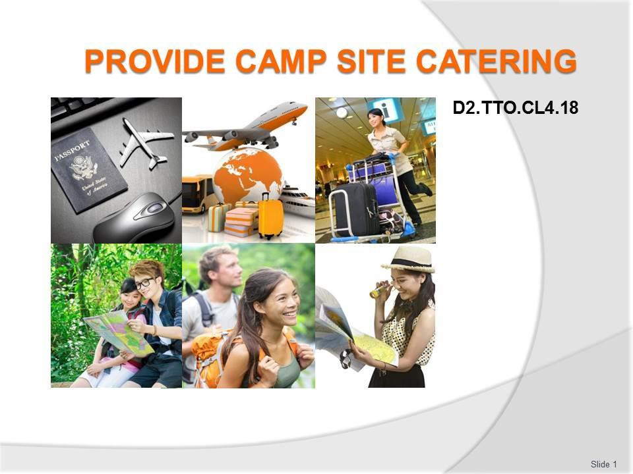
Slide No | Trainer Notes
1. | Trainer advises trainees this Unit comprises six Elements, as listed on the slide explaining:  - Each Element comprises a number of Performance Criteria which will be identified throughout the class and explained in detail  - Trainees can obtain more detail from their Trainee Manual  - At times the course presents advice and information about various protocols but where their workplace requirements differ to what is presented, the workplace practices and standards, as well as policies and procedures must be observed.

Slide
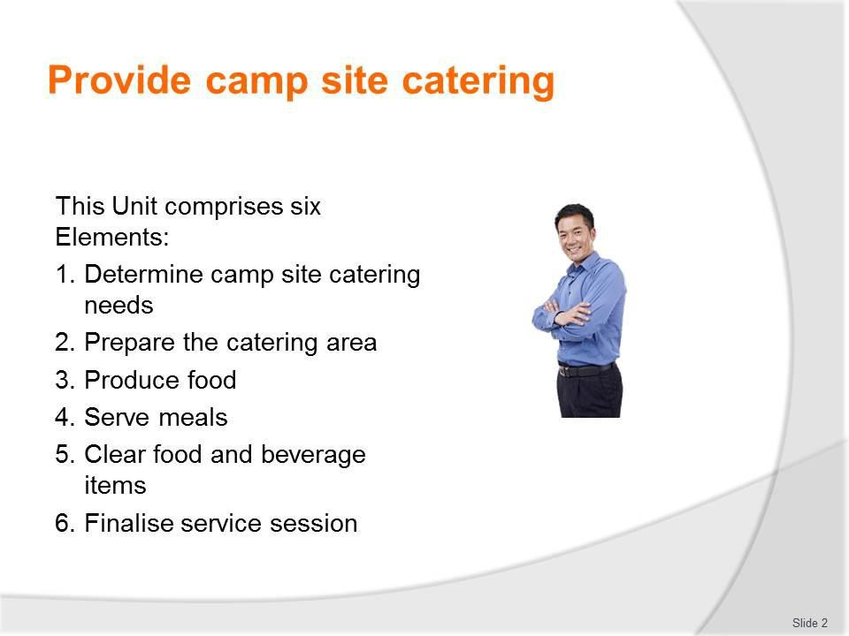
Slide No | Trainer Notes
2. | Trainer advises trainees that assessment for this Unit may take several forms, all of which are aimed at verifying they have achieved competency for the Unit as required.  Trainer indicates to trainees the methods of assessment that will be applied to them for this Unit.

Slide
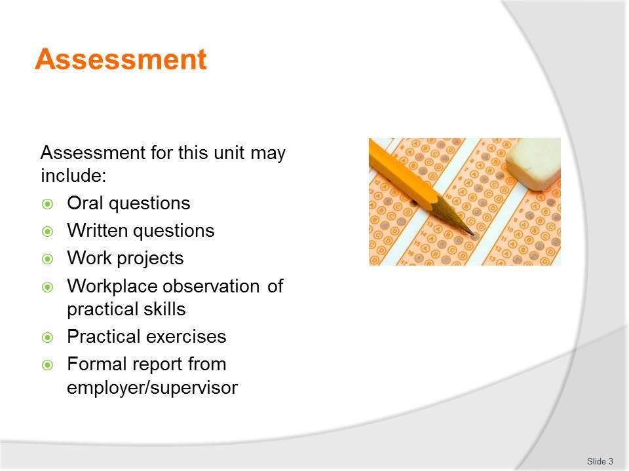
Slide No | Trainer Notes
3. | Trainer identifies for trainees the Performance Criteria for this Element, as listed on the slide.  Class Activity – General Discussion  Trainer leads a general class discussion by asking questions such as:  - What experience do you have with camp catering?  - When and where?  - What were the groups and what did they require?  - Why is camp site catering a requirement for some tours?  - What does it involve?

Slide
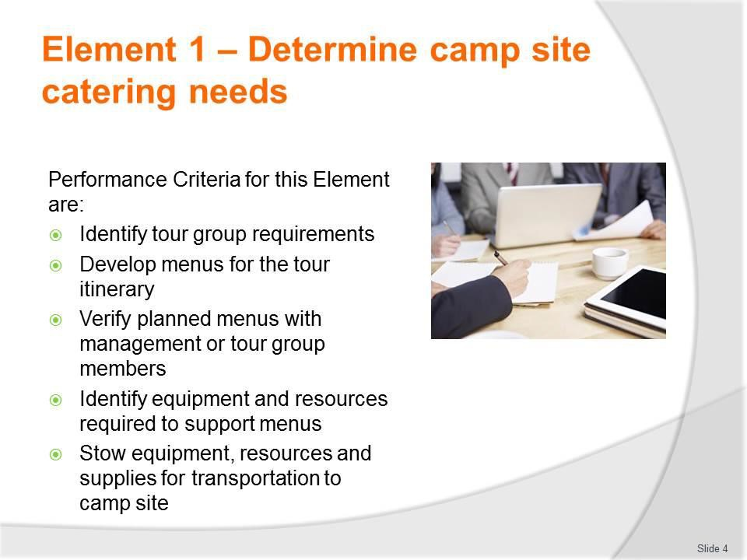
Slide No | Trainer Notes
4. | Trainer identifies for trainees the Performance Criteria for this Element, as listed on the slide.  Class Activity – General Discussion  Trainer leads a general class discussion by asking questions such as:  - What experience do you have with camp catering?  - When and where?  - What were the groups and what did they require?  - Why is camp site catering a requirement for some tours?  - What does it involve?

Slide
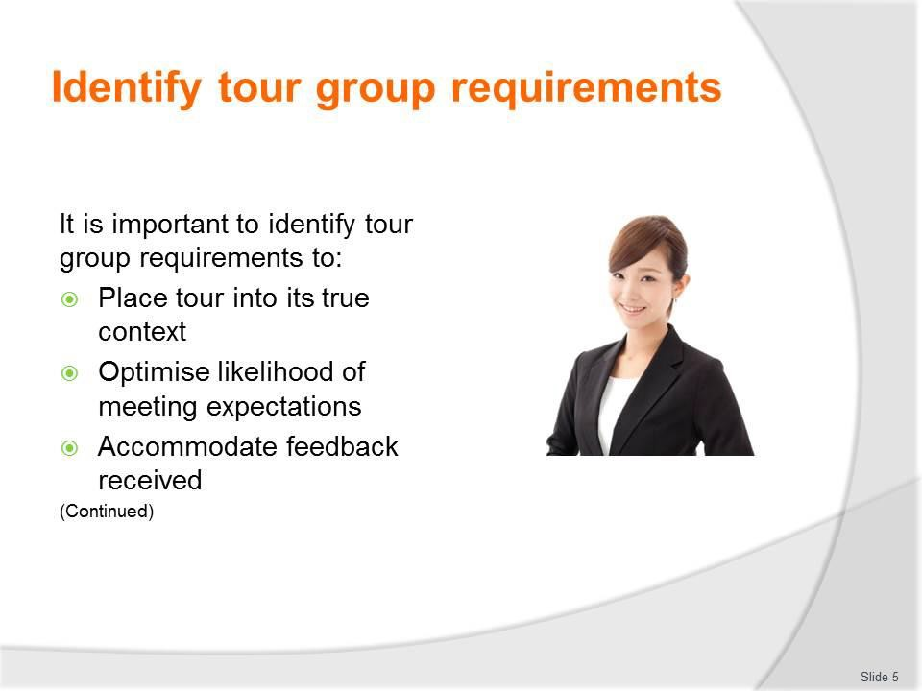
Slide No | Trainer Notes
5. | Trainer explains it is important to identify tour group requirements to:  - Place the tour to be conducted into its true context – by putting the tour, inclusions and catering into perspective as this applies to the individual tour. A primary requirement here is to determine if the tour is:  - A private/custom tour  - A standard/scheduled tour  - Optimise likelihood of meeting tour group expectations – in relation to:  - Special requests made by customers in relation to the tour – some (but not all) Tour Operators will accommodate certain special requests for menu items and/or beverages if they are cost neutral and if they can be fitted in to other constraints such as itinerary, local conditions, and available resources  - Inclusions (in this case promises made about meals, dishes, food and beverages) which have been promoted as being part of the tour – in advertisements for the tour as presented in the media, tour brochures and other promotional materials  - Accommodate feedback received – from:  - Previous tour group members – on the basis of:  - Formal written feedback received  - Issues raised during the end-of-tour discussion which should be standard for every Tour Group to have with their tour group

- Topics and issues mentioned as part of the standard Tour report generated by tour leaders and tour staff (including catering staff) when a tour has completed
- Local/host communities where camps have been set-up and where catering has been provided.

Slide
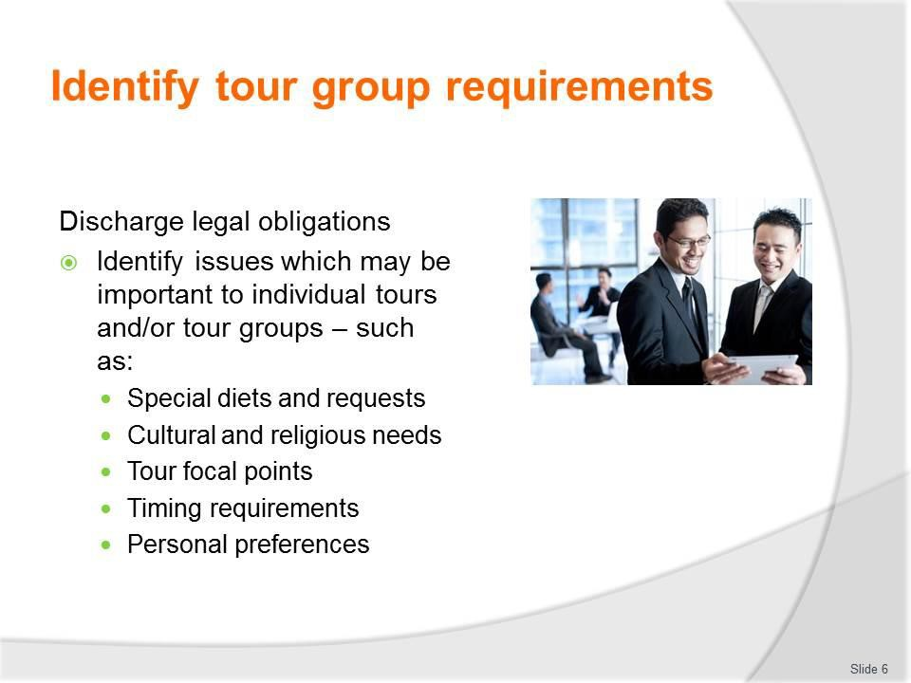
Slide No | Trainer Notes
6. | Trainer continues identifying need to identify tour group requirements – to:  - Discharge legal obligations – as imposed by:  - Contracts for the tour which have been developed/entered into – especially those attaching to custom/private tours  - Legislation relating to false advertising  - Identify issues which may be important to individual tours and/or tour groups – which may include:  - Special diet needs of tour group members  - Allergies which need to be accommodated  - Cultural preferences for food  - Religion-based requirements  - Specific focal points of a tour – such as:  - ‘Taste of the Country/Region’; Tours with a certain food and/or beverage- based focus; Camp fire nights;  - Barbecue nights; Spit roasts; Tours highlighting local cooking styles  - Timing requirements for meals and refreshments  - Personal and/or group preferences – for:  - Types of food and beverages used; Cooking styles; Serve sizes.

Classroom Activity – Guest Speaker
Trainer arranges for Catering Officer/Manager from a tour operation to attend and:
- Discuss their role and responsibilities
- Identify what they do at the start of a tour to determine what is required and the menus to be served
- Provide sample menus and recipes
- Give advice on providing camp site catering
- Tell anecdotes of their experience with providing camp site catering.

Slide
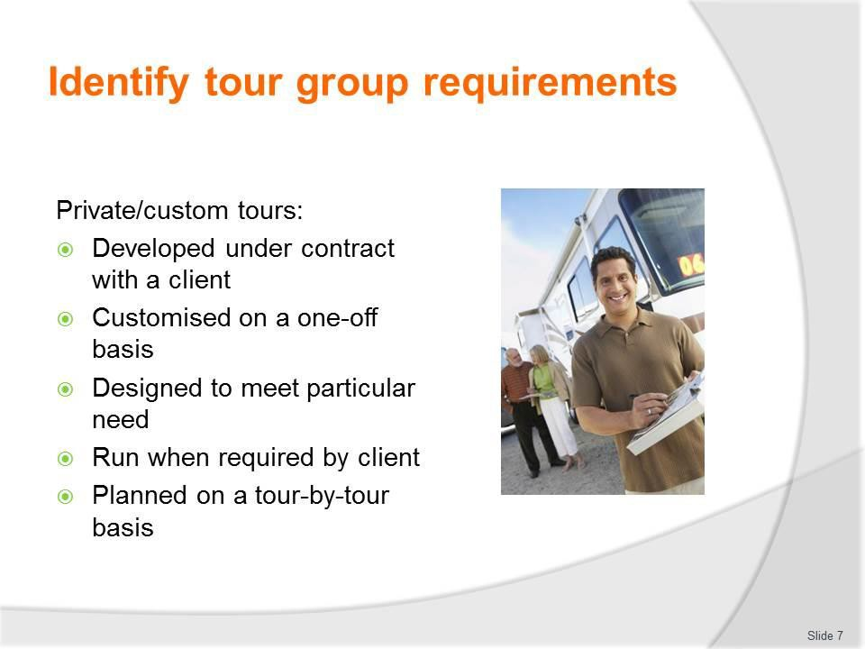
Slide No | Trainer Notes
7. | Trainer describes/defines  Private/custom tours  Private/custom tours are tours which are:  - Developed under contract with a client (individual or group)  - Customised on a one-off basis – in terms of:  - Focus  - Interpretive activities  - Commentary  - Itinerary  - Cost  - Inclusions  - Designed specifically and totally to meet the stated/identified needs of the individual client  - Run at a time and date determined by the client  - Planned and prepared/organised on a tour-by-tour basis.  Classroom Activity – Handouts  Trainer distributes and discusses advertising materials promoting various standard/scheduled tours.

Slide
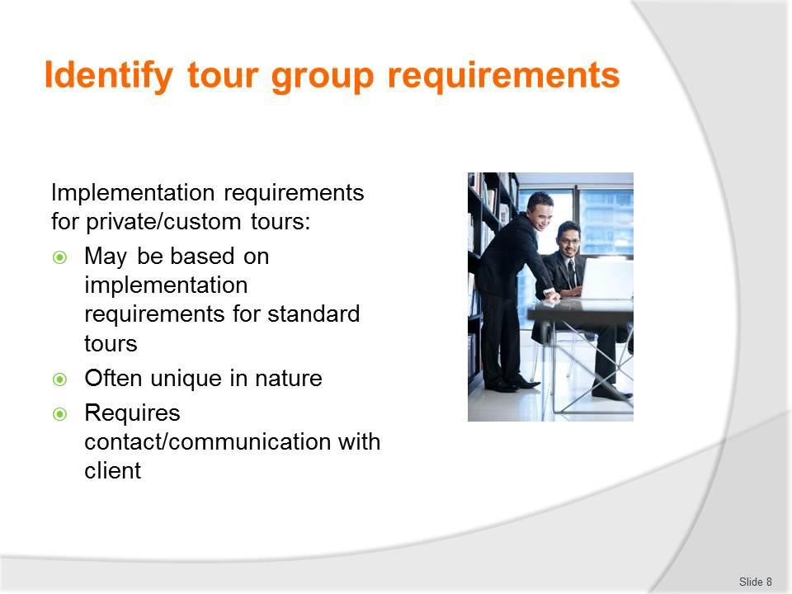
Slide No | Trainer Notes
8. | Trainer discusses implementation requirements for private/custom tours:  - May be based on implementation requirements for standard tours – planning of these tours may have been based around a standard tour for the purposes of efficiency or because scheduled tours cover/address much of the requirements for the private tour  - Will often be unique in nature – given the one-off nature of these tours  - Can often require contact with the client to:  - Discuss and interpret requirements  - Confirm requirements  - Clarify issues  - Obtain recipes  - Capture details of special requests, allergies, requirements based on culture, religion and other factors.

Slide
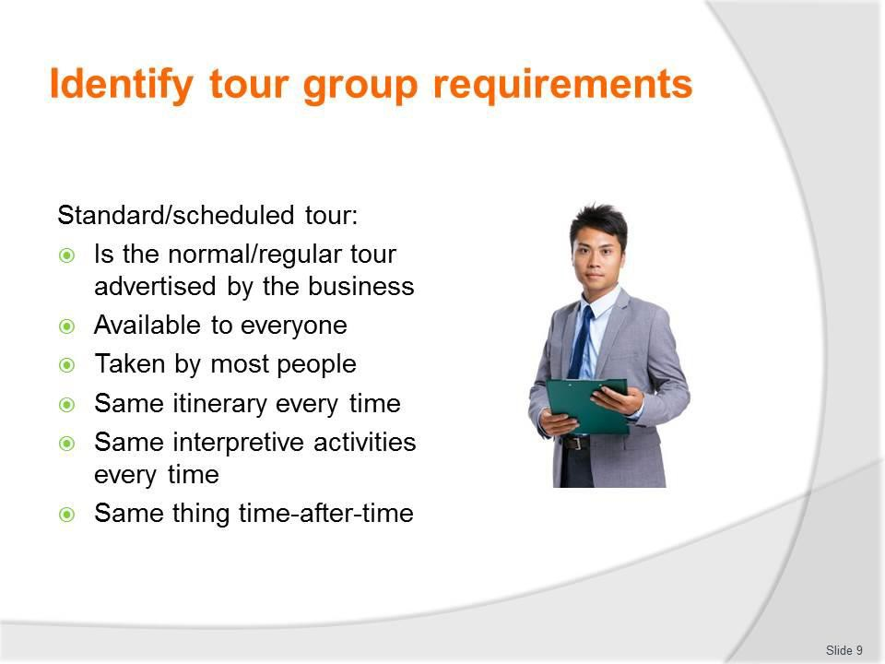
Slide No | Trainer Notes
9. | Trainer describes/defines  Standard/scheduled tour  A standard/scheduled tour (also known as a ‘regular’ tour):  - Is the normal tour advertised generally by the company  - Is available to all/members of the public  - Is the type of tour most people take  - Operates using the same itinerary every time  - Features the same interpretive activities, inclusions and scripted commentary every time  - Is essentially the same tour for all tour group members, time-after-time – subject to seasonal changes and other foreseeable and unforeseeable factors.

Slide
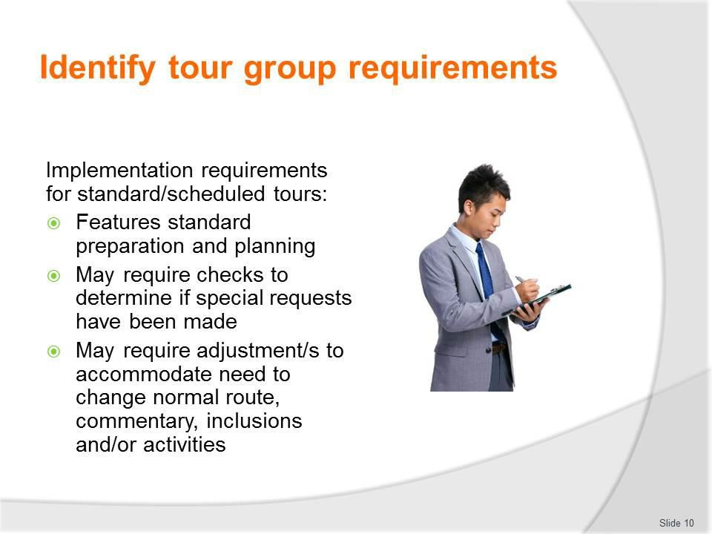
Slide No | Trainer Notes
10. | Trainer discusses implementation requirements for standard/scheduled tours:  - Is standard – in terms of:  - Preparing required resources  - Checking usual lists and documentation  - Ensuring the same tour delivered previously is replicated this time to maintain quality and consistency of delivery  - May require checking to determine if any special requests have been made – and/or are approved or are required by management  - May require adjustment – to accommodate the changes (to route, commentary, inclusions, interpretive activities) brought about by seasonal factors in this case, to the standard menus) brought about by seasonal factors as food move in and out of season, and as the prices of ingredients dictate.

Slide
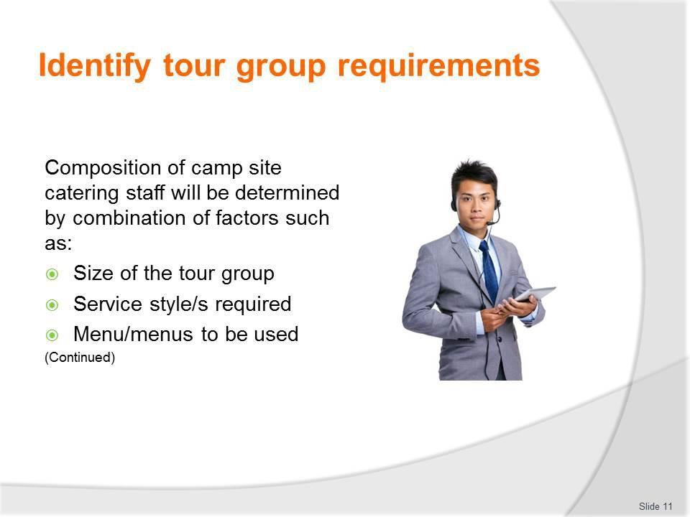
Slide No | Trainer Notes
11. | Trainer discusses camp site catering staff noting the nature of camp site catering staff can vary between operators and between individual tours and identifying relevant factors which may dictate the composition of camp site catering staff will be:  - Size of the tour group – tour group numbers  - Service style – that is, whether catering is to be:  - Self-catered to some/any extent – where tour group members prepare their own meals from provisions provided (and perhaps prepared) by the catering staff  - Self-service – where catering staff prepare and present the food and tour group members serve themselves  - Fully-served – where the food is prepared, served to and cleared from the tour group  - Menus/menu items to be used for the tour.

Slide
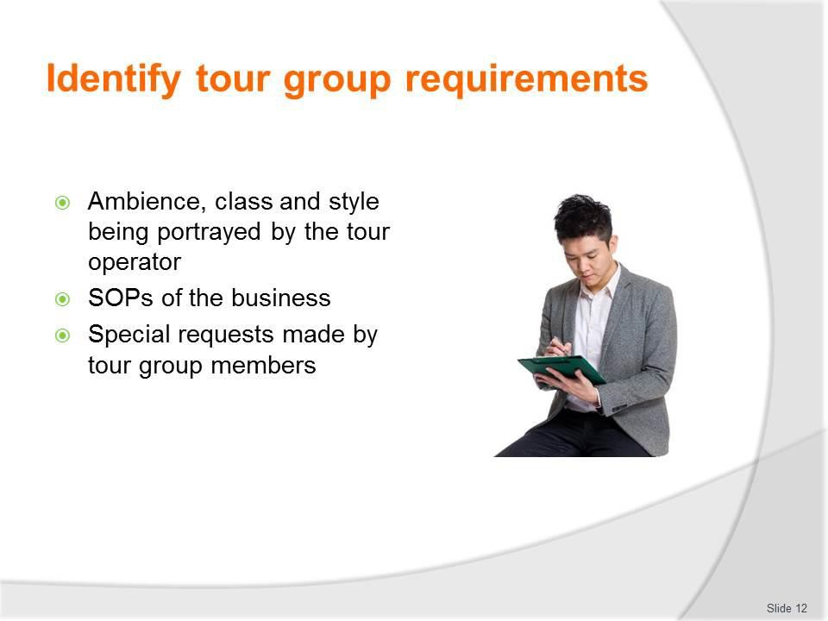
Slide No | Trainer Notes
12. | Trainer continues identifying factors which will determine composition of staff for camp site catering:  - Ambience, class and style being portrayed by the tour operator – for the tour  - SOPs of the business – in relation to the way they operate catering for tours  - Special requests made by tour group members – including any requests which have been supported by extra funds to enable more/different staffing personnel and/or staffing levels.

Slide
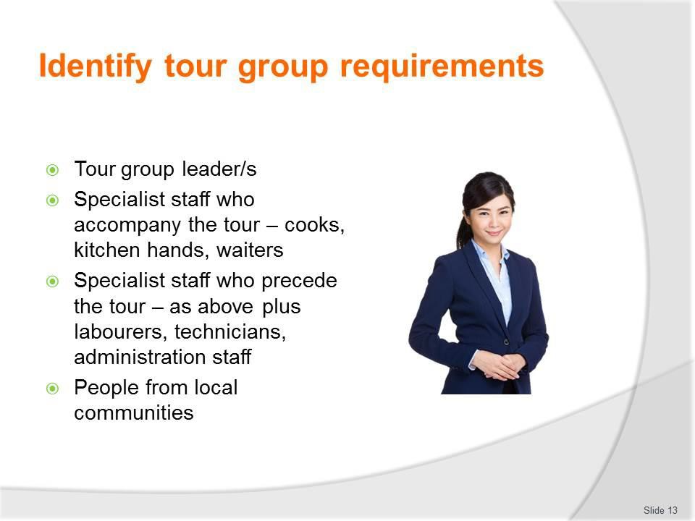
Slide No | Trainer Notes
13. | Trainer identifies examples of catering staff for camp site catering:  - Tour group leaders who double as the caterer for the group – this means they will lead the tour, do the commentary, conduct activities and also:  - Set up the camp and catering requisites; Prepare and cook the food; Serve the food and drinks; Clean up after the meals  - Specialist staff who accompany the tour and travel with the group – such as:  - Cooks; Kitchen hands; Waiters  - Specialist staff who precede the tour group and set up the catering facilities at the camp in advance of group’s arrival – such as those mentioned above, plus:  - Labourers – to set-up tents/marquees  - Technicians – to test, confirm or treat water supply  - Administrators – to negotiate with land managers/local communities  - These people will break camp after meals are finished and either:  - Move to the next location and prepare the next meal  - Leap-frog another crew/team and set-up for the meal after next  - Return to the head office for other deployment  - People from local communities – there may be an arrangement where local people are employed in various roles to assist with cooking, service, entertainment, interpretive activities and other support roles.

Classroom Activity – Guest Speakers
Trainer arranges for selection of people identified on the slide to attend and:
- Discuss their experience with camp site catering
- Describe their roles, responsibilities and experience
- Provide advice regarding provision of camp site catering.

Slide
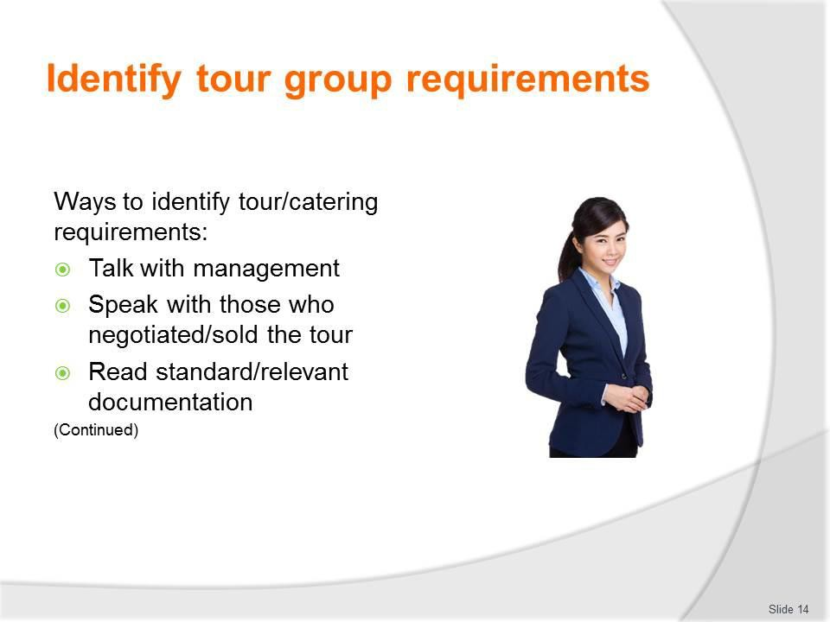
Slide No | Trainer Notes
14. | Trainer states those involved with camp site catering for tours can identify what is required for an upcoming tour by:  - Talking with management – who organised to tour and/or prepared the itinerary, budget and the advertising for the tour  - Speaking with those (for example, personnel from sales and marketing) who developed the requirements for a custom tour with the client – because they will have first-hand knowledge about what is required as a result of talking with the tour group  - Reading the standard documentation for a scheduled/standard tour – this means taking the time to read and note the details contained in:  - Itineraries  - Advertisements and promotional material for the tour  - Tour briefs  - Tour-specific catering checklists and loading sheets  - Budgets  - Tour Reports.  Classroom Activity – Handouts  Trainer distributes and discusses documentation identified on the slide.

Slide
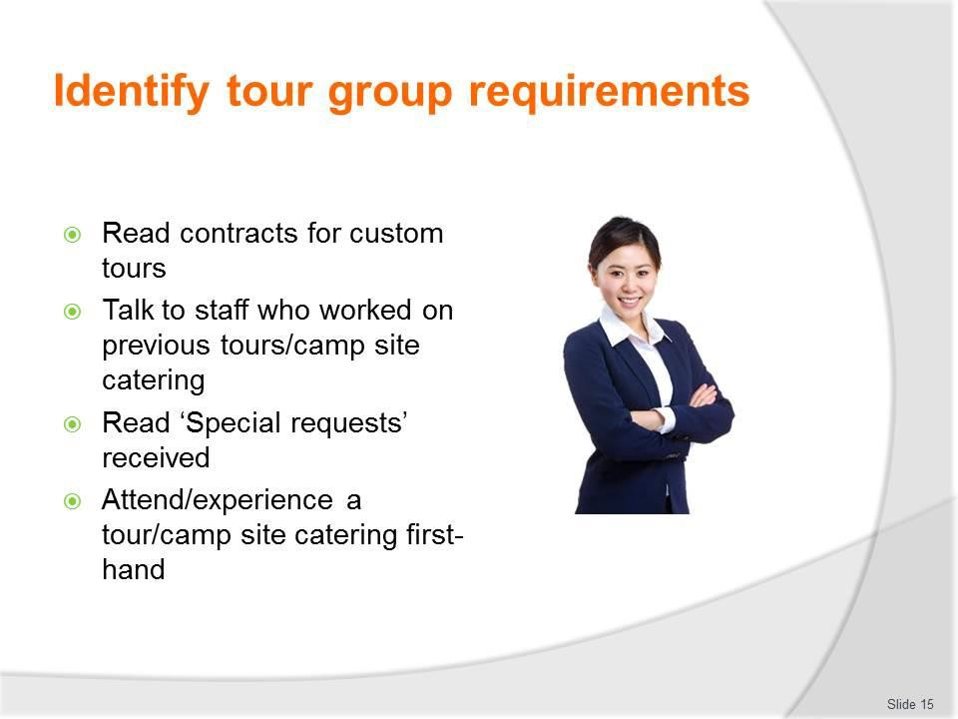
Slide No | Trainer Notes
15. | Trainer continues identifying ways to determine tour/catering requirements:  - Reading the contract prepared and signed for a custom/private tour – to identify the specifics which have been requested, negotiated and agreed with the tour group/client  - Talking to Tour Guides, Tour Group Leaders, Cooks and Catering Staff who have catered for previous identical and/or similar tours – to get their thoughts and ideas about what is needed and what is involved  - Talking directly with tour group members who have booked for the tour – to identify their individual requirements, expectations and/or preferences  - Reading ‘Special Requests’ made by tour group members – using a range of options as provided by the individual tour operator, such as:  - Website options; Social media options; Hard copy forms  - Going on a tour as a ‘working’ tour group member – to gain a personal, first-hand impression of what is provided, when it is provided and how it is provided.  Classroom Activity – Excursion  Trainer arranges for students to visit a camp site catering location and:  - Talk to staff  - View facilities

- Observe activities
- Experience set-up, food prep and service.

Slide
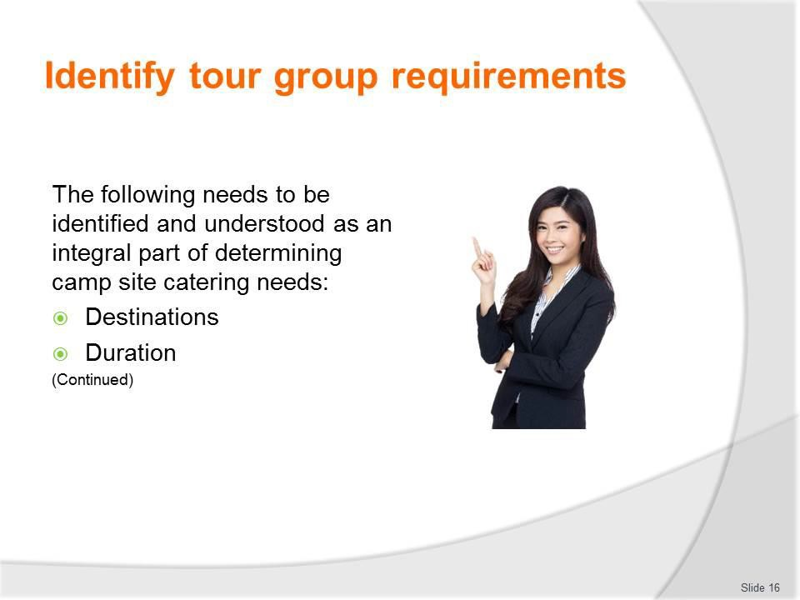
Slide No | Trainer Notes
16. | Trainer identifies examples of what needs to be identified and understood as an integral part of determining camp site catering needs:  - Destinations – it is necessary to know the itinerary for the tour with reference to:  - Learning where the tour is going – in terms of towns, cities, regions or other nominated areas, sites or locations  - Identifying locations for meals – some sites have catering facilities in place, some can provide ingredients/supplies  - Determining facilities available camp site(s)/destinations –operators tend to use camp sites/locations/providers they have used previously so they are dealing with a ‘known quantity’  - Identifying locations for refreshments to be provided as part of the tour – and whether these are to be provided through a local provider, on/from the tour vehicle, or in a more formal and substantial form  - Identifying which, if any meals, are to be provided by third party providers  - Determining some menu items – tour groups may expect certain dishes at certain locations/destinations  - Duration of the tour – considerations here include:  - Timing of the tour – time of year tour is conducted as this influences availability of local, fresh produce

- Day of the week the tour leaves – as there can be a need to pre-arrange the delivery of some foods/provisions in advance (on the Friday) where a tour departs on a Saturday or Sunday
- Length of the tour – to identify:
  - Number of nights the tour is for
  - Number and date and time of meals to be catered for
  - Number and date and time of meals to be provided by third parties
  - ‘Free time’ – where tour group members have been advised in advance they will be required to buy their own meal from a local provider as they see fit/to suit their own taste or budget
  - Number of overnight stays – which indicate need for dinner and breakfast for the group
  - Time when tour returns – to determine if lunch is required on the final day of the tour.

Slide
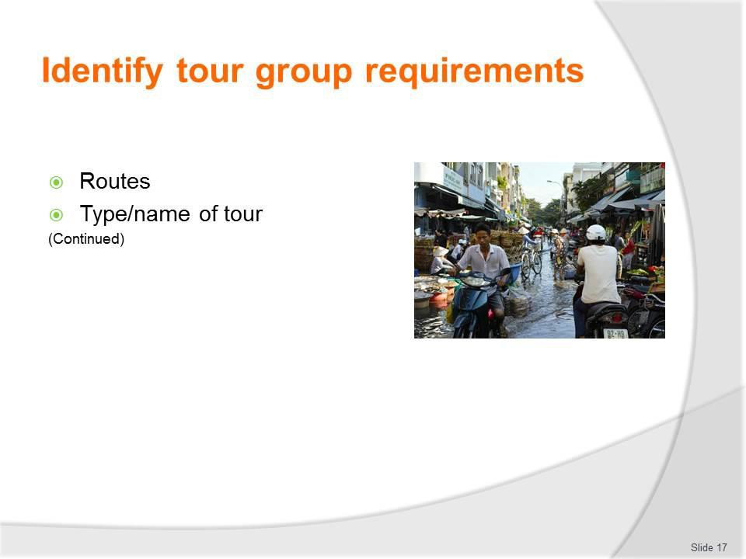
Slide No | Trainer Notes
17. | Trainer continues to identify examples of what needs to be identified and understood as an integral part of determining camp site catering needs:  - Routes to be taken – this is important because:  - It may be possible to acquire better quality provisions from a provider along the way  - It may be possible to buy cheaper items on route  - Some provisions may only be able to be acquired from local providers along the tour route  - The operator may have contractual arrangement with providers to supply the tour and charge back to head office  - The tour may cook prepare and cook fish and game caught by tour group members  - Type/name of the tour – because this will/may:  - Give a context or general ‘flavour’ for the menu items which can/must be selected for the tour  - Provide direction for service standards  - Indicate a theme which needs to be integrated into the catering  - Highlight certain meals to be prepared at nominated dates/times/locations on the tour.

Slide
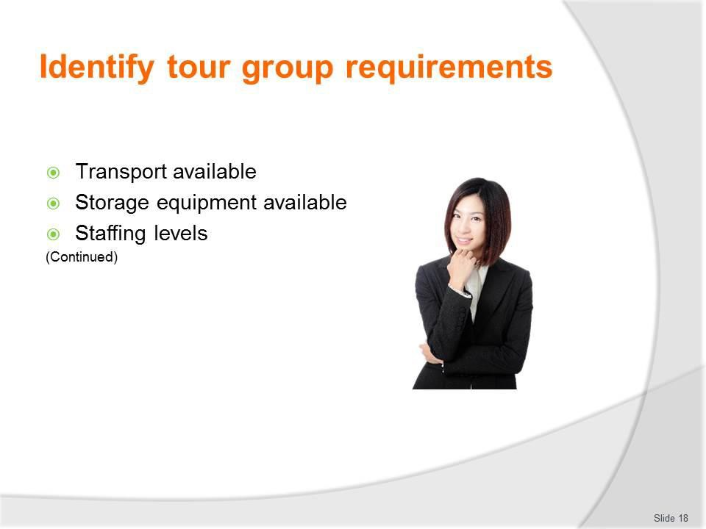
Slide No | Trainer Notes
18. | Trainer continues to identify examples of what needs to be identified and understood as an integral part of determining camp site catering needs:  - Transport available for the tour to move equipment, resources and supplies – common options are:  - All catering requirements are loaded onto the standard tour vehicles as part of the standard loading for these vehicles  - Separate catering units (vans, trailers, trucks [for tents, marquees and large catering equipment], portable cool rooms) are provided in addition to the passenger-carrying buses or 4WD vehicles  - Equipment available for the safe storage of perishable food – this may relate to:  - Providing portable cool rooms – which may be trailer- or truck-mounted  - Using smaller portable (gas and/or low voltage) refrigeration units  - Generator-powered and/or solar-powered refrigeration and/or freezer units  - Staffing levels for the tour – this relates to:  - Identifying the number of staff the tour operator has assigned to the tour based on tour group numbers and labour budget imperatives  - Finding the actual names of the individual personnel who have been assigned to the tour – it is good to know in advance exactly who will be provided the labour for the catering because it is a fact of life some staff are better than others/have more skills, and some staff have strengths that other staff do not

- Being able to think about (in advance) what the staffing levels/staff members will realistically allow to be provided in terms of food/menu items and service
- Pre-planning roles and responsibilities for those who have been allocated to the tour
- Providing necessary pre-tour training for certain employees so they are proficient when on tour.

Slide
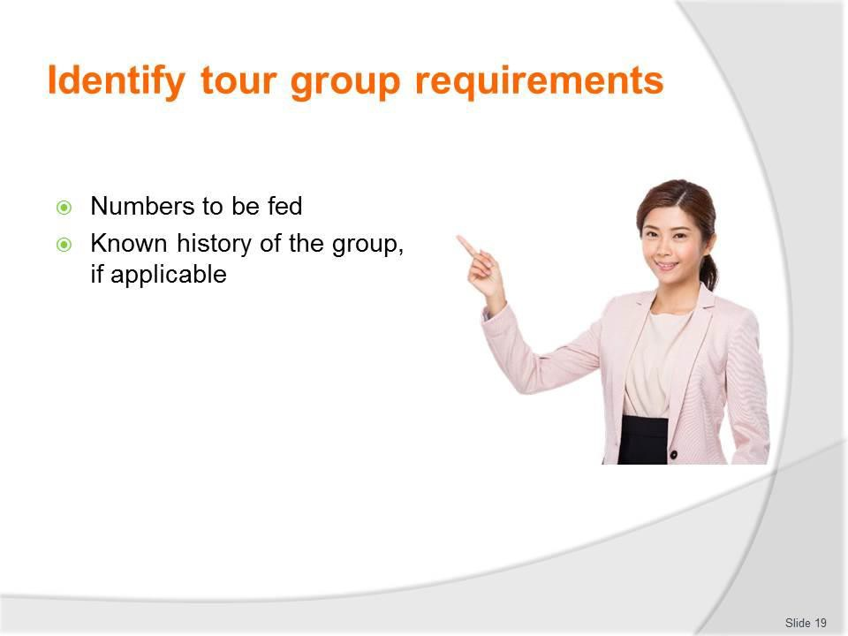
Slide No | Trainer Notes
19. | Trainer continues to identify examples of what needs to be identified and understood as an integral part of determining camp site catering needs:  - Number of people who have to be fed – this relates to determining:  - Number of tour group members for each service session  - Number of tour and support staff who have to be fed for each service session  - Age and gender of those who need to be catered for – as this impacts selection of menu items, style of food and serve sizes  - Previous history of the group – if the group has toured with the same tour operator previously it is essential the feedback forms, Tour Reports and any other comments obtained from that group are accessed to ensure:  - Previous problems which were identified are avoided/not repeated  - Suggestions for improvement are accommodated wherever possible  - Any issues raised are addressed to the best of the ability of the organisation.

Slide
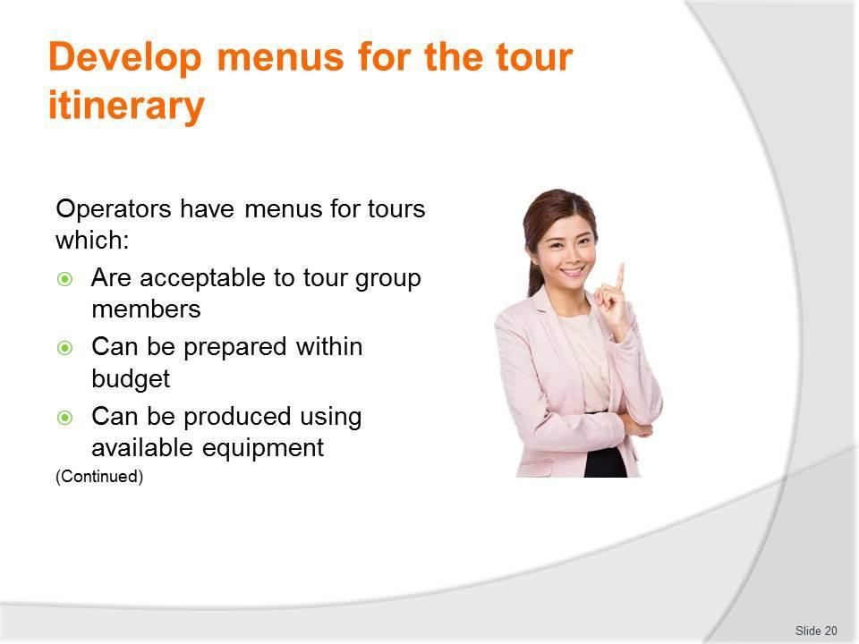
Slide No | Trainer Notes
20. | Trainer discusses standard menus stating for most tours where there is a need for camp site catering there will be an established range of menus which have been developed and these menus will have been trialled, tested and refined over time and reflect meals which:  - Have proved to be tasty and acceptable to tour group members  - Can be prepared within budget  - Are able to be prepared using available equipment.

Slide
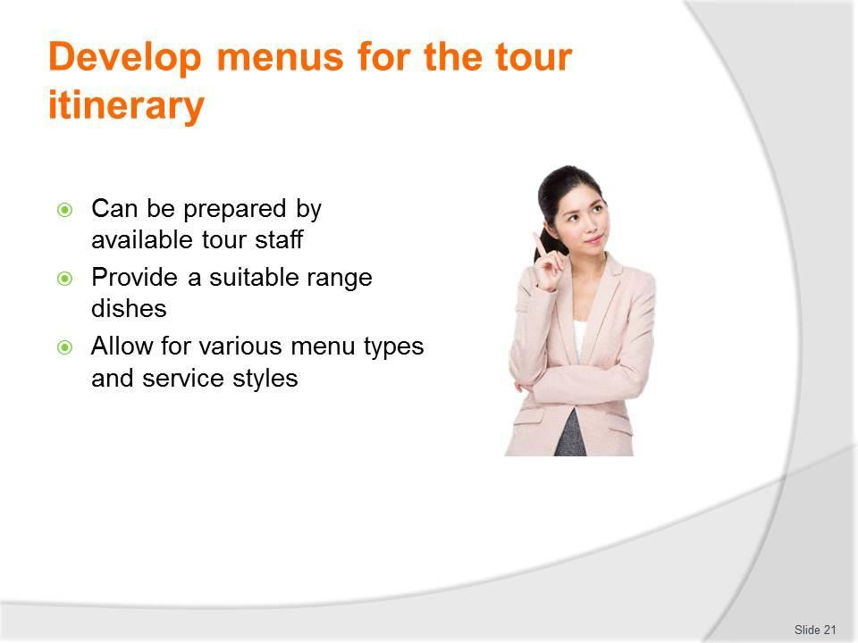
Slide No | Trainer Notes
21. | Trainer continues discussing standard tour/camp menus observing they:  - Can be cooked by the existing staff – without the need to hire new/extra staff or train/re-train staff  - Provide a suitable range of food (and beverages) – so there is a variety of:  - Basic ingredients  - Cooking styles  - Enable differences (where required) in terms of:  - Menu types  - Service styles.  Classroom Activity – Handouts  Trainer distributes and discusses a selection of camp site catering menus.

Slide
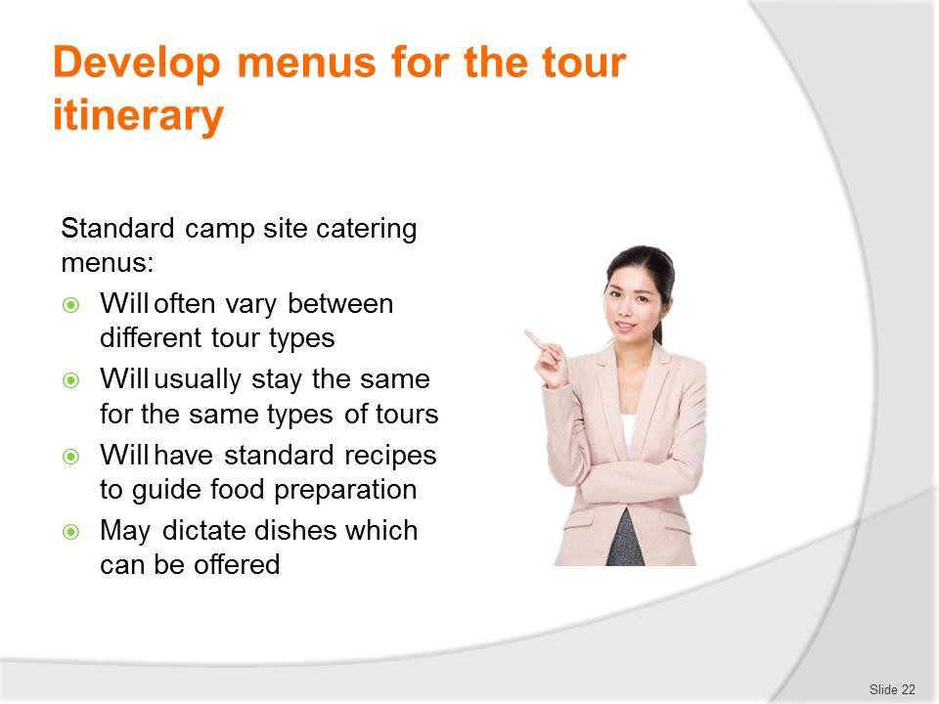
Slide No | Trainer Notes
22. | Trainer provides further information about camp site catering menus noting they:  - Will often vary between different tour types – to reflect the nature of the tours and the available resources  - Will usually stay the same for the same types of tours – this facilitates staffing of catering crew, ordering/purchasing of ingredients, preparation of loading sheets, loading of vehicles  - Will have standard recipes to guide the preparation of each menu item – see following slides  - May dictate the dishes which can be offered on a tour – there may be no room for catering staff to change the menu items listed  - Where changes to dishes are being considered there can be a need to:  - Generate a new draft standard recipe  - Cost the new/revised recipe  - Demonstrate the cost meets acceptable budget constraints for the dish, meal or tour.

Slide
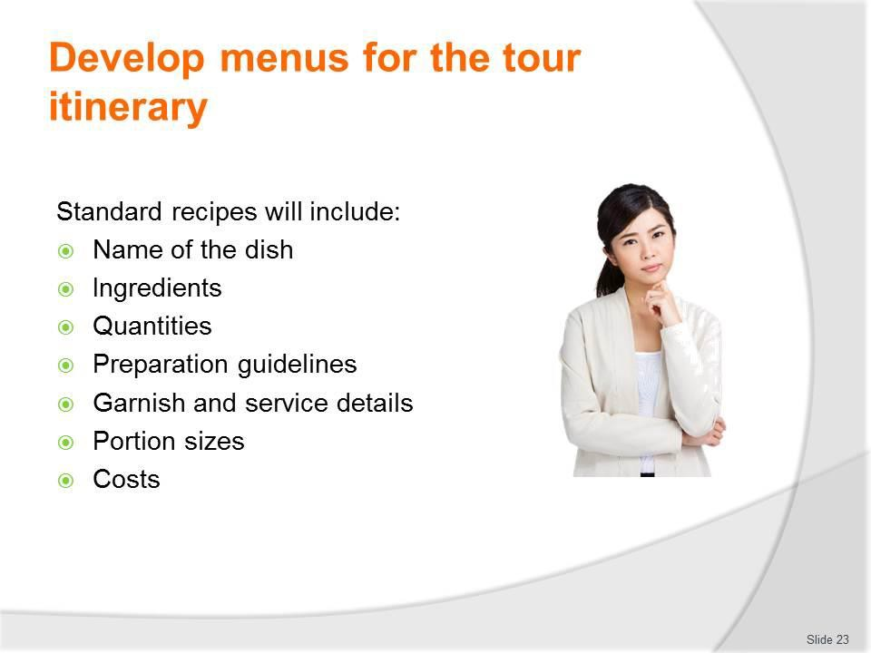
Slide No | Trainer Notes
23. | Trainer introduces standard recipes stating they are a precise record of ingredients, method, serving instructions and cost of a menu item, noting while there are several variations on the layout and content of a standard recipe they should include:  - Name of the dish/menu item  - List of ingredients  - Required quantities of each ingredient  - Specific preparation guidelines  - Garnish and service details  - Portion sizes  - Costs.  Classroom Activity – Handouts  Trainer distributes and discusses a selection of standard recipes.

Slide
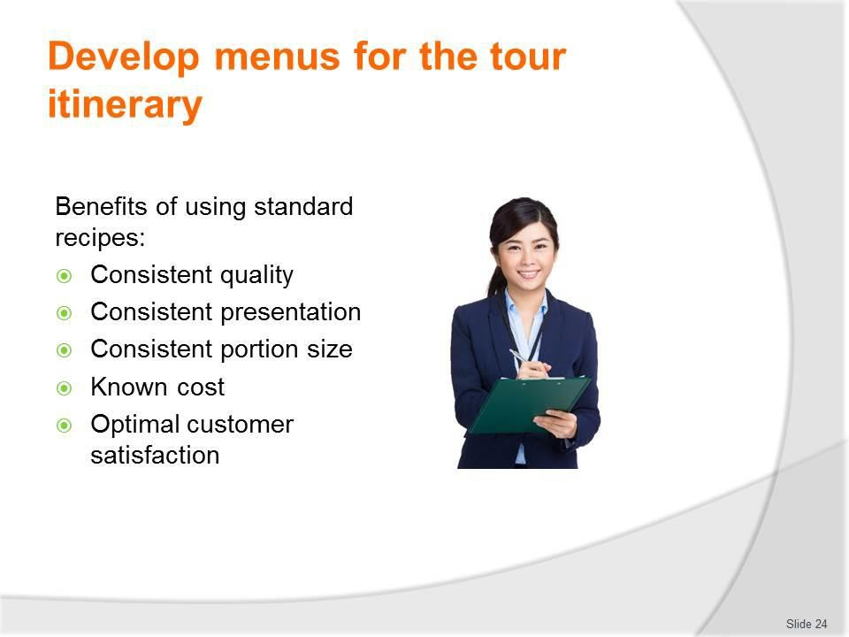
Slide No | Trainer Notes
24. | Trainer explains standard recipes are used because they standardise the production of recipes meaning that regardless of who makes them there will be:  - Consistent quality – items always taste the same  - Consistent presentation – dishes always look the same  - Consistent portion size – each recipe will always produce the same number of customer serves/quantity  - Known cost – for each menu item and each serve of each item  - Optimal customer satisfaction – based on the development of a recipe which has changed over time to reflect customer feedback about taste, portion size and other relevant criteria.

Slide
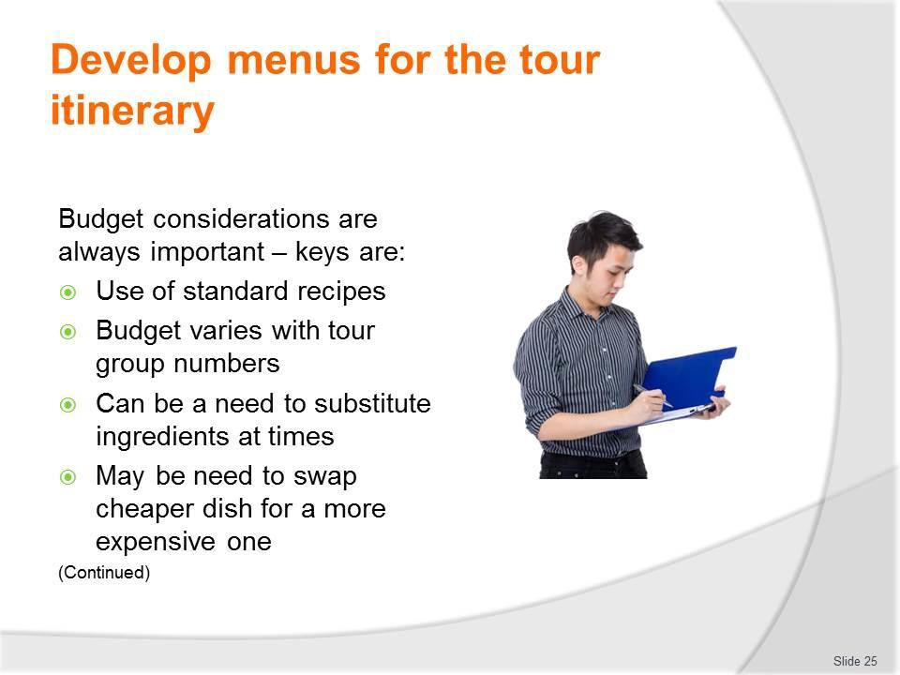
Slide No | Trainer Notes
25. | Trainer identifies importance of budget in providing camp site catering noting keys in this regard are:  - As identified, the use of standard recipes greatly assists in this regard  - The budget will/may vary depending on tour group numbers – greater numbers mean more money is available for ingredients  - There may be a need to substitute expensive ingredients for less expensive ones where funding is tight  - There may be a need to swap one dish for another where the cost prices are prohibitive.

Slide
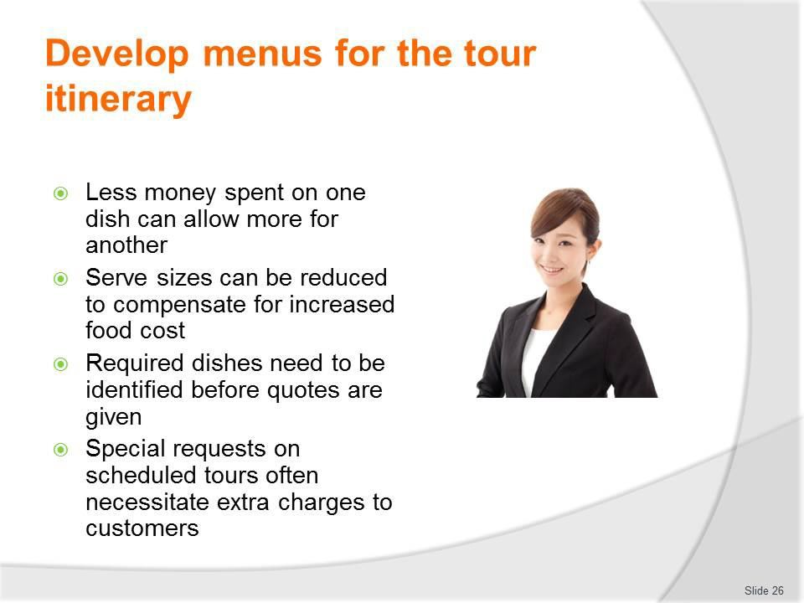
Slide No | Trainer Notes
26. | Trainer continues giving keys in relation to budgets:  - It may be possible to limit the costs of one dish so extra money can be spent on another – but the nett result must be ‘cost neutral’ meaning the end result must not entail extra cost to the business  - Reducing serve sizes to lower cost per head where the cost of ingredients has risen unacceptably  - Negotiate dishes required by custom/private tour groups before a final price for the tour is given – so the cost of ingredients can be appropriately factored into the final price  - Recover extra costs from tour group members who are participating in scheduled tours where they have special catering requests which incur additional expense for the tour company.

Slide
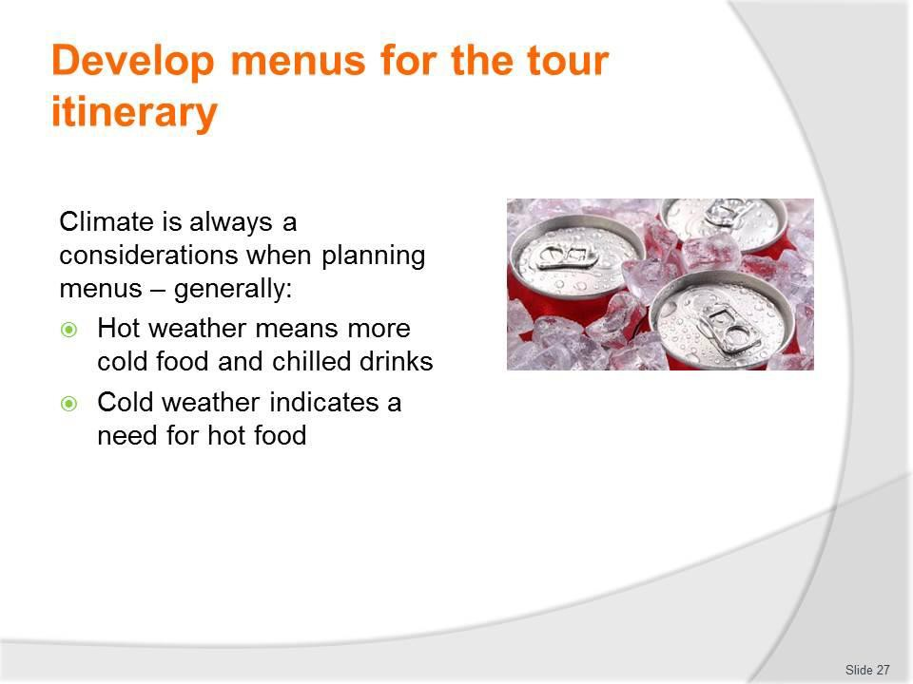
Slide No | Trainer Notes
27. | Trainer addresses climate considerations in relation to menus for camp site catering observing menus produced need to reflect – at least to an extent – the expected climate for the tour, highlighting the climate is traditionally the ‘expected’ climate for the time of the year the tour is being conducted based on experience and historical evidence.  In general terms (which are always subject to cultural and special requests):  - Hot weather means more cold food and chilled drinks  - Cold weather indicates a need for hot food.  Classroom Activity – Discussion/Q&A session  Trainer asks students to identify examples of hot and cold F&B that are suitable for camp site catering under different climatic conditions.

Slide
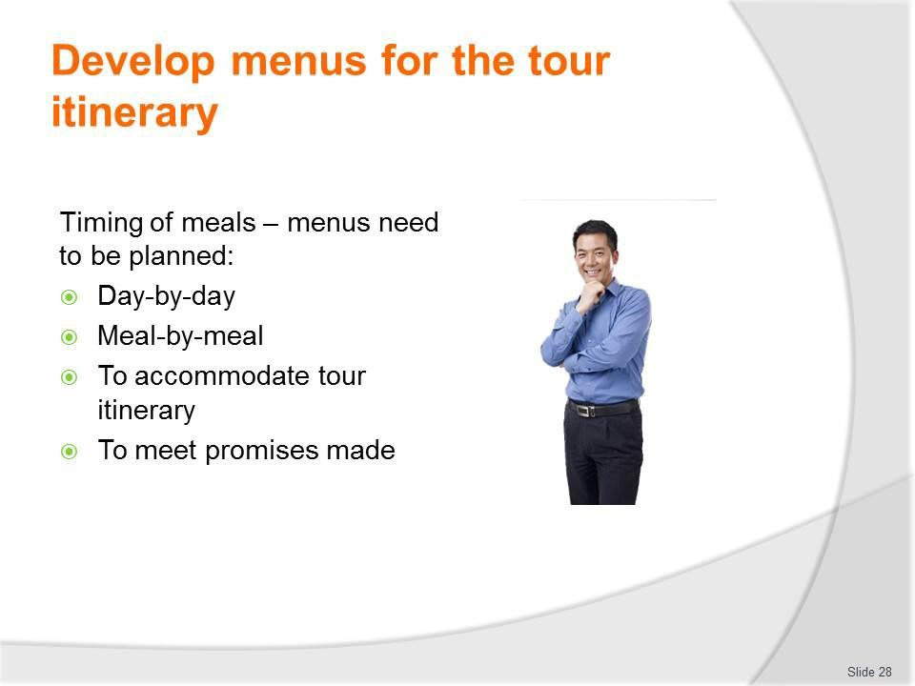
Slide No | Trainer Notes
28. | Trainer introduces consideration of timing of meals for camp catering noting menus need to be planned:  - Day-by-day  - Meal-by-meal.  There is a need for menus and meals to match the itinerary for the tour and any other advertised statements or promises made.

Slide
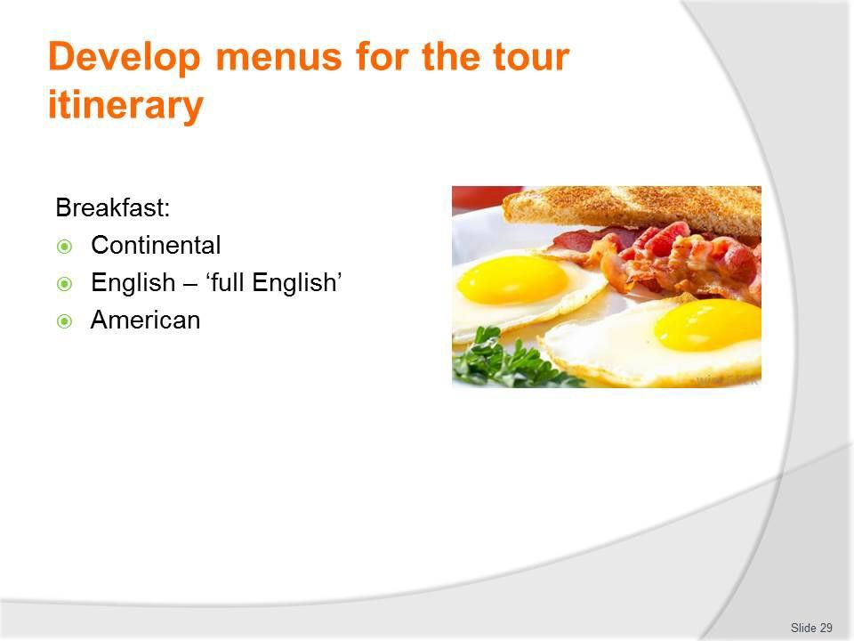
Slide No | Trainer Notes
29. | Trainer discusses possible breakfast options:  Breakfast  Breakfast is the first meal of the day and commonly served on tour between 6:00 – 8:00AM.  In addition to local traditional breakfast dishes the following variations are common and popular.  Continental  ‘Continental’ is a term used to describe what might be available in France or Germany as being from Continental Europe as opposed to England.  It typically comprises a small. Light breakfast featuring bread/toast, rolls or pastry such as croissants and baguettes served with a preserve or honey and accompanies by coffee.  English breakfast  This is a large hot breakfast which can include fried bacon rashers, eggs (scrambled, poached or fried), grilled lamb cutlets, grilled tomatoes, fried mushrooms, kedgeree (curried fish and rice), fried kidneys, livers, and toast.  There is also a cold part of the English breakfast which includes the continental breakfast as well as cereal, and a selection of fruit and juices.  Tea and/or coffee is also served.

American
This is similar to the English breakfast except hot cakes (pancakes) are also served with whipped butter, and maple syrup sometimes with bacon rashers.
Classroom Activity – Discussion/Q&A session
Trainer asks students to identify examples of menu items for meal options identified on slide.

Slide
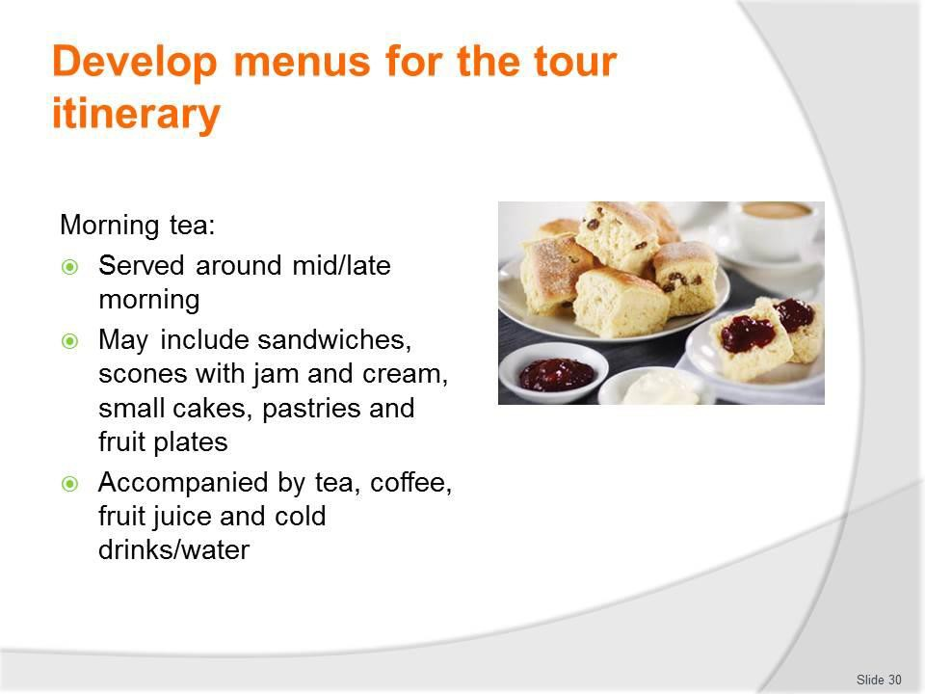
Slide No | Trainer Notes
30. | Trainer discusses morning tea:  Morning tea  - Morning teas may be served between 10:00 – 11:00AM.  - Morning tea may include a selection of sandwiches, scones with jam and cream, small cakes, pastries and fruit plates.  - These are accompanied by tea, coffee, fruit juice and cold drinks/water.  Classroom Activity – Discussion/Q&A session  Trainer asks students to identify examples of menu items for meal identified on slide.

Slide
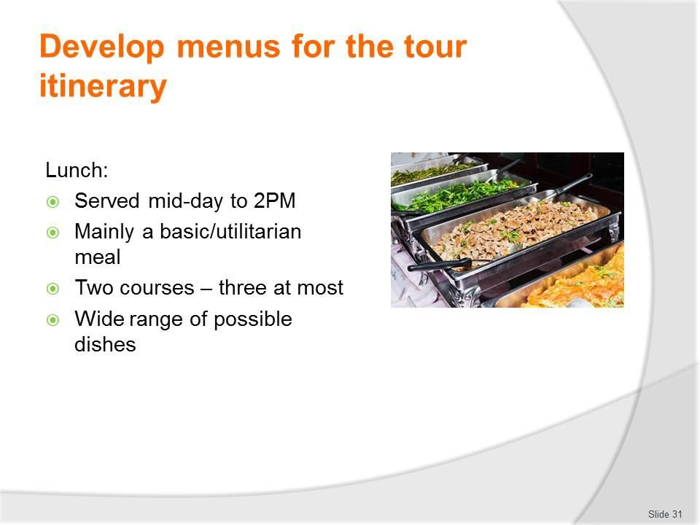
Slide No | Trainer Notes
31. | Trainer discusses possible lunch options:  Lunch  - Lunch is the mid-day meal and normally served between noon – 2:00PM  - It is more often than not considered a utilitarian meal  - In other words, it serves to satisfy hunger, and get people back on tour  - Most lunches offer limited courses (two is common, three is maximum)  - There are no hard and fast rules governing what can or cannot be served at lunch with pasta, wet dishes, roasts, salads, grills and sandwiches being acceptable and popular choices.  Classroom Activity – Discussion/Q&A session  Trainer asks students to identify examples of menu items for meal identified on slide.

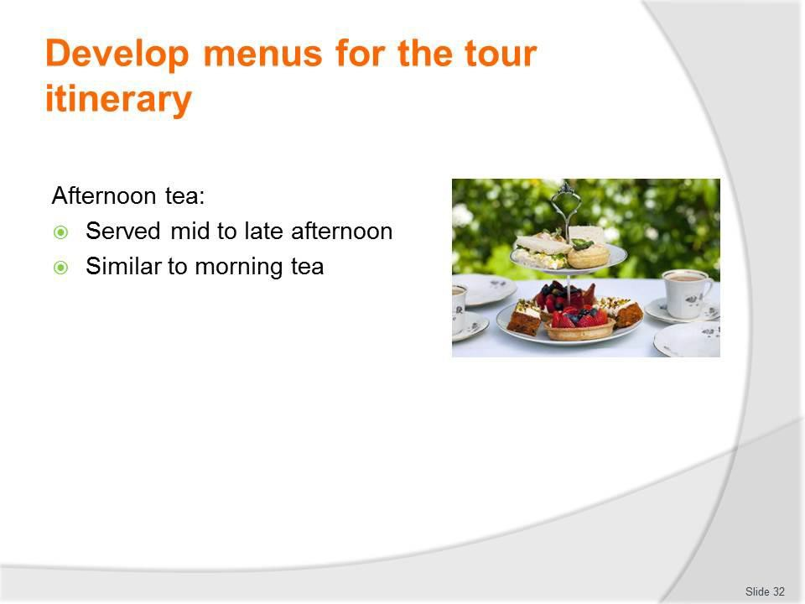
Slide
Slide No
Trainer Notes
32.
Trainer discusses afternoon tea:
Afternoon tea
Served usually between 3:00 – 5:00PM, it is similar to morning tea, although there is sometimes more emphasis on cakes.

Slide
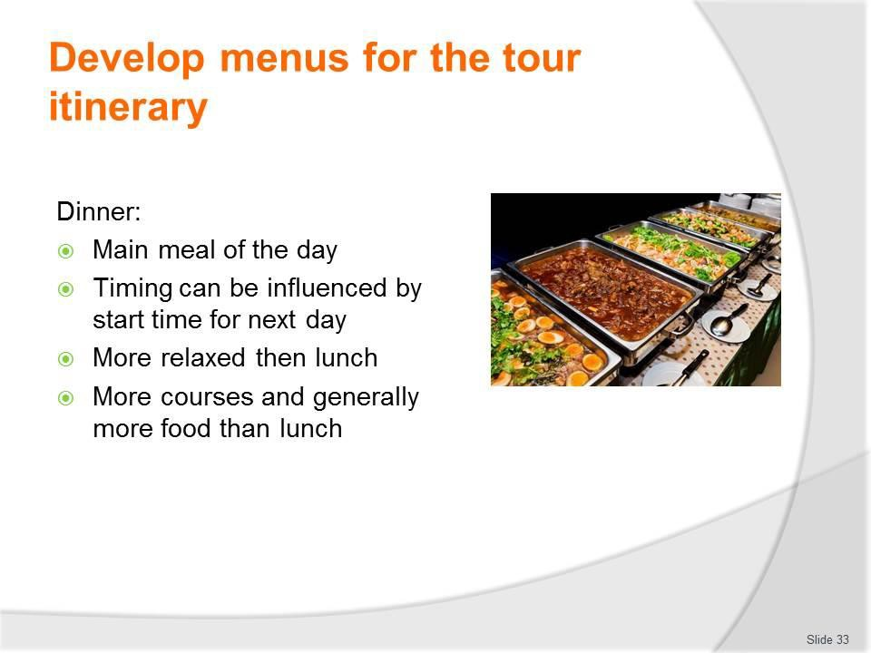
Slide No | Trainer Notes
33. | Trainer discusses dinner:  Dinner  - Seen as the main meal of the day it is normally served any time between 6:00 – 9:00PM  - The timing of dinner tonight often reflects the starting/departure time for the tour tomorrow  - The dinner tends to be more relaxed than lunch and dishes are often more elaborate with more courses (or certainly three courses: perhaps entrees, soups, main courses, hot and cold desserts) offered  - There is really no limit as to what can be served with a great variety of options available from (to mention a few) pasta, game, poultry, meat (all types), seafood.  Classroom Activity – Discussion/Q&A session  Trainer asks students to identify examples of menu items for meal identified on slide.

Slide
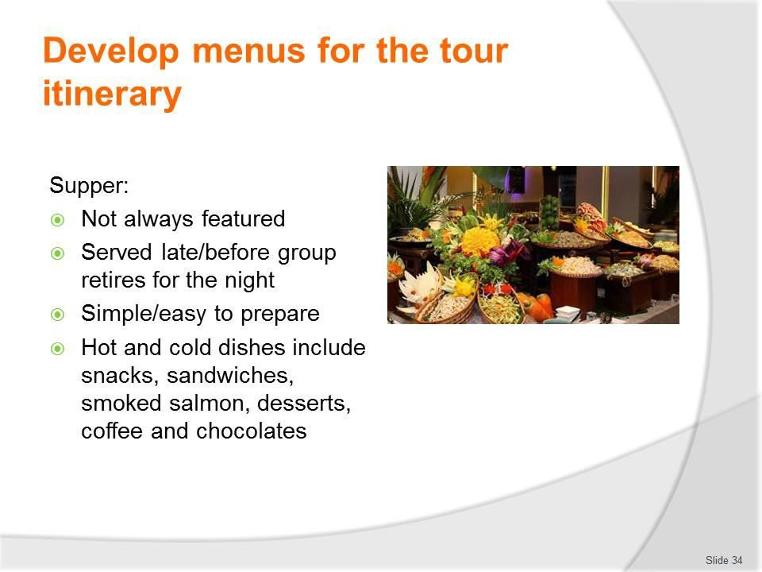
Slide No | Trainer Notes
34. | Trainer discusses supper:  Supper  - Suppers are often not a feature of tours/camp site catering but may be served late in the evening before the tour group retires for the night  - They are traditionally simple and easy to prepare  - They may feature hot and cold dishes include snacks, sandwiches, smoked salmon, desserts, coffee and chocolates.

Slide
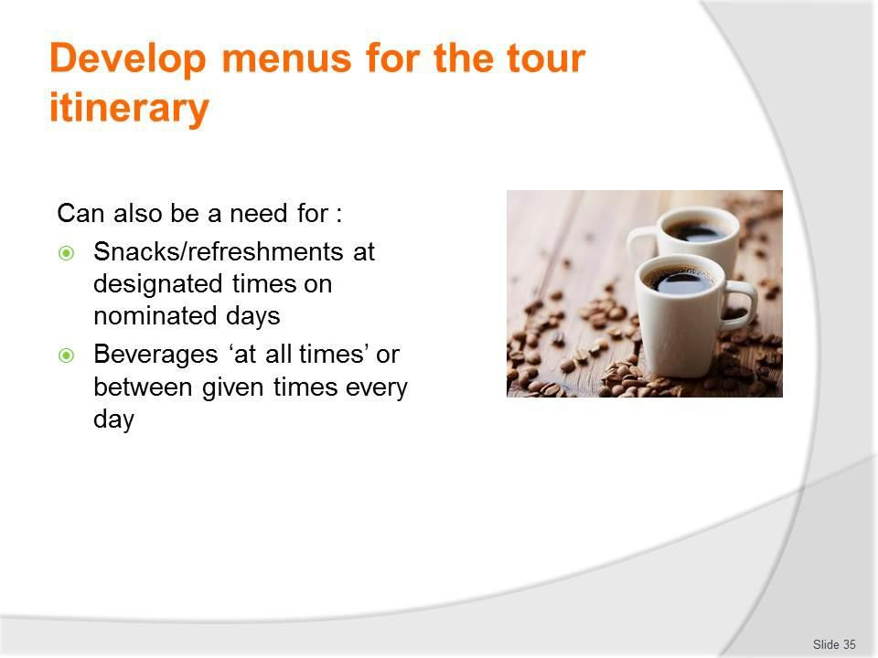
Slide No | Trainer Notes
35. | Trainer notes in addition to meals already identified, tours where there is camp site catering can require:  - Snacks/refreshments at designated times on nominated days – to replace and/or supplement standard meal times  - Beverages ‘at all times’ or between given times every day – so tour group members can have ready access to liquid refreshment.

Slide
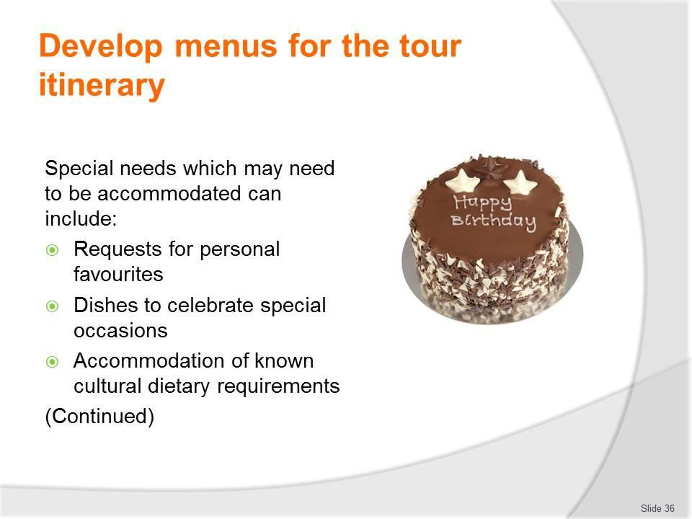
Slide No | Trainer Notes
36. | Trainer gives examples of special needs which may need to be accommodated:  - Requests for personal favourites of individual tour group members  - Dishes to celebrate special occasions – anniversaries, birthdays, holidays, sporting events, personal achievements  - Accommodation of known cultural dietary requirements.  Classroom Activity – Discussion/Q&A session  Trainer asks students to give examples of special requests (menu items and/or beverages) listed on the slide.

Slide
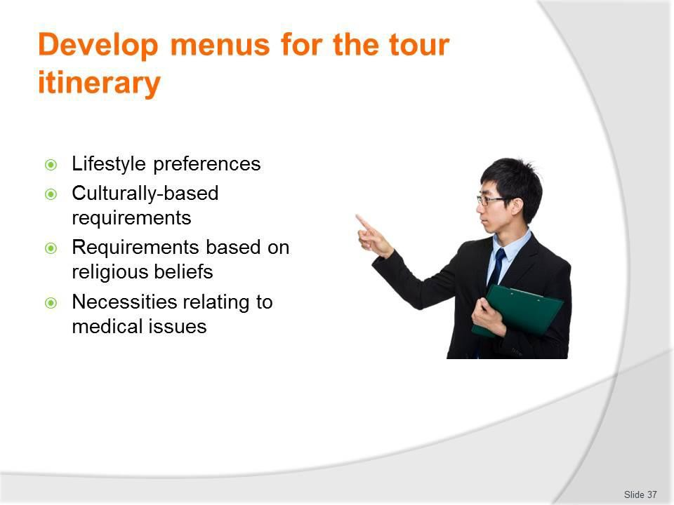
Slide No | Trainer Notes
37. | Trainer continues to give examples of special needs which may need to be accommodated:  - Life-styles preferences of tour groups which have to be met – such as those who want a macro-biotic diet, and people who subscribe to the various vegetarian options: see following slides  - Culturally-based food preferences and requirements  - Dishes and/or foods which need to align with religious preferences or restrictions  - Medical issues necessitating certain foods and/or cooking styles – see following slides.  Classroom Activity – Discussion/Q&A session  Trainer asks students to give examples of special requests (menu items and/or beverages) listed on the slide.

Slide
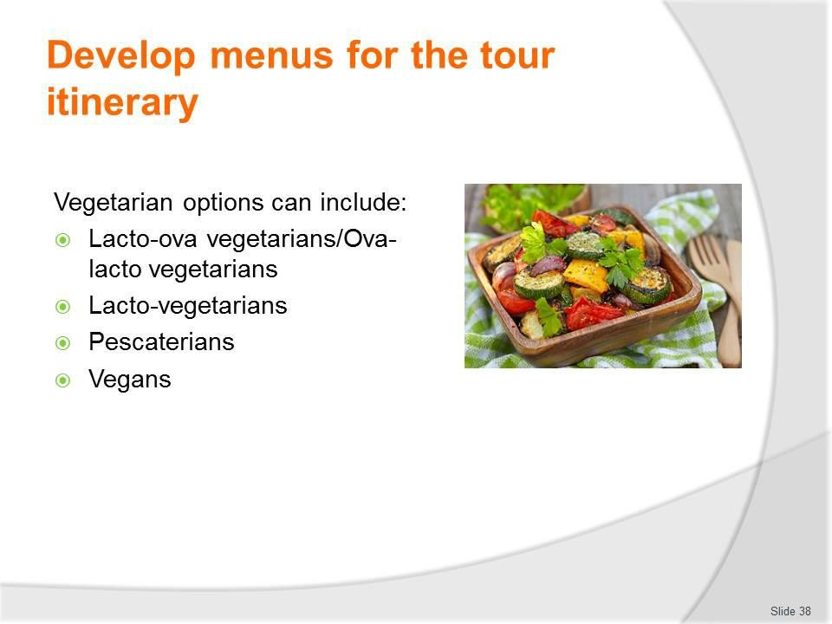
Slide No | Trainer Notes
38. | Trainer discusses vegetarian options stating they can relate to:  - Lacto-ova vegetarians/Ova-lacto vegetarians – these are the majority of vegetarians: they eat dairy products and eggs but not meat of any kind (meat, poultry or fish)  - Lacto-vegetarians – they do not eat meat, poultry or fish: they do not eat eggs but they do eat dairy products  - Pescatarians – people who do not eat meat, poultry or animal flesh but do eat fish  - Vegans – this definition is open to various definitions so it is best to check exactly what the person means when they say they are vegan  - Generally a vegan can be seen as anyone who does not eat meat, poultry, fish, eggs or dairy products and does not eat foods derived from animals (such as gelatine).  Classroom Activity – Guest Speakers  Trainer arranges for people from the groups identified on the slide to attend and:  - Describe their food preferences  - Give examples of recipes  - Explain ways to cater for their requirements.

Slide
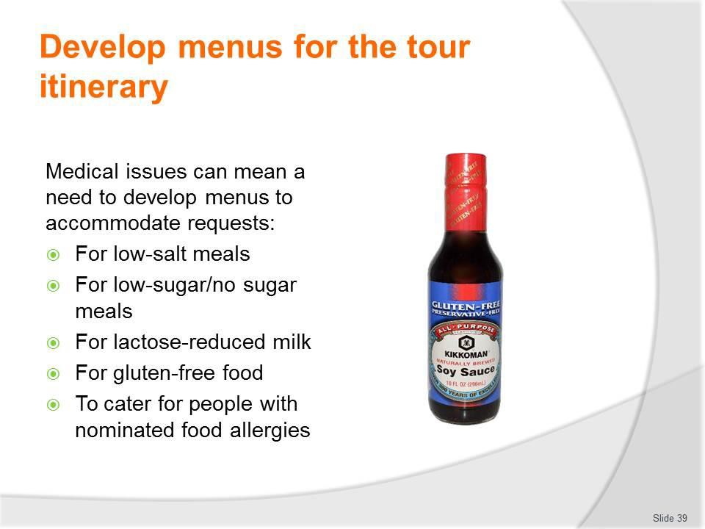
Slide No | Trainer Notes
39. | Trainer discusses medical issues noting there can be a need to create menus which accommodate the following medically-related issues:  - Requests for low-salt meals  - Requests for low-sugar/no sugar meals – for diabetics  - Requests for lactose-reduced milk – for those who are lactose intolerant  - Requests for gluten-free food – from patrons who have celiac disease  - Requests to cater for people with various food allergies.  Classroom Activity – Guest Speaker  Trainer for suitable person to attend and:  - Identify menus to cater for medical needs  - Give recipes for same  - Stress need to accommodate these requirements  - Illustrate possible medical consequences of not meeting these needs.

Slide
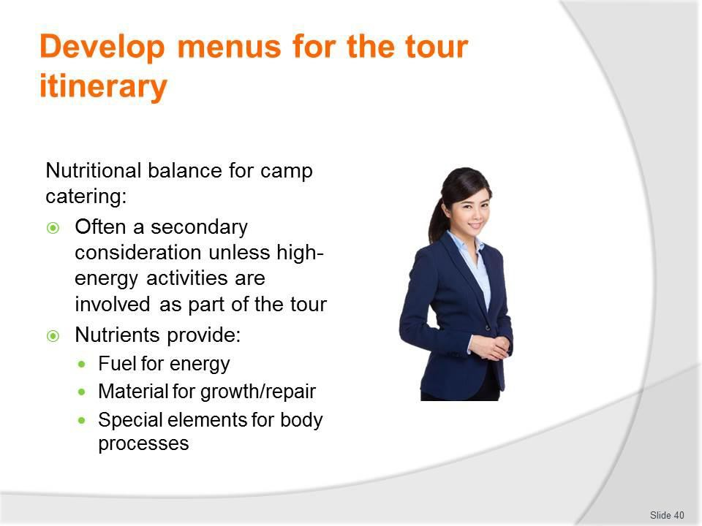
Slide No | Trainer Notes
40. | Trainer discusses nutritional balance in camp menus observing:  - In reality ‘nutritional balance’ is a secondary consideration for many tour menus unless the tour is one where members are expected to exert a lot of energy in terms of hiking, playing sport or engaging in activity on a regular and sustained basis  - A nutrient is a source of nourishment found in food and they are needed by the body to:  - Provide fuel for energy  - Provide materials for growth, repair and maintenance  - Provide special elements needed for body processes.  Classroom Activity – Guest Speaker  Trainer for medical person/nutritionist to attend and:  - Identify nutrients and amounts required  - Explain their role/function  - Identify foods to use to provide requirements.

Slide
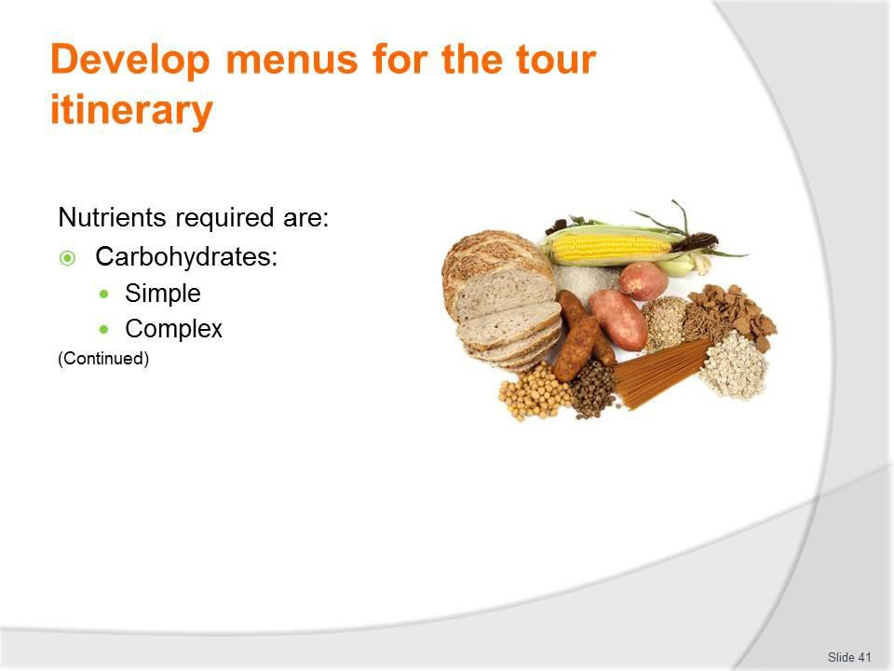
Slide No | Trainer Notes
41. | Trainer explains the nutrients that the body needs are:  Carbohydrates  Carbohydrates are the human body's main source of energy, so it is important that the diet includes enough to provide energy for basic functions such as breathing as well as the physical activity of the day.  Carbohydrates are classified as either:  - Simple carbohydrates  - Foods high in sugars – for example, sugars found in cane (sucrose), fruit (fructose), milk (lactose), honey  - Complex carbohydrates – the starches found in plant foods such as potatoes, rice, bread, pasta, noodles.

Slide
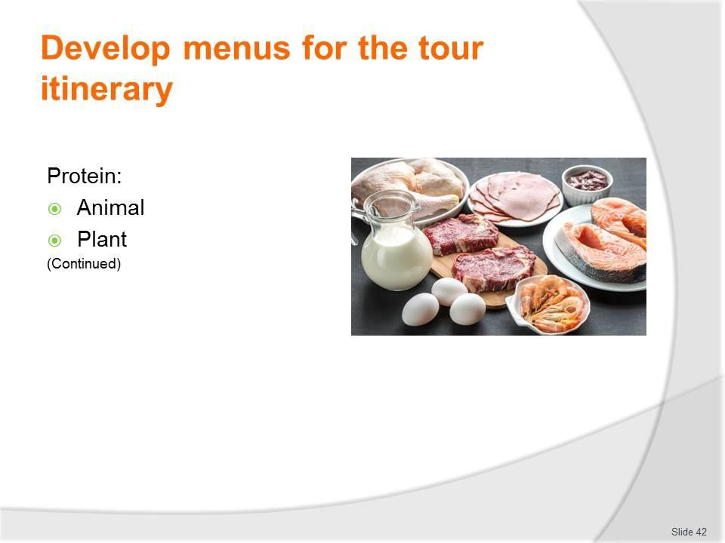
Slide No | Trainer Notes
42. | Trainer continues explaining the nutrients that the body needs are:  Protein  Protein is needed to produce, repair and maintain all the cells throughout the body (hair, fingernails, muscles, blood).  Many foods contain a good source of protein:  - Animal proteins  - Meats, poultry, seafood, game, eggs, dairy  - Plant protein  - Some plant foods also contain good sources of protein such as soy products like tofu or bean curd and plant foods such as grains, nuts, seeds and legumes.

Slide
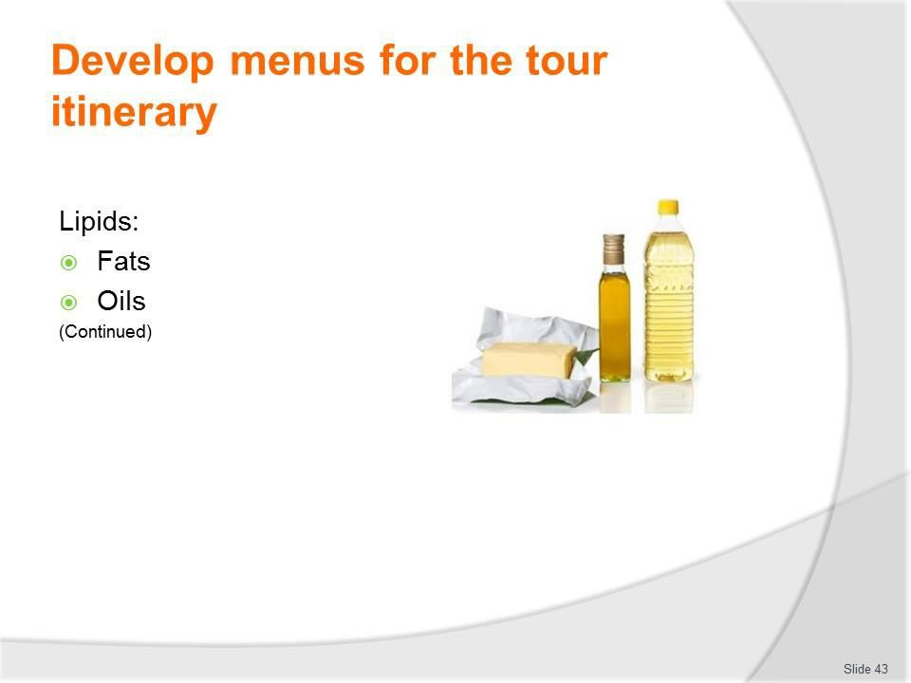
Slide No | Trainer Notes
43. | Trainer continues explaining the nutrients that the body needs are:  Lipids  Lipid is the combined term used to describe foods that are a fat or oil.  Lipids are used in the body in the structure of cells, to provide insulation, to assist in the transport of fat soluble vitamins and can be used as a source of energy.  Lipids can be classified as:  - Fats – these are usually solid at room temperature and come from birds – for example, butter, chicken fat, lard  - Plant-based coconut and palm fats are exceptions  - Oils – these are normally liquid at room temperature and made from plants, seeds and fruit.

Slide
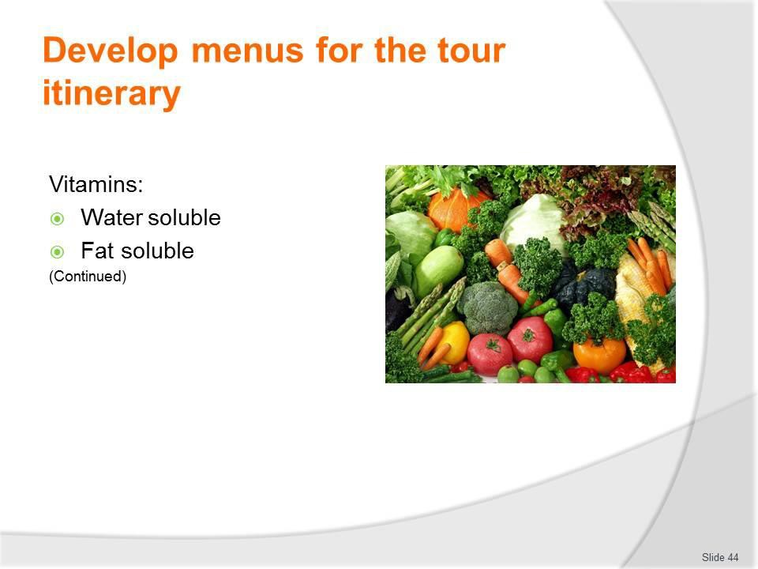
Slide No | Trainer Notes
44. | Trainer continues explaining the nutrients that the body needs are:  Vitamins  Vitamins are micronutrients, meaning they are only needed in very small amounts.  Eating a balanced diet as outlined in dietary guidelines (see Classroom Activity, below) will provide most customers with sufficient quantities of these vitamins.  Vitamins are divided into two groups based on their solubility:  - Water soluble  - Vitamins C and the B complex vitamins  - Fat soluble  - Vitamins A, D, E, K.  Classroom Activity – Internet Research  Trainer supervises internet research and subsequent classroom discussion by visiting: http://www.nhmrc.gov.au/_files_nhmrc/publications/attachments/n31.pdf

Slide
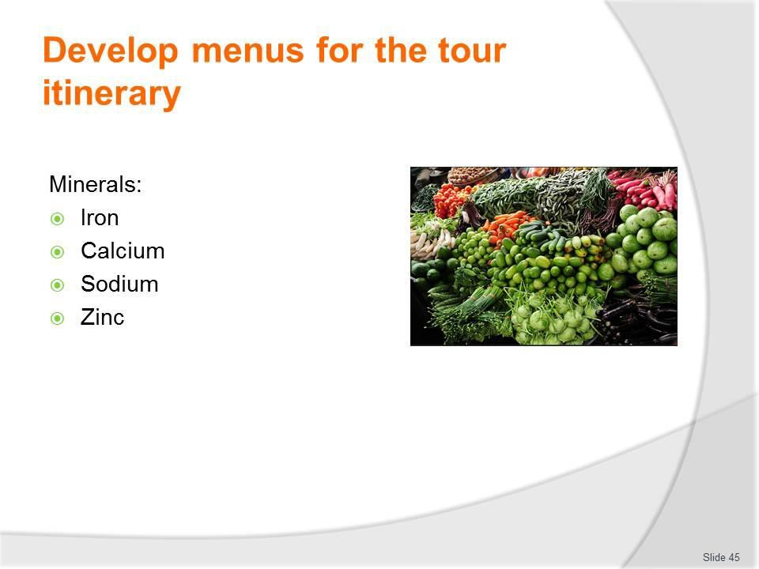
Slide No | Trainer Notes
45. | Trainer continues explaining the nutrients that the body needs are:  Minerals  Minerals like vitamins are also micronutrients and only needed in very small amounts.  Again eating a balanced diet as outlined in dietary guidelines will provide sufficient quantities of the 17 minerals that the body needs for health.  Each of the minerals plays an important role in the body’s daily processes. There are 4 minerals that are often discussed when considering health, they are:  - Iron  - Required for the production of red blood cells  - Assist in the transport of oxygen  - Calcium  - Essential for strengthening bones and teeth  - Play a role in muscle functioning and blood clotting  - Sodium  - Essential in balancing fluid in the body  - Zinc  - Needed for growth.

Slide
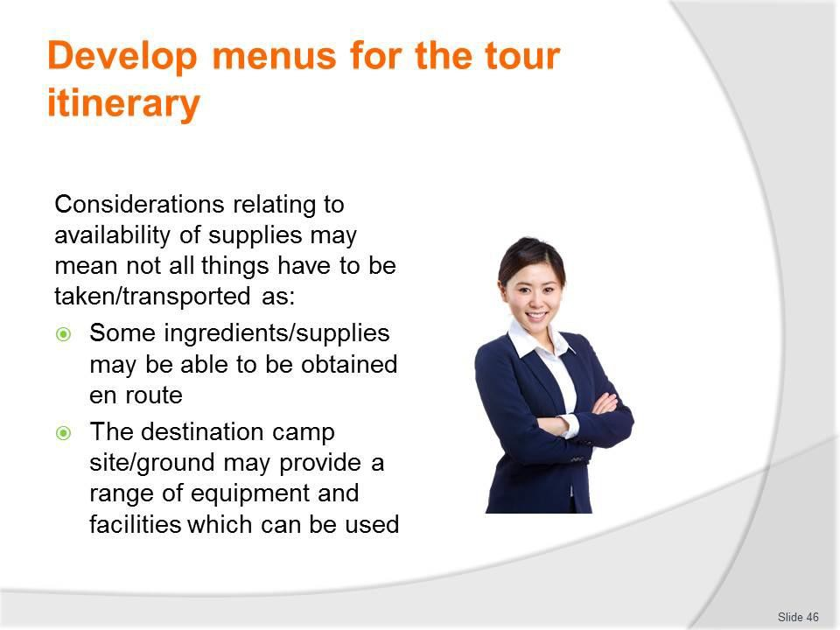
Slide No | Trainer Notes
46. | Trainer discusses availability of supplies highlighting the menus for each day and/or individual meals can sometimes depend on the availability of supplies explaining this means not all catering ingredients (or catering equipment) will necessarily be carried with the tour.  In some cases, menus for certain days and meal times will be developed to take into account:  - Ingredients which may be able to be obtained en route – this can mean:  - Better quality items may be able to be acquired along the way  - Cheaper goods may be available along the route  - Unique/local goods may only be available along the course of the tour  - The tour operator has a commercial agreement with a third party supplier to provide certain items  - Equipment and facilities available at the camp site destination – which, for example, may mean:  - Spit roasts are cooked only at a site where there is spit roasting equipment available on site  - A more formal service may only be provided at camp sites where there are tables and chairs and covered dining areas.

Slide
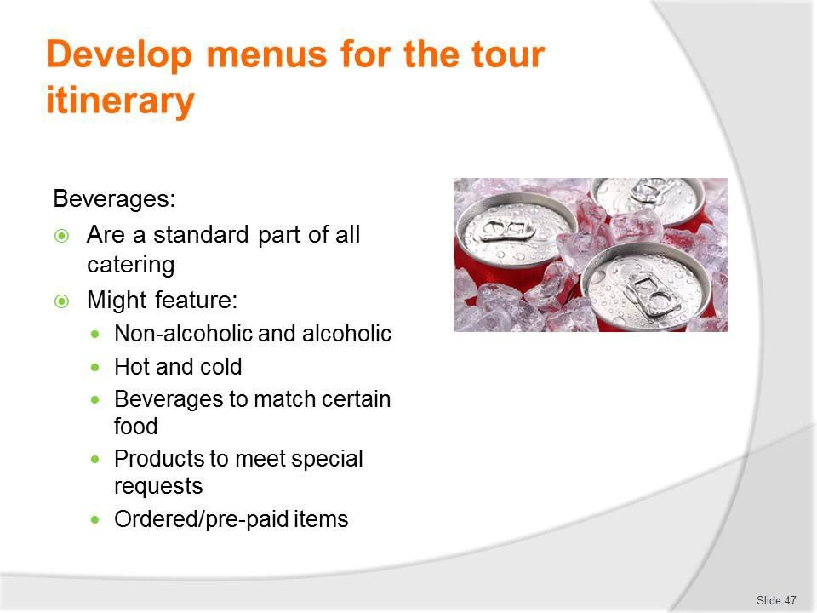
Slide No | Trainer Notes
47. | Trainer discusses beverages for camp catering observing:  - Beverages are a standard party of all camp site catering  - The standard offering of drinks may feature:  - Proprietary brands of soft drink  - Fruit juices  - Tea and coffee  - A basic range of alcoholic beverages – beer, wine and spirits  - Service of alcohol must always:  - Comply with host country legislation  - Meet restrictions which may be applicable in host communities  - Extra beverages may be stocked to:  - Accompany certain dishes  - Meet special requests  - Accommodate pre-paid arrangements made by tour group members.  Classroom Activity – Discussion/Q&A session  Trainer asks students to identify beverages which may be taken/provided as part of camp catering.

Slide
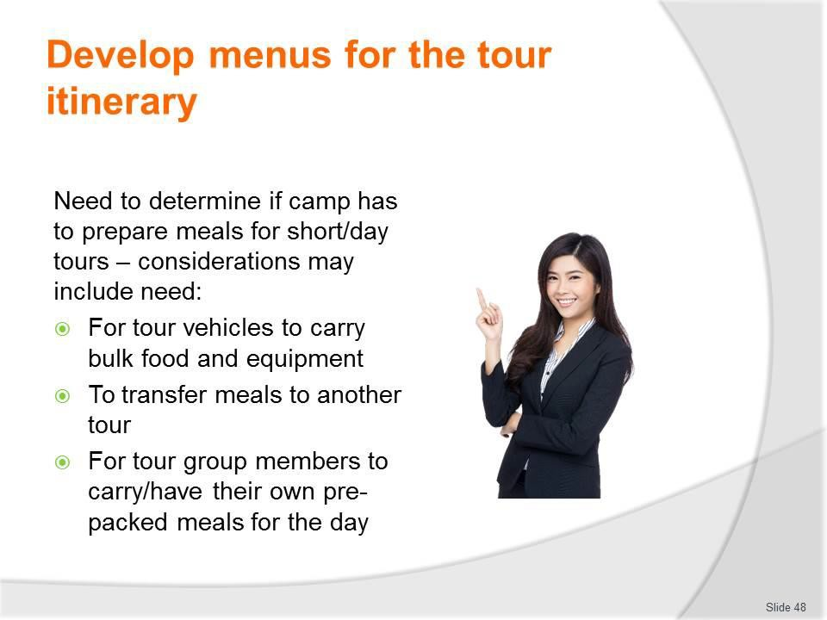
Slide No | Trainer Notes
48. | Trainer notes development of some menus will also need to take into account whether the meals are to be prepared at the camp site for transport to other destinations as part of short and day tours from the camp site.  This consideration may need the following to be addressed:  - The carriage of meals by own tour vehicles to a remote location away from the camp site  - Transfer of meals to another tour for transport by them for use on their tour – that is, the need for the camp to cater for the food and beverage needs of another tour operated in the area by the same tour operator  - Carriage of meals by individual tour group members for their personal use throughout the day.

Slide
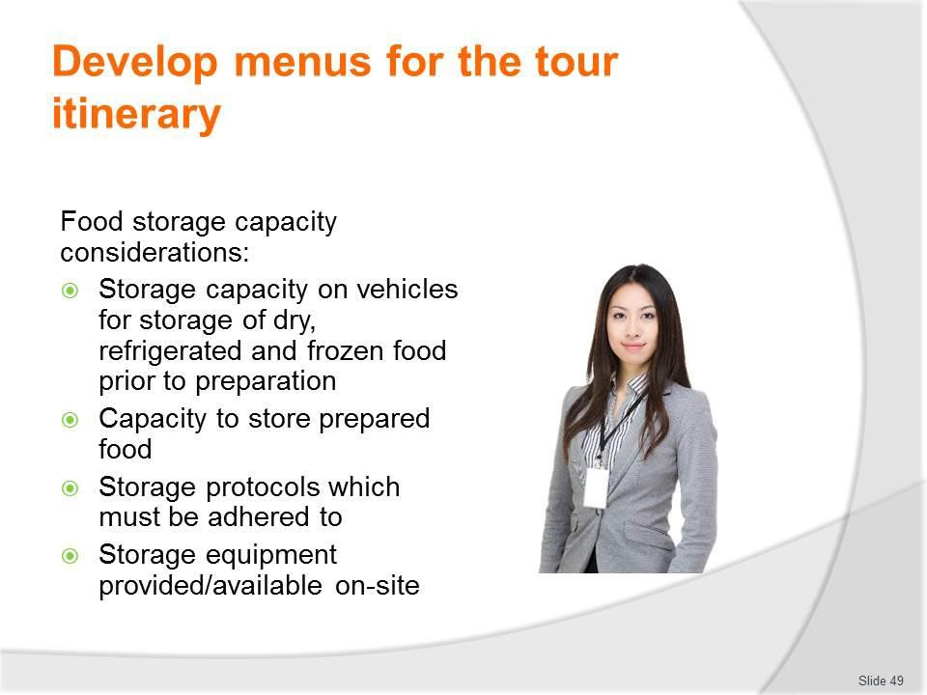
Slide No | Trainer Notes
49. | Trainer discusses food storage capacity stating there is always limited storage capacity for food storage when providing camp site catering simply because it is off-site catering and does not enjoy the same type and extent of resources available in most other commercial catering undertakings.  This issue necessitates consideration of:  - Storage capacity on catering and tour vehicles for storage of dry, refrigerated and frozen food prior to its preparation  - Capacity in catering and tour vehicles to store prepared food after it has been cooked and is waiting to be served/eaten  - Storage protocols which must be adhered to regarding prepared food – for later re- use and/or re-heating for service  - Note: some operators put a total ban on the storage of prepared food for later service, due to food safety concerns  - Storage equipment provided/available on-site at camps where catering is being undertaken.

Slide
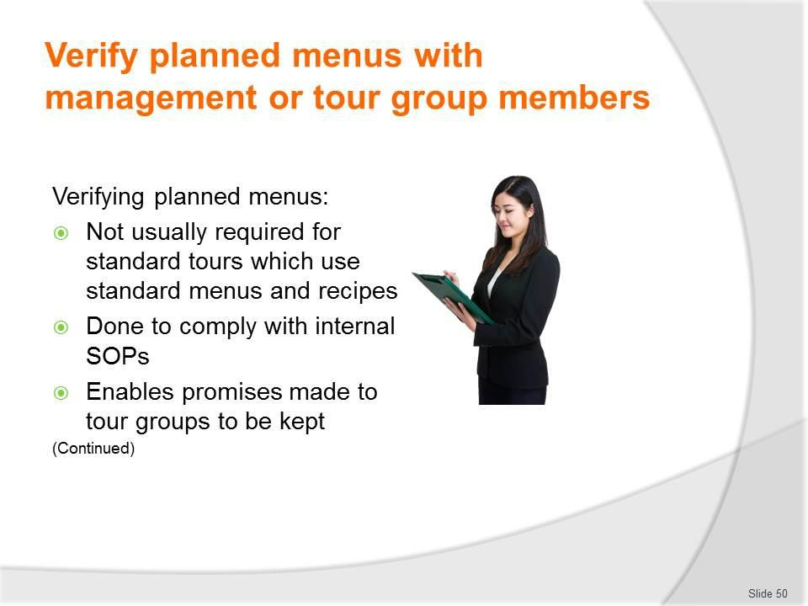
Slide No | Trainer Notes
50. | Trainer explains need to verify planned menus with management and tour group members highlighting for standard tours there is rarely a need to confirm menus with tour groups – there is more of a need to do this with custom tours.  There can be a need to verify menus planned for a tour (prior to providing them) in order to:  - Comply with internal organisational protocols – it may be SOP in businesses that this occur for:  - Every standard tour  - Just for custom/private tours  - Nominated tours – especially those:  - Involving new clients  - Where VIPs are involved  - To new destinations, on new routes  - Keep promises made to tour group members – that they will (for example):  - Be consulted in relation to the catering  - Have an opportunity to suggest/identify menu items  - Be able to notify specific issues – medical, cultural, lifestyle and similar

- Be presented with a range of options from which they can choose
- Be presented with draft menus before they are confirmed as ‘operational’ for the tour.

Slide
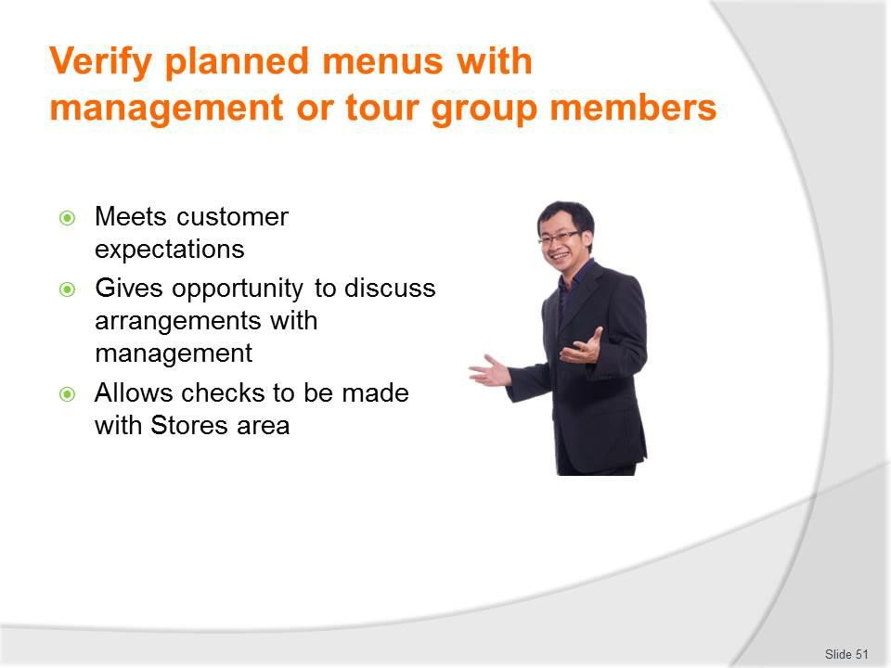
Slide No | Trainer Notes
51. | Trainer continues explaining need to verify planned menus – to:  - Meet customer expectations – that:  - The tour operator is customer-focussed  - Individual preferences will be (to some extent) accommodated  - Their tour is (or can be) a unique experience from a catering perspective  - Discuss arrangements/planned menus with management or administration – to:  - Check food cost is within budget  - Confirm menu items are regarded as sufficient and suitable  - Learn of factors which may impact the proposed menus – such as (for example):  - Clash in need to use limited equipment  - Transport restrictions due to vehicle breakdown  - Unanticipated staff leave/absences (cooks, catering staff)  - Identify need to revise/modify menus as required  - Obtain final approval to proceed with the planned menus  - Check with Stores and/or Purchasing – that:  - The required resources (food and equipment) are available  - Required resources can be ordered/obtained by the required date.

Slide
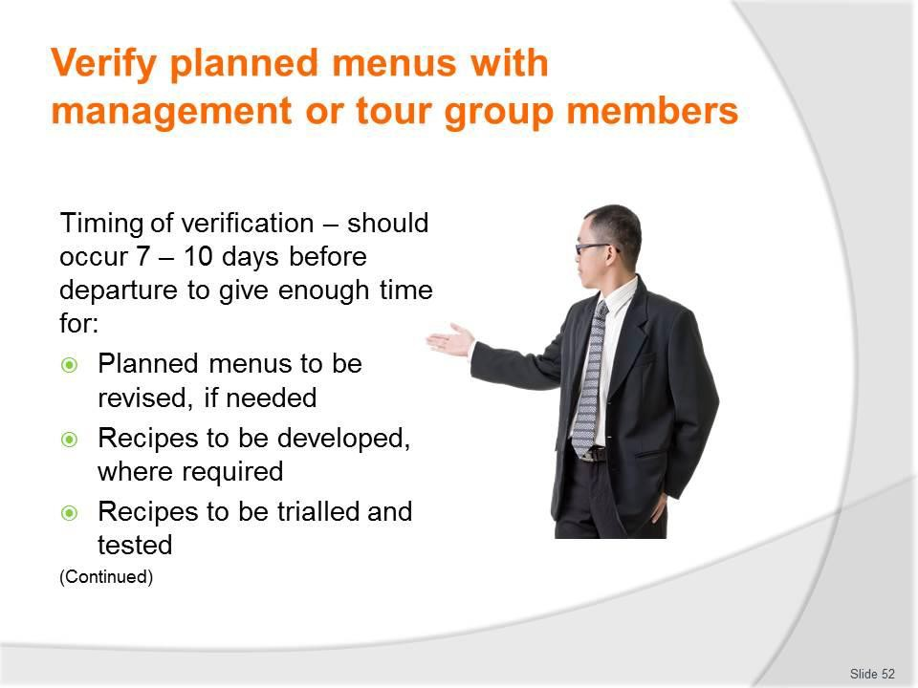
Slide No | Trainer Notes
52. | Trainer discusses timing of verification of planned menus explaining the need to verify menus for a tour needs to occur ‘sufficiently in advance’ (say, 7 – 10 days before departure) of the tour to enable sufficient time for:  - Planned menus to be revised, if needed  - Recipes to be developed, where required  - Recipes to be trialled and tested.

Slide
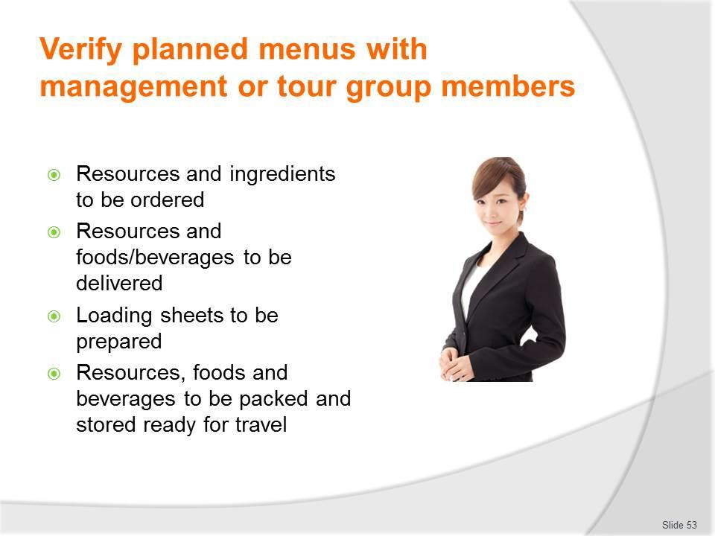
Slide No | Trainer Notes
53. | Trainer continues identifying reasons need to verify planned menus – so:  - Resources and ingredients can be ordered  - Resources and foods/beverages can be delivered  - Loading sheets can be prepared  - Resources, foods and beverages can be packed and stored ready for travel.

Slide
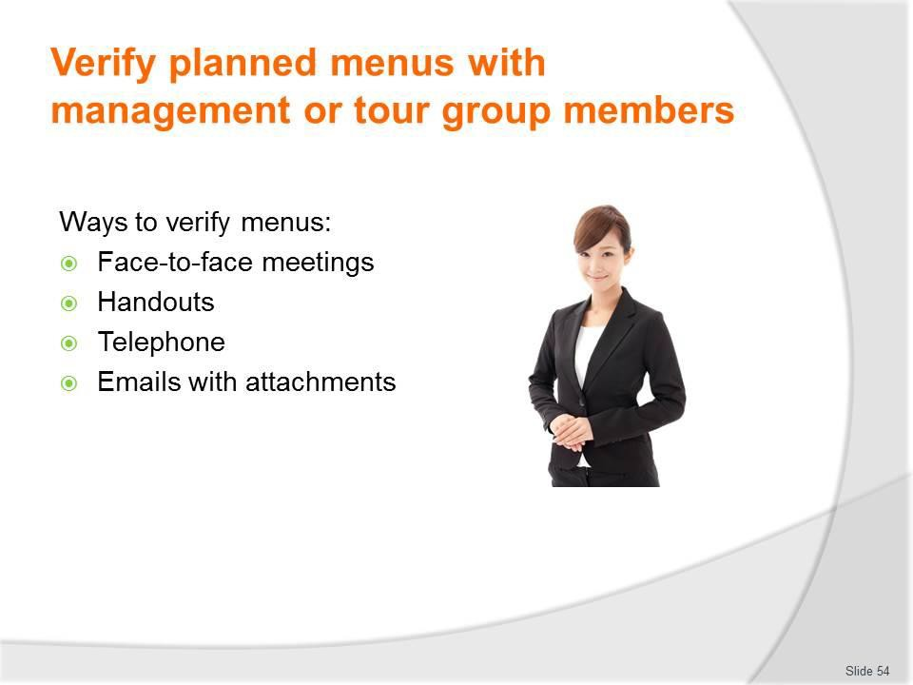
Slide No | Trainer Notes
54. | Trainer presents ways to verify planned menus:  - Face-to-face meeting with relevant people with appropriate discussions  - Use of handouts to show menus, recipes, costs and other matters as needed.  Where there is a need to communicate with tour group members in this regard it may be acceptable to:  - Use telephone contact to discuss matters  - Send emails with relevant attachments of menus, recipes, photos of dishes, lists of options for menu items, indication of additional costs to cover special requests.  Classroom Activity – Guest Speaker  Trainer arranges for manager of tour company to attend and:  - Identify issues discussed when verifying menus  - Explain need for this process/stage  - Detail how it takes place and who is involved.

Slide
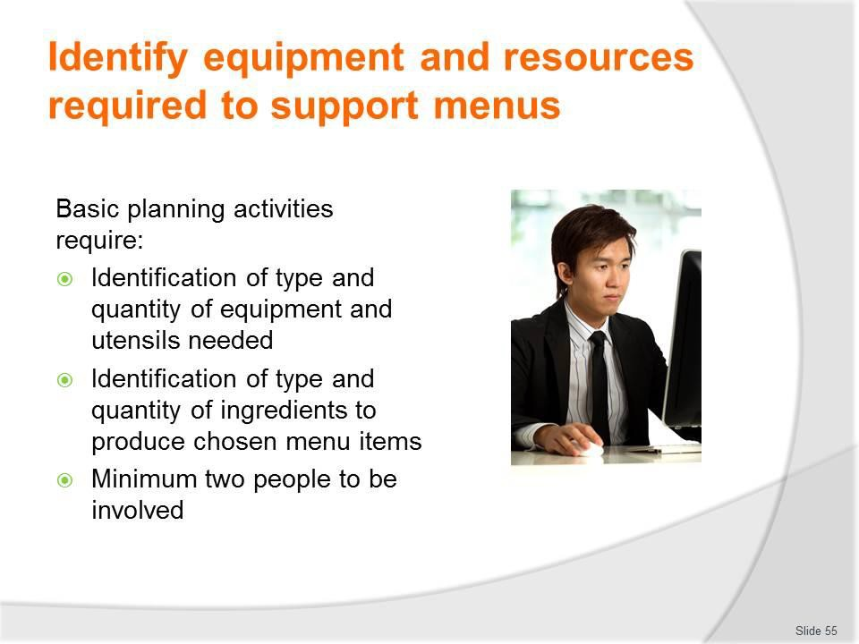
Slide No | Trainer Notes
55. | Trainer discusses basic planning noting planning and preparation for camp site catering requires:  - Identifying the type and quantity of physical resources (equipment and utensils) needed to produce and serve the food and beverages  - Identifying the type and quantity of ingredients needed to prepare and serve all identified menu items and drinks  - At least two people to do the planning, identification of items and ingredients and perform/check the calculations.

Slide
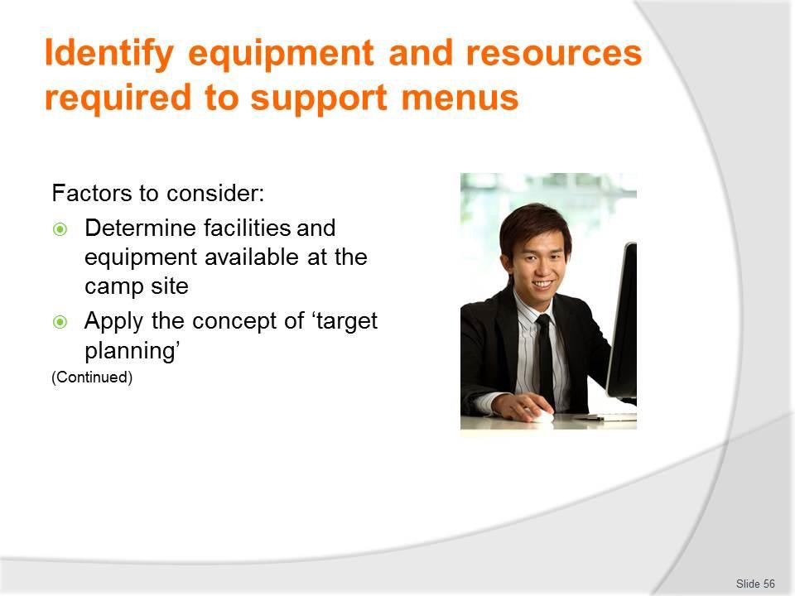
Slide No | Trainer Notes
56. | Trainer identifies factors to consider:  - Determining facilities and equipment available at the camp site – many tours visit the same camp sites every time so there is often a good understanding of what cooking equipment, storage, utensils, water and infrastructure is available  - Menus should be based on available facilities and equipment to reduce the need to carry/transport items  - Where a new camp site is being used, options to determine available facilities and equipment are:  - Visit the site in advance to inspect it  - Contact the owners/operators/body in charge and:  - Enquire about what is available  - Make arrangements for required items to be supplied  - Applying the concept of ‘target planning’ – this means:  - Using the approved menus and the standard recipes which support them for the individual menu items as the basis for calculating ingredients and food quantities required  - The standard recipe will indicate the ‘Yield’ for the recipe (that is, how many people the recipe will feed) – this should be used as the basis for the calculation  - There is often a need to ‘adjust’ the recipe to achieve required serves/portions (see following slides)

- This approach ensures all ingredients (but no more, no excess) will be identified and obtained and packed
- Using the approved menus and the standard recipes which support them for the individual menu items as the basis for calculating cooking equipment and utensils required
- The standard recipe will indicate the cooking method for the menu items for the tour and only these items need to/should be packed
- Attention needs to be paid to ensuring increased equipment is identified/loaded where standard recipes have to be adjusted upwards – for example, increasing the yield may require a bigger pot, more pans or a different piece of cooking equipment.
Classroom Activity – Demonstration and Small Group Exercise
Trainer shows class how to use target planning to identify requirements for a menu item (or menu or tour) and provides opportunity for students to do the same.

Slide
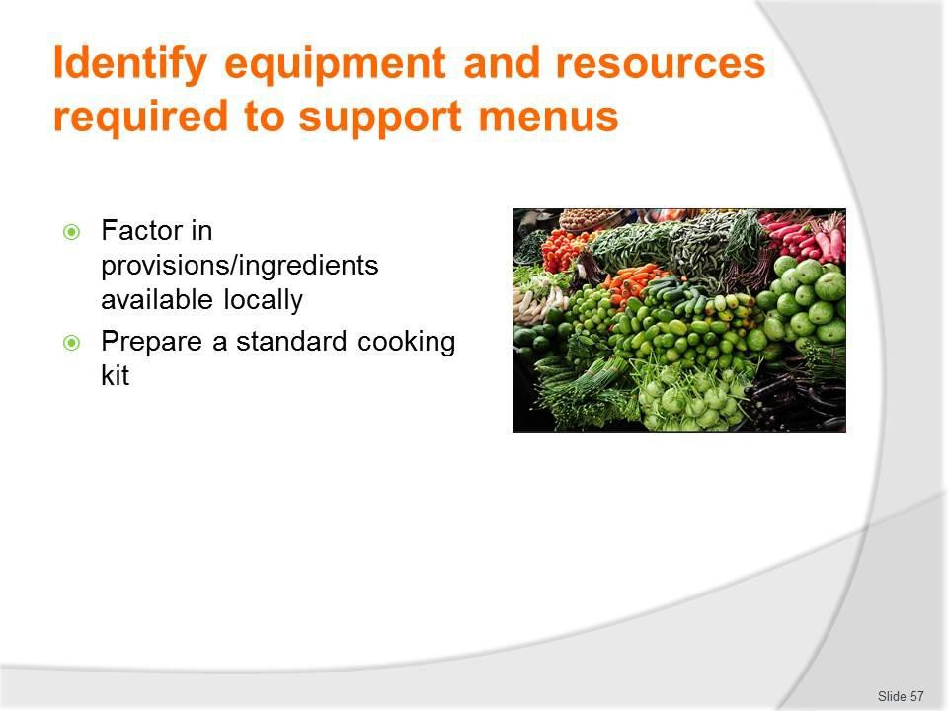
Slide No | Trainer Notes
57. | Trainer continues identifying factors to consider:  - Factoring in provisions/ingredients available locally – there can be a need to calculate the food/beverage requirements for a tour taking into account items which are available at the site or en route. This:  - May be SOP for some tour operators and/or some tours but not for others  - May not be a reliable option – there is always uncertainty when having to rely on a third party  - Could be part of a contractual arrangement with a local and reliable food supplier or catering venue  - Reduces the need to load and carry certain items – which saves on weight and space  - May enable fresher produce to be served at more locations – as opposed to carrying frozen, dry or dehydrated alternatives  - Preparing a standard cooking kit – many camp site catering crews develop and carry a supplementary kit for all tours they service  - This is usually a box (or two or more) of basic utensils and ingredients – these items are taken over-and-above the items identified and carried as a result of the target planning done: see Classroom Activity below  - These kits have evolved over time in response to situations where catering crews have discovered a need for items they have previously forgotten or not considered packing for a tour, but found they needed/could have used.

Classroom Activity – Discussion/Q&A session
Trainer asks students to identify possible contents of standard cooking kit. Possible answers/inclusions:
- The cook’s favourite knives/knife kit
- Matches and/or lighters
- First aid kit
- Paper towels
- Tea towels
- Cleaning cloths
- Chopping boards
- A range of cooking utensils – such as strainers, spoodles, slotted spoons, carving forks, spatulas and similar
- Salt and pepper
- A range of proprietary sauces
- Cooking oil
- Spice kit/rack

Slide
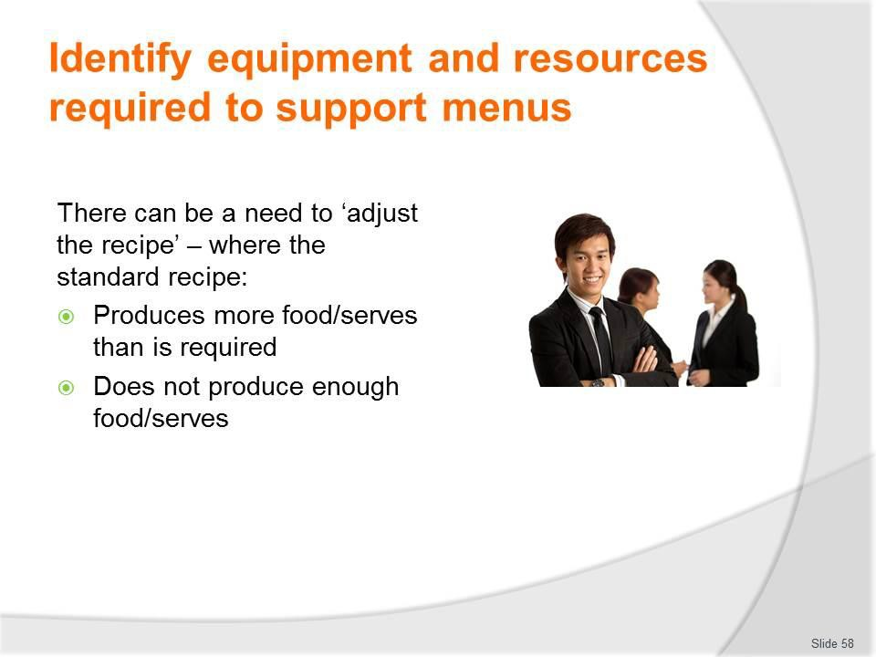
Slide No | Trainer Notes
58. | Trainer explains adjustment/s of recipes stating:  - Adjusting a recipe means altering the quantities of ingredients to allow the production of more or less of a dish but retain the required flavour, appearance and other characteristics of the dish.  For example:  - There may be a recipe for 50 portions of Chicken Marengo but only a need to produce 20 serves  - Or there may be a recipe that yields 50 serves but there is a need for 150 serves.  Special care needs to be taken when adjusting a recipe because mistakes can easily occur when calculating the new/revised quantities: there is no point getting nearly all of the calculations right, and messing up just one or two.  Classroom Activity – Demonstration and Individual Exercise  Trainer shows class how to adjust a recipe up and down and then provides an opportunity for students to do the same.

Slide
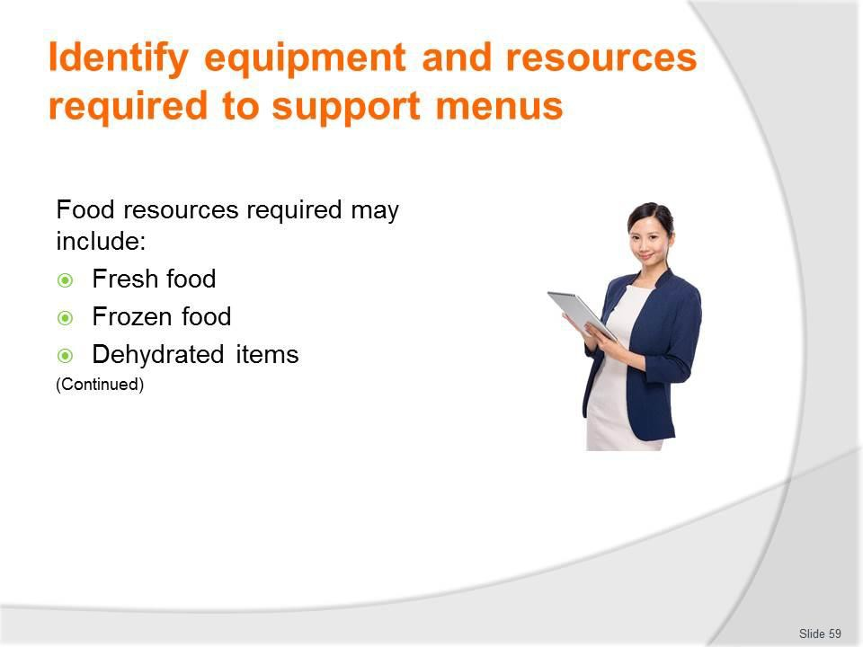
Slide No | Trainer Notes
59. | Trainer discusses and identifies food which may be required for camp catering offering type of foods carried for a tour need to reflect the duration of the tour – for example, an overnight tour where catering is only required for dinner on Day 1 and breakfast on Day 2 would focus more on fresh food than a 14-day tour to remote areas.  This said, food types commonly carried for camp site catering can include:  - Fresh food – which needs to be refrigerated below 5⁰C and so necessitates refrigeration units:  - Meats – all types and cuts including vacuum packed; Poultry – all types and cuts; Fish and seafood; Fruit; Vegetables; Eggs  - Frozen food – which needs to be stored at or below -18⁰C and so necessitates a freezer:  - A range of the above ‘fresh’ items  - Processed items – goods which have been partially prepared by the supplier  - Prepared meals – prepared by the operator or a contracted venue for re-heating at the camp  - Dehydrated items – which save on weight and space.

Classroom Activity – Samples and Discussion
Trainer provides examples of foods identified on the slide and leads a discussion on:
- The types of tours they might be used on
- How they might be used/the dishes which may be prepared using them
- Considerations which need to be addressed regarding their transportation and storage for camp site catering.

Slide
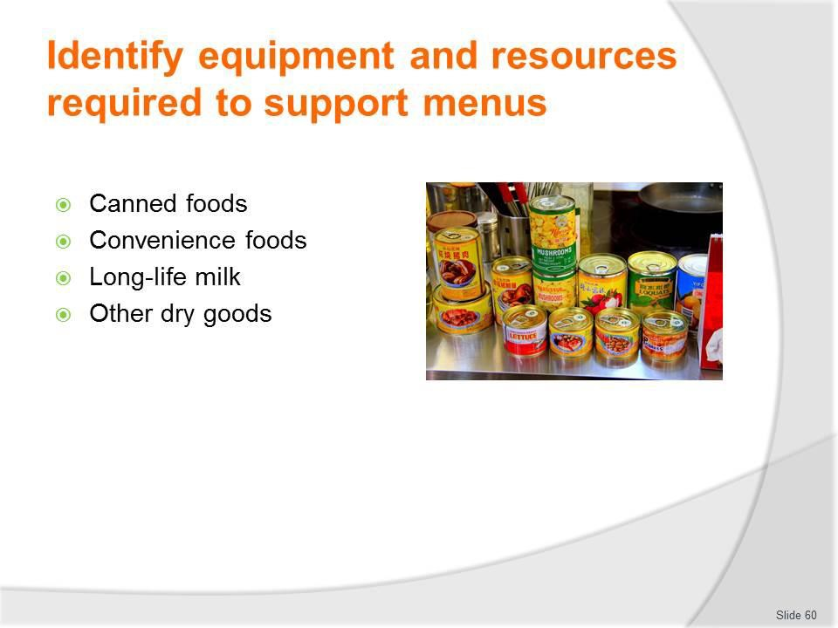
Slide No | Trainer Notes
60. | Trainer continues identifying foods:  - Canned food – commonly fruit, vegetables, fish  - For tours, due to the likelihood of breakage on rough roads, ‘jars’ of food are traditionally avoided  - Convenience foods – these are pre-prepared food items manufactured by food suppliers and may include:  - Sauce mixes; Boosters; Proprietary sauces; Energy bars; Biscuits; Dried pasta  - Long-life food – milk  - Other dry goods – ‘dry’ goods are those that do not require refrigeration while sealed/unopened). They include powdered products, canned food, convenience food as well as:  - Flour; Sugar; Nuts.  Classroom Activity – Samples and Discussion  Trainer provides examples of foods identified on the slide and leads a discussion on:  - The types of tours they might be used on  - How they might be used/the dishes which may be prepared using them  - Considerations which need to be addressed regarding their transportation and storage for camp site catering.

Slide
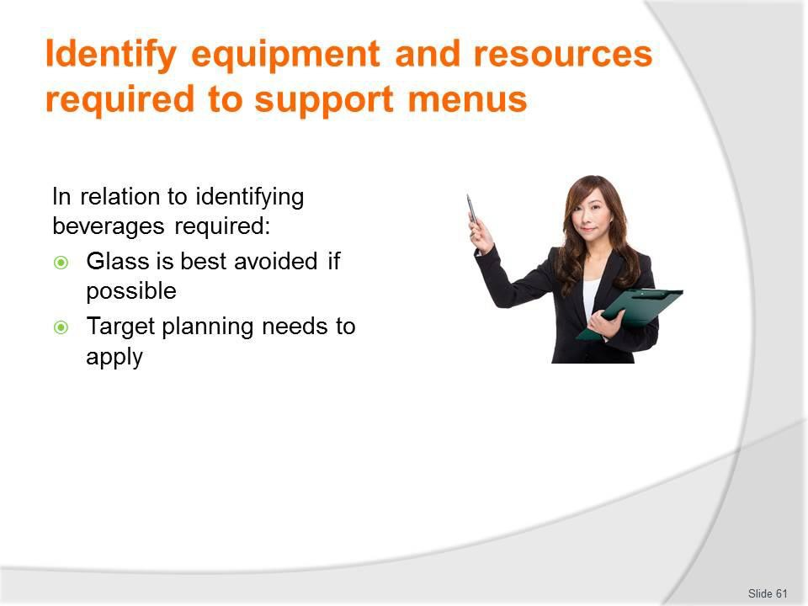
Slide No | Trainer Notes
61. | Trainer discusses provision of beverages stating:  - Glass is to avoided where ever possible – meaning there is a preference for canned product and plastic bottles  - Target planning needs to apply – in terms of product types, brand names and quantities.  Classroom Activity – Group Exercise/Discussion  Trainer identifies a tour, menus and tour group numbers for same and asks students to:  - Identify the alcoholic and non-alcoholic beverages which should be loaded for this tour  - Determine the quantities of each which should be packed.

Slide
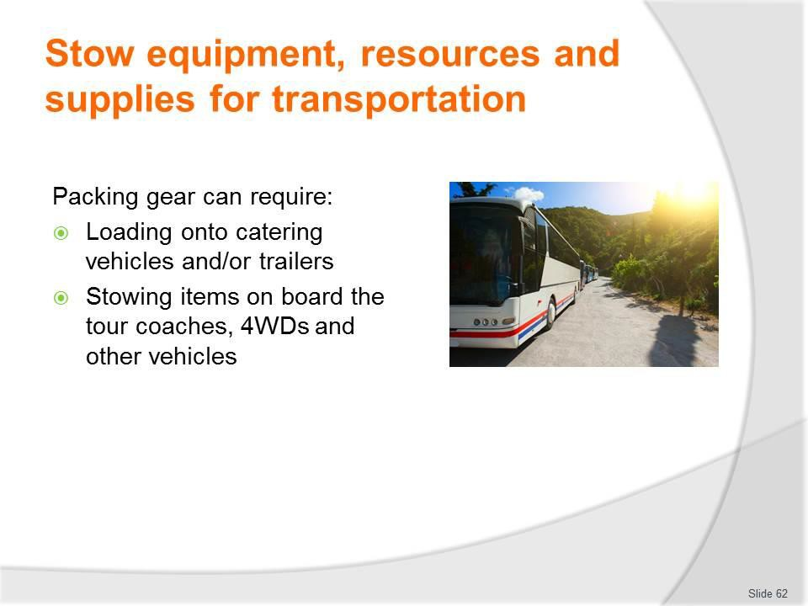
Slide No | Trainer Notes
62. | Trainer notes packing the gear for camp catering may require:  - Loading onto catering vehicles and/or trailers – purpose-built for the job  - Stowing items on board the tour coaches, 4WDs and other vehicles – as part of their other touring equipment.

Slide
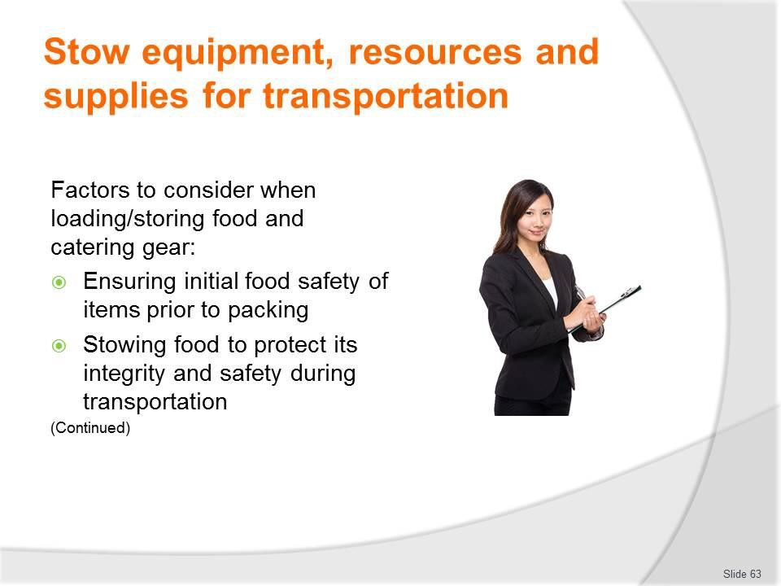
Slide No | Trainer Notes
63. | Trainer presents factors to consider when loading/storing food and catering gear:  - Ensuring initial food safety of items prior to packing – this involves:  - Checking ‘use by’ dates of food – these must not be exceeded for food safety reasons. Standard practice is to rotate stock in storage using the FIFO technique to avoid having to throw out out-of-date food  - Making sure all packaging is intact and not broken/damaged – to help protect the integrity of the food  - Verifying refrigerated and frozen food is at the correct temperature prior to loading – at or below 5⁰C for refrigerated food, and at or below -18⁰C for frozen food  - Stowing food to protect its integrity and safety during transportation – which may require:  - Making sure all those who handle food have been suitable trained in food safety and safe food handling techniques  - Ensuring staff have washed their hands before they handle food  - Loading food into clean and sanitised containers  - Using nominated refrigerated storage units for different items  - Pre-chilling freezers and refrigerator units  - Storing any pre-prepared hot food at or above 60⁰C – to maintain food safety  - Using food thermometers to check temperatures

- Never storing any food directly on the floor
- Discarding food that fails to comply with applicable food safety protocols
- Separating foodstuffs from contaminants – so that detergents, cleaning agents and fuel for vehicles and cooking equipment are separated (preferably in a different vehicle) from the food
- Protecting all unpacked food
- Verifying the vehicle/s to be used for food transport have been properly serviced and maintained.
Classroom Activity (1) – Internet Research
Trainer supervises internet research and subsequent classroom discussion by visiting:
http://www.foodstandards.gov.au/publications/documents/complete_safefood.pdf - ‘Safe Food Australia’ to see recognised food safety protocols
Classroom Activity (2) – Demonstration and Practical
Trainer shows students how to use food thermometer and provides opportunity for them to do the same.

Slide
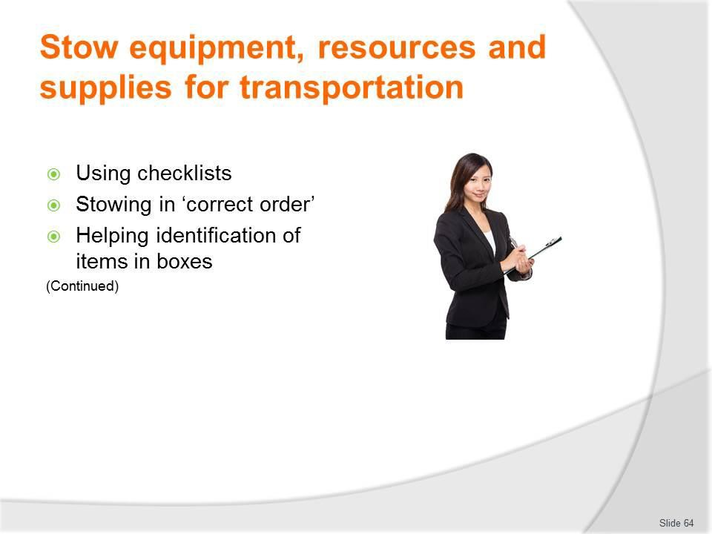
Slide No | Trainer Notes
64. | Trainer continues presenting factors to consider when loading/storing food and catering gear:  - Using checklists to ensure all items are packed – these checklists may be:  - Developed as part of the process of identifying food and resource requirements  - Standard ‘loading sheets’ used to guide the loading of standard gear for standard tours/camps  - Stowing in the correct order – for example:  - Loading catering gear (equipment and utensils) first  - Loading food items lass – as late as practicable prior to departure as opposed to the day before or days before  - Stowing items in accordance with projected usage needs while on tour – so catering staff can readily access the items they need in the sequence they will need them  - Items needs first are traditionally packed and loaded, last  - Taking action to aid identification of contents of storage units and boxes – this may be done by:  - Fixing a list to the outside of the container – indicating what is inside  - Developing a control list/document – which is used as a central database for identifying the contents of individual containers  - Using see-through containers.

Slide
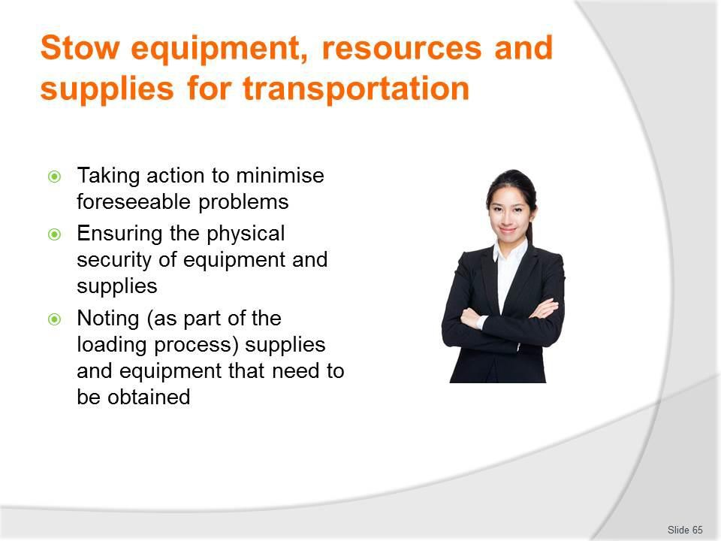
Slide No | Trainer Notes
65. | Trainer continues presenting factors to consider when loading/storing food and catering gear:  - Taking action to minimise foreseeable problems – such as:  - Double-packing liquids – in an effort to contain leaks if the container is cracked/broken  - Using straps and restraints and padding to stop gear and boxes and items moving about during travel – to help reduce damage caused by constant rubbing  - Ensuring the physical security of equipment and supplies – which can be done by:  - Making sure doors to food vehicles/food storage compartments are closed and locked – to prevent loss/theft and avoid contamination from various external sources  - Never leaving food/catering vehicles or containers unattended  - Stowing gear and dry food in built-in compartments in the vehicle/s, if available  - Noting (as part of the loading process) supplies and equipment that need to be obtained – with a view to:  - Replacing food which has to be discarded to maintain the safety of the food that is loaded

- Topping up items which are needed but have been short-supplied – and will need to be supplemented as the tour proceeds
- Obtaining replacement equipment and utensils for items identified as damaged or unserviceable as part of the loading process.

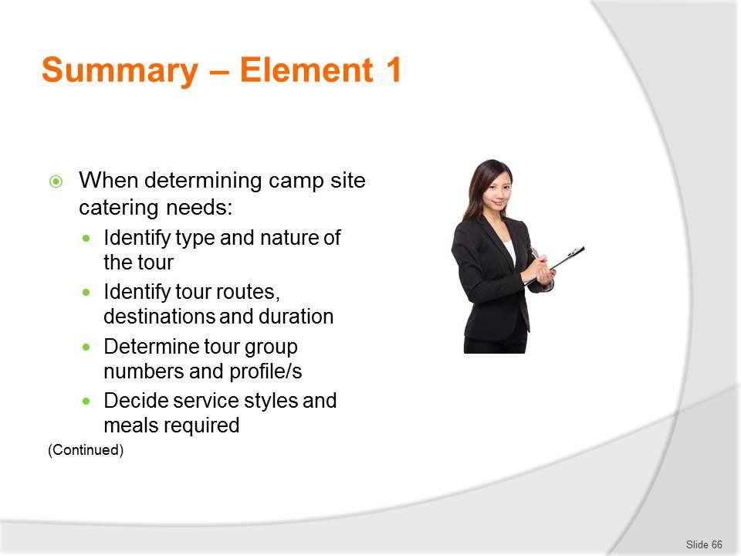
Slide
Slide No
Trainer Notes
66.
Trainer provides a recap of the Element asking questions to check trainee understanding and responding to questions from trainees, as required.

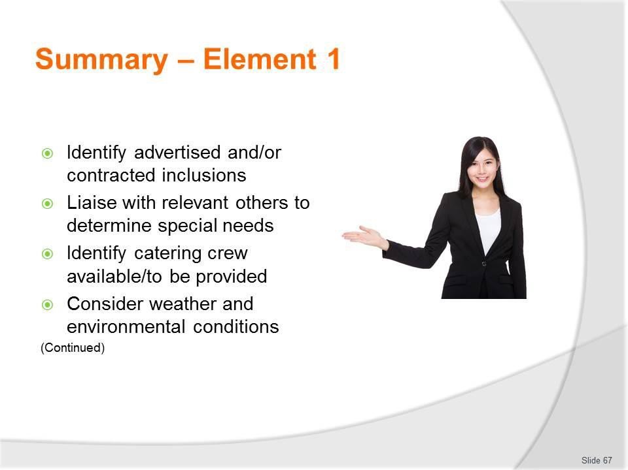
Slide
Slide No
Trainer Notes
67.
Trainer provides a recap of the Element asking questions to check trainee understanding and responding to questions from trainees, as required.

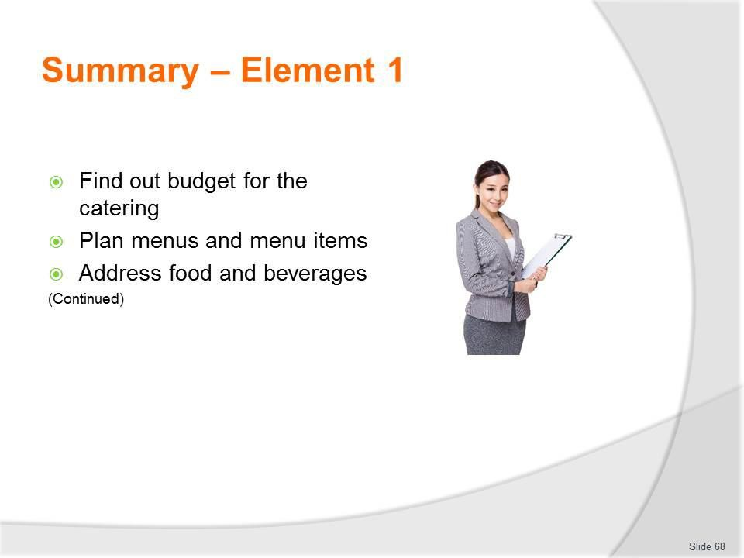
Slide
Slide No
Trainer Notes
68.
Trainer provides a recap of the Element asking questions to check trainee understanding and responding to questions from trainees, as required.

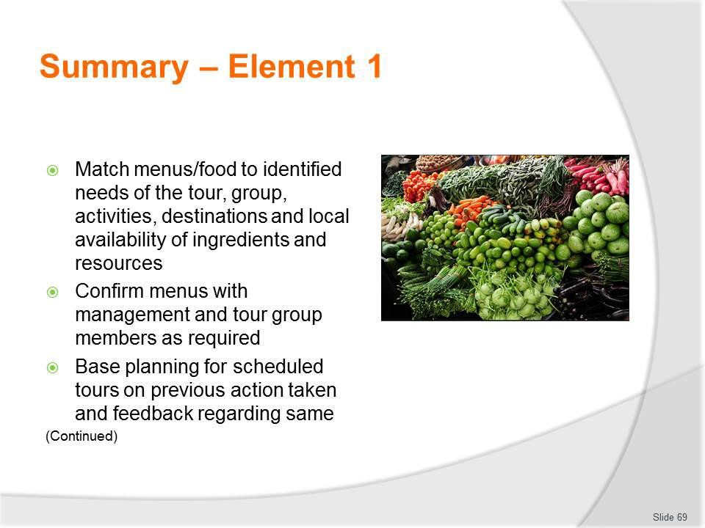
Slide
Slide No
Trainer Notes
69.
Trainer provides a recap of the Element asking questions to check trainee understanding and responding to questions from trainees, as required.

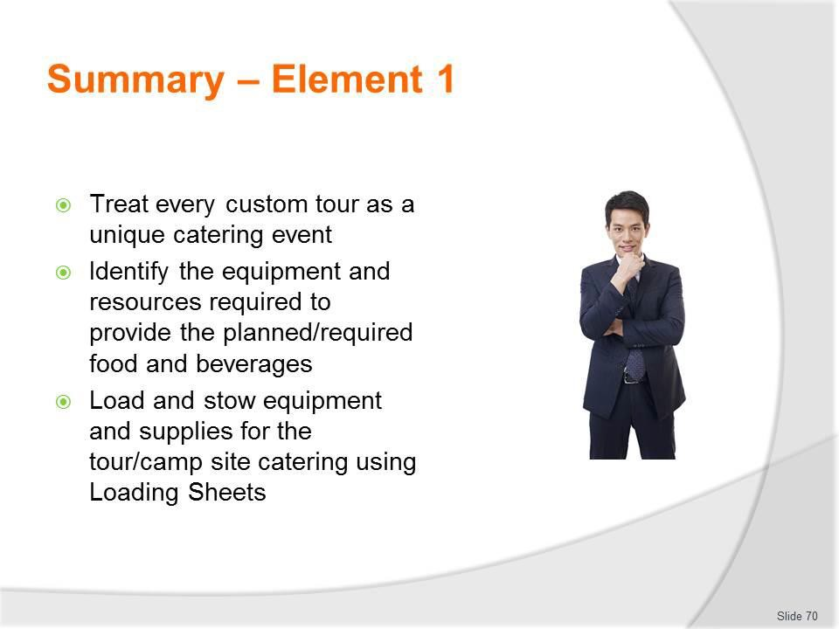
Slide
Slide No
Trainer Notes
70.
Trainer provides a recap of the Element asking questions to check trainee understanding and responding to questions from trainees, as required.

Slide
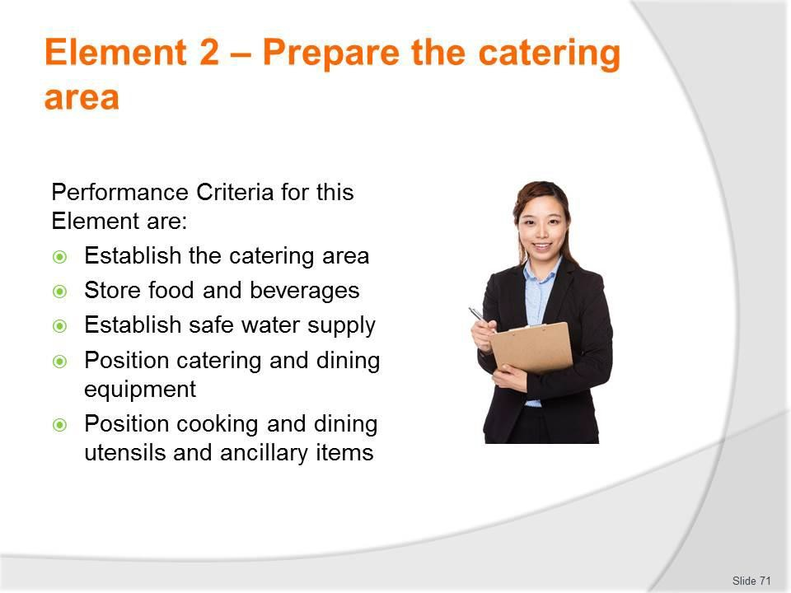
Slide No | Trainer Notes
71. | Trainer identifies for trainees the Performance Criteria for this Element, as listed on the slide.  Class Activity – General Discussion  Trainer leads a general class discussion by asking questions such as:  - What might be involved in established the catering area in a camp site?  - What can be done to establish a safe water supply?  - How would you know if the water at a camp site is safe or not?

Slide
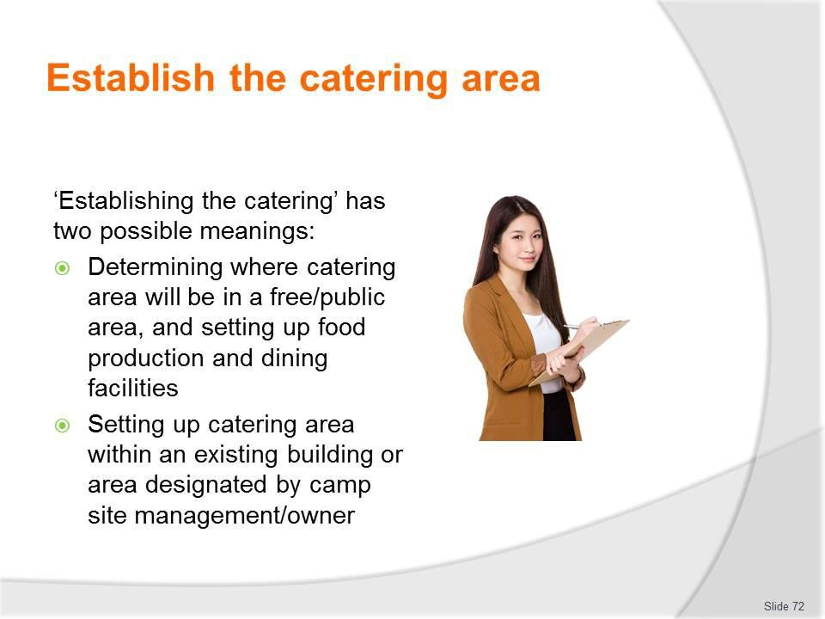
Slide No | Trainer Notes
72. | Trainer notes ‘Establishing the catering’ has two possible meanings:  - Determining where the catering area will be (as distinct from other camp areas such as food service area, sleeping/tent areas, activity areas, latrines) in a free/public area, and setting up the catering (food production and dining) facilities  - Setting up the catering area within an existing building or area designated by the camp site management/owner.

Slide
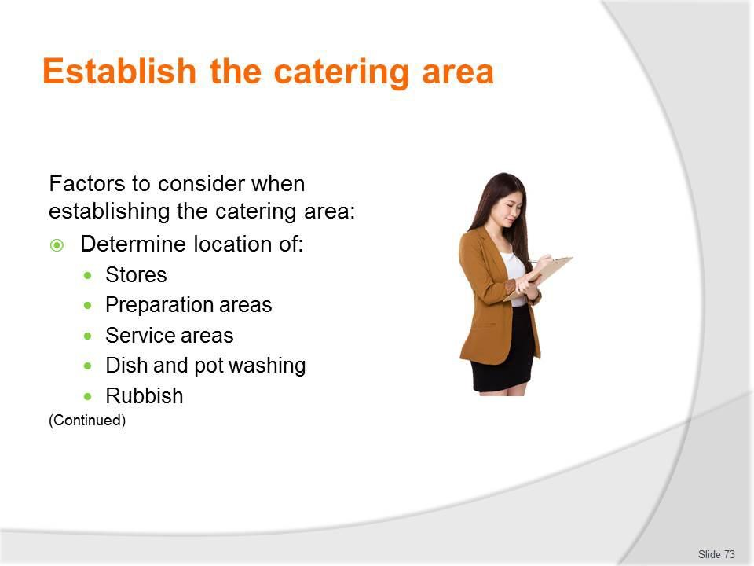
Slide No | Trainer Notes
73. | Trainer presents factors to consider when establishing the catering area:  - Determine the layout for all the individual areas and items which comprise total catering provision. This means considering the relative location (that is, the relationship to one another) of the following:  - Food and beverage storage – dry, frozen and refrigerated  - Preparation areas and surfaces including food washing  - Food and beverage service areas and equipment  - Clean-up facilities – for dishwashing, pot washing and cleaning glassware  - Rubbish  - Factors to take into account in this regard are:  - Logical flow – to save unnecessary walking between points  - Security – to protect items from theft/unauthorised use  - Previous work layouts for similar tours  - Built-in facilities which need to be used and cannot be moved.

Slide
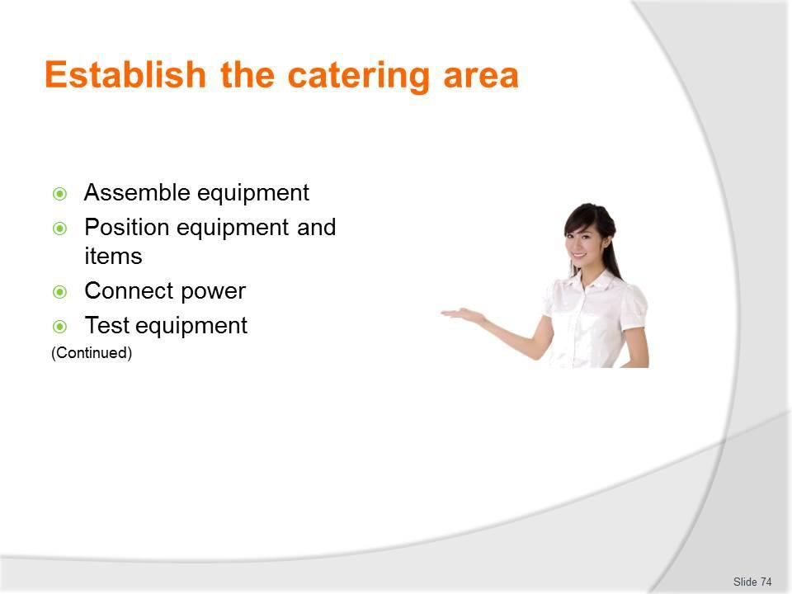
Slide No | Trainer Notes
74. | Trainer continues presenting factors to consider when establishing the catering area:  - Assemble equipment – which has had to be dismantled for the purpose of transportation  - Position equipment and items – see later slides  - Connect power sources – this can require:  - Positioning, filling and running the generators – and hooking equipment up to them  - Plugging electrical leads into power points where provided at camp sites  - Using RCDs, extension leads and power boards  - Connecting units to provided gas cylinders/tanks in established camp sites – or attaching equipment to portable gas bottles/cylinders  - When connected, gas-powered equipment must not only be checked ‘operationally’ but gas leads/lines must also be checked for leaks  - Test equipment – as soon as all equipment has been assembled and/or positioned it must be tested  - This is important to give maximum notice of malfunctions so repairs can be made or alternatives obtained or worked out  - Testing needs to be ‘operational’ testing meaning it has to address the operational elements of each item as it will actually be used, not just whether or not it ‘turns on and off’.

Slide
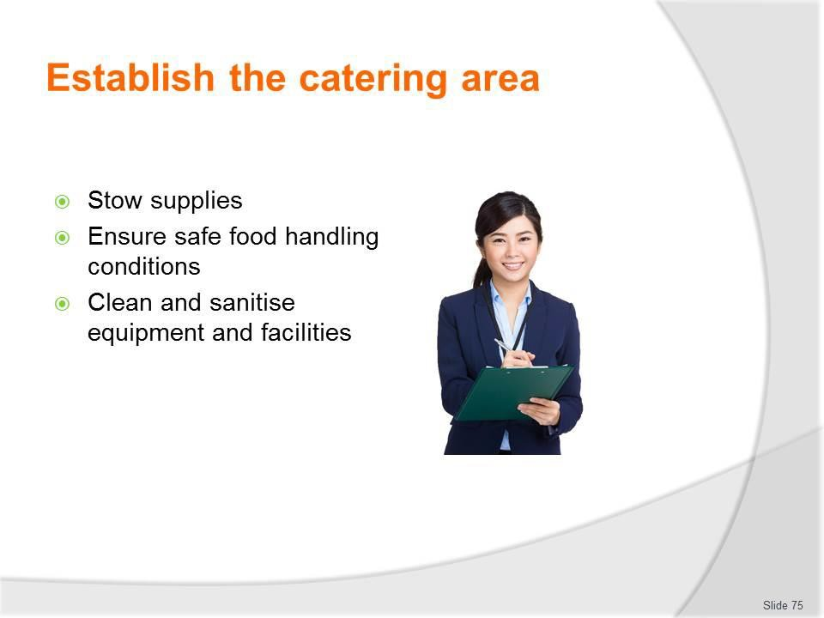
Slide No | Trainer Notes
75. | Trainer continues presenting factors to consider when establishing the catering area:  - Stow supplies on-site – which involves:  - Re-locating required food from tour/catering vehicles to catering area – it is often necessary to move all the food but attention should be paid to only re- locating what is needed for the service sessions to be provided at the camp  - There is no point moving food simply for the sake of moving it  - Ensure safe food handling conditions – which will involve:  - Running refrigeration provided on-site as soon as crew arrives if it is not already turned on – to pre-chill them  - Using a food thermometer to:  - Determine temperature of operating/in situ units – to identify if they are acceptable or need to be adjusted  - Monitor temperatures on an ongoing basis  - Making sure it is just the catering crew who handle/store the food  - Checking integrity of food which is delivered to the camp by third party providers  - Making sure places where food is stored is protected from infestation and contamination

- Clean and sanitise equipment and facilities – this:
  - May be required by the FSP for the operation
  - Should occur for all equipment and utensils which have been transported to the camp
  - Should occur for all equipment and utensils provided at an established camp/catering site or area
  - Requires protecting food from contamination by the cleaning process
  - Storing cleaning agents after use separately from the food
  - Washing hands after cleaning and before handling food.

Slide
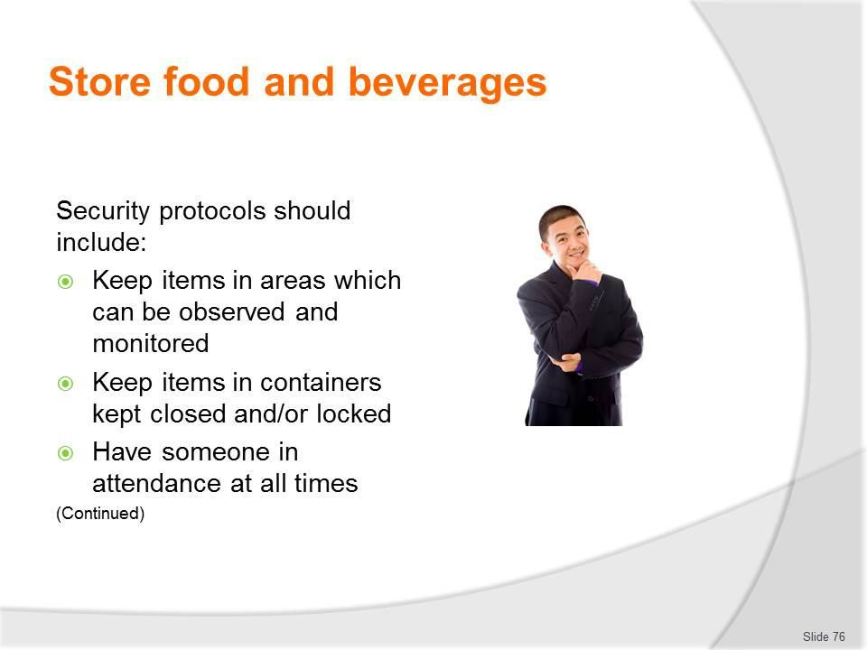
Slide No | Trainer Notes
76. | Trainer presents security protocols:  - Keep all food and beverages in areas which can be observed and monitored – so potential theft or unauthorised access can be identified  - Keep food and beverages in containers which are kept closed and/or locked – as opposed to allowing individual items to lie around  - Have someone in attendance in the catering area at all times – to deter theft/ unauthorised use.

Slide
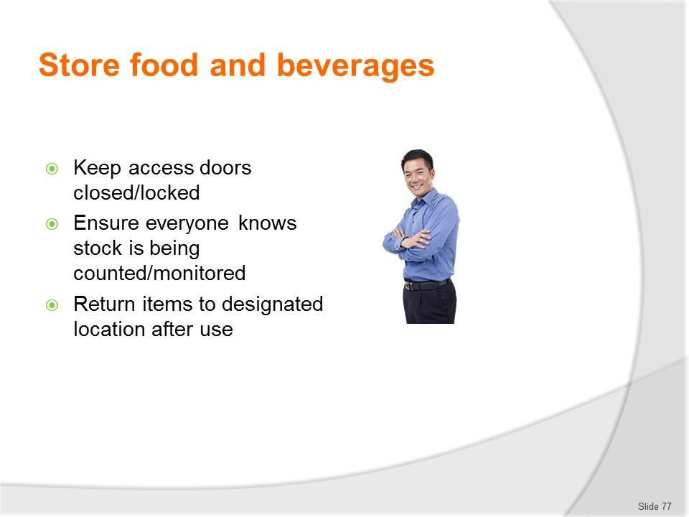
Slide No | Trainer Notes
77. | Trainer continues presenting security protocols:  - Keep doors (where provided) to catering areas closed – and locked  - Make everyone aware stock is being monitored/counted – by telling them and/or making security protocols ‘obvious’  - Returning items to their assigned storage area once they have been used.

Slide
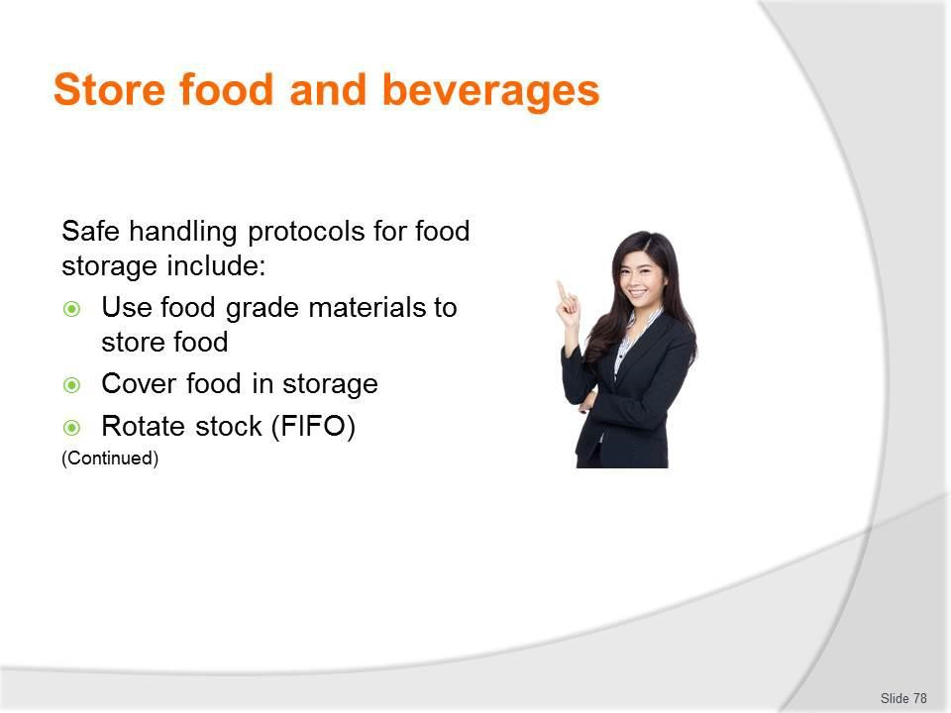
Slide No | Trainer Notes
78. | Trainer provides safe food handling protocols in relation to food storage:  - Use food grade materials to store food that is susceptible to contamination – such as stainless steel  - Cover food in storage – to protect it from contamination  - Rotate stock to ensure it is used in the correct sequence – the method used for most food is FIFO: any food that exceeds its use-by date must be thrown out.

Slide
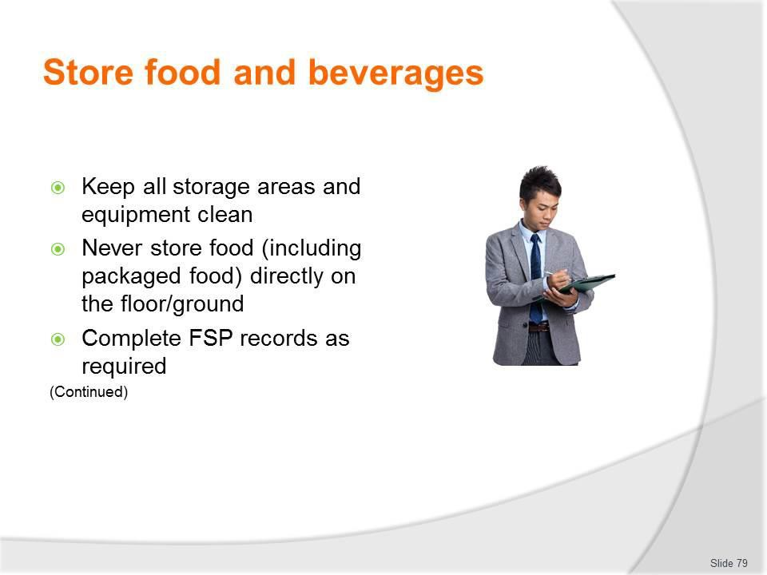
Slide No | Trainer Notes
79. | Trainer continues providing safe food handling protocols in relation to food storage:  - Keep all storage areas and equipment clean – meaning ‘free from visible contamination and odour’  - Never store food (including packaged food) directly on the floor or the ground – always put food on tables or shelving  - Supporting food safety records must be completed – to provide evidence required checks have been conducted, and to record temperatures of refrigerated and freezer units.  Classroom Activity – Handouts  Trainer distributes and discusses sample camp-related FSP and associated records which need to be completed in relation to storage of food.

Slide
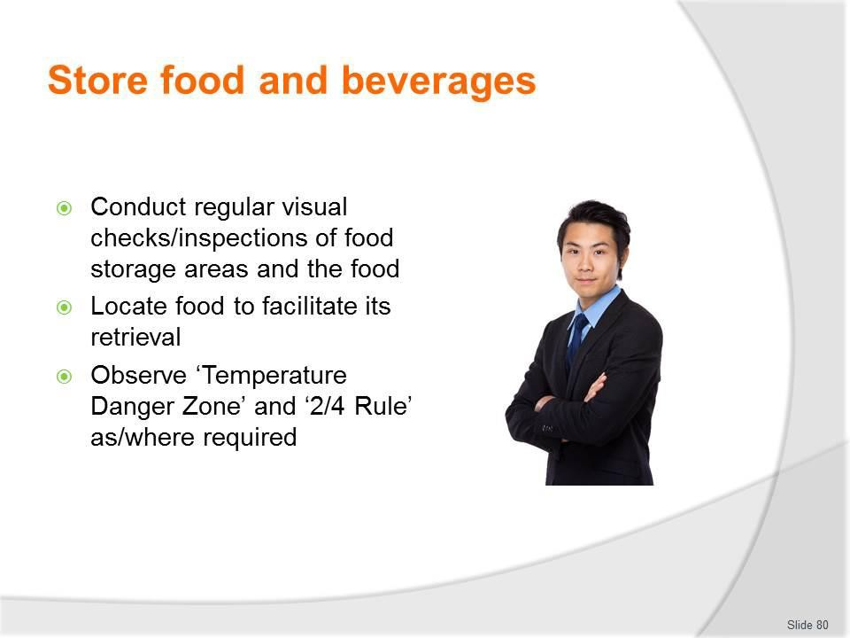
Slide No | Trainer Notes
80. | Trainer continues providing safe food handling protocols in relation to food storage:  - Conduct regular visual checks/inspections of food storage areas and the food itself  - Locate food to facilitate its retrieval in accordance with menu planning/intended use of items  - Requirements relating to observation of the ‘Temperature Danger Zone’ and the ‘2/4 Rule’ (see later slides) must be observed and implemented.  Classroom Activity – Guest Speaker  Trainer arranges for local Health Inspector to attend and:  - Provide advice regarding creating and maintaining safe food handling protocols relating to camp site catering.

Slide
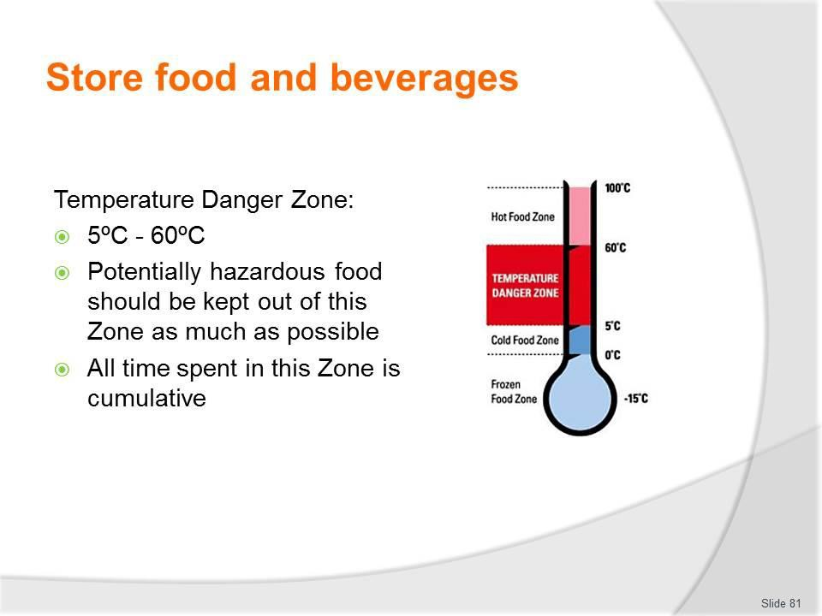
Slide No | Trainer Notes
81. | Trainer discusses Temperature Danger Zone observing:  - The Temperature Danger Zone is the temperature range in which bacteria multiply most rapidly  - The range is 5ºC - 60ºC  - Every effort must be made to keep potentially hazardous food out of this temperature range  - Where food has to be in this range (such as when it is being prepared), the amount of time that food spends in this zone must be minimised  - It is important to note that all time food spends in the Temperature Danger Zone is cumulative. If a piece of meat is left out on a preparation surface for 1 hour, refrigerated and then brought back out into the catering/food preparation area, the time it then spends in the Temperature Danger Zone is added to the previous time  – the clock (and the bacteria count) does not get reset to zero when the food was put in the fridge again.

Slide
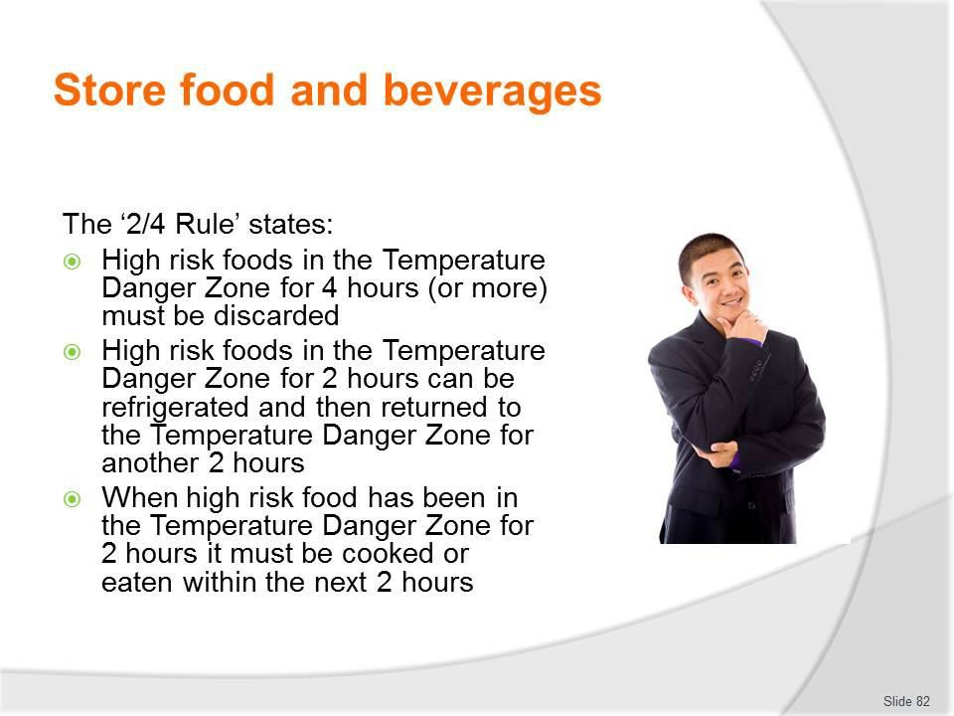
Slide No | Trainer Notes
82. | Trainer discusses 2/4 Rule observing:  - The 2/4 rule states:  - High risk foods that have been in the Temperature Danger Zone for 4 hours (or more) must be discarded/thrown out  - High risk foods that have been in the Temperature Danger Zone for 2 hours can be refrigerated and then returned to the Temperature Danger Zone for another 2 hours, maximum  - When high risk food has been in the Temperature Danger Zone for 2 hours it must be cooked or eaten within the next 2 hours or thrown out  - There are no exceptions to this rule.

Slide
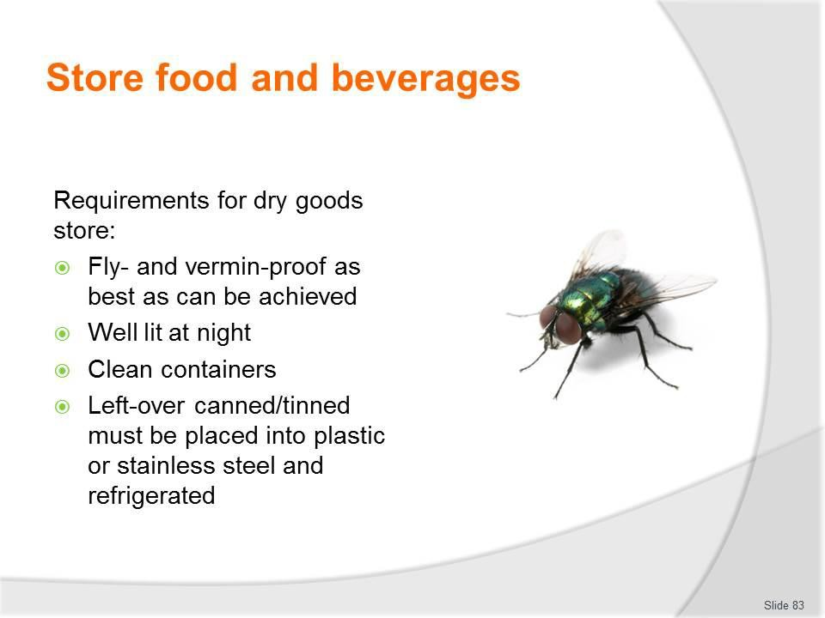
Slide No | Trainer Notes
83. | Trainer presents protocols for dry goods storage:  - The area is fly- and vermin-proof as best as can be achieved – to minimise contamination by pests  - For night-time use make sure the area is well lit – to allow staff to see what they are doing and identify and remedy spillages  - Food storage containers are cleaned and sanitised before being re-used/re-filled – rather than being re-filled without cleaning in between uses, and as opposed to continually topping up the contents  - Any canned/tinned food must be transferred to an appropriate container and refrigerated once the container has been opened – it is not acceptable (for example) to open a can, use half of the contents and then return the open can to dry storage  - The food must completely used or be transferred to a plastic or stainless steel (or other appropriate) container and then placed under refrigeration  - If this cannot be done, the left-over food must be thrown out.

Slide
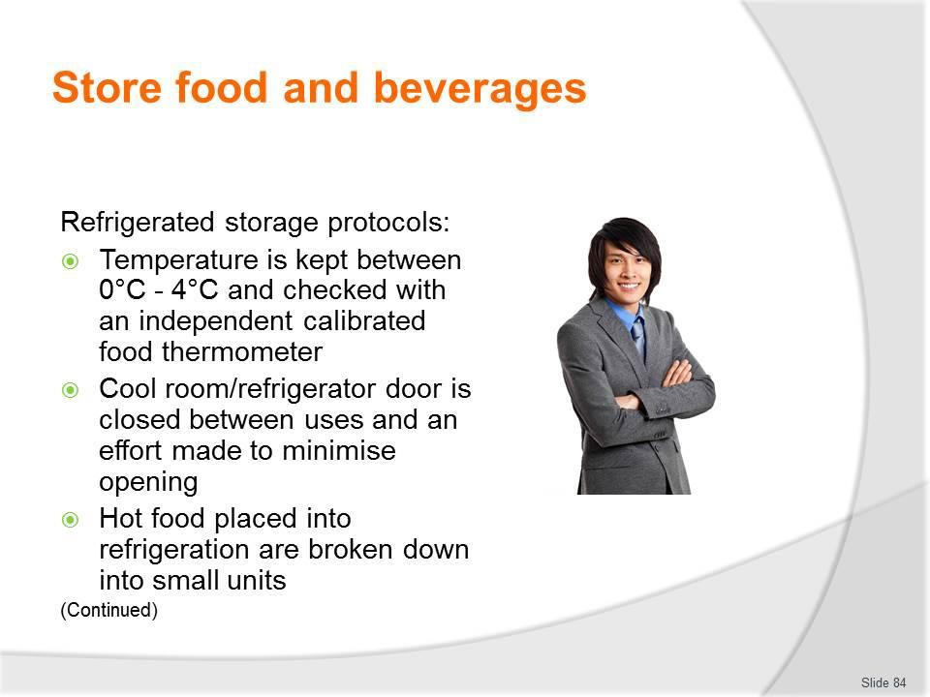
Slide No | Trainer Notes
84. | Trainer presents protocols for refrigerated storage:  - The temperature is kept between 0°C - 4°C and this temperature is checked with an independent calibrated food thermometer – checks must be done at least once per day  - A calibrated thermometer is one which has been tested and proved to be accurate to within+/-1°C  - High risk foods (see following slide) should be able to be stored at 5°C for 7 days. They should be eaten within this time or discarded. Where the temperature is 3°C or less, this time could extend beyond 7 days  - The cool room/refrigerator door is closed between uses and an effort made to minimise opening frequency – an open door raises the temperature and makes the unit more expensive to operate  - Hot food placed into refrigeration are broken down into small units – to enable faster cooling  - Where large units of food are placed in the refrigerator it takes a lot longer for the core of that food to move out of the Temperature Danger Zone  - Hot foods should be allowed to cool (perhaps by placing the food in pots into tubs full of a cold water) before being placed under refrigeration: frequent stirring of the item will help it to cool quicker

- The ‘Two-step rule’ for cooling hot foods must be complied with (see later slide)
- Some food safety plans prohibit the saving/refrigeration of cooked/hot food to avoid potential food safety problems in this regard.
Classroom Activity – Demonstration and Practical
Trainer demonstrates how to calibrate a food thermometer and provides an opportunity for students to do the same.

Slide
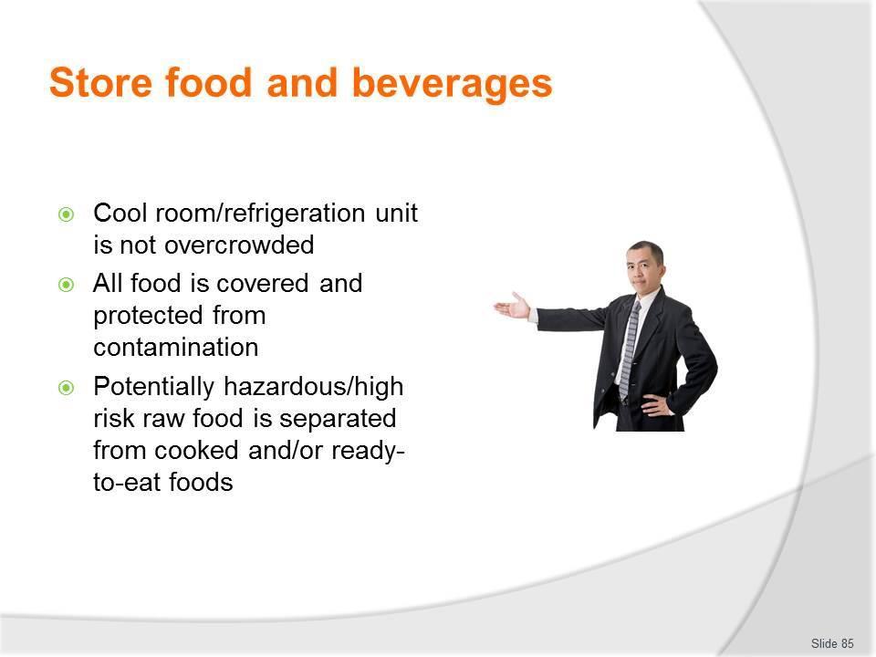
Slide No | Trainer Notes
85. | Trainer continues presenting protocols for refrigerated storage:  - The cool room/refrigeration unit is not overcrowded – in order to enable air to circulate freely around food items  - All food is covered and protected from contamination – plastic film with a label attached to identify the food is common  - Potentially hazardous/high risk raw food is separated from cooked and/or ready-to- eat foods – this is to prevent cross contamination  - Never store potentially hazardous/high risk raw food above cooked and/or ready-to-eat foods as there is the potential for raw blood or juice to drip down onto the food below.

Slide
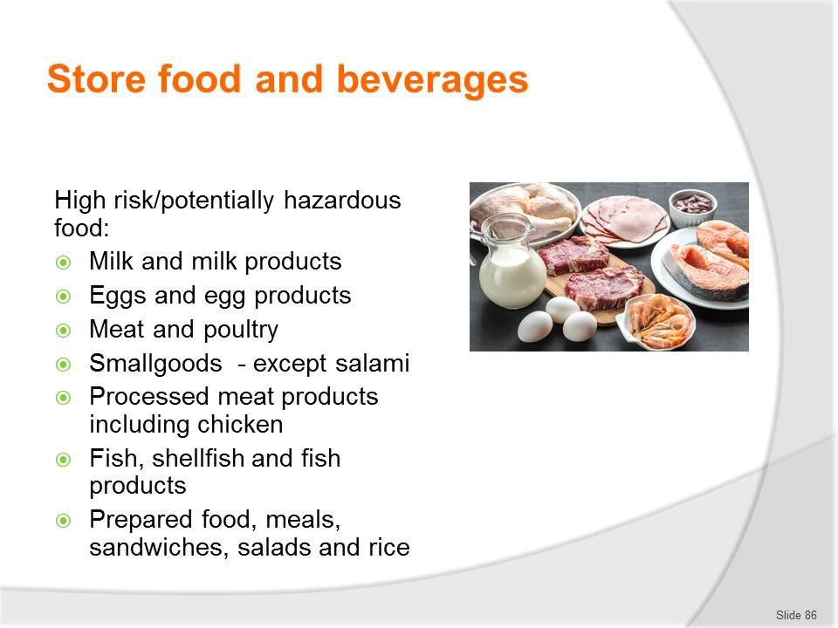
Slide No | Trainer Notes
86. | Trainer discusses high risk foods stating:  - High risk foods (also known as ‘potentially hazardous’ foods) are those which are high in protein, such as:  - Milk and milk products – butter, yoghurt, custards, cream cakes, cheese, baked custard tarts and dips  - Eggs and egg products – quiche, fresh pasta, duck and game bird eggs  - Meat and poultry – all types and all cuts  - Smallgoods products – ham, pressed chicken, but note salami is not a high risk food  - Processed meat products including chicken – pate, meat pies, sausages, sausage rolls, rissoles, meat balls  - Fish, shellfish, fish products, fish soups and fish stocks – caviar, fish balls, patties, salads, sauces and stews  - Prepared food, meals, sandwiches, salads and rice.

Slide
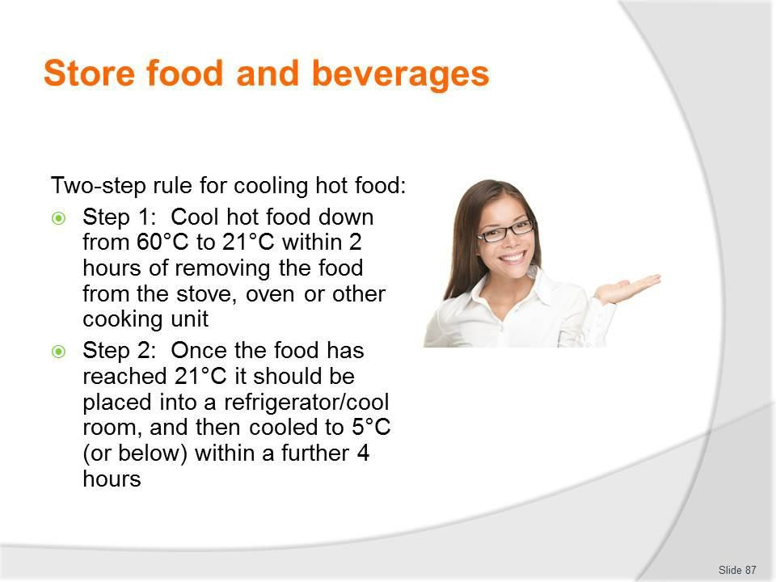
Slide No | Trainer Notes
87. | Trainer presents two-step rule for cooling hot food noting:  - The two-step rule provides direction for the cooling of high risk hot food. It states:  - Step 1: Cool hot food down from 60°C to 21°C within 2 hours of removing the food from the stove, oven or other cooking unit  - Step 2: Once the food has reached 21°C it should be placed into a refrigerator/cool room, and then cooled to 5°C (or below) within a further 4 hours  - If the cooling of high risk food does not meet these criteria, the food must be thrown out  - In addition, note that once the food has reached 5°C, it can safely be put in the freezer.

Slide
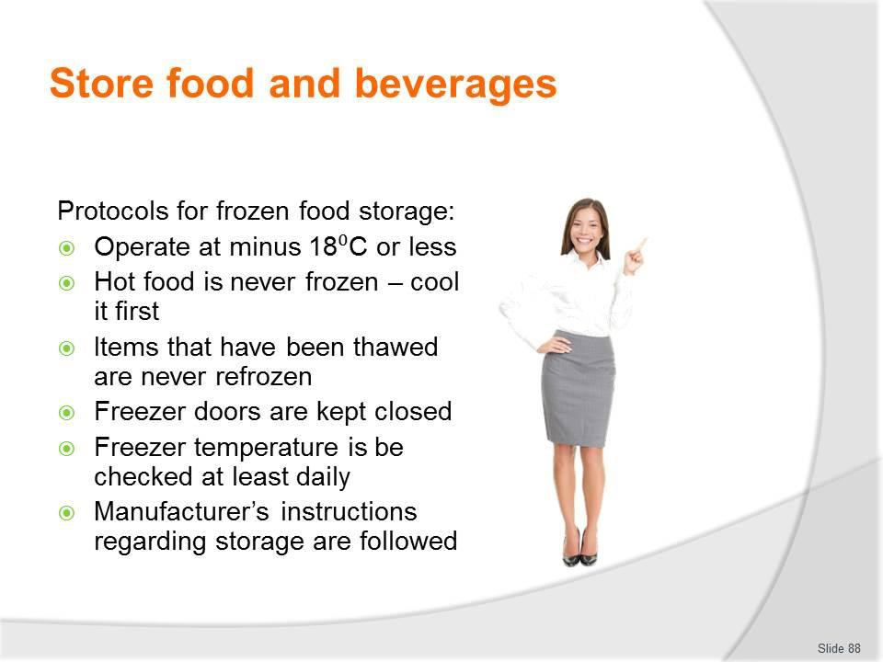
Slide No | Trainer Notes
88. | Trainer presents protocols for frozen storage:  - Operate at minus 18⁰C or less  - Hot food is never frozen – cool it first following the two-step rule for cooling hot food  - Items that have been thawed are never refrozen  - Freezer doors are kept closed when the freezer is not in use  - Freezer temperature is be checked at least daily to ensure correct operating temperature  - Manufacturer’s instructions regarding the storage of frozen food products are followed – these may relate to storage temperatures and the length of time the product can be stored (for quality and/or safety reasons).  Classroom Activity – Demonstration and Practical  Trainer demonstrates how to use food thermometer to take the temperature of a refrigeration unit and freezer and provides opportunity for students to do the same.

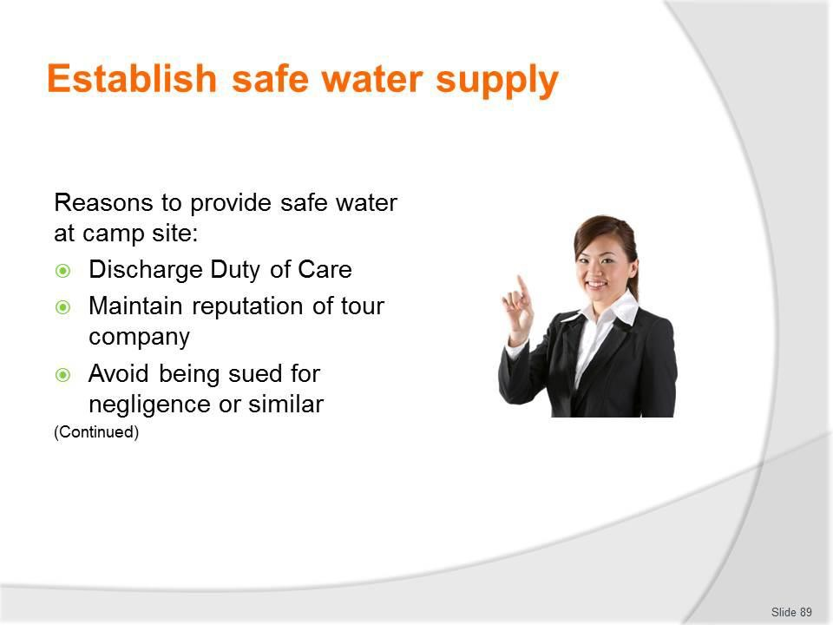
Slide
Slide No
Trainer Notes
89.
Trainer gives reasons to provide safe water:
- Discharge Duty of Care responsibilities
- Maintain the reputation of the tour company
- Avoid being sued for negligence or similar.

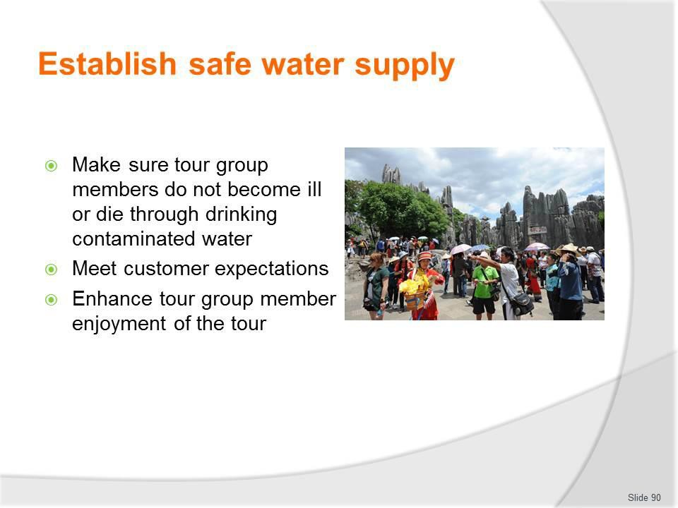
Slide
Slide No
Trainer Notes
90.
Trainer continues giving reasons to provide safe water:
- Make sure tour group members do not become ill or die through drinking contaminated water
- Meet customer expectations
- Enhance tour group member enjoyment of the tour.

Slide
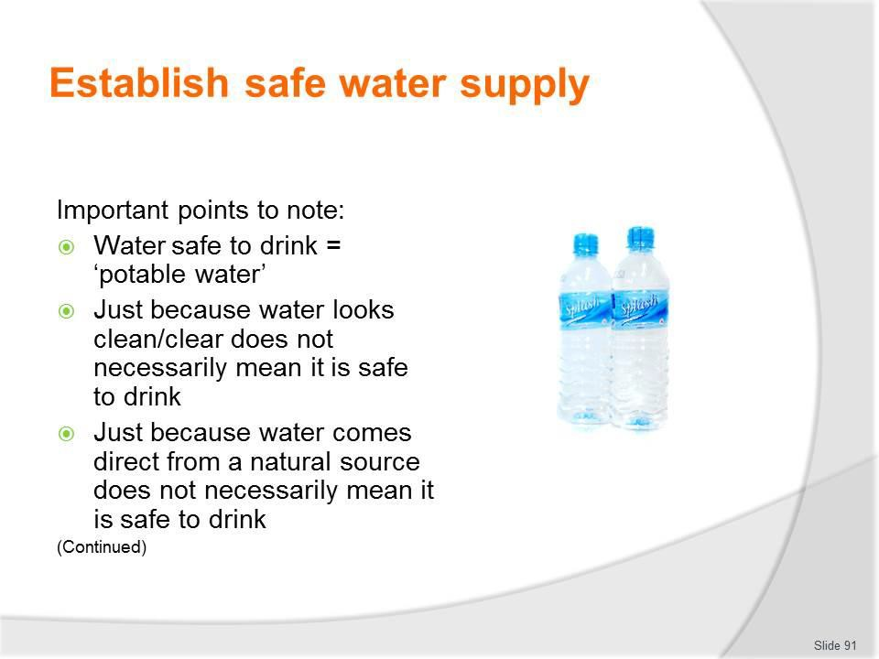
Slide No | Trainer Notes
91. | Trainer presents important points to note:  - Water that is safe to drink is also called ‘potable water’  - Just because water looks clean/clear does not necessarily mean it is safe to drink  - Just because water comes direct from a natural source (river or lake) does not necessarily mean it is safe to drink.

Slide
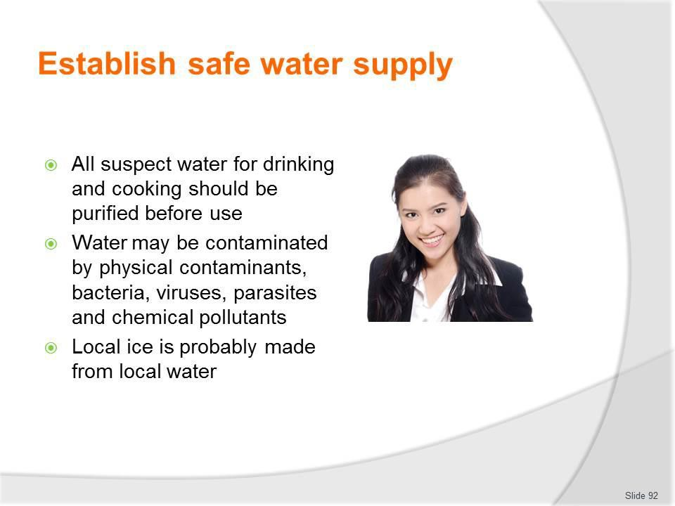
Slide No | Trainer Notes
92. | Trainer continues presenting important points to note:  - All suspect water to be used for drinking and cooking should be purified before use  - Water may be contaminated by physical contaminants, bacteria, viruses, parasites and chemical pollutants  - Local ice is probably made from local water.

Slide
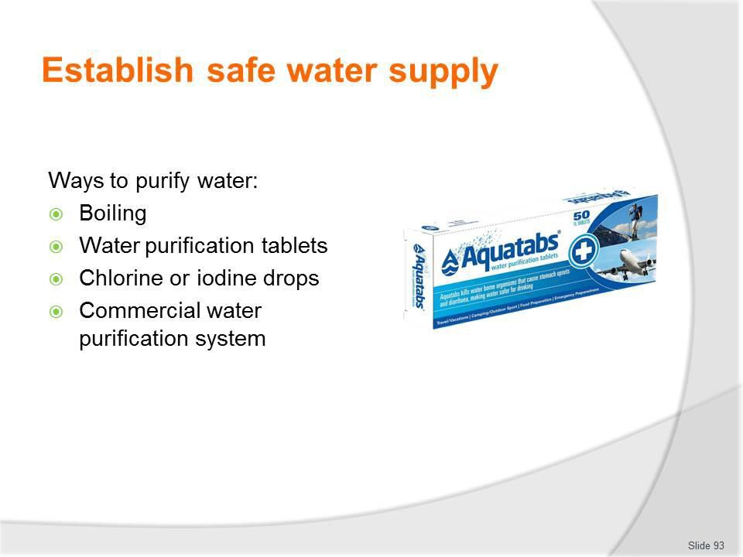
Slide No | Trainer Notes
93. | Trainer presents ways to purify water:  - Bringing the water to a rolling boil and boiling for five minutes, scoop any scum/detritus off the top – allow to cool, as necessary, prior to use  - Using water purification tablets – such as iodine, chlorine or halazone and following instructions provided regarding:  - Method  - Number of tablets to the amount of water  - Adding chlorine drops or liquid iodine – following manufacturer instructions  - Using a commercial water purification system – featuring a combination of activated charcoal filtering plus a chemical (such as iodine).  Classroom Activity (1) – Internet Research  Trainer supervises internet research and subsequent classroom discussion by visiting:  http://www.princeton.edu/~oa/manual/water.shtml - A guide to water purification  http://www.instructables.com/id/How-To-Purify-Water-Using-Iodine-Tincture/ - How to purify water using iodine tincture  http://en.wikipedia.org/wiki/Portable_water_purification - Portable water purification http://www.wikihow.com/Purify-Water - How to purify water (Five ways)  http://www.traveldoctor.com.au/Page/Knowledge-Hub/Travel-health-fact-sheets/Eating- and-drinking-safely - Eating and drinking safely.

Classroom Activity (2) – Demonstration and Practical
Trainer demonstrates how to purify water as identified on the slide and provides opportunity for students to do same.

Slide
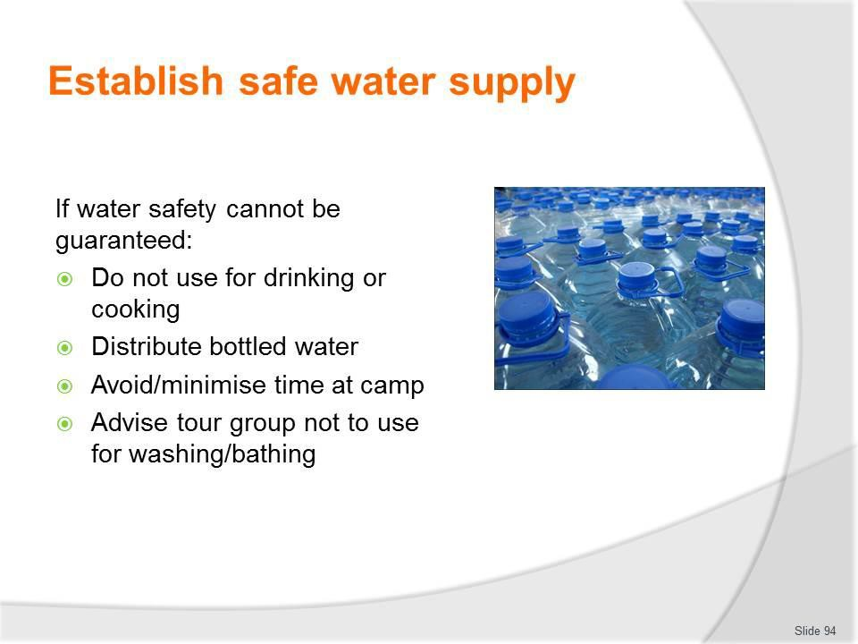
Slide No | Trainer Notes
94. | Trainer stresses where the water at a camp site cannot be tested or cannot be made safe to drink:  - It must not be used for drinking or cooking  - Sealed bottles of brand name water should be used and issued to tour group members  - Time at the camp site should be avoided altogether or minimised  - Tour group members should be advised not to use it for bathing/washing.

Slide
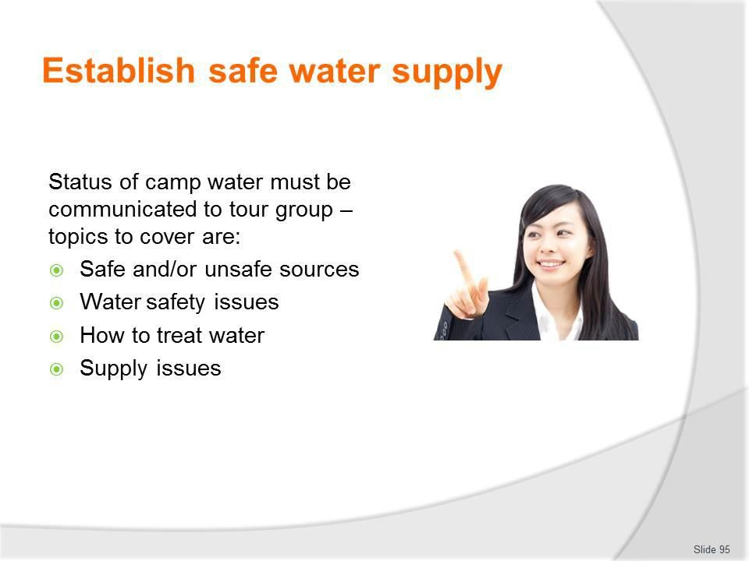
Slide No | Trainer Notes
95. | Trainer highlights the status of camp water should be communicated to tour group members observing this may be done by the catering crew, or the person in charge of catering may share details with the Tour Leader who then passes the information on to the group.  Topics to discuss/communicate are:  - Identification of water sources – which:  - Are safe and can be used  - Are not safe and must not be used  - Water safety issues – in relation to:  - Whether or not tap water, where available, is fit to drink – and/or bathe in  - Whether or not pump or well water, where available, is fit to drink – and/or bathe in  - How to treat the water to make it safe – including:  - Demonstrations of how to do this  - Distribution of required equipment and/or materials  - Supply of water – and details regarding, as appropriate:  - Need to conserve water and limits its use  - Free/unrestricted supply  - Any cost associated with accessing water  - Prohibited/private sources which cannot be used by the tour group.

Slide
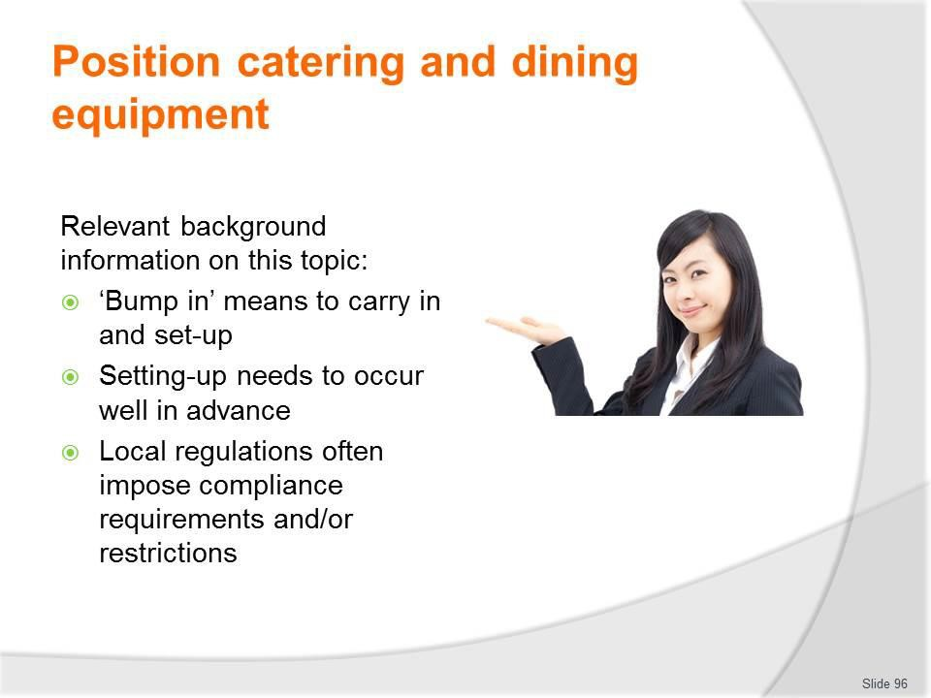
Slide No | Trainer Notes
96. | Trainer presents relevant background information:  - ‘Bump in’ means to carry in, assemble and/or position equipment – to take items from the tour and/or catering vehicles and put them where required  - ‘Bump out’ means taking the items out of the area – and disassembling and/or re-loading them back on to the vehicles for transportation  - All this work needs to be completed well in advance of scheduled dining sessions – because food preparation and production still needs to occur before service can take place  - There may be local ‘regulations’ which need to be complied with – such as:  - Where certain items – especially cooking equipment, generators and open fires – can be located  - Use that can and cannot be made of installed/provided equipment  - Safety requirements regarding operation of equipment  - Times at which items/areas can and cannot be used.

Slide
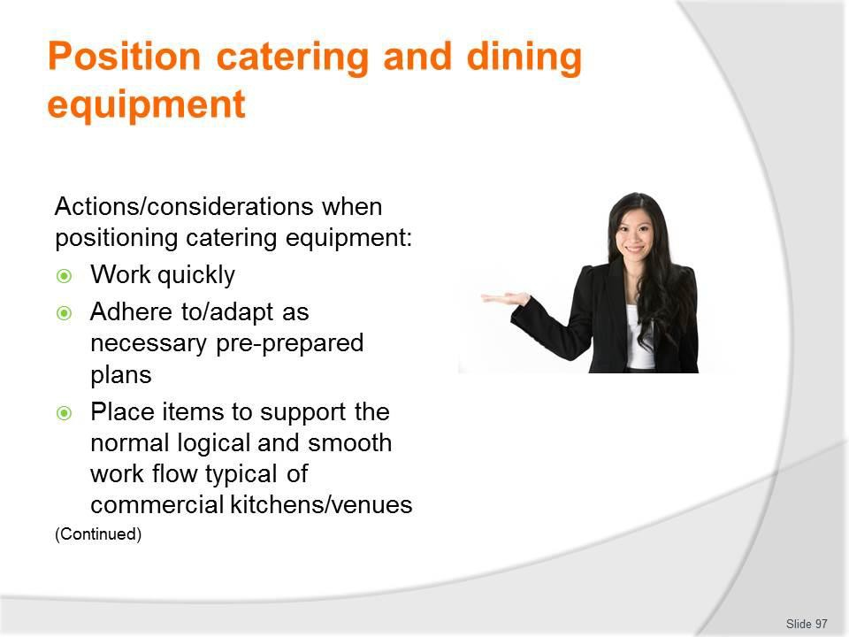
Slide No | Trainer Notes
97. | Trainer identifies actions/considerations when positioning catering equipment for camp site catering:  - Work quickly – time is important  - Time lost at this stage can often not be recovered/made up at a later stage  - Adhere to (and or adapt as necessary) any pre-prepared plans for catering areas/equipment – which may have:  - Been prepared for previous similar tours  - Been prepared for the same destination  - Been prepared especially for this tour  - Place items to support the normal logical and smooth work flow typical of commercial kitchens/venues – that is:  - Storage to preparation  - Preparation to production  - Production to service.

Slide
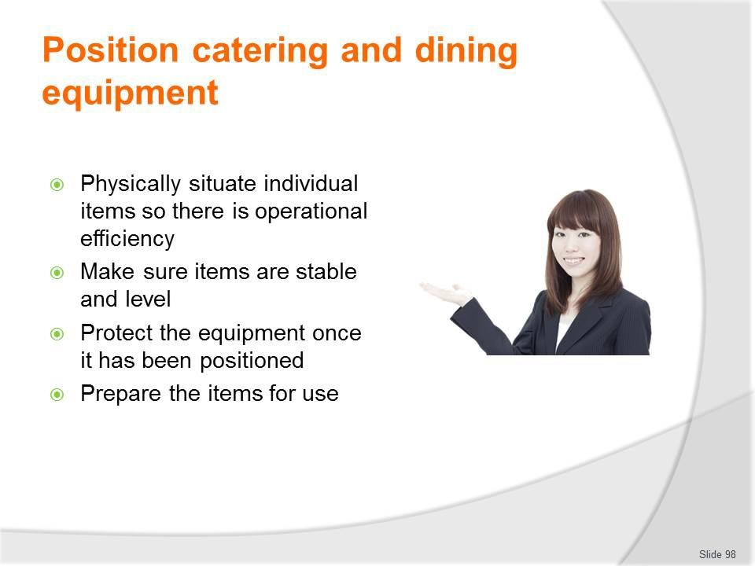
Slide No | Trainer Notes
98. | Trainer continues identifying actions/considerations when positioning catering equipment for camp site catering:  - Physically situate individual items so there is operational efficiency – in terms of, for example:  - Providing sufficient working space to enable safe movement when handling heavy objects, hot items, carrying wide containers with food on them, and allowing others to perform their work without interruption  - Locating individual items correctly – so, if possible:  - One item does not obstruct/block another; Opening one item does not impede access to another; Cooking equipment is not placed on top of other equipment; They do not protrude and present an injury risk  - Make sure items are stable and level – and they do not:  - Wobble; Over-hang an edge; Risk tipping up/over; Allow food/cooking oil or liquid to accumulate on one side/corner of an item or drip or spill  - Protect the equipment once it has been positioned – from:  - Contamination – after they have been cleaned and positioned, to the best extent possible: using covers is effective  - Prevailing weather conditions  - Prepare the items for use – in addition to testing (see section 2.1) and depending on the items and the menu items to be produced there may be a need to:  - Load fat into deep fat fryers – and heat to melt  - Pre-heat ovens.

Slide
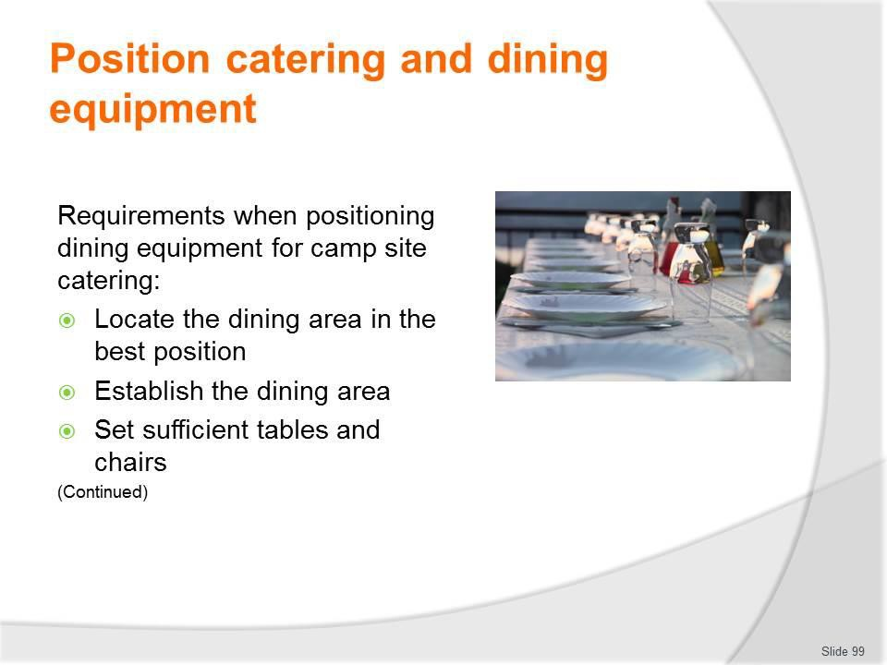
Slide No | Trainer Notes
99. | Trainer identifies requirements when positioning dining equipment for camp site catering:  - Locate the dining area in the best position – which should:  - Take advantage of views available  - Optimise natural/available shelter from the elements  - Position it to facilitate the transport/service of food from the catering area – that is, as close as is practical to the kitchen area  - Establish the dining area – which may involve:  - Using dining facilities provided on-site  - Pitching dining tents or putting up marquees – if required  - Set sufficient tables and chairs – to accommodate known group members.

Slide
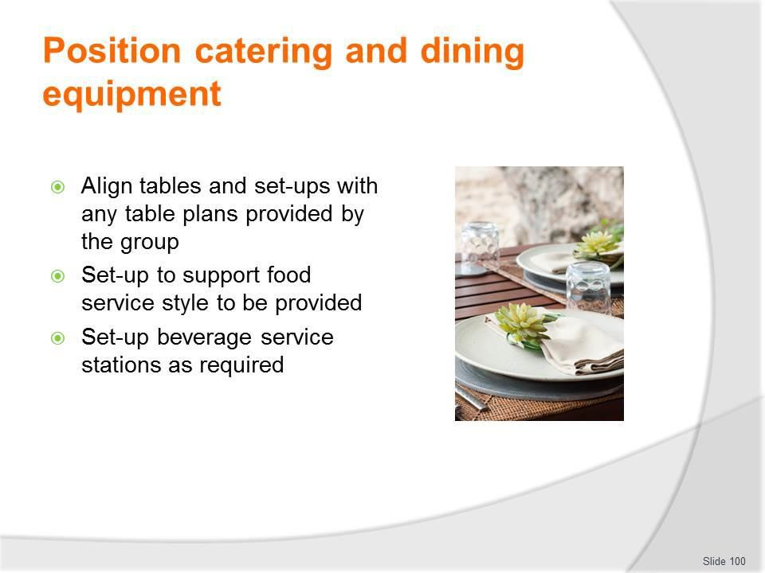
Slide No | Trainer Notes
100. | Trainer continues identifying requirements when positioning dining equipment for camp site catering:  - Align tables and set-ups with any table plans provided by the group – for custom tours which may specify:  - Need for a head table  - Number of tables  - Number of seats at each table  - Set-up to support food service style to be provided – which may/may not require establishing:  - Crockery station/pick-up point  - Cutlery station  - Food displays – for hot and/or cold food  - Set-up beverage service stations as required – which may require:  - Setting/providing glassware and other beverage service accoutrements  - Creating a service bar – and loading with stock  - Positioning drink refrigeration.

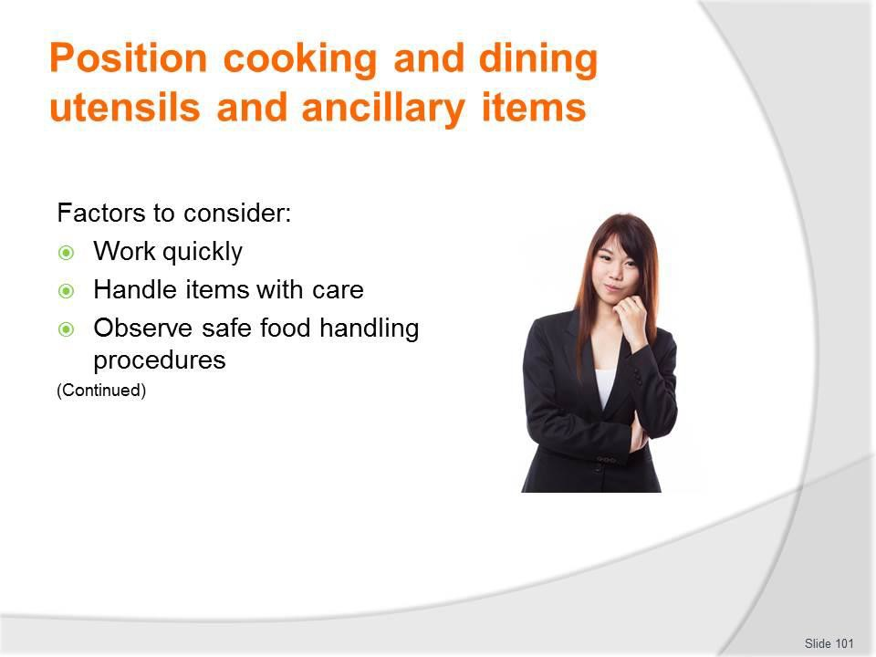
Slide
Slide No
Trainer Notes
101.
Trainer presents factors to consider when locating cooking and dining utensils and ancillary items:
- Work quickly
- Handle items with care
- Observe safe food handing protocols – because these items will be used for food handling or service.

Slide
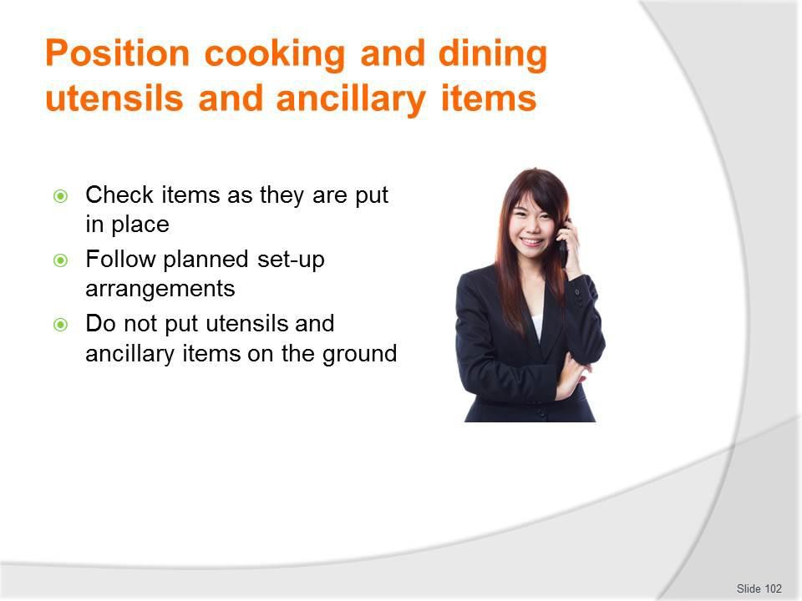
Slide No | Trainer Notes
102. | Trainer continues presenting factors to consider when locating cooking and dining utensils and ancillary items:  - Check items as they are put in place – to:  - Make sure they are clean – clean/sanitise items as necessary  - Verify they are safe to use/suitable for use – that is, they have not been damaged during transport  - Follow planned set-up arrangements – such that:  - Catering vehicles are positioned as close as possible to the areas – to:  - Reduce walking/carrying required  - Save time  - Items are placed in the designated location – so that:  - There is consistency across camp set-ups  - All catering/tour staff know where things are  - Items are located in the required sequence – first things first because:  - Food preparation and production may depend on having certain items available/in place  - Many placements are dependent on other items having been already put in place

- Do not put utensils and ancillary items on the ground – store them:
  - On portable racking
  - On tables
  - On mobile shelving
  - On built-in shelves and facilities available on-site
  - In the planned/designated location or space.

Slide
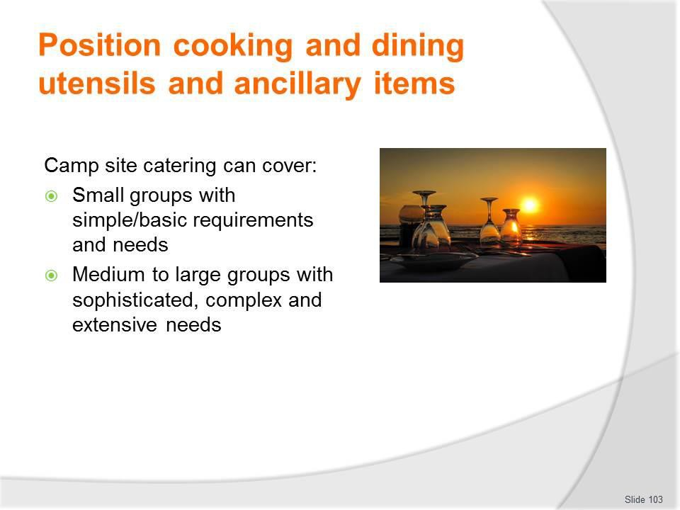
Slide No | Trainer Notes
103. | Trainer observes it is possible the catering for a camp can cover a wide range of tour options in terms of:  - Small groups with simple catering requirements – based on producing small amounts of food using items such as portable stoves with camp stoves (and perhaps a reflector oven), a small range of pots and pans to fry, grill and re-heat basic menu items such as grilled meat, pan-fried fish and reconstituted convenience food  - Medium to large groups requiring sophisticated menu items and service – essentially reproducing the same standard and quantities of catering generated out of a kitchen and provided from a restaurant at a three-star plus venue.

Slide
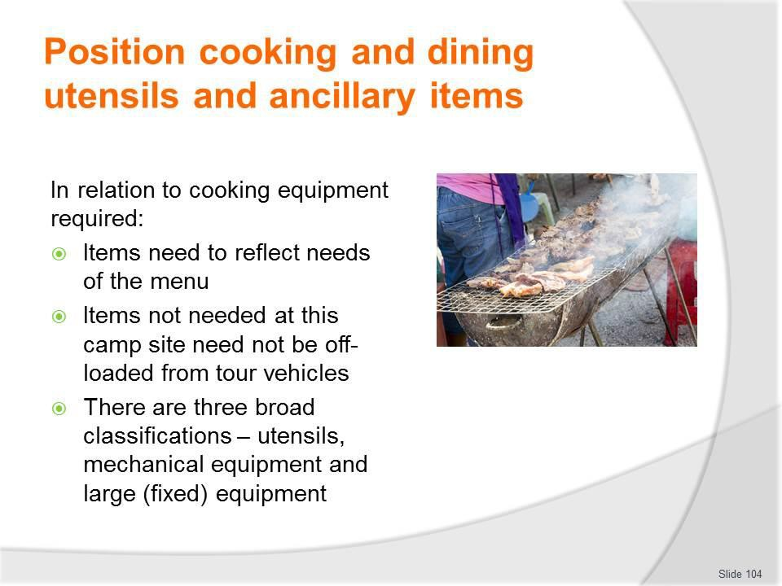
Slide No | Trainer Notes
104. | Trainer observes:  - The equipment must reflect the menu items to be prepared, produced and served  - All the required items need to be positioned, and there is no need or time to position items which are not needed for this camp/service session  - Because there is such a large range of equipment and utensils available it is useful to group them into three categories: utensils, mechanical equipment and large (fixed) equipment.

Slide
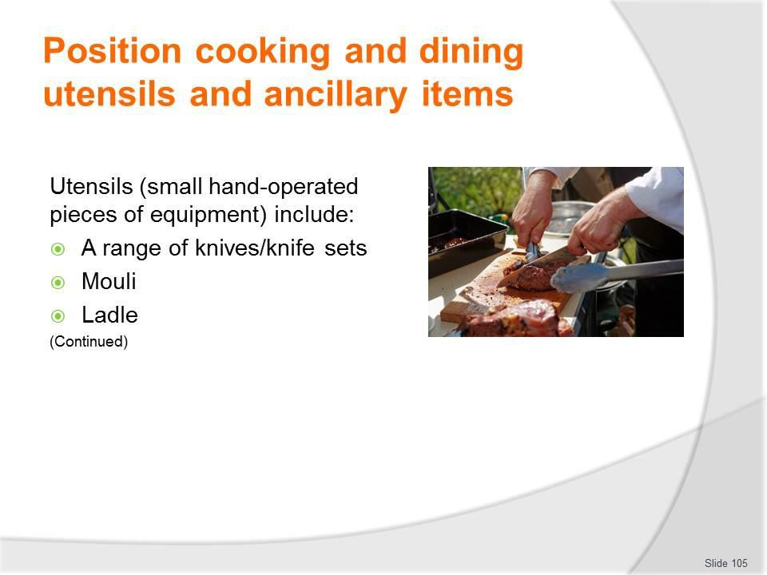
Slide No | Trainer Notes
105. | Trainer presents and discusses ‘Utensils’ stating they include:  - A range of knives (or knife kits) – such as:  - Chef’s knife – used for chopping, slicing and dicing  - Utility knife – used for salad and vegetable preparation  - Paring knife – used for trimming and paring fruit and vegetables  - Boning knife – used for boning out joints  - Slicing knife – used for carving and slicing cooked meats  - Serrated knife – used to cut breads and cakes  - Butcher’s knife – used for cutting, sectioning and trimming raw meat  - Cleaver – used for chopping and splitting raw meat and vegetables  - Palette knives – known as ‘spatulas’, these are used to lift, mix, spread and scrape soft mixtures  - Steel – for sharpening knives  - Mouli – used to strain pips, skins etc from purees and other mixtures  - Ladle – used to scoop foods and liquids from one container/pot to put into another container/bowl.  Classroom Activity – Samples and Demonstration/Explanation  Trainer presents examples of items listed on the slide and demonstrates/explains their use.

Slide
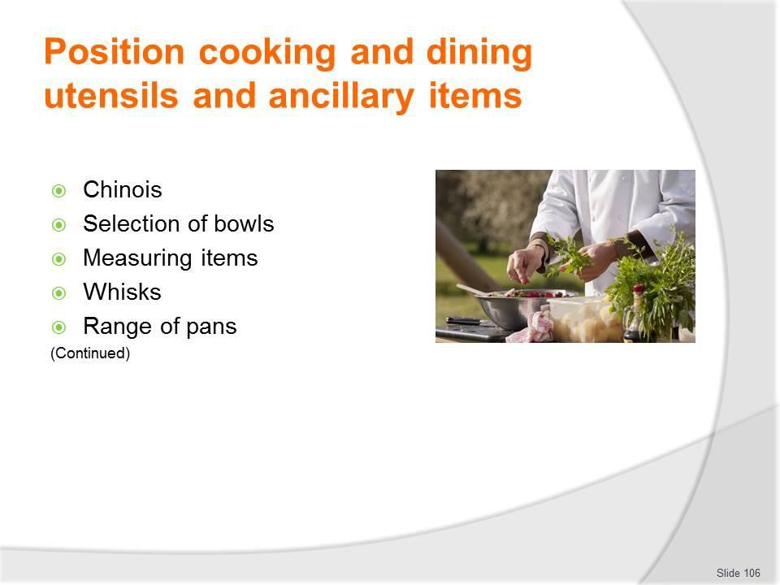
Slide No | Trainer Notes
106. | Trainer continues discussing/presenting utensils:  - Chinois – a conical sieve  - Selection/range of bowls – for mixing and holding food  - Measuring bowls, cups, spoons and scales – for weighing ingredients  - Whisk – used to whisk/aerate a variety of ingredients in many recipes  - A range of pans – which might include:  - Bain-marie – used to keep foods hot when on display and/or ready for service  - Braiser – used for browning, braising and stewing  - Double boiler – used to cook foods at low temperatures and not over direct heat  - Inserts/hotel pans– used for baking, steaming and holding foods at service counters  - Roasting pan – used to roast larger meat cuts  - Sauce pot – used to cook soups, sauces and other liquids  - Sauté pans (sauteuse and sautoir) – used to brown, sauté and fry food  - Stock pot – used to cook stocks, soups and other large volumes of liquid  - Wok – used for stir-frying  - Frying pan – for basic pan frying.

Classroom Activity – Samples and Demonstration/Explanation
Trainer presents examples of items listed on the slide and demonstrates/explains their use.

Slide
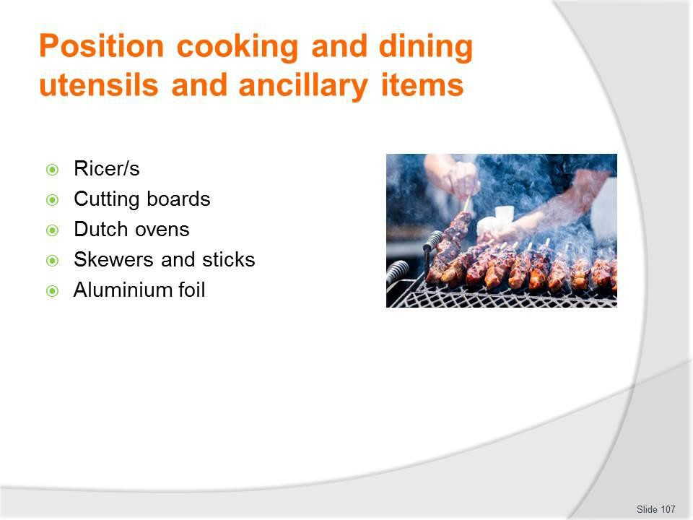
Slide No | Trainer Notes
107. | Trainer continues discussing/presenting utensils:  - Ricer – a piece of equipment (similar to an over-sized garlic press) used to make (for example) mashed potatoes  - Cutting boards – for chopping food  - Dutch ovens – a camp favourite which is expected by many tour groups  - Skewers and sticks – these are another camp favourite used for cooking shashliks/kebabs over an open fire/on a grill plate  - Aluminium foil – popular for cooking food in the coals of a camp fire.  Classroom Activity – Samples and Demonstration/Explanation  Trainer presents examples of items listed on the slide and demonstrates/explains their use.

Slide
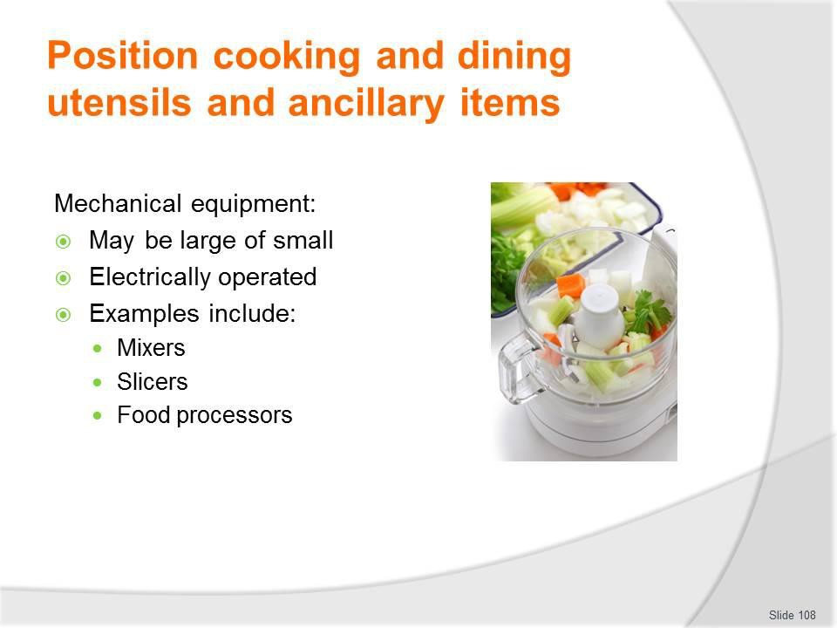
Slide No | Trainer Notes
108. | Trainer presents and discusses ‘Mechanical equipment’ stating:  - They can be large or small and is electrically operated and include:  - Mixers – used for blending ingredients, liquidising foods and making sauces  - Slicers – necessary for slicing a variety of meats and other products  - Food processor – used for cutting and mixing food.  Classroom Activity – Samples and Demonstration/Explanation  Trainer presents examples of items listed on the slide and demonstrates/explains their use.

Slide
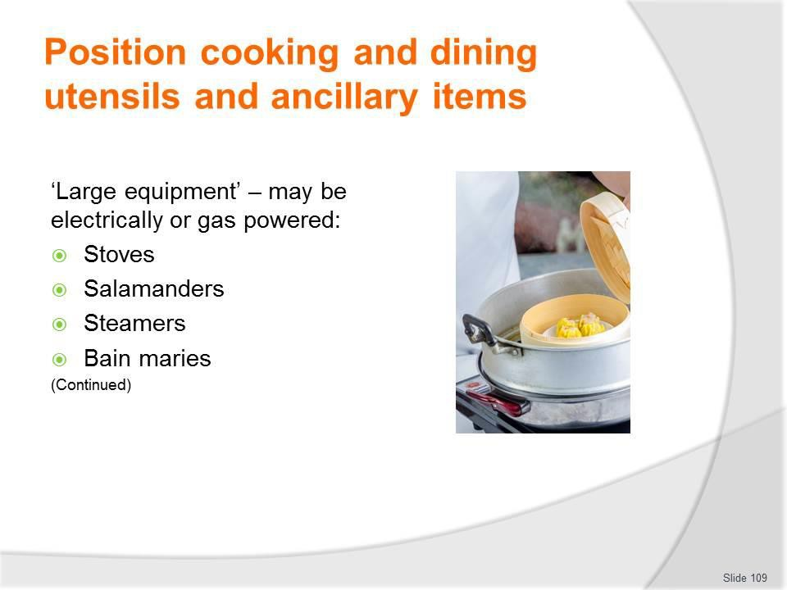
Slide No | Trainer Notes
109. | Trainer presents and discusses ‘Large equipment’ stating they can be electrically or gas operated and include items such as:  - Stoves – for baking, roasting plus use of burners on top of the stove for heating, re- heating and other stove-top cooking such as sautéing, boiling  - Salamanders – used to heat and brown foods as well as to prepare dishes like crème brûlée where the top of the dish has to be caramelised  - Steamers – required for steaming foods such as fish, seafood, chicken and vegetables  - Bain maries – usually used to keep hot foods hot while on display/waiting for service.  Classroom Activity – Samples and Demonstration/Explanation  Trainer presents examples of items listed on the slide and demonstrates/explains their use.

Slide
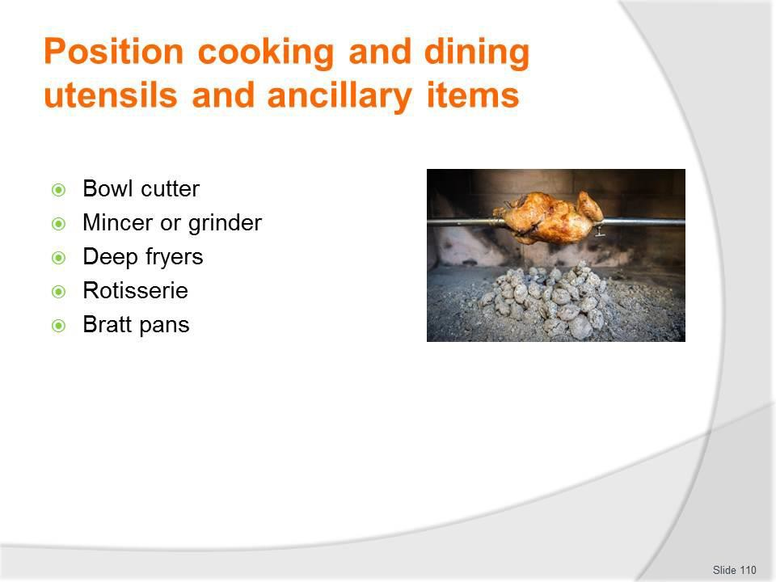
Slide No | Trainer Notes
110. | Trainer continues identifying and discussing large equipment:  - Bowl cutter – used to chop/slice meat and to cut vegetables  - Mincer or grinder – used for mincing/grinding all types of meats and poultry  - Deep fryers – required for the cooking of a wide variety of dishes including battered fish and seafood, chips/French fries, fritters, onion rings, tempura vegetables  - Rotisserie – used for roasting (usually chickens)  - Bratt pans – a deep, rectangular, large capacity (50 – 120 litres) cooking pot used to prepare stocks, sauces, soups and wet dishes: has a tilting mechanism so foods can be tipped out into storage, display or service containers.  Classroom Activity (1) – Samples and Demonstration/Explanation  Trainer presents examples of items listed on the slide and demonstrates/explains their use.  Classroom Activity (2) – Practical Group Exercise  Trainer provides information on a mock tour/camp site together with all necessary resources and assists and oversees efforts at positioning catering equipment/utensils in a simulated food preparation and production area.

Slide
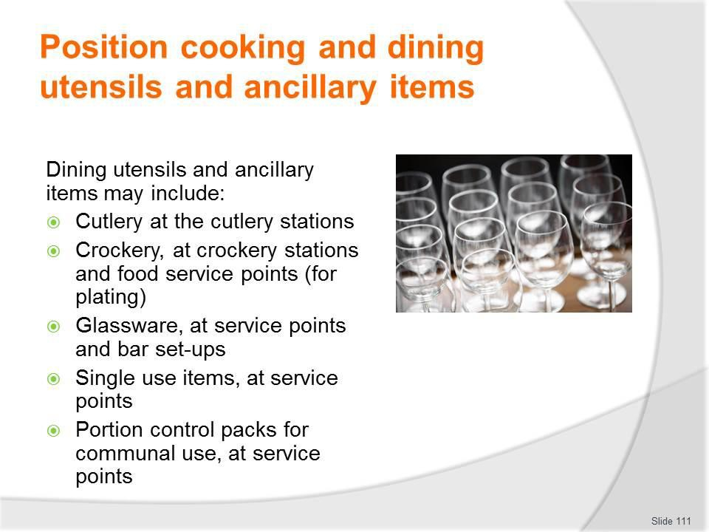
Slide No | Trainer Notes
111. | Trainer identifies and discusses dining utensils and ancillary items stressing they should reflect the prepared menus for the tour/camp and/or the specific service session being prepared for indicating items that may be required can include:  - Cutlery, at the cutlery stations – which may include knives (main and entree), forks (main and entree), spoons (tea, soup, dessert)  - Crockery, at crockery stations and food service points (for plating) – which may include main course plates, side plates, soup bowls, dessert bowls, cups and saucers, serving platters  - Glassware, at service points and bar set-ups – which may include a variety of types of glasses appropriate to the beverages being served (beer glasses, wine glasses, highballs, old fashioned plus others as needed), jugs for juice and water  - Single use items, at service points – these are items intended to be used once and then discarded, such as paper serviettes, drinking straws, stirrers, plastic/disposable cutlery, doilies  - Portion control packs for communal use, at service points – these are pre-packed items giving single serves of products such as condiments, proprietary sauces, sugar, sweetener, jams, tea and coffee, biscuits.  Classroom Activity (1) – Samples and Demonstration/Explanation  Trainer presents examples of items listed on the slide and demonstrates/explains their use.

Classroom Activity (2) – Practical Group Exercise
Trainer provides information on a mock tour/camp site together with all necessary resources and assists and oversees efforts at positioning dining equipment/utensils in a simulated food service area.

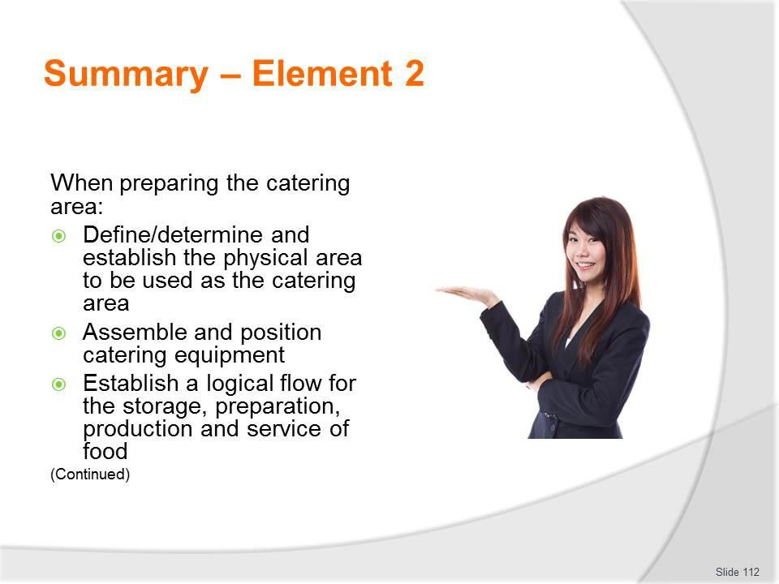
Slide
Slide No
Trainer Notes
112.
Trainer provides a recap of the Element asking questions to check trainee understanding and responding to questions from trainees, as required.

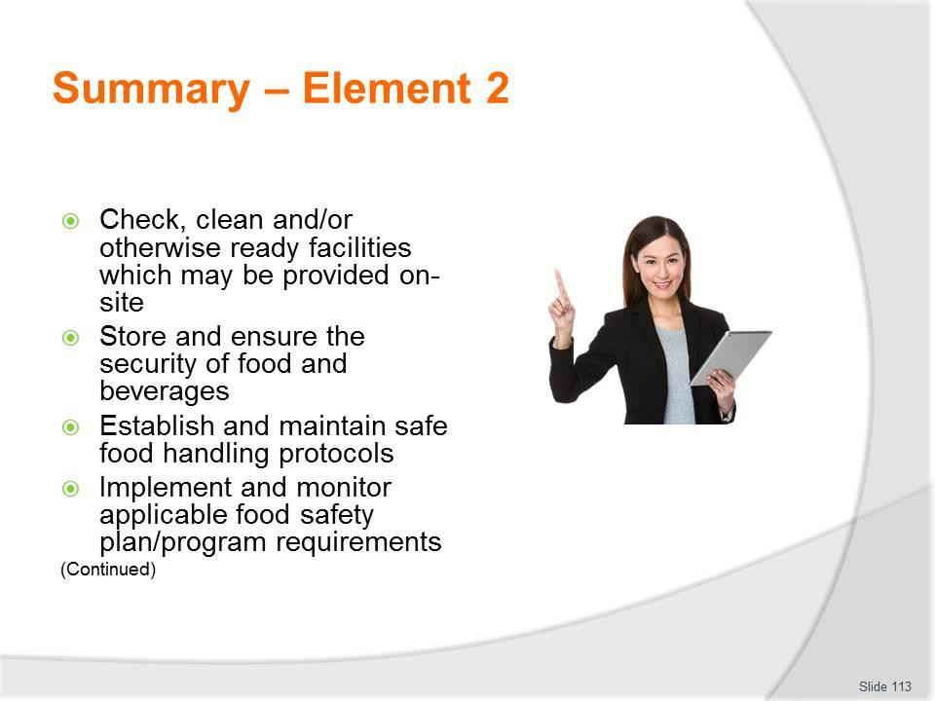
Slide
Slide No
Trainer Notes
113.
Trainer provides a recap of the Element asking questions to check trainee understanding and responding to questions from trainees, as required.

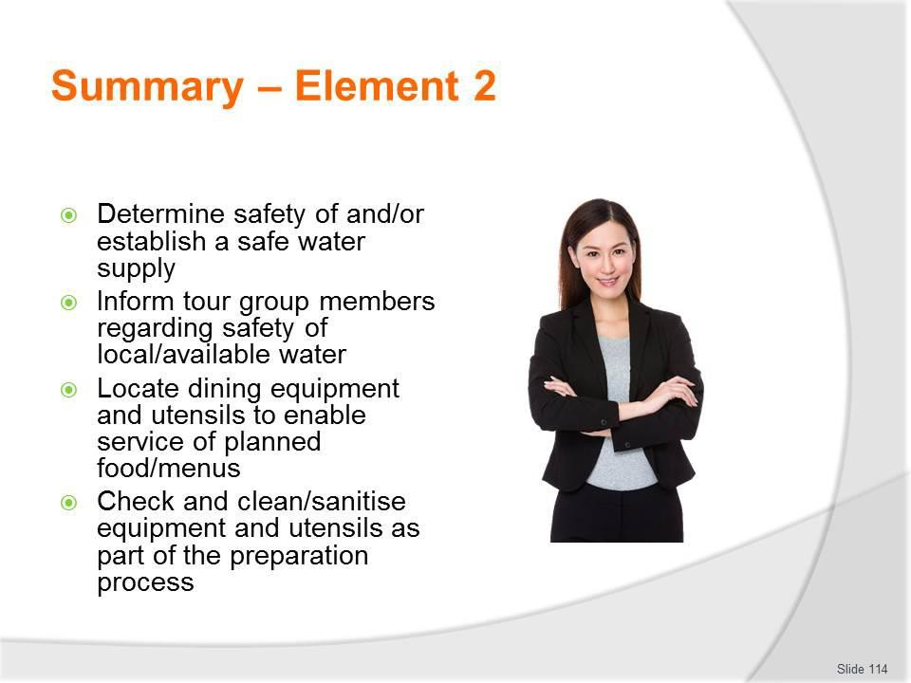
Slide
Slide No
Trainer Notes
114.
Trainer provides a recap of the Element asking questions to check trainee understanding and responding to questions from trainees, as required.

Slide
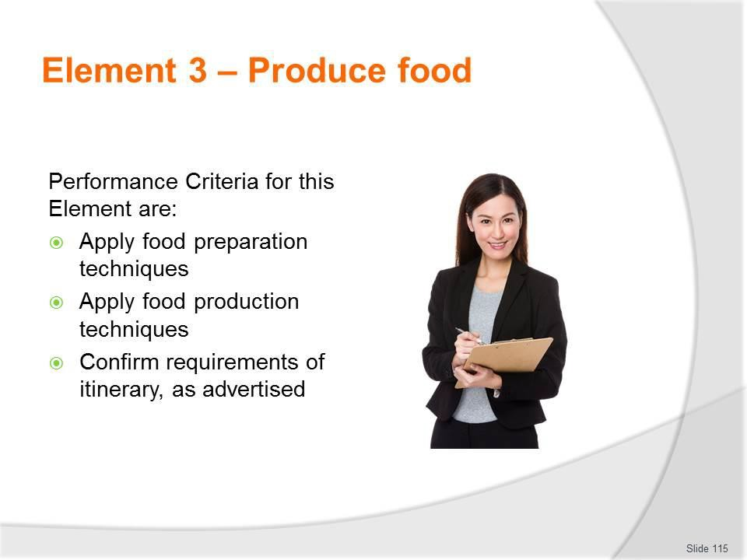
Slide No | Trainer Notes
115. | Trainer identifies for trainees the Performance Criteria for this Element, as listed on the slide.  Class Activity – General Discussion  Trainer leads a general class discussion by asking questions such as:  - What food preparation techniques may be used to prepare food for camp site catering?  - What food production techniques may be used to prepare food for camp site catering?

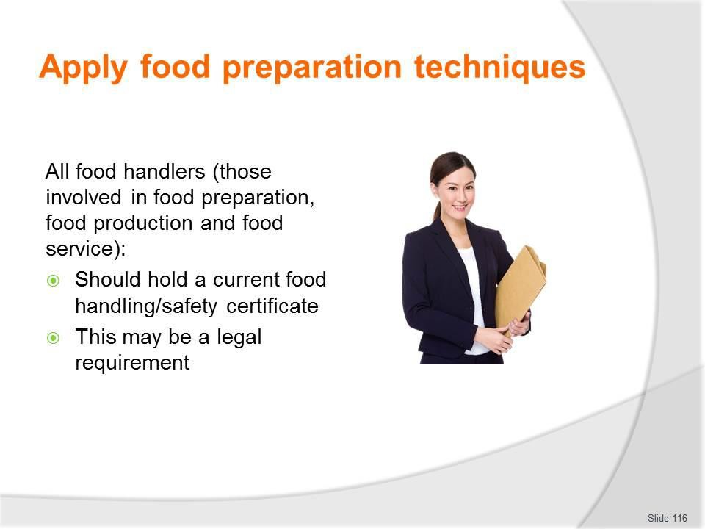
Slide
Slide No
Trainer Notes
116.
Trainer emphasises:
- All catering crew should hold food handling/safety certificate
- This may be a legal requirement.

Slide
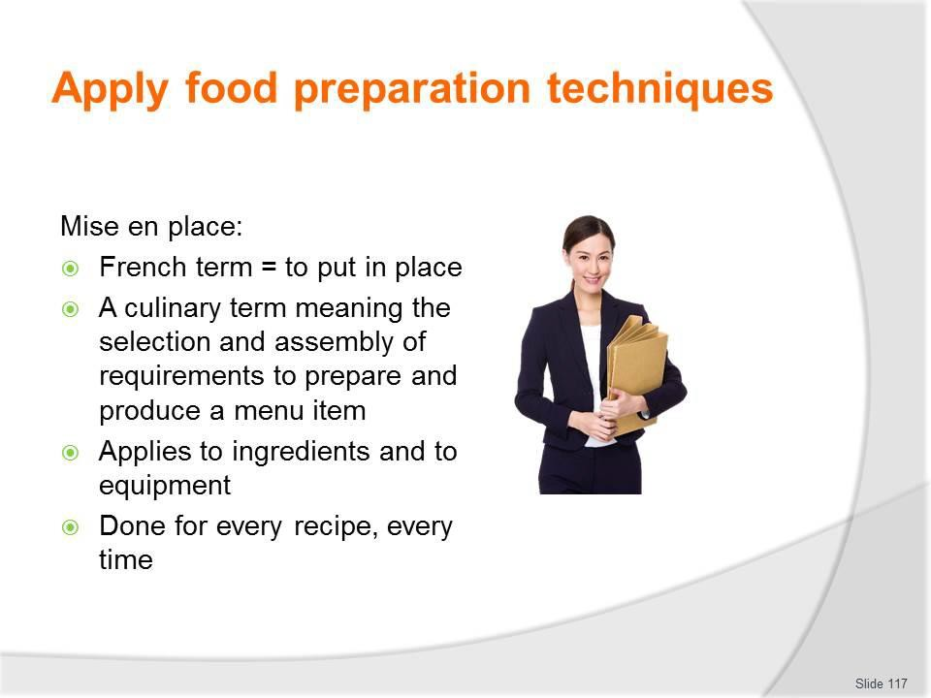
Slide No | Trainer Notes
117. | Trainer discusses mise en place explaining :  - Selecting and assembling the equipment and utensils needed is part of the process known in catering/the kitchen as ‘mise en place’  - This is a French term meaning ‘to put in place’  - Mise en place applies to both ingredients and equipment needed for a dish and overall food preparation  - Mise en place is something to be done for every recipe, every time an item is produced.

Slide
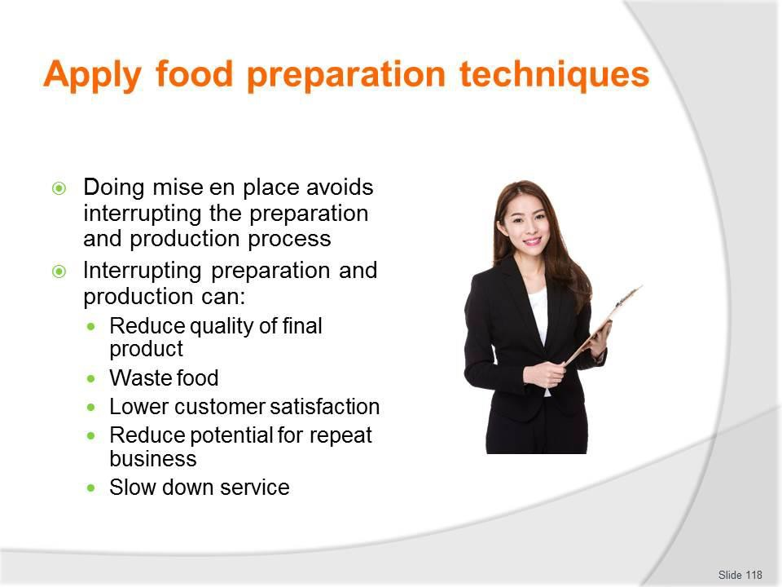
Slide No | Trainer Notes
118. | Trainer identifies reasons to do mise en place:  - To avoid interruption to the production process – which raises the risk of:  - Producing a poor quality end product – because the required cooking/preparation procedure has not been followed  - Wasting food – because the poor quality product has to be discarded  - Lowering customer satisfaction levels – if they are served poor quality food  - Reducing the potential for repeat business – if tour group members are not happy with the food they have been served  - Slowing down the service of food to the group – and/or the production time of items.

Slide
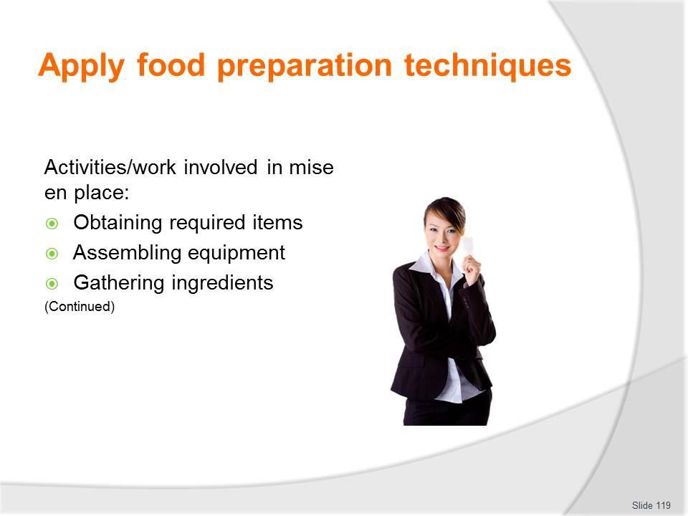
Slide No | Trainer Notes
119. | Trainer identifies work involved in mise en place can involve:  - Obtaining the necessary items ready for use – that is, getting items from trucks/vehicles or the portable ‘store area’ and placing them in position ready to use  - Putting items together so they are ready to use – as many items need to be dismantled for cleaning, storage and/or transport so they need to be re-assembled for use  - Gathering together all the ingredients for the dish – so they are weighed, measured, checked and ready to use/prepare.

Slide
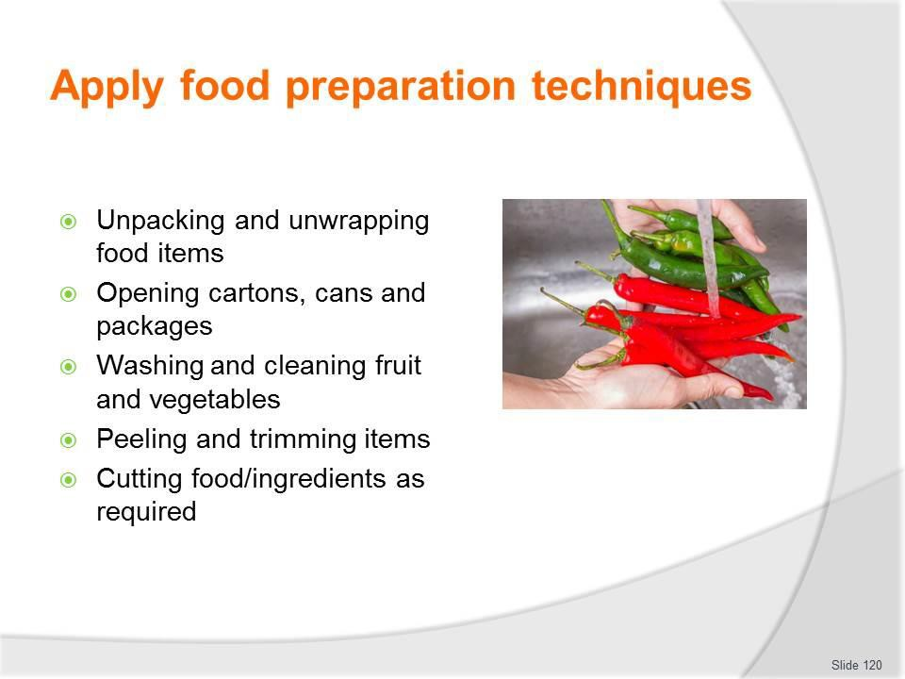
Slide No | Trainer Notes
120. | Trainer continues identifying mise en place activities:  - Unpacking and unwrapping food items – so they are ready to use  - Opening cartons, cans and packages – and other containers holding food needed for the menu item/s being prepared  - Washing and cleaning fruit and vegetables – see later slides  - Peeling and trimming items – see later slides  - Cutting food/ingredients as required – see later slides.

Slide
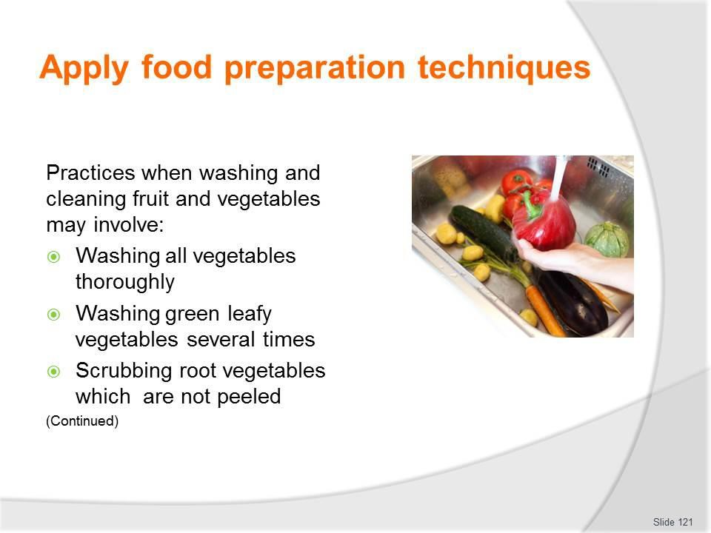
Slide No | Trainer Notes
121. | Trainer states standard practices when washing and cleaning fruit and vegetables may involve:  - Washing all vegetables thoroughly in cold water  - Washing green leafy vegetables (for example, spinach, lettuce, silverbeet and kale) several times to make sure any insects and dirt clinging to the leaves are removed  - Scrubbing root vegetables which are not peeled, such as potatoes used for baking, with a stiff brush under running cold water.  Classroom Activity – Demonstration and Practice  Trainer demonstrates practices identified on the slide and provides opportunity for students to do the same.

Slide
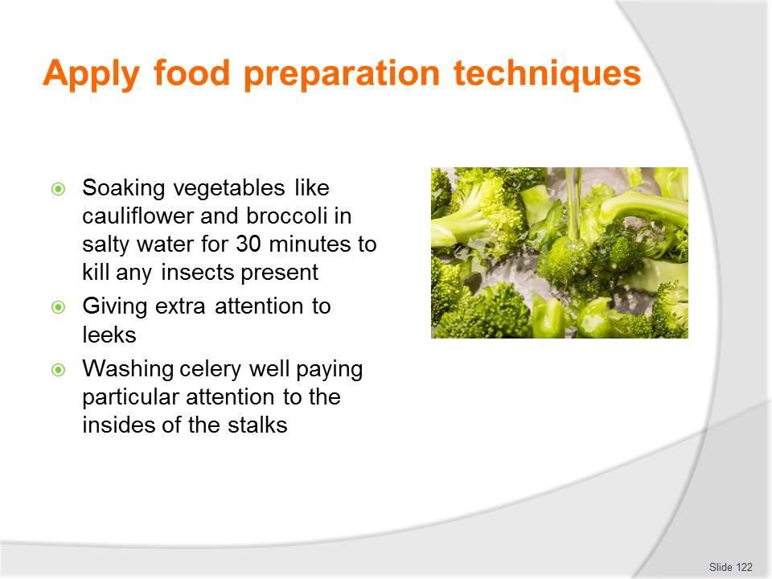
Slide No | Trainer Notes
122. | Trainer continues describing SOPs when washing and cleaning fruit and vegetables:  - Soaking vegetables like cauliflower and broccoli in salty water for 30 minutes to kill any insects present  - Giving extra attention to leeks which need special washing to remove dirt between the layers of the vegetable– after cutting leeks lengthwise, hold them under cold running water, separating the layers to remove the dirt  - Washing celery well – pay particular attention to the insides of the stalks which often need vigorous washing to remove clinging dirt.

Slide
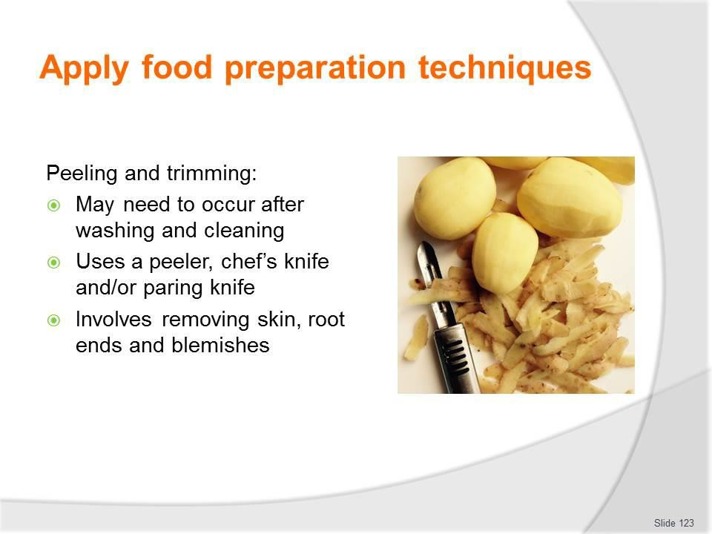
Slide No | Trainer Notes
123. | Trainer discusses peeling and trimming stating:  - After the vegetables have been washed and cleaned thoroughly, many need to be peeled and trimmed  - A peeler, a chef’s knife or a paring knife may be used to remove skin, root ends and blemishes.

Slide
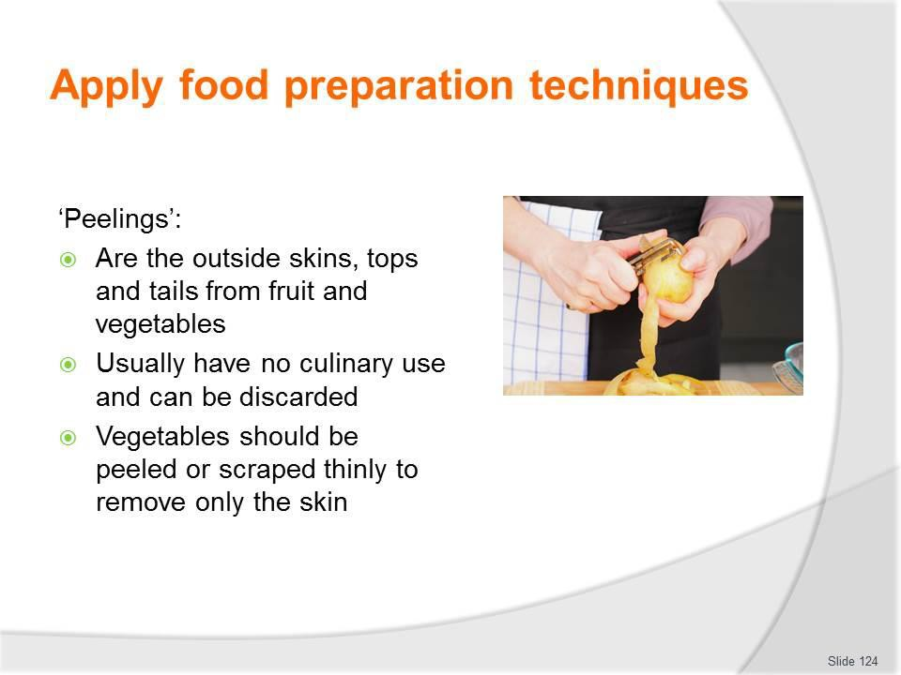
Slide No | Trainer Notes
124. | Trainer discusses peelings stating:  - These are the outside skins, tops and tails from fruit and vegetables  - They usually have no culinary use and can be discarded  - Vegetables should be peeled or scraped thinly to remove only the skin, as most nutrients are just below the skin/surface  - Thin peeling also, naturally, minimises wastage.

Slide
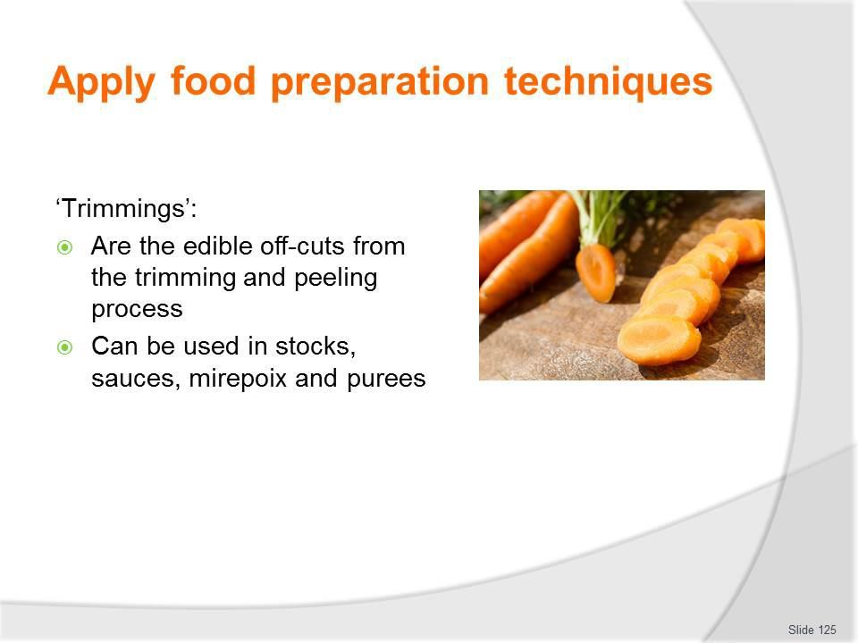
Slide No | Trainer Notes
125. | Trainer discusses trimmings stating:  - Trimmings are the edible good quality off-cuts from fruit and vegetable preparation  - They should be saved for use in stocks, sauces, mirepoix and puree  - The flesh of some vegetables turns brown when exposed to air  - To prevent this happening the following procedures are recommended:  - Cover peeled potatoes in cold water until they are ready for use  - Jerusalem artichokes and eggplants can be placed in a mixture of cold water and acid, usually lemon juice or vinegar. For small quantities, the acid may be sprinkled directly onto the vegetables  - The peels of some vegetables – such as zucchini and squash – are edible and therefore the vegetables do not need peeling: just wash them thoroughly.

Slide
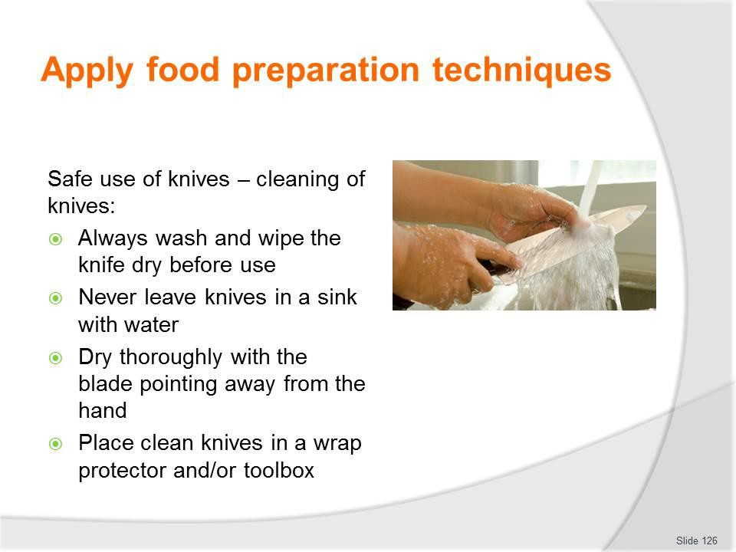
Slide No | Trainer Notes
126. | Trainer provides advice regarding safe use of knives:  Cleaning of knives  - Always wash and wipe the knife dry before use  - Never leave knives in a sink with water  - Dry thoroughly with the blade pointing away from the hand  - Place clean knives in a wrap protector and/or toolbox.  Classroom Activity – Demonstration and Practice  Trainer demonstrates practices identified on the slide and provides opportunity for students to do the same.

Slide
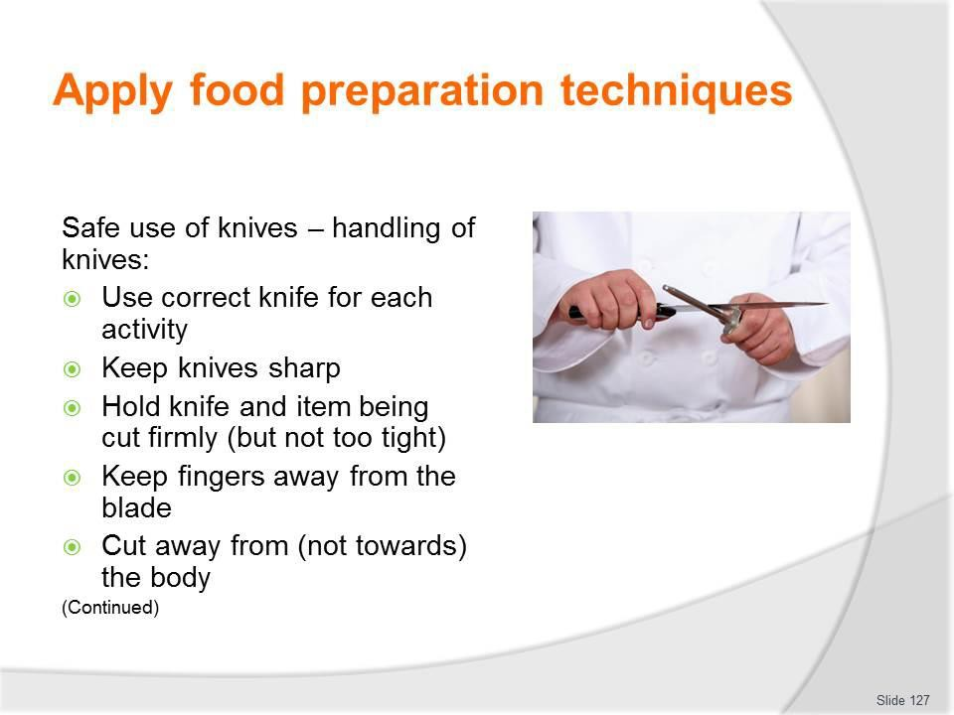
Slide No | Trainer Notes
127. | Trainer continues providing advice regarding safe use of knives:  Handling knives  - Use correct knife for each activity  - Keep knives sharp  - Hold knife and item being cut firmly (but not too tight)  - Keep fingers away from the blade  - Cut away from (not towards) the body.  Classroom Activity – Demonstration and Practice  Trainer demonstrates practices identified on the slide and provides opportunity for students to do the same.

Slide
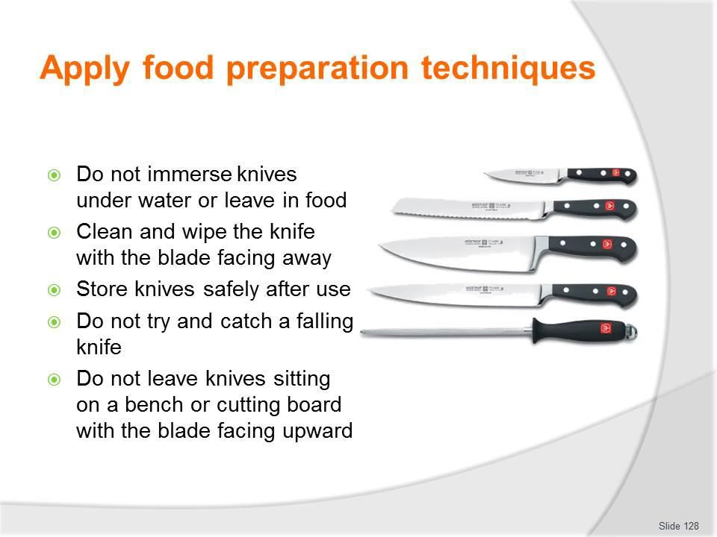
Slide No | Trainer Notes
128. | Trainer continues providing advice regarding safe use of knives:  - Do not immerse knives under water or leave them in food  - Clean and wipe the knife with the blade facing away  - Store knives safely after use  - Do not try and catch a falling knife  - Do not leave knives sitting on a bench or cutting board with the blade facing upward.  Classroom Activity – Demonstration and Practice  Trainer demonstrates practices identified on the slide and provides opportunity for students to do the same.

Slide
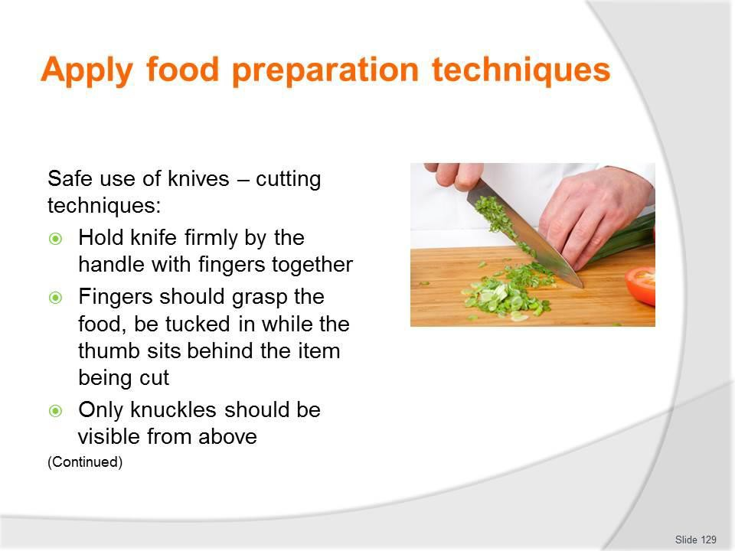
Slide No | Trainer Notes
129. | Trainer continues providing advice regarding safe use of knives:  Cutting techniques  - Hold knife firmly by the handle with fingers together  - Fingers should grasp the food, be tucked in while the thumb sits behind the item being cut  - Only knuckles should be visible from above.  Classroom Activity (1) – Demonstration and Practice  Trainer demonstrates practices identified on the slide and provides opportunity for students to do the same.  Classroom Activity – Internet Research  Trainer supervises internet research and subsequent classroom discussion by visiting: http://www.youtube.com/watch?v=cV0c7qiNjuI (‘Basic knife skills 1 of 2’: 8 mins)  http://www.youtube.com/watch?v=WSTBJ82nUts (‘Basic knife skills 2 of 2’: 7 mins 34 secs)

Slide
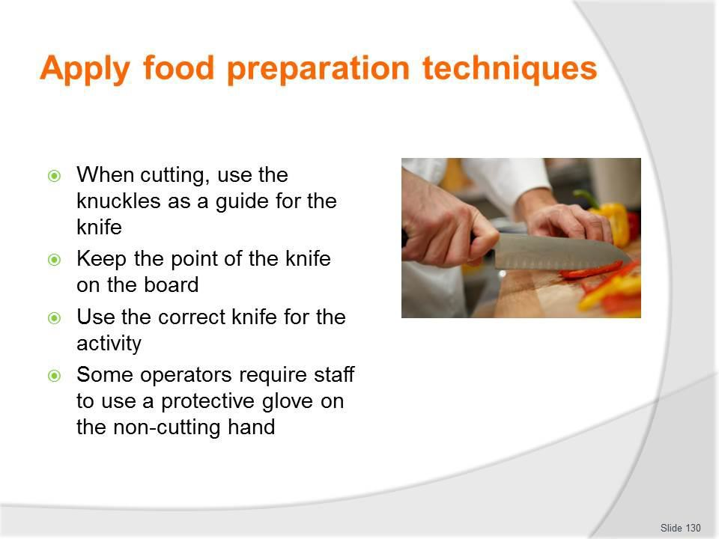
Slide No | Trainer Notes
130. | Trainer continues providing advice regarding safe use of knives:  - When cutting, use the knuckles as a guide for the knife  - Keep the point of the knife on the board  - Use the correct knife for the activity – make the effort to get the right knife, and to change knives between jobs as appropriate: it takes five seconds to change knives but hours to go to the doctor and get stitched up!  - Some operators require staff to use a protective glove on the non-cutting hand.  Classroom Activity – Demonstration and Practice  Trainer demonstrates practices identified on the slide and provides opportunity for students to do the same.

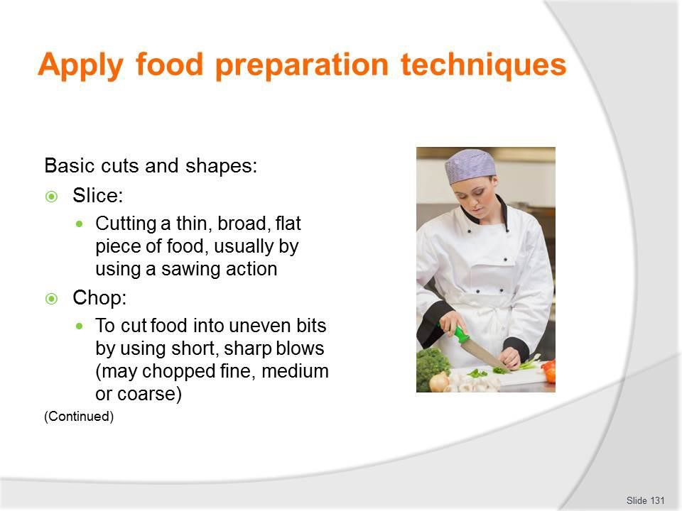
Slide
Slide No
Trainer Notes
131.
Trainer presents basic cuts and shapes as identified on the slide identifying uses as:
- Slice – examples of use:
  - Bread slices
  - Onion rings
- Chop – examples of use:
  - Chopped parsley for salads and duxelle

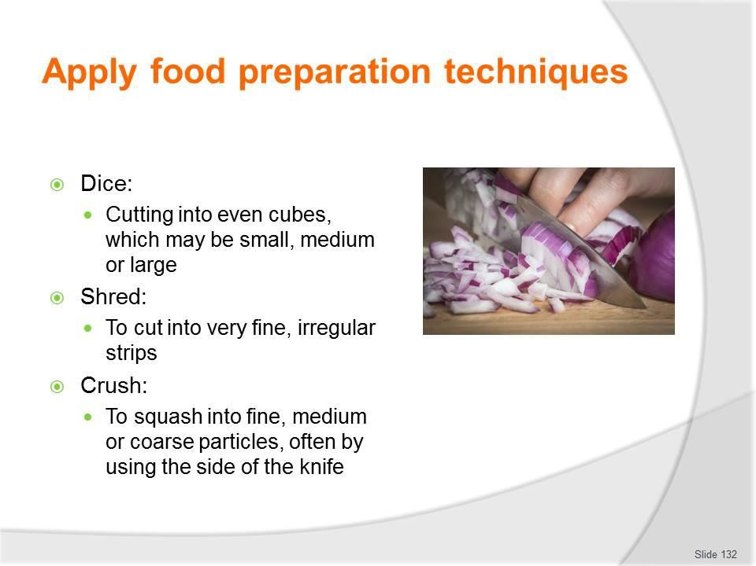Slide

Slide No Trainer Notes

- Trainer continues presenting basic cuts and shapes as identified on the slide identifying uses as:
  - Dice – examples of use:
    - Macedoine
    - Brunoise
  - Shred – examples of use:
    - Lettuce, for use in salads
    - Cabbage, for use in coleslaw
  - Crush – examples of use:
    - Crushed garlic.

Slide
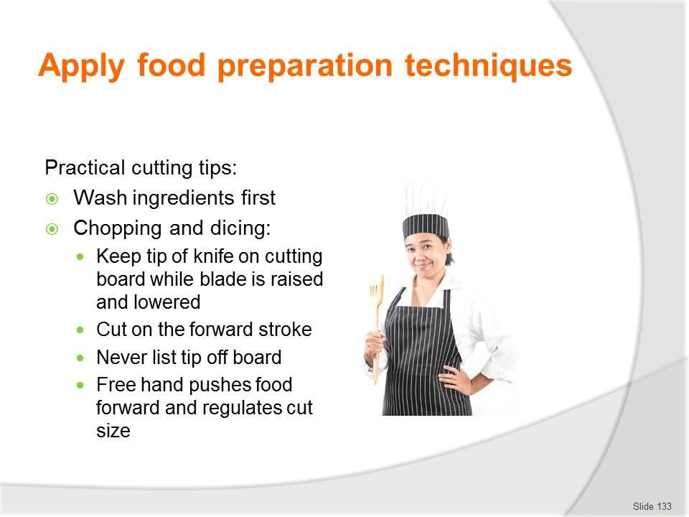
Slide No | Trainer Notes
133. | Trainer gives practical cutting tips:  - Always wash vegetables prior to preparing them.  Chopping and dicing  - For chopping and dicing, the tip of the knife is usually kept on the cutting board while the blade is raised and lowered rapidly with a forward up and down movement  - The cutting is done on the forward stroke  - Never lift the tip of the knife off the cutting board  - The free hand is used to push the food towards the blade and/or regulate the size of the cut.  Classroom Activity – Demonstration and Practice  Trainer demonstrates practices identified on the slide and provides opportunity for students to do the same.

Slide
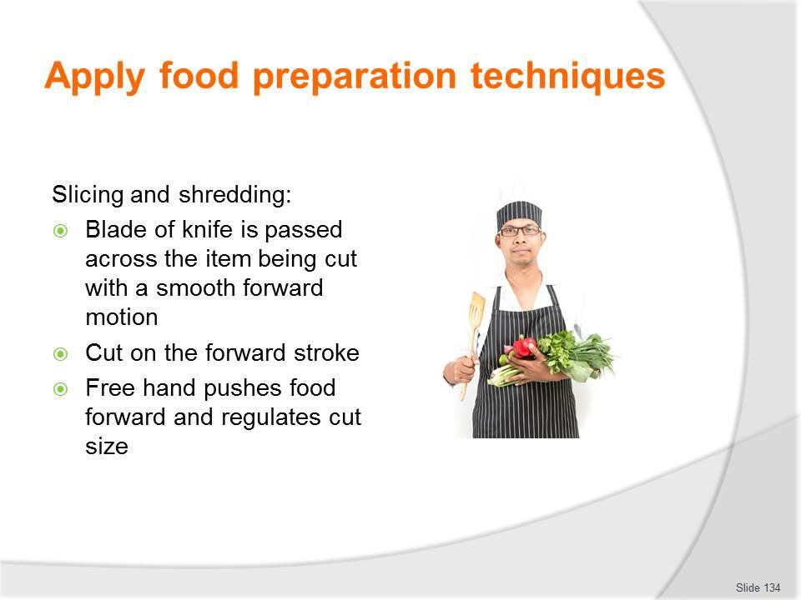
Slide No | Trainer Notes
134. | Trainer continues giving practical cutting tips:  Slicing and shredding  - For slicing and shredding, the blade of the knife is passed across the item being cut with a smooth forward motion  - Again the cutting is done on the forward stroke  - The free hand is used to push the food towards the blade and/or regulate the size of the cut.  Classroom Activity – Demonstration and Practice  Trainer demonstrates practices identified on the slide and provides opportunity for students to do the same.

Slide
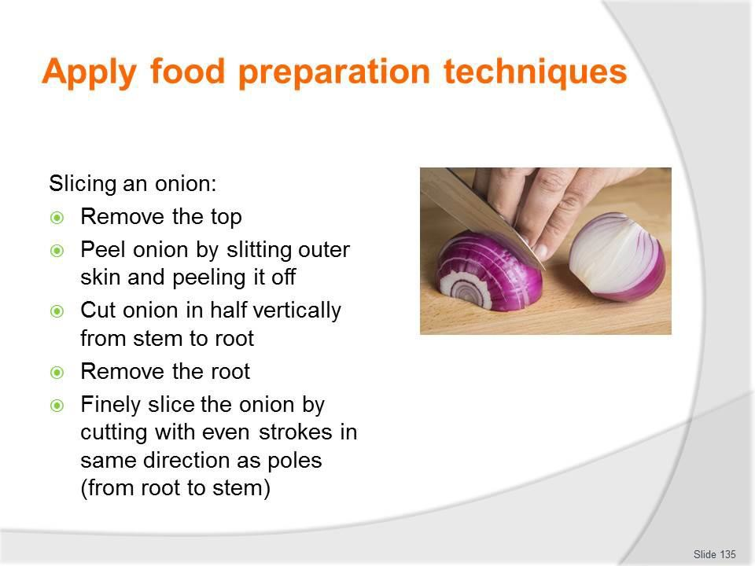
Slide No | Trainer Notes
135. | Trainer explains procedures for slicing an onion:  - Remove the top  - Peel the onion by slitting the outer skin and peeling it off  - Cut the onion in half vertically from the stem to the root  - Remove the root – this permits the slices of onion to fall apart  - Finely slice the onion by cutting with even strokes in the same direction as the poles (from root to stem)  - The uses of sliced onion include making soups, sauces, stews, braises and vegetable dishes.  Classroom Activity – Demonstration and Practice  Trainer demonstrates practices identified on the slide and provides opportunity for students to do the same.

Slide
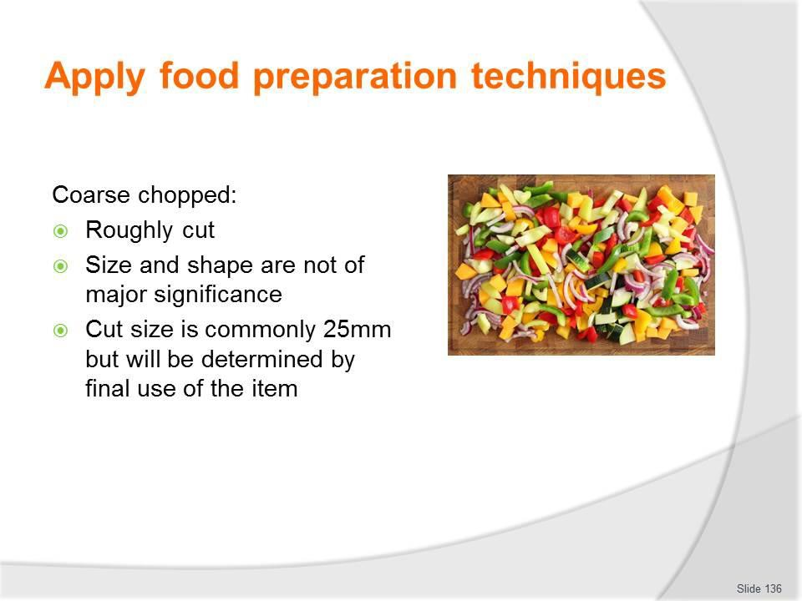
Slide No | Trainer Notes
136. | Trainer discusses coarse chopped ingredients stating:  - Coarse chopped cuts are ‘roughly’ cut vegetables  - That is, the size and shape do not need to be as precise or accurate as all other cuts because the vegetables are (usually) strained out of the product being produced and are not served to customers  - Cut size is commonly approximately 25 mm  - A ‘mirepoix’ is roughly chopped vegetables (carrot, celery and onion: thyme is added) used as basis for sauces and to improve flavour of cooked meats  - The size of the mirepoix (that is, the size of the pieces of vegetables) is determined by what it will be used for  - For example, the mirepoix for a fish stock would be smaller than the mirepoix for a beef stock because fish stock only takes 20 minutes to cook whereas beef stock takes 6 – 8 hours.  Classroom Activity – Demonstration and Practice  Trainer demonstrates practices identified on the slide and provides opportunity for students to do the same.

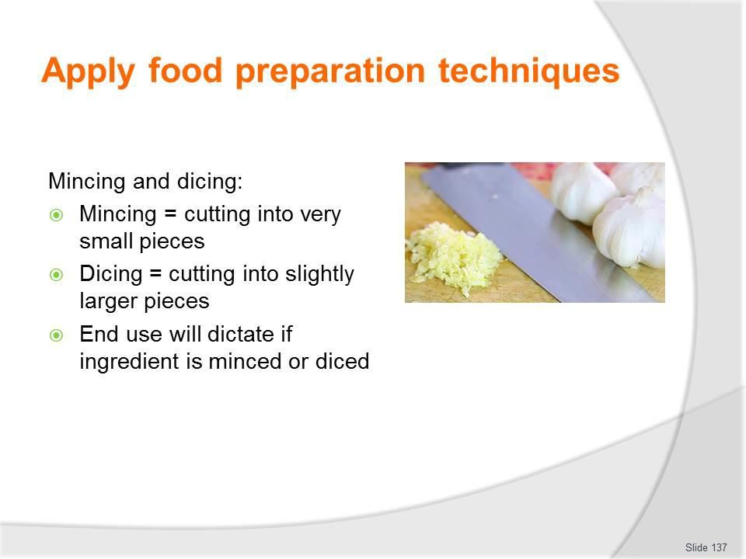
Slide
Slide No
Trainer Notes
137.
Trainer discusses
Mincing and dicing
- Mincing means cutting into very small pieces
- Dicing means cutting into slightly larger pieces (Macedoine and Brunoise are a dice)
- The end use for the item will dictate whether it is minced or diced.

Slide
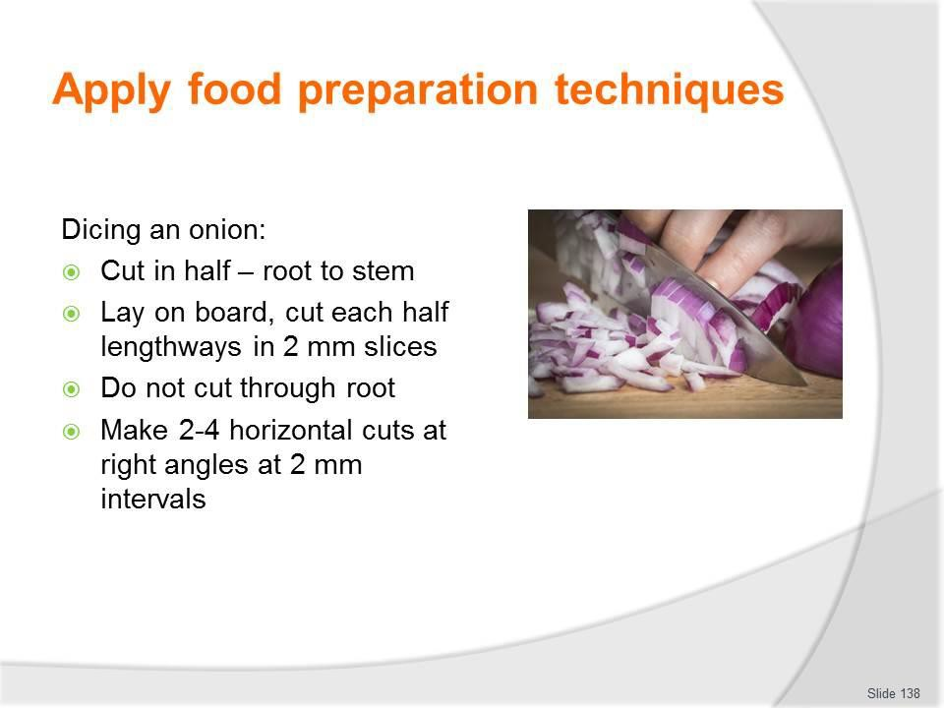
Slide No | Trainer Notes
138. | Trainer describes dicing an onion:  Dicing an onion  Dicing an onion presents a special problem for cutting because it is layered rather than a solid piece. Practice dicing an onion as follows:  - Cut a peeled onion in halves from root to stem – do not remove the root  - Lay the cut surface on the cutting board and with the tip of the chef’s knife, cut each half lengthways at 2 mm intervals: do not cut through the root of the onion as this holds the slices together  - Next, make 2 – 4 horizontal cuts (depending on the size of the onion) at right angles to the other cuts. Now, the onion has been cut in two directions and the root end is still holding the pieces together  - Slice down through the onion at 2 mm intervals from top to bottom. The onion will fall onto cutting board in small dice.  The piece left over containing the root is used in mirepoix or put into stocks.  Classroom Activity (1) – Demonstration and Practice  Trainer demonstrates practices identified on the slide and provides opportunity for students to do the same.

Classroom Activity (2) – Internet Research
Trainer supervises internet research and subsequent classroom discussion by visiting: http://www.youtube.com/watch?v=dtBssdM2nTU (‘How to Brunoise’: 28 secs)
http://www.youtube.com/watch?v=ML5flgorZYc (‘How to Dice, Julienne, Brunoise and Batonnet’: 2 mins 57 secs).

Slide
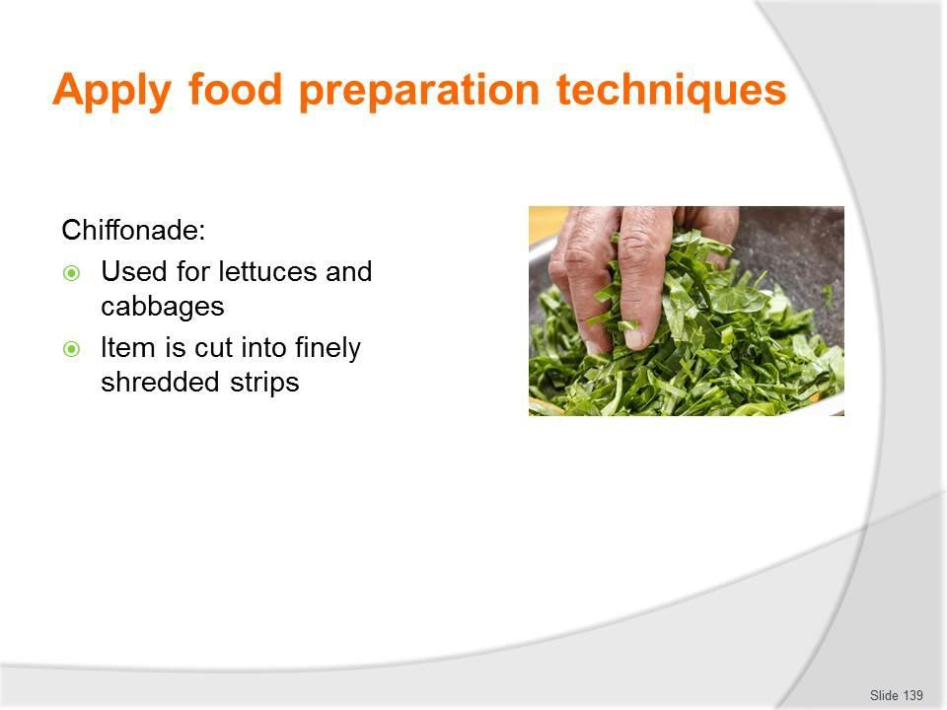
Slide No | Trainer Notes
139. | Trainer discusses various cuts:  Chiffonade  This is a cut where the product (usually lettuce or cabbage) is cut into finely shredded strips.  Classroom Activity (1) – Internet Research  Trainer supervises internet research and subsequent classroom discussion by visiting:  http://www.youtube.com/watch?v=aO-9VmnXHB8 - ‘How to chiffonnade a lettuce’: 28 secs.  Classroom Activity (2) – Demonstration and Practice  Trainer demonstrates practice identified on the slide and provides opportunity for students to do the same.

Slide
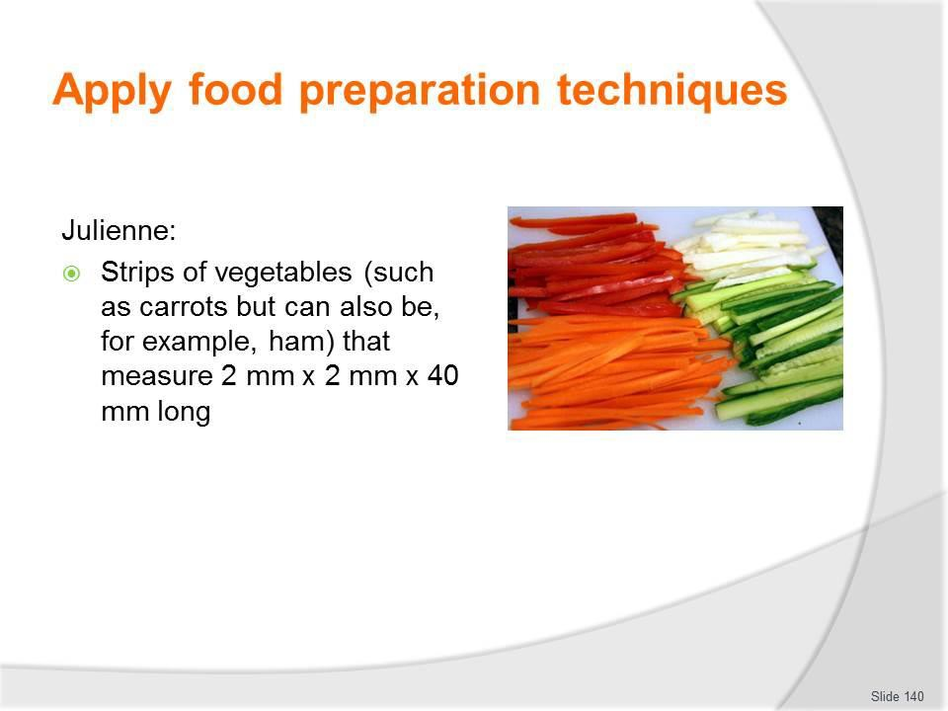
Slide No | Trainer Notes
140. | Trainer discusses various cuts:  Julienne  These are strips of vegetables (such as carrots but can also be, for example, ham) that measure 2 mm x 2 mm x 40 mm long.  The procedure is:  - Top, tail and peel a carrot  - Cut the carrot into lengths of approximately 40 mm  - Square off the sides of each length  - Slice the carrot into thin strips 3 mm thick – take the thin strips, lay them flat on the cutting board, and using a chef’s knife, cut lengthwise to obtain smaller, thin matchstick strips.  Classroom Activity (1) – Demonstration and Practice  Trainer demonstrates practice identified on the slide and provides opportunity for students to do the same.  Classroom Activity (2) – Internet Research  Trainer supervises internet research and subsequent classroom discussion by visiting:  http://www.youtube.com/watch?v=ML5flgorZYc (‘How to Dice, Julienne, Brunoise and Batonnet’: 2 mins 57 secs).

Slide
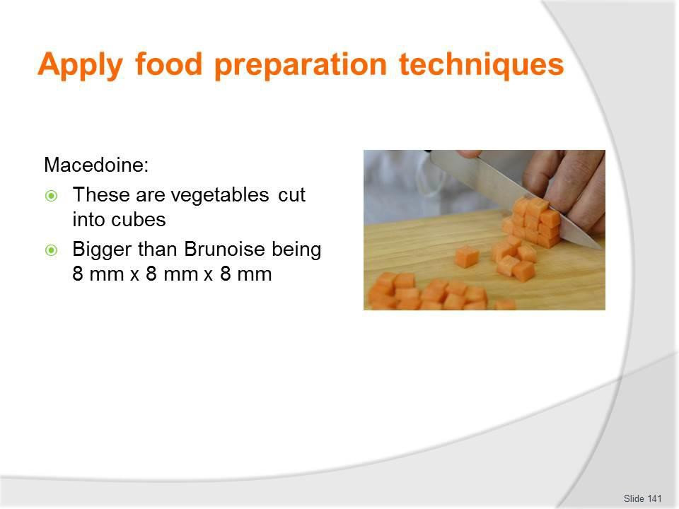
Slide No | Trainer Notes
141. | Trainer discusses various cuts:  Macedoine  These are vegetables cut into cubes.  They are bigger than Brunoise being 8 mm x 8 mm x 8 mm. The procedure for preparing a macedoine of apple is:  - Peel and core the apple and place it into acidulated water (water with added lemon juice) until ready for use – placing the apple into acidulated water prevents it from oxidising in the air and turning brown  - Stand the apple upright and square it off, then cut the apple into 8 mm thick slices – place the slices onto the cutting board and cut into 8 mm strips, then cut the strips into 8 mm cubes.  Classroom Activity – Demonstration and Practice  Trainer demonstrates practice identified on the slide and provides opportunity for students to do the same.

Slide
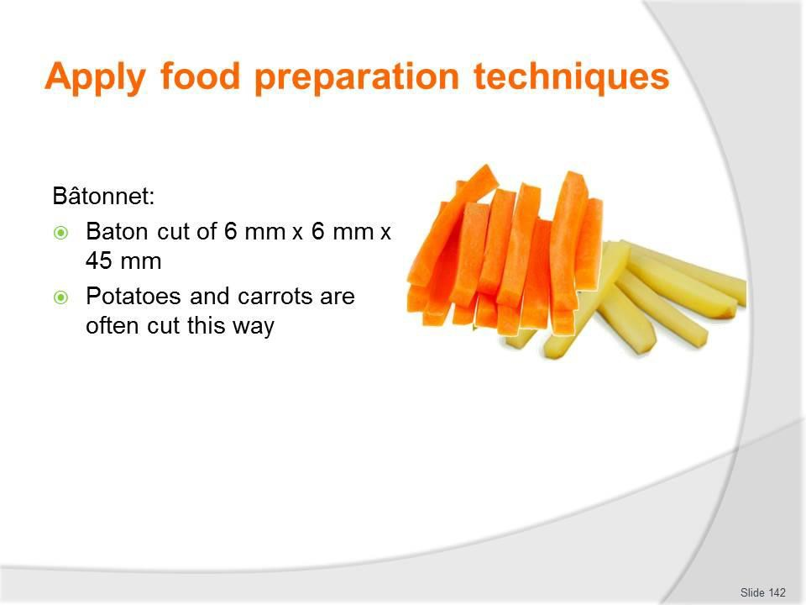
Slide No | Trainer Notes
142. | Trainer discusses various cuts:  Bâtonnet  - This is a baton cut of 6 mm x 6 mm x 45 mm.  - Potatoes and carrots are often cut this way.  Classroom Activity – Demonstration and Practice  Trainer demonstrates practice identified on the slide and provides opportunity for students to do the same.

Slide
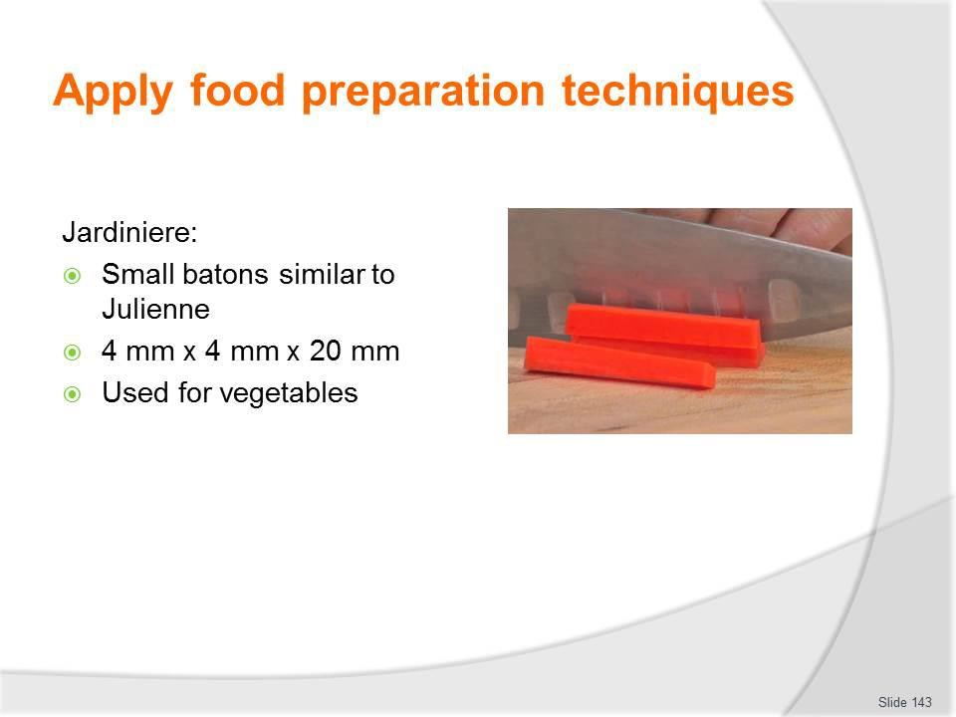
Slide No | Trainer Notes
143. | Trainer discusses various cuts:  Jardiniere  - These are small batons of vegetables, similar to Julienne but bigger being 4 mm x 4 mm x 20 mm.  Classroom Activity – Demonstration and Practice  Trainer demonstrates practice identified on the slide and provides opportunity for students to do the same.

Slide
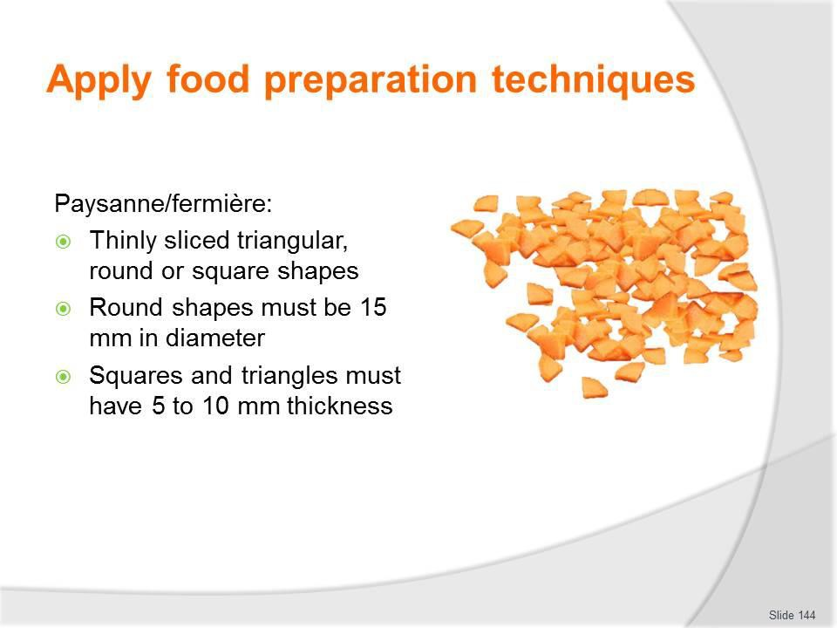
Slide No | Trainer Notes
144. | Trainer discusses various cuts:  Paysanne/fermière  - These are thinly sliced triangular, round or square shapes.  - The round shapes must be 15 mm in diameter, and the squares and triangles must have 5 to 10 mm thickness.  Classroom Activity – Demonstration and Practice  Trainer demonstrates practice identified on the slide and provides opportunity for students to do the same.

Slide
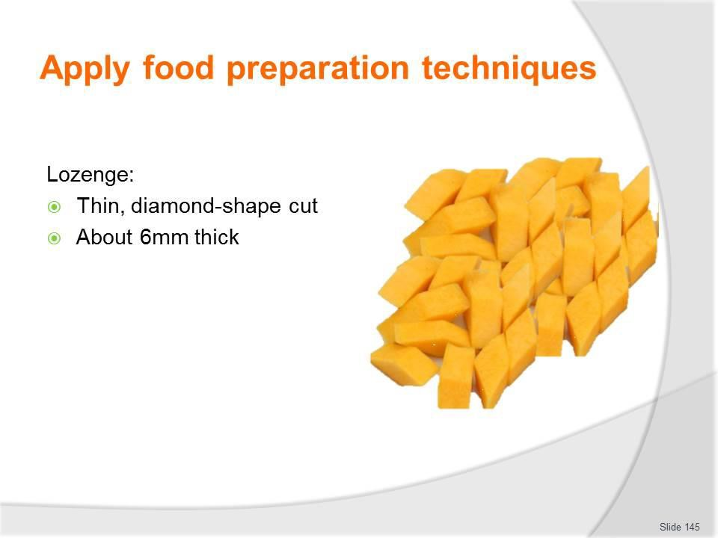
Slide No | Trainer Notes
145. | Trainer discusses various cuts:  Lozenge  - A thin diamond-shape cut about 6 mm thick.  Classroom Activity (1) – Internet Research  Trainer supervises internet research and subsequent classroom discussion by visiting:  http://www.youtube.com/watch?v=ur85o7hgvyQ (‘How to cut a lozenge from a carrot’: 3 mins 20 secs).  Classroom Activity (2) – Demonstration and Practice  Trainer demonstrates practice identified on the slide and provides opportunity for students to do the same.

Slide
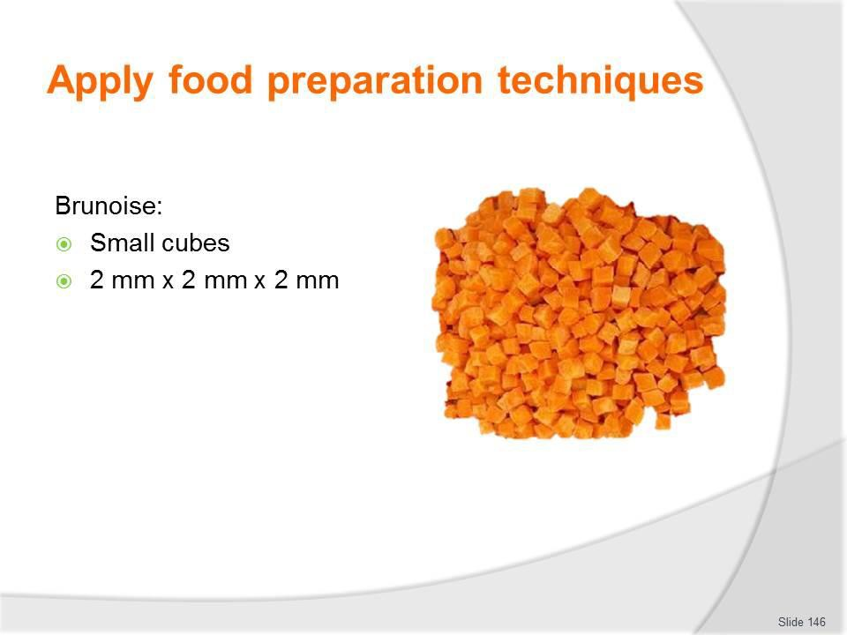
Slide No | Trainer Notes
146. | Trainer discusses various cuts:  Brunoise  These are small cubes measuring 2 mm x 2 mm x 2 mm. The procedure is:  - Cut into julienne – the first step of cutting into brunoise is to cut into julienne  - Stack the julienne strips into piles and then cut through the pile of julienne strips at 3 mm spaces to produce the brunoise cubes – using this technique is much quicker than cutting one strip at a time.  Classroom Activity (1) – Demonstration and Practice  Trainer demonstrates practice identified on the slide and provides opportunity for students to do the same.  Classroom Activity (2) – Internet Research  Trainer supervises internet research and subsequent classroom discussion by visiting: http://www.youtube.com/watch?v=dtBssdM2nTU (‘How to Brunoise’: 28 secs)

Slide
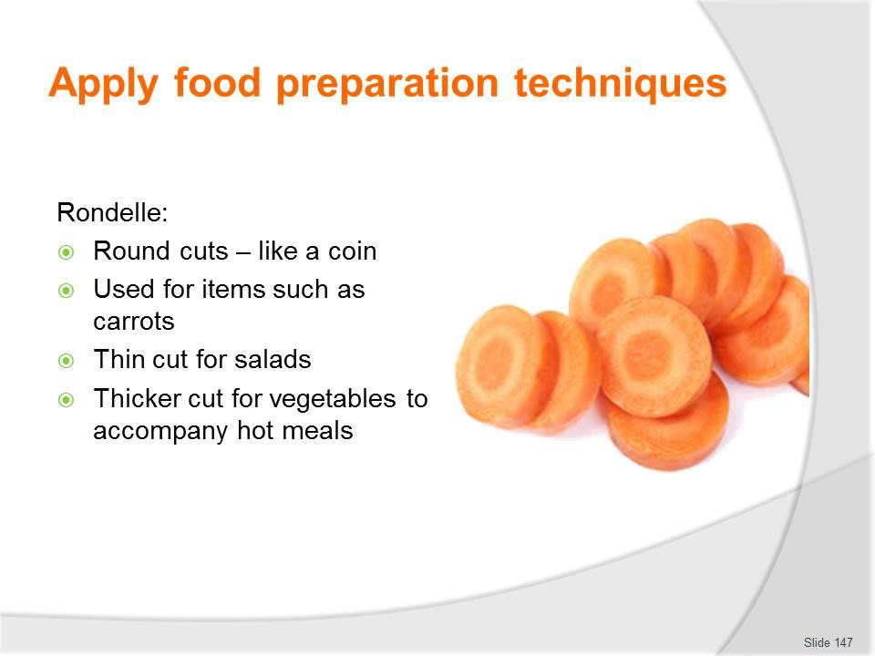
Slide No | Trainer Notes
147. | Trainer discusses various cuts:  Rondelle  - These are round cuts (like a coin) of, for example, a carrot  - The rounds can be of different thicknesses for different uses – thinner cuts for salads, thicker cuts for use as a vegetable to accompany a meal.  Classroom Activity (1) – Demonstration and Practice  Trainer demonstrates practice identified on the slide and provides opportunity for students to do the same.  Classroom Activity (2) – Internet Research  Trainer supervises internet research and subsequent classroom discussion by visiting:  http://www.youtube.com/watch?v=wvy_sUJKJ1U (‘Classic Carrot Cuts - Rondelle, Demilune, Paysanne’: I min 49 secs)  http://www.youtube.com/watch?v=FpSEs_hEBG4 (‘Chef Kyle - Carrot/rondelle cut’: 2 mins 45 secs)

Slide
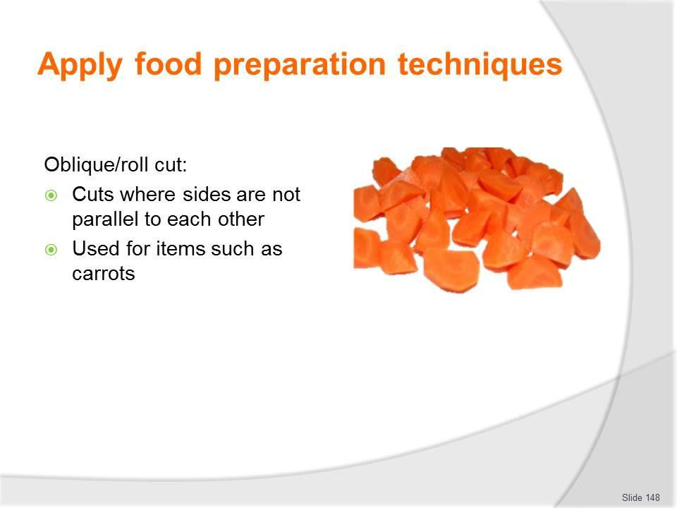
Slide No | Trainer Notes
148. | Trainer discusses various cuts:  Oblique/roll cut  - A cut where the sides of the carrot are not parallel to each other  - This cut requires rolling the carrot between cuts to obtain this unique shape and unusual shape.  Classroom Activity (1) – Demonstration and Practice  Trainer demonstrates practice identified on the slide and provides opportunity for students to do the same.  Classroom Activity (2) – Internet Research  Trainer supervises internet research and subsequent classroom discussion by visiting: See http://www.youtube.com/watch?v=jShrXQInpek (‘How to oblique cut on vegetable’).

Slide
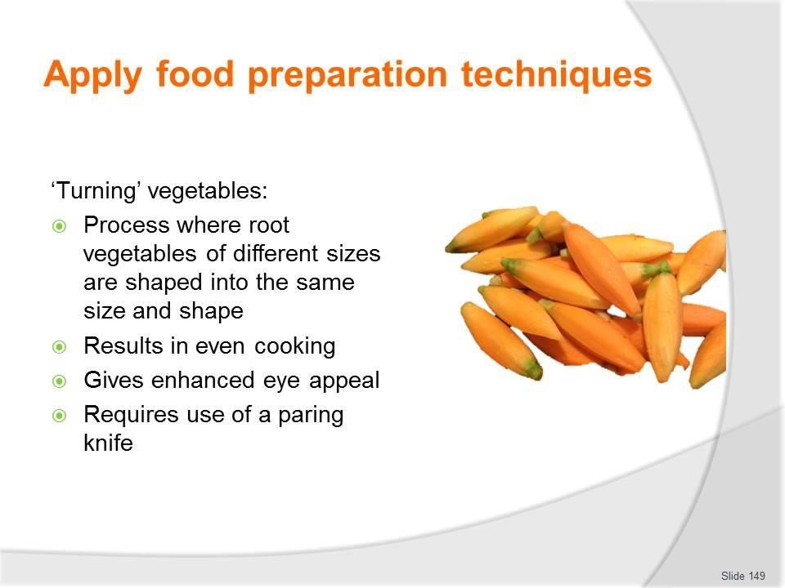
Slide No | Trainer Notes
149. | Trainer discusses turned vegetables stating:  - Turning is the process where root vegetables (commonly potatoes and carrots are turned) of different sizes are shaped (or ‘turned’) into the same size and shape  - This results in even cooking and enhanced presentation/eye appeal  - The best knife to use for turning vegetables is a turning knife but a standard paring knife is also suitable  - The vegetable to be turned is first cut to the required size and then held in one hand: the knife is used in the other  - There is a knack to turning vegetables into regular-shaped barrels – one way to learn the even wrist action required for turning is to practice on a hard boiled egg (shell on): hold the egg lengthways between finger and thumb and scrape the blade lightly down the shell until comfortable with the even flow of the knife  - An exception is turned mushrooms. A series of grooves are scored in a mushroom cap, at an angle of approximately 25°, removing the skin at the same time.  Classroom Activity – Demonstration and Practice  Trainer demonstrates how to turn a potato and carrot and provides opportunity for students to do the same.

Slide
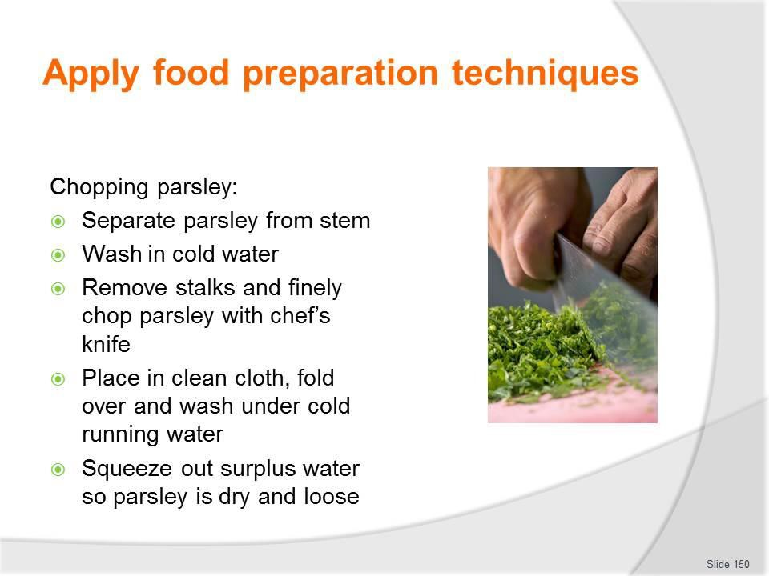
Slide No | Trainer Notes
150. | Trainer discusses  Chopping parsley  The following procedure is recommended:  - Separate parsley from stem  - Wash the parsley in a bowl of cold water  - Remove the stalks and finely chop the parsley with a chef’s knife  - Place in a clean cloth, fold over and wash under cold running water and squeeze out the surplus water so the parsley is dry and loose.  Classroom Activity – Demonstration and Practice  Trainer demonstrates practice identified on the slide and provides opportunity for students to do the same.

Slide
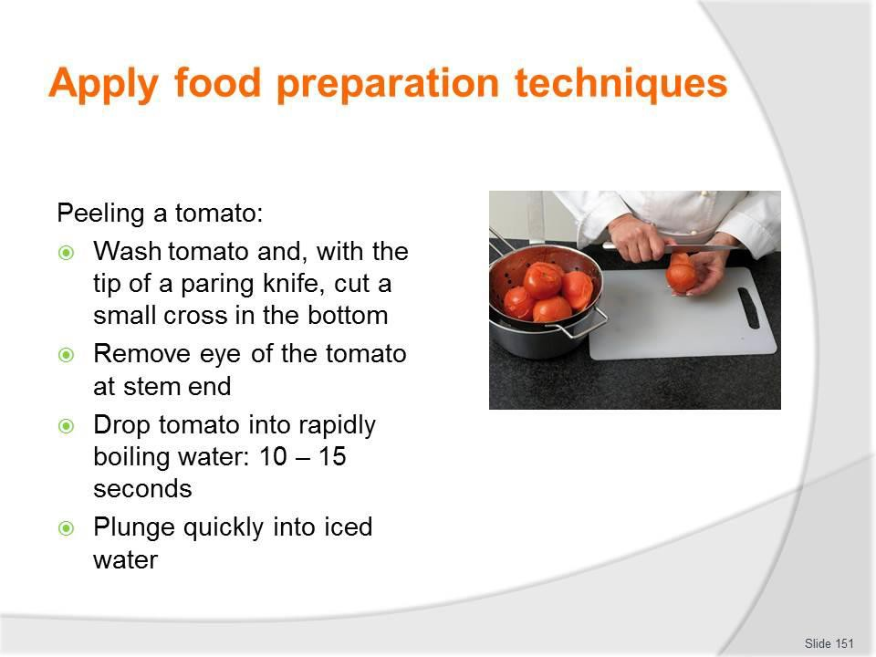
Slide No | Trainer Notes
151. | Trainer discusses:  Peeling a tomato  The only way to peel a tomato without damaging its flesh is by dropping it into boiling water first.  The following procedure is recommended:  - Wash the tomato and, with the tip of a paring knife, cut a small cross in the bottom  - Remove the eye of the tomato, that is, the stem end  - Drop the tomato into rapidly boiling water for 10 – 15 seconds  - Plunge it quickly into iced water – the skin will now be split and easy to remove.  If some of the flesh comes away with the skin, it means the tomato has been left in the boiling water for too long.  The uses of diced onion include compound butters, sauces, duxelles and cooked tomato concasses.  Classroom Activity – Demonstration and Practice  Trainer demonstrates practice identified on the slide and provides opportunity for students to do the same.

Slide
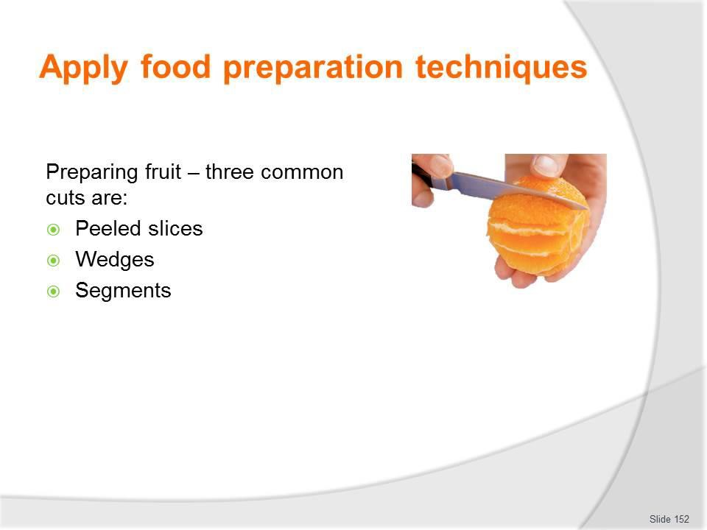
Slide No | Trainer Notes
152. | Trainer discusses:  Preparing citrus fruit  Lemons, oranges and grapefruits are frequently used for garnishing and can be cut into a variety of shapes.  The three common cuts are slices, wedges and segments.  Peeled slices  - Remove both ends of the fruit to just expose the flesh  - Stand the fruit on a cutting board and with a sharp knife and using a slightly curved action, slice off the skin and the pith without cutting too much into the flesh. After the first slice, follow the line of the exposed flesh  - Turn the fruit on its side and cut slices 3 mm thick and remove any pips.  Wedges  - Remove both ends of the fruit without cutting into the flesh  - Stand fruit on a cutting board and cut in half. Then cut each half into four to six wedges, depending on size of the fruit  - Remove any pips and cut off the strip of pith from the centre of each wedge.  Segments

- Cut off the ends of the fruit squarely so as to just expose the flesh
- Stand the fruit on a cutting board and with a sharp knife and using a slightly curved action, slice downwards following the shape of the fruit to remove all the peel and pith and as little of the flesh as possible
- Hold the fruit in one hand and, working over a basin, remove each segment by cutting along each side of it close to the membrane
- Squeeze the juice from the core into the bowl.
Classroom Activity – Demonstration and Practice
Trainer demonstrates practices identified on the slide and provides opportunity for students to do the same.

Slide
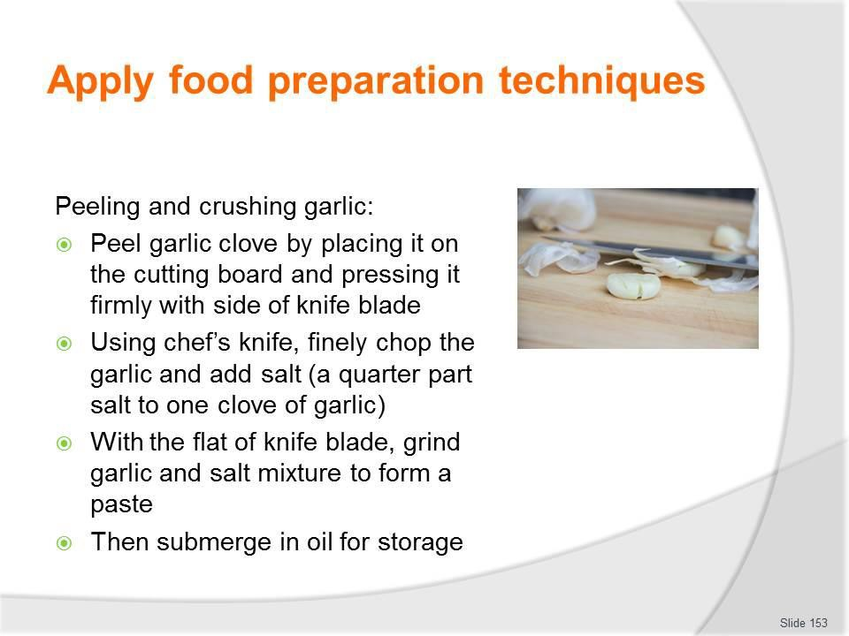
Slide No | Trainer Notes
153. | Trainer discusses:  Peeling and crushing garlic  Garlic has a very strong aroma which can taint other food, so crushing garlic should be one of the last tasks in mise en place preparation.  - Peel the garlic clove by placing it on the cutting board and pressing it firmly with the side of the knife blade  - The peel is now broken and the clove can be easily removed  - Using a chef’s knife, finely chop the garlic and then add salt in the ratio of a quarter part salt to one clove of garlic  - With the flat of the knife blade, grind the garlic and salt mixture to form a paste  - The garlic is then submerged in oil for storage.  After crushing garlic, always wash the cutting board in hot, soapy water to remove all traces of the garlic aroma.  Classroom Activity – Demonstration and Practice  Trainer demonstrates practice identified on the slide and provides opportunity for students to do the same.

Slide
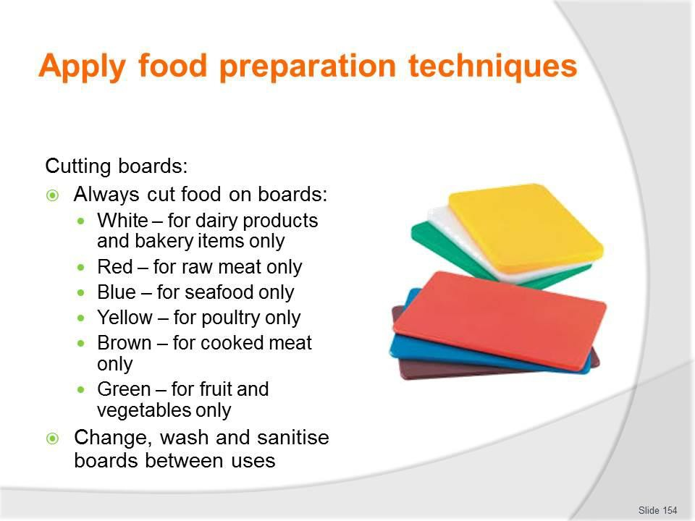
Slide No | Trainer Notes
154. | Trainer discusses use of chopping boards:  - Cut food on the appropriate chopping board  - The following gives an indication of the common uses and colours:  - White – for dairy products and bakery items only  - Red – for raw meat only  - Blue – for seafood only  - Yellow – for poultry only  - Brown – for cooked meat only  - Green – for fruit and vegetables only  - Always change, wash and sanitise boards between uses.

Slide
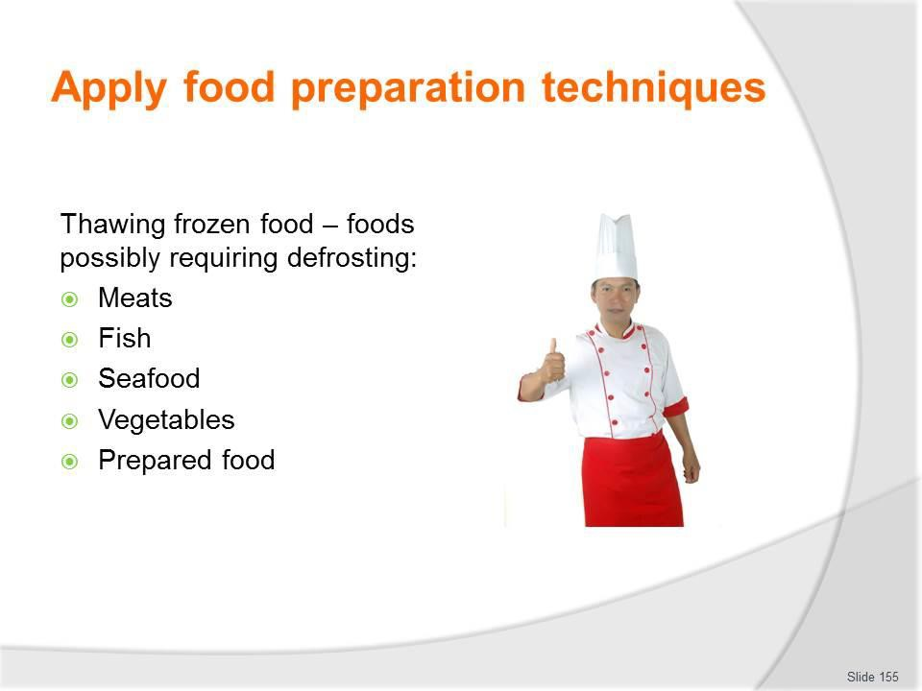
Slide No | Trainer Notes
155. | Trainer discusses thawing of frozen food: Products which may need to be thawed Foodstuffs which require defrosting include:  - Meats – all types and all cuts  - Fish – all types; whole fish and all cuts  - Seafood – such as prawns and scallops  - Vegetables  - Prepared food – such as:  - Bought-in, pre-prepared food – such as breaded prawns  - Items prepared in-house and frozen for later use.

Slide
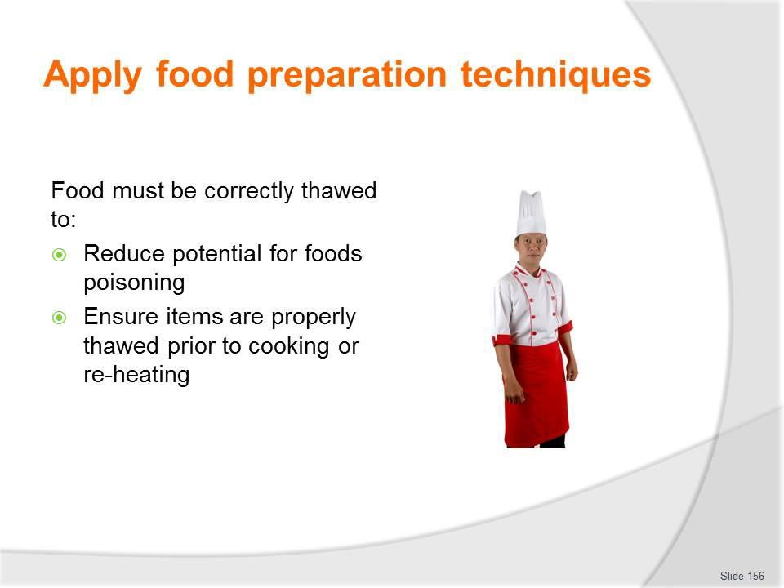
Slide No | Trainer Notes
156. | Trainer continues discussing thawing of frozen food: Importance of thawing food products correctly Foods must be thawed correctly to:  - Reduce the potential for food poisoning – if improper defrosting techniques are used the thawing process may take too long raising the possibility of bacteria multiplying to unacceptable/dangerous levels  - Ensure the item is properly thawed before cooking or reheating – if items are not properly defrosted then the cooking process:  - May not allow the food to be heated to the required temperature to ensure food safety  - May not properly cook the item – meaning an unsatisfactory product (uncooked, unpalatable) is served to the customer.

Slide
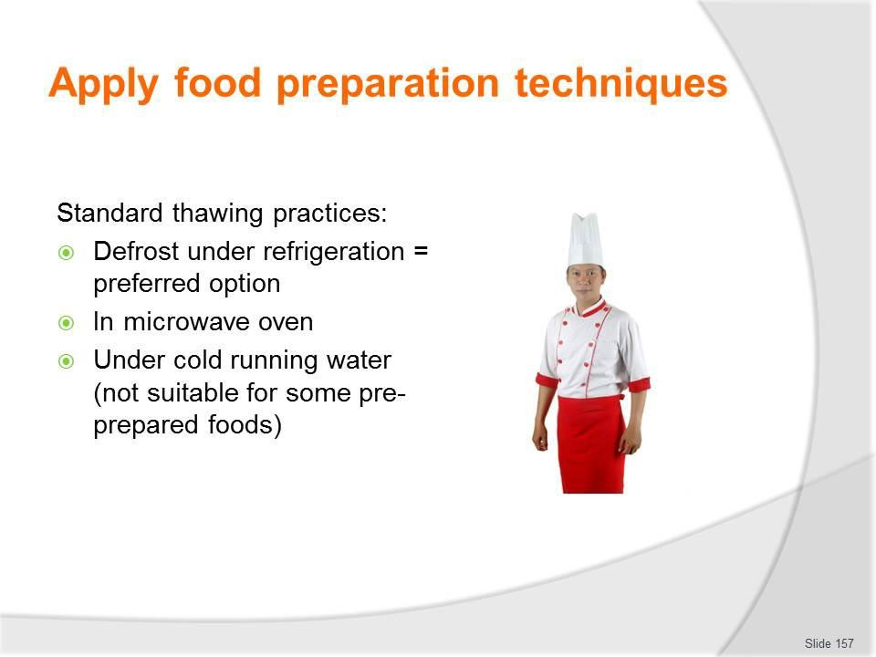
Slide No | Trainer Notes
157. | Trainer continues discussing thawing of frozen food:  Standard thawing practices  There are three ways to defrost frozen products:  - In a refrigerator/cool room – large pieces of meat may take 2 - 3 days to defrost so planning ahead is vital  - Thawing under refrigeration is the preferred method of thawing as the food is always out of Temperature Danger Zone (5⁰C to 60⁰C)  - If pressed for time a microwave can be used to defrost items – moving pieces of food during the procedure to ensure even defrosting and guard against cooking of items  - Run the item under cold water (less than 20°C) – this is not suitable for all frozen items  - For example, this option could not be used to thaw crumbed fish but it would be suitable for thawing fresh fish fillets.

Slide
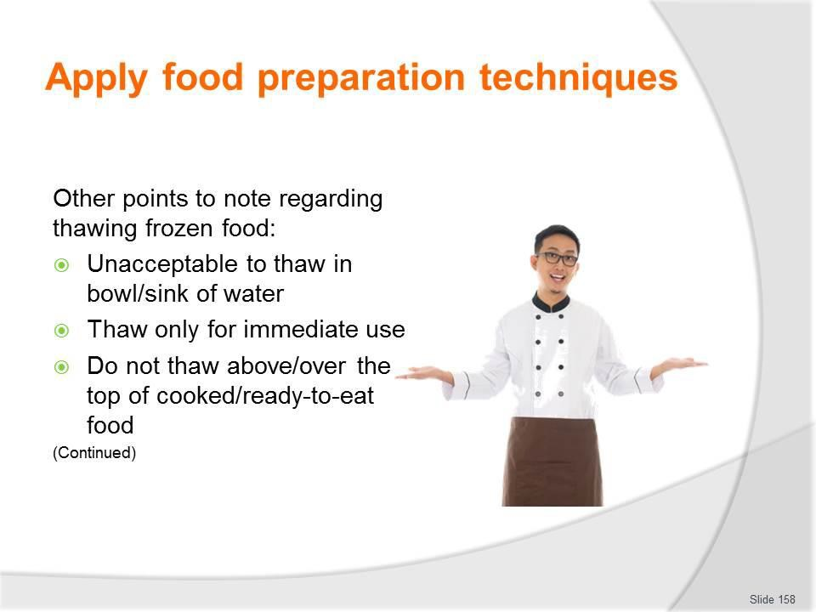
Slide No | Trainer Notes
158. | Trainer continues discussing thawing of frozen food:  Other points to note:  - It is not acceptable to thaw items out by placing them in a bowl or sink of water  - Only defrost the items and amounts required for use/service  - Never thaw products above cooked/ready-to-eat products – to guard against cross contamination.

Slide
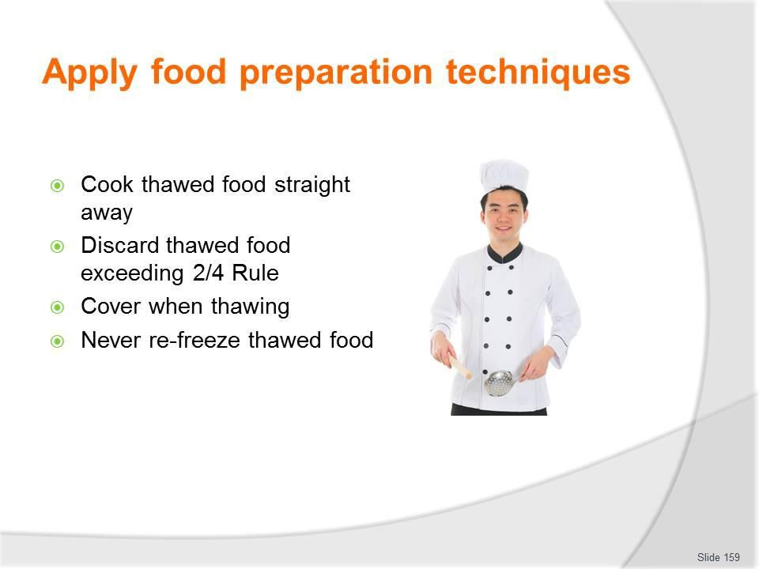
Slide No | Trainer Notes
159. | Trainer continues discussing thawing of frozen food:  - All food should be cooked immediately after thawing  - Discard all food that exceeds the 2/4 rule  - Throw out all food defrosted in an uncovered state – or which has defrosted in damaged packaging  - Discard all food which has been thawed and re-frozen.

Slide
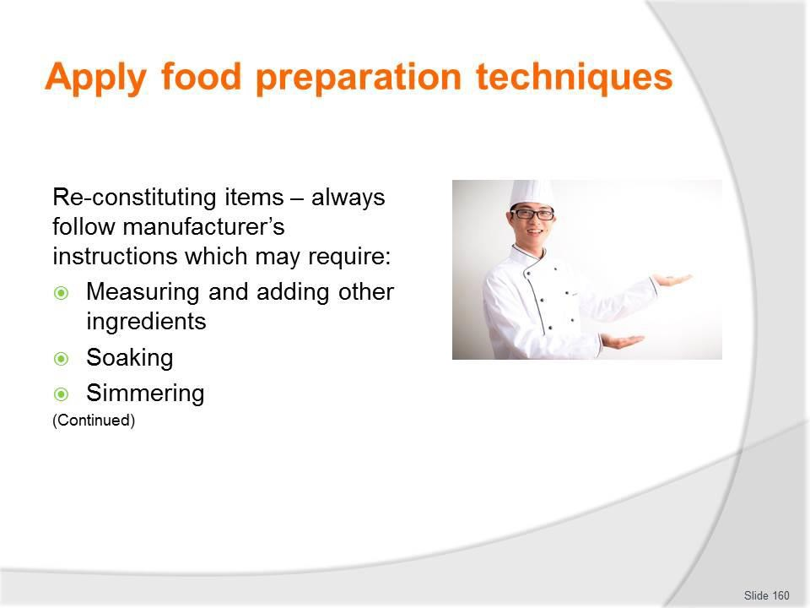
Slide No | Trainer Notes
160. | Trainer discusses re-constituting items highlighting manufacturer’s instructions explaining procedures may include:  - Measuring and adding other ingredients to the product – commonly required ingredients to be used as part of the reconstitution process (depending on the type of the ingredient/product) include:  - Water; Cream; Milk; Stock; Seasonings  - Soaking – there can often be a requirement to pour dried ingredients and add liquid to soak and re-hydrate the ingredient prior to further processing  - Simmering – some ingredients:  - May need to be soaked for a nominated amount of time before being simmered  - Can have water added and be simmered straight away.  Classroom Activity – Demonstration and Practice  Trainer demonstrates practices identified on the slide and provides opportunity for students to do the same.

Slide
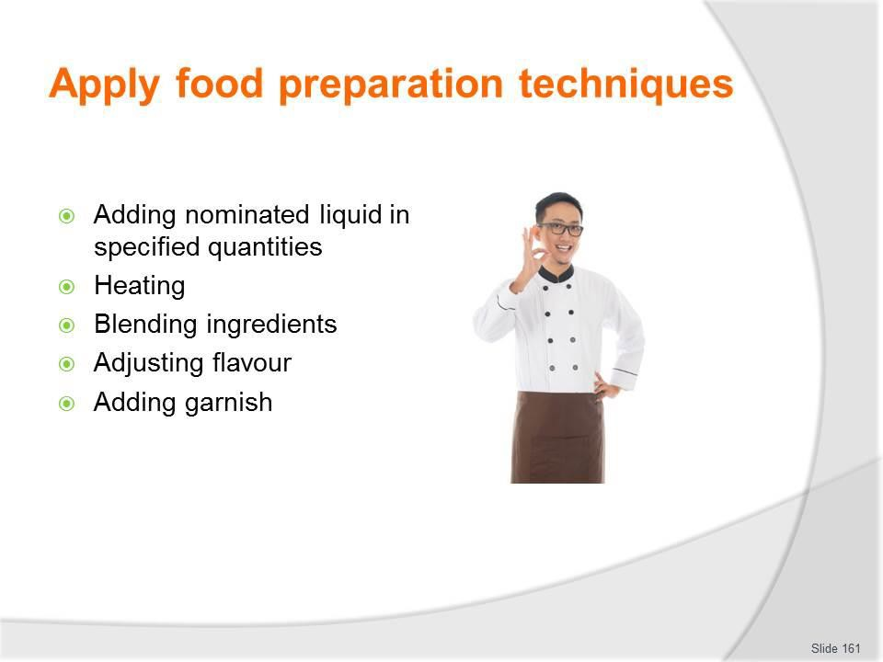
Slide No | Trainer Notes
161. | Trainer continues discussing re-constituting items:  - A mix of actions such as:  - Adding nominated liquid in specified quantities  - Blending ingredients  - Applying heat in a specified manner (in a pot/saucepan, in the microwave) and cooking for a given time  - Adjusting flavour of the product – which may require:  - Addition of salt and pepper  - Inclusion of herbs and spices  - Addition of lemon juice or vinegar  - Addition of condiments of any sort  - Addition of sweetening agent (such as sugar or honey)  - Adding garnishes – to the finished/reconstituted product to enhance presentation.  Classroom Activity – Demonstration and Practice  Trainer demonstrates practices identified on the slide and provides opportunity for students to do the same.

Slide
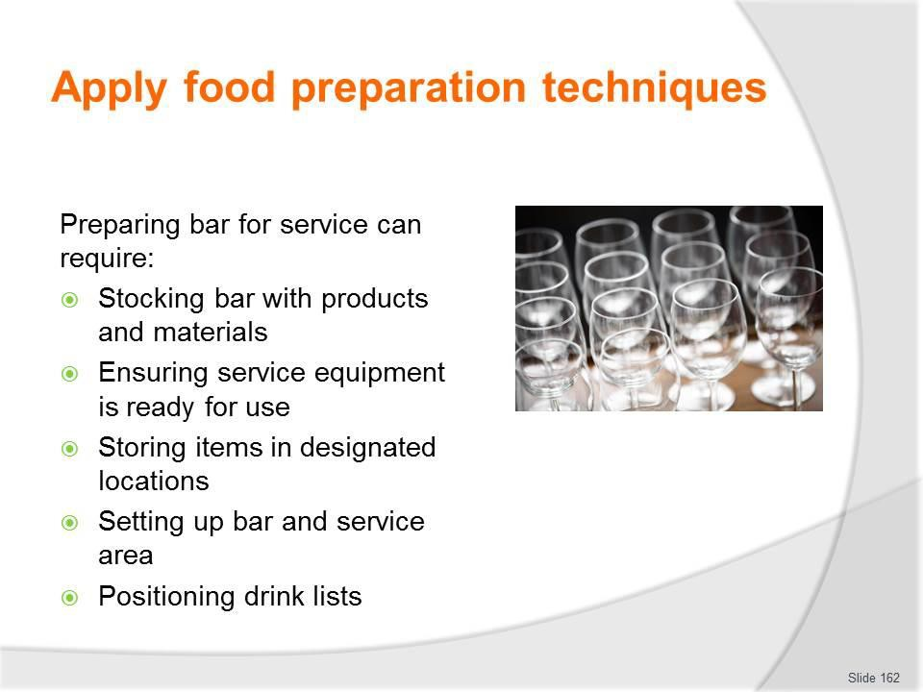
Slide No | Trainer Notes
162. | Trainer describes preparing a bar for service explaining the process may include:  - Stocking bar products and materials in accordance with enterprise requirements – including :  - Beverages – hot, cold, alcoholic and non-alcoholic as planned/required; Glassware and service gear; Ice  - Straws; Tongs and service spoons  - Ensuring service equipment is ready for use – meaning items are:  - Clean; Operational; Sufficient in number  - Storing items in the correct place at the correct temperature – so that:  - Cold drinks are served cold  - Hot drinks are hot  - Setting up the bar and service area – ready for:  - Staff to serve and prepare drinks  - Customers to use – as in:  - Self service; Open bar – where all drinks are free; Paid service – where guests pay for drinks they order  - Setting out lists – to:  - Advise what is available  - Indicate prices, if applicable.

Classroom Activity – Group Exercise
Trainer provides room, resources and a mock tour/camp scenario and asks students to prepare the bar to service this group.

Slide
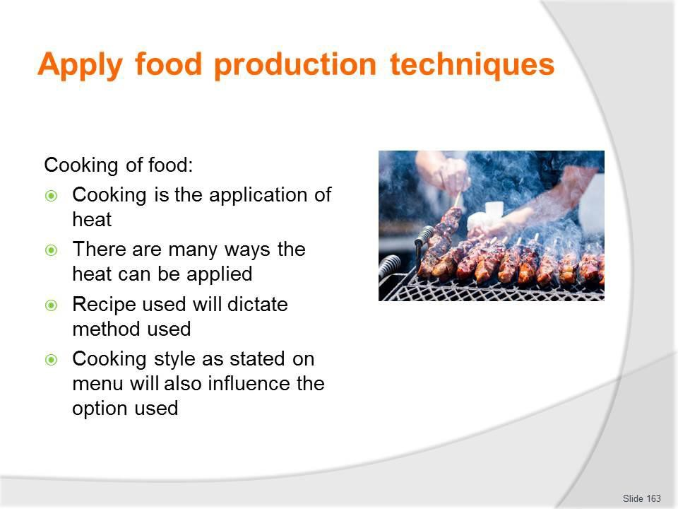
Slide No | Trainer Notes
163. | Trainer introduces this section by stating:  - No recipes will be provided (except for those used for demonstration purposes) because:  - Standard recipe requirements will vary between tour operators  - Catering teams have their own sets of standard recipes  - Ingredients vary enormously between different locations  - Tour types and individual tour needs often dictate the menu items to be prepared  - Budgets will dictate the raw ingredients which can be used  - Cooking may be seen as the application of heat to food  - There are many ways heat can be applied, and a wide range of equipment with which to apply it, as identified earlier  - The recipe being used will dictate the cooking method to be used  - The cooking style is often indicated on the menu, too.

Slide
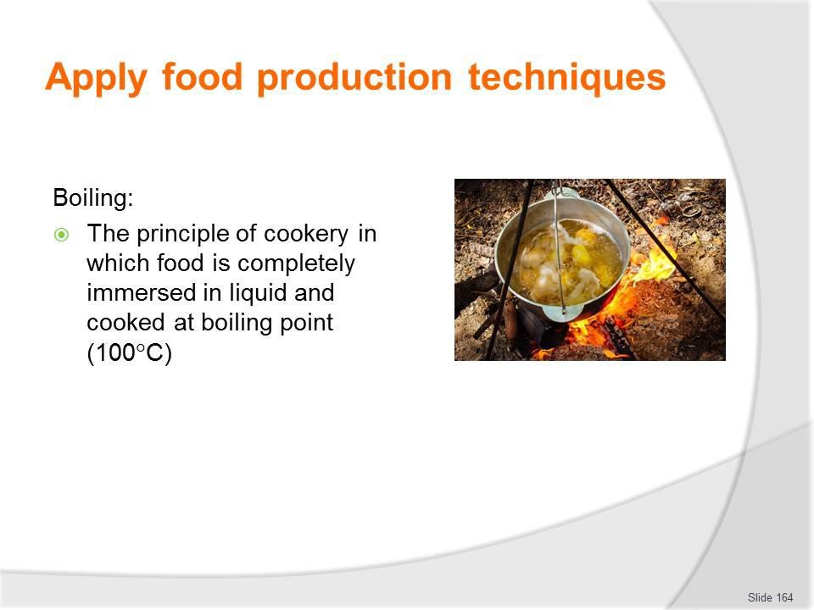
Slide No | Trainer Notes
164. | Trainer discusses food production techniques:  Boiling  Boiling is the principle of cookery in which food is completely immersed in liquid and cooked at boiling point (100°C).  Classroom Activity (1) – Internet Research  Trainer supervises internet research and subsequent classroom discussion by visiting:  https://www.youtube.com/watch?v=FGvRniFAC1s – Fung Bros food: Boiling crabs  https://www.youtube.com/watch?v=A8yPmXpzkvU – The difference between boiling and simmering.  Classroom Activity (2) – Demonstration and Practice  Trainer demonstrates cooking method identified on the slide and provides opportunity for students to do the same.

Slide
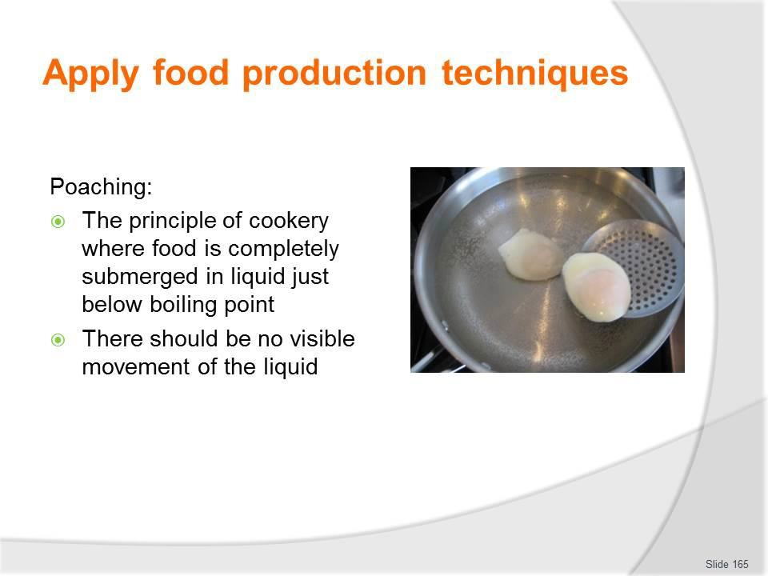
Slide No | Trainer Notes
165. | Trainer discusses food production techniques:  Poaching  Poaching is the principle of cookery where food is completely submerged in liquid just below boiling point: there should be no visible movement of the liquid.  Classroom Activity (1) – Internet Research  Trainer supervises internet research and subsequent classroom discussion by visiting:  https://www.youtube.com/watch?v=cIvpbSEboYI – How to make the perfect poached eggs  https://www.youtube.com/watch?v=KtZ14xEbgzg – The simple way to poach an egg.  Classroom Activity (2) – Demonstration and Practice  Trainer demonstrates cooking method identified on the slide and provides opportunity for students to do the same.

Slide
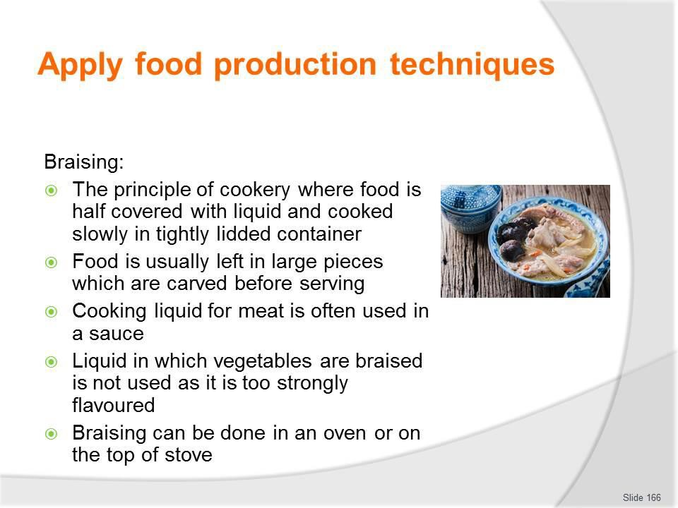
Slide No | Trainer Notes
166. | Trainer discusses food production techniques:  Braising  Braising is the principle of cookery where food is half covered with an appropriate liquid and cooked slowly in a tightly lidded container.  The food is usually left in large pieces which are carved before serving: the cooking liquid for meat is often used in a sauce however the liquid in which vegetables are braised is not used for sauce as it is too strongly flavoured.  Braising can be done in an oven or on the top of the stove.  Classroom Activity (1) – Internet Research  Trainer supervises internet research and subsequent classroom discussion by visiting: https://www.youtube.com/watch?v=pqpv_EkXhFg – How to braise https://www.youtube.com/watch?v=BZmVYtHejUY – Braising.  Classroom Activity (2) – Demonstration and Practice  Trainer demonstrates cooking method identified on the slide and provides opportunity for students to do the same.

Slide
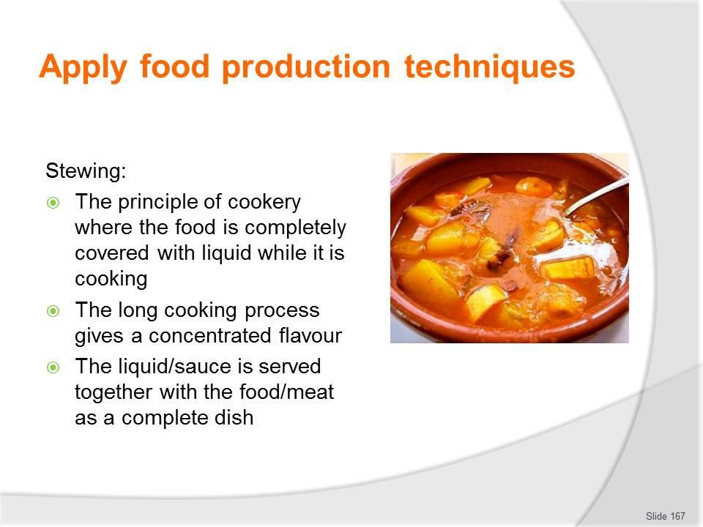
Slide No | Trainer Notes
167. | Trainer discusses food production techniques:  Stewing  Stewing is the principle of cookery where the food is completely covered with liquid while it is cooking. The long cooking process gives a concentrated flavour and the sauce which are served together as a complete dish.  Classroom Activity (1) – Internet Research  Trainer supervises internet research and subsequent classroom discussion by visiting: https://www.youtube.com/watch?v=-yrfpxKDzY4 – Stewing meat  https://www.youtube.com/watch?v=cVkZnUf1RuM – What’s the difference between braising and stewing?  Classroom Activity (2) – Demonstration and Practice  Trainer demonstrates cooking method identified on the slide and provides opportunity for students to do the same.

Slide
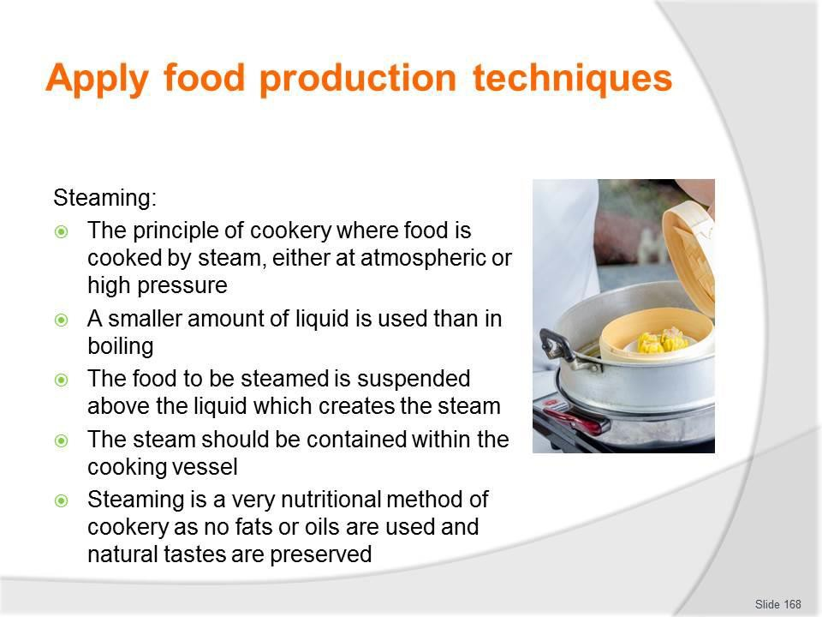
Slide No | Trainer Notes
168. | Trainer discusses food production techniques:  Steaming  Steaming is the principle of cookery where food is cooked by steam, either at atmospheric or high pressure.  A smaller amount of liquid is used than in boiling. The food to be steamed is suspended above the liquid which creates the steam. The steam should be contained within the cooking vessel. Steaming is a very nutritional method of cookery as no fats or oils are used and natural tastes are preserved.  Classroom Activity (1) – Internet Research  Trainer supervises internet research and subsequent classroom discussion by visiting: https://www.youtube.com/watch?v=CXcmnl2o6IQ – Steam cooking food basics https://www.youtube.com/watch?v=Vmqfl3mxfK0 – How to steam vegetables.  Classroom Activity (2) – Demonstration and Practice  Trainer demonstrates cooking method identified on the slide and provides opportunity for students to do the same.

Slide
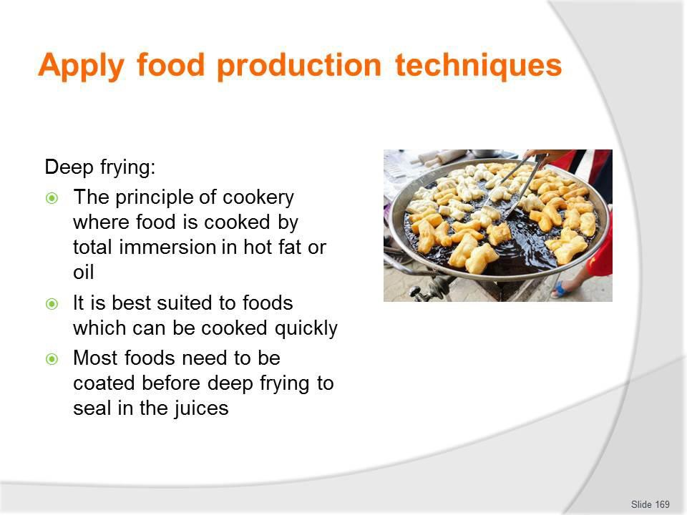
Slide No | Trainer Notes
169. | Trainer discusses food production techniques:  Deep frying  Deep frying is the principle of cookery where food is cooked by total immersion in hot fat or oil. It is best suited to foods which can be cooked quickly.  Most foods need to be coated before deep frying to seal in the juices.  Classroom Activity (1) – Internet Research  Trainer supervises internet research and subsequent classroom discussion by visiting: https://www.youtube.com/watch?v=0y9fSgUwNuo – How to deep fry chicken https://www.youtube.com/watch?v=RsCri2J3Ngk – How to make fish and chips.  Classroom Activity (2) – Demonstration and Practice  Trainer demonstrates cooking method identified on the slide and provides opportunity for students to do the same.

Slide
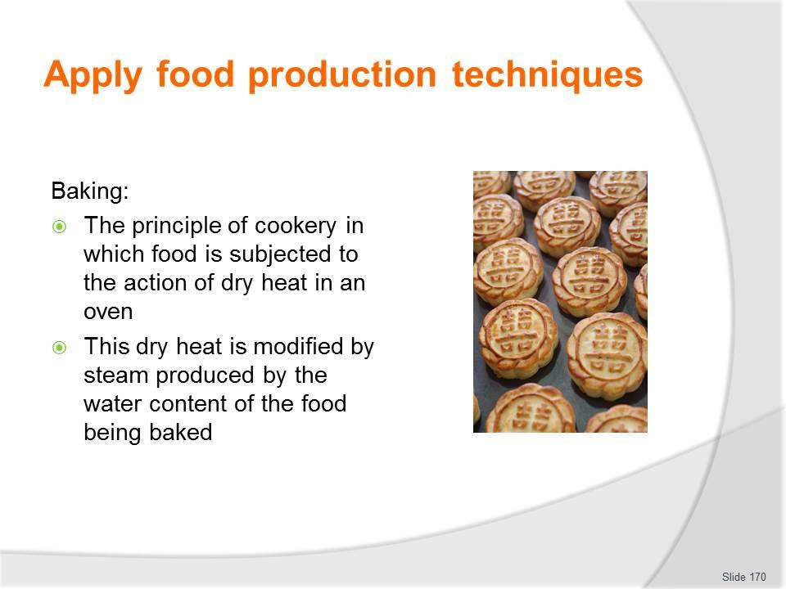
Slide No | Trainer Notes
170. | Trainer discusses food production techniques:  Baking  Baking is the principle of cookery in which food is subjected to the action of dry heat in an oven.  This dry heat is modified by steam produced by the water content of the food being baked.  Classroom Activity (1) – Internet Research  Trainer supervises internet research and subsequent classroom discussion by visiting:  https://www.youtube.com/playlist?list=PL2758929ECA7F0018 – to access a list of baking recipes and videos on how to make them.  Classroom Activity (2) – Demonstration and Practice  Trainer demonstrates cooking method identified on the slide and provides opportunity for students to do the same.

Slide
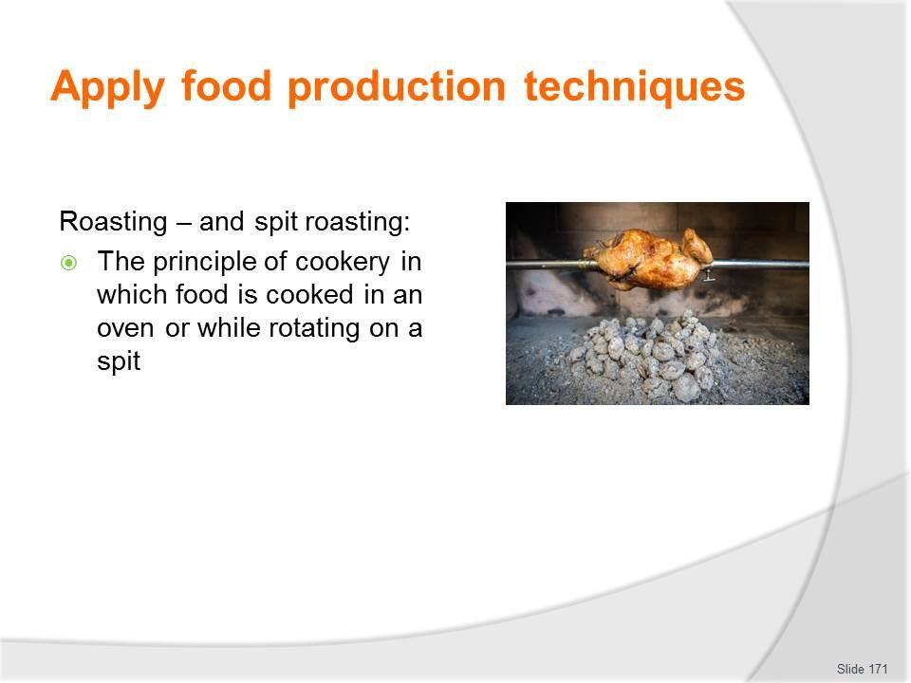
Slide No | Trainer Notes
171. | Trainer discusses food production techniques:  Roasting  Roasting, and spit roasting, is the principle of cookery in which food is cooked in an oven or while rotating on a spit (see later slide).  Classroom Activity (1) – Internet Research  Trainer supervises internet research and subsequent classroom discussion by visiting:  https://www.youtube.com/watch?v=SsHGYfIHS8o – How to cook the perfect roast (roast beef)  https://www.youtube.com/watch?v=c1_V2y_9KCM – How to make the ultimate slow- cooked beef pot roast.  Classroom Activity (2) – Demonstration and Practice  Trainer demonstrates cooking method identified on the slide and provides opportunity for students to do the same.

Slide
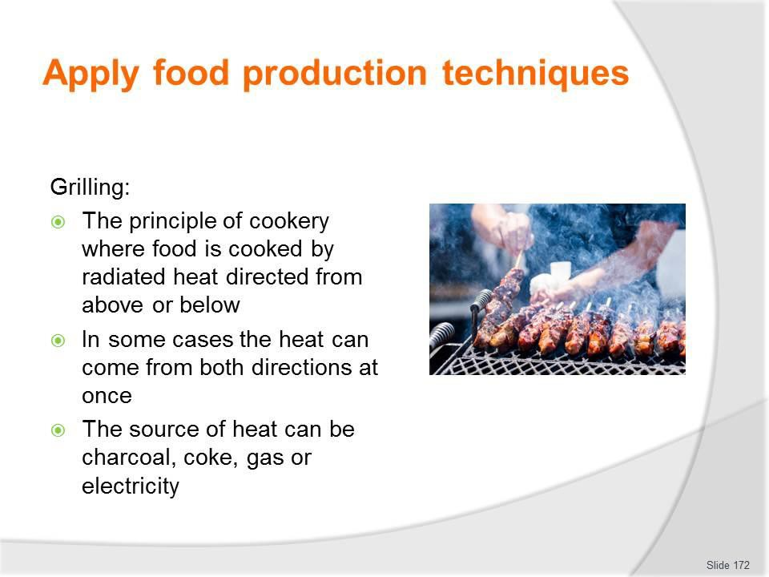
Slide No | Trainer Notes
172. | Trainer discusses food production techniques:  Grilling  Grilling is the principle of cookery where food is cooked by radiated heat directed from above or below: in some cases the heat can come from both directions at once.  The source of heat can be charcoal, coke, gas or electricity.  Classroom Activity (1) – Internet Research  Trainer supervises internet research and subsequent classroom discussion by visiting:  https://www.youtube.com/watch?v=V_yDTSrsv5g – The art of grilling: how to grill a steak  https://www.youtube.com/watch?v=rEx9gPhtjzs – How to cook a steak with Gordon Ramsay.  Classroom Activity (2) – Demonstration and Practice  Trainer demonstrates cooking method identified on the slide and provides opportunity for students to do the same.

Slide
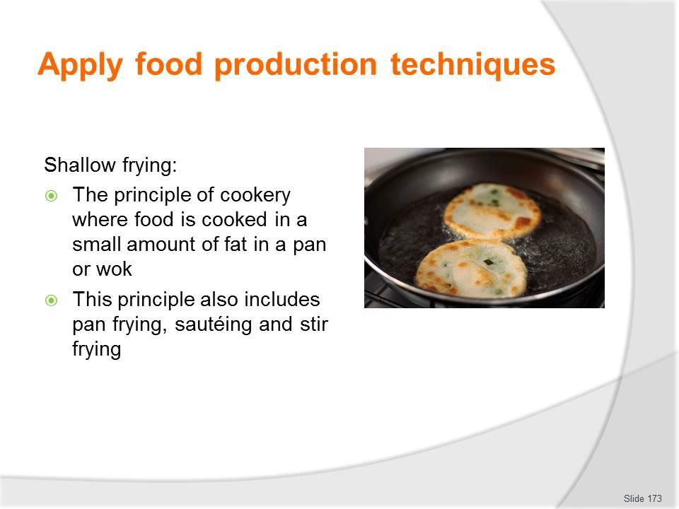
Slide No | Trainer Notes
173. | Trainer discusses food production techniques:  Shallow frying  Shallow frying is the principle of cookery where food is cooked in a small amount of fat in a pan or wok.  This principle also includes pan frying, sautéing and stir frying.  Classroom Activity (1) – Internet Research  Trainer supervises internet research and subsequent classroom discussion by visiting: https://www.youtube.com/watch?v=_29Os6bcZYI – How to shallow fry and deep fry https://www.youtube.com/watch?v=8USTo7EqrI – Shallow fry.  Classroom Activity (2) – Demonstration and Practice  Trainer demonstrates cooking method identified on the slide and provides opportunity for students to do the same.

Slide
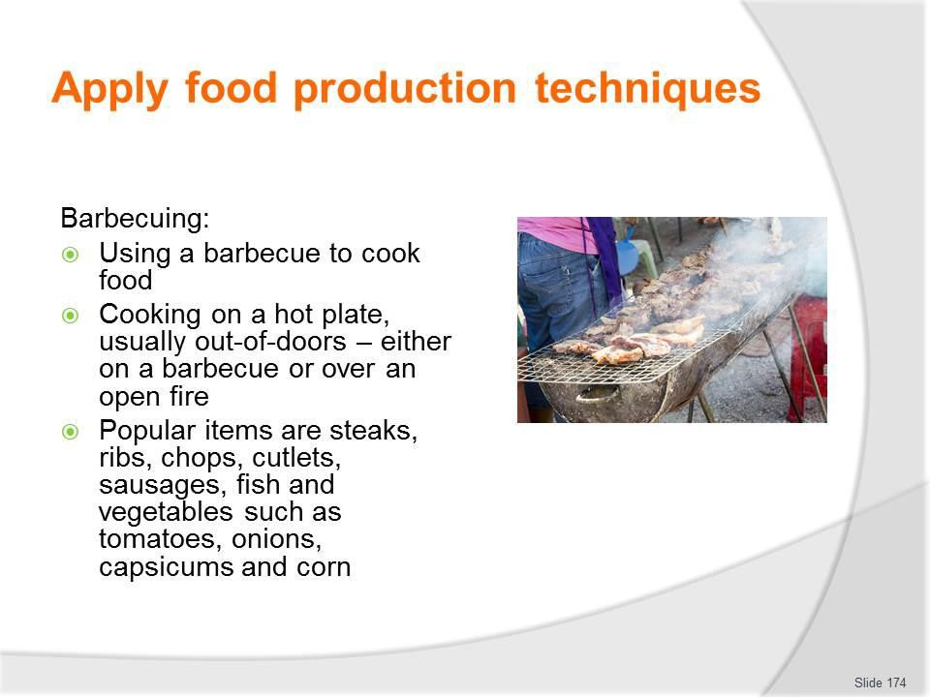
Slide No | Trainer Notes
174. | Trainer discusses food production techniques:  Barbecuing  Barbecuing can be seen as: Using a barbecue to cook food  Cooking on a hot plate, usually out-of-doors – either on a barbecue or over an open fire.  Popular items cooked this way include steaks, ribs, chops, cutlets, sausages, fish and a variety of vegetables such as tomatoes, onions, capsicums and corn.  Classroom Activity (1) – Internet Research  Trainer supervises internet research and subsequent classroom discussion by visiting: https://www.youtube.com/watch?v=vpS5mHJBQDE – Barbecue chicken https://www.youtube.com/watch?v=tC6keui55e8 – How to barbecue ribs.  Classroom Activity (2) – Demonstration and Practice  Trainer demonstrates cooking method identified on the slide and provides opportunity for students to do the same.

Slide
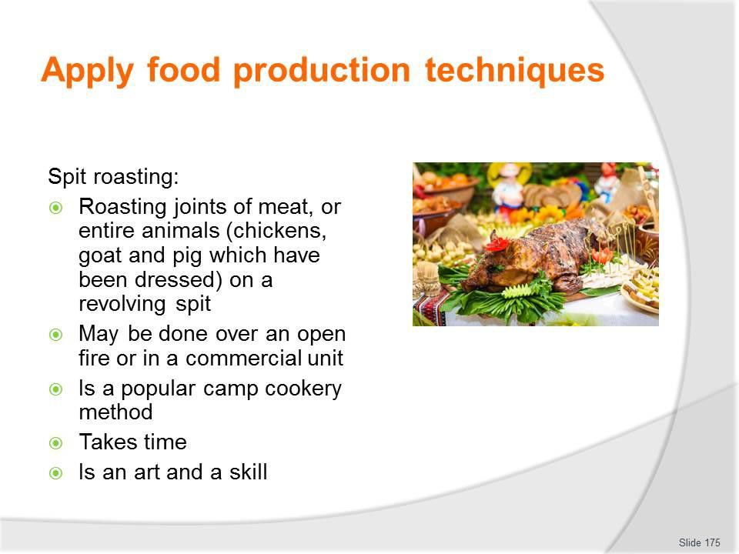
Slide No | Trainer Notes
175. | Trainer discusses food production techniques:  Spit roasting  - Spit roasting is the roasting of joints of meat, or entire animals (such as chickens, goat and pig which have been dressed) on a revolving spit  - Spit roasting may be achieved:  - Over an open fire  - Using a commercial spit roaster or rotisserie  - It is critical to understand spit roasting:  - Is a popular cooking method for camps  - Takes time – and the process needs to commence well in advanced of expected service  - Is an art and a skill – only experienced persons should be used for the process and it should never be attempted for the first time for paying tour group members by those who have not had previous experience.  Classroom Activity (1) – Internet Research  Trainer supervises internet research and subsequent classroom discussion by visiting:  http://www.lifestylefood.com.au/articles/top-5-tips-for-the-perfect-spit-roast.aspx and http://bbqspitrotisseries.blogspot.com.au/2012/06/spit-roasted-meat.html for more detail.

Classroom Activity (2) – Demonstration and Practice
Trainer demonstrates cooking method identified on the slide and provides opportunity for students to do the same.

Slide
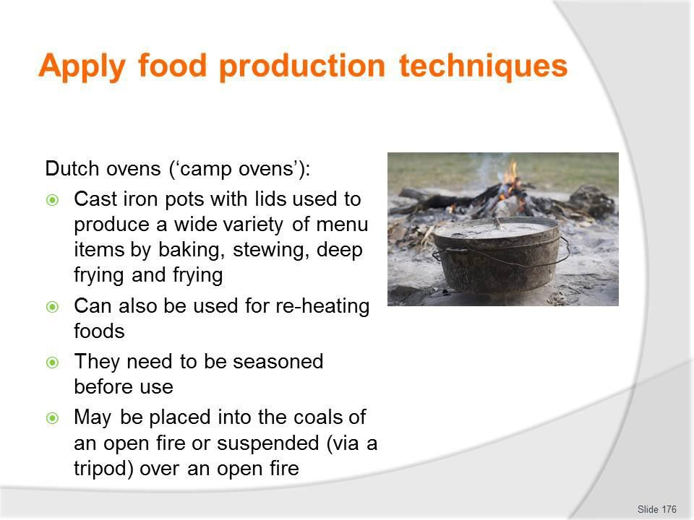
Slide No | Trainer Notes
176. | Trainer discusses food production techniques:  Dutch ovens  These are essentially cast iron pots with lids which can be used to produce a wide variety of menu items by baking, stewing, deep frying and frying and can also be used for re-heating foods.  They are also called ‘camp ovens’.  They need to be seasoned before use and may be placed into the coals of an open fire or suspended (via a tripod) over an open fire.  Classroom Activity (1) – Internet Research  Trainer supervises internet research and subsequent classroom discussion by visiting: https://www.youtube.com/watch?v=5J9amg4LHwY – Dutch oven cooking 101  https://www.youtube.com/watch?v=JaAhYGNlgfE – Dutch oven cooking: cooking breakfast  https://www.youtube.com/watch?v=8IIly7se1pk – How to bake bread in a Dutch oven https://www.youtube.com/watch?v=1TRhLLjt_Nw – Dutch oven chicken.  Classroom Activity (2) – Demonstration and Practice  Trainer demonstrates seasoning of camp ovens prior to use and the cooking method identified on the slide and provides opportunity for students to do the same.

Slide
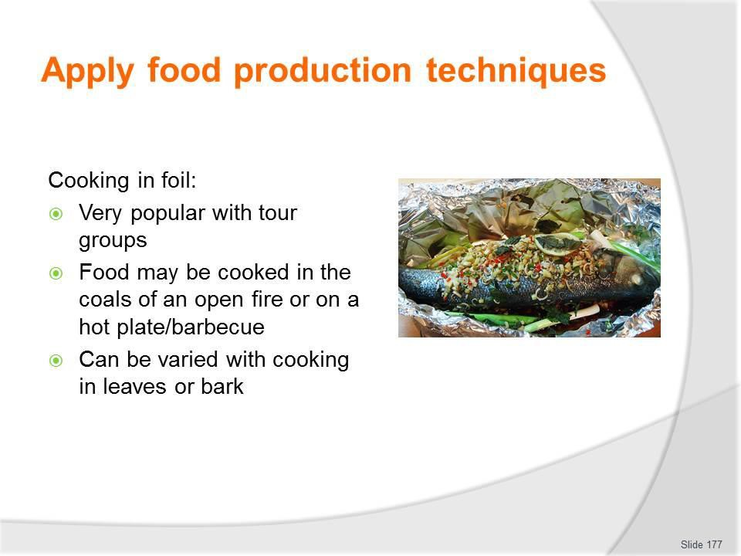
Slide No | Trainer Notes
177. | Trainer discusses food production techniques:  Cooking in foil  - For many tour group members food cooked in foil in a camp fire is the ultimate in camp site catering  - Food may be wrapped in foil and:  - Cooked in the coals of an open fire  - Cooked on a hot plate/barbecue  - Variations of this technique include:  - Cooking in leaves  - Cooking in bark.  Classroom Activity (1) – Internet Research  Trainer supervises internet research and subsequent classroom discussion by visiting:  http://www.foodnetwork.com/recipes/articles/50-things-to-grill-in-foil.html - 50 things to grill in foil  http://www.artofmanliness.com/2010/07/20/cooking-around-the-campfire-9-easy-and- delicious-foil-packet-recipes/ - Cooking around the campfire: 9 easy delicious foil packet recipes.

Classroom Activity (2) – Demonstration and Practice
Trainer demonstrates cooking methods identified on the slide and provides opportunity for students to do the same.

Slide
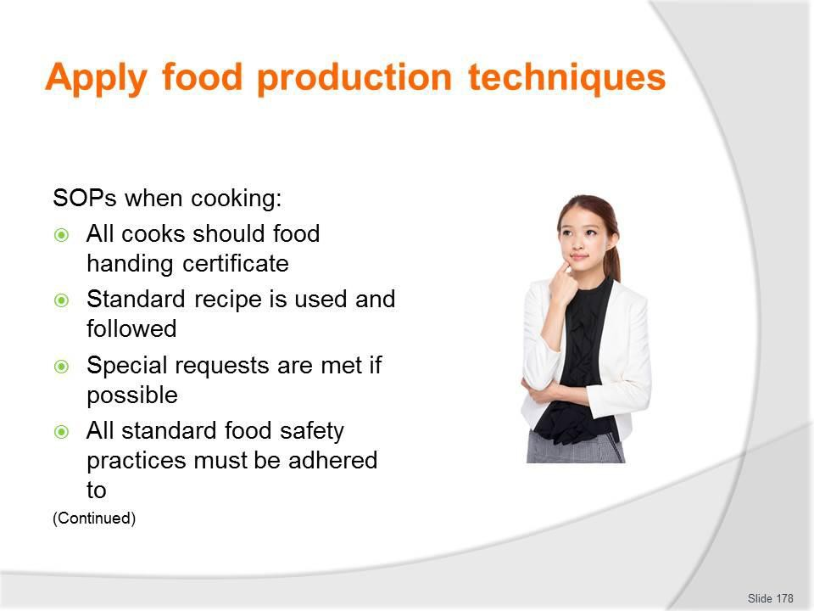
Slide No | Trainer Notes
178. | Trainer presents standard operational practices to be observed/implemented when producing food:  - All food handlers hold a current and recognised food handling certificate  - Correct recipe has been selected and adhered to in all aspects  - Special requests/requirements of customers have been met, where possible  - All standard safe food practices have been implemented as part of the storage, preparation, cooking, holding and service processes.

Slide
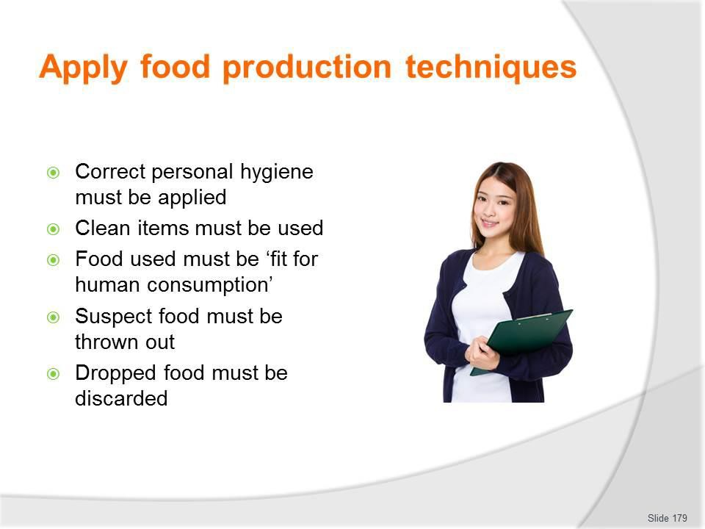
Slide No | Trainer Notes
179. | Trainer continues presenting SOPs when cooking:  - Correct personal hygiene practices have been implemented during the preparation and other food handling phases  - Only clean items have been used to prepare and serve the food – meaning items must have been washed using detergent, sanitised and protected from contamination after cleaning  - All food used:  - Has been obtained from reputable sources and complies with legislated requirements  - Is checked and deemed safe before use  - Suspect food, food that has been dropped on the floor and food which does not comply with safe food handling protocols must be discarded and not served.  Classroom Activity – Guest Speaker  Trainer arranges for experienced camp site cook to attend and:  - Discuss their role and responsibilities when providing camp site catering  - Give advice and tips on preparing and producing camp site catering  - Provide sample recipes.

Slide
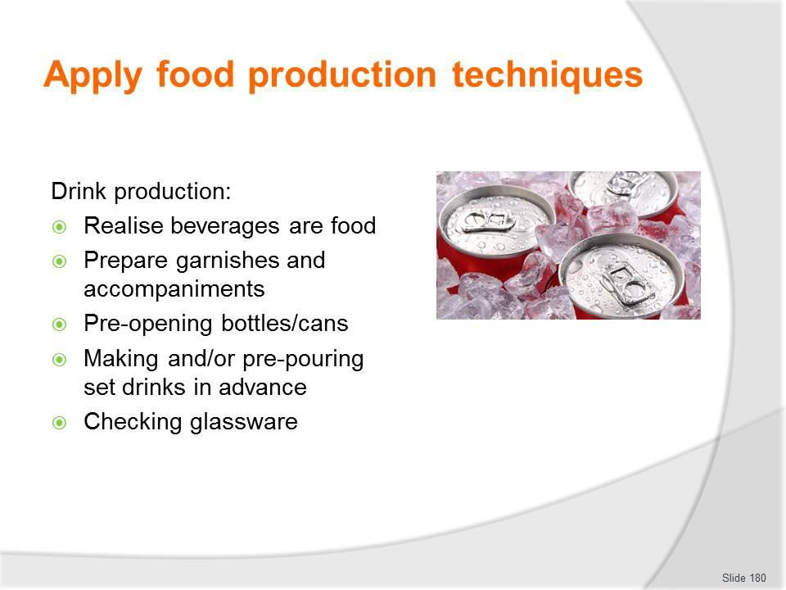
Slide No | Trainer Notes
180. | Trainer discusses drink production noting this requires:  - Accepting beverages are food – for the purposes of food safety  - Preparing a suitable range of garnishes and accompaniments – which may include:  - Crushing ice; Slicing oranges and lemons; Preparing plastic drink decorations  - Pre-opening bottles, cans and other containers – as arranged for service with meals, such as:  - Red and white table wine; Sparkling wine; Beer; Fruit juice  - Making drinks in advance of the meal/arrival of tour group members – as arranged for the meal, such as:  - Fresh fruit juices; Punches; Cocktails; Pre-pouring drinks into jugs – for placement on tables/service to or for guests; Teas and coffees  - Checking glassware and jugs when handling them – to ensure:  - They are clean not chipped or cracked; They are clean.  Classroom Activity – Demonstration and Practical  Trainer provides resources and ingredients and demonstrates production of representative range of alcoholic and non-alcoholic hot and cold drinks suitable for camp catering and provides opportunity for students to do the same.

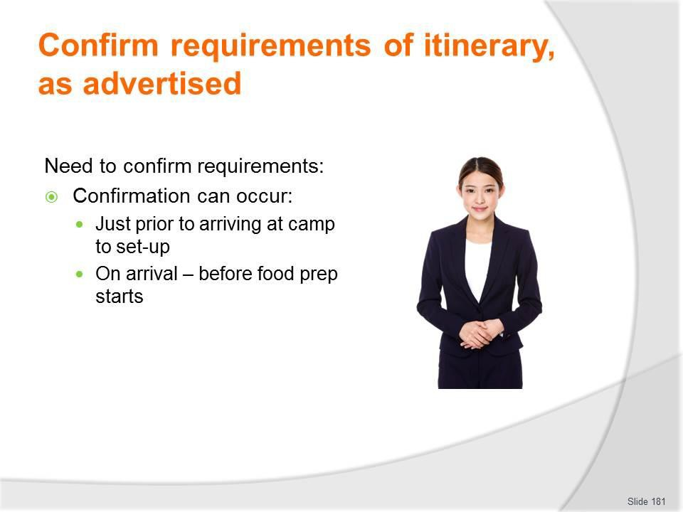
Slide
Slide No
Trainer Notes
181.
Trainer discusses need to confirm requirements explaining:
- Confirming requirements can occur:
  - Just before the camp site is reached
  - On arrival at the camp – before food preparation and production begins.

Slide
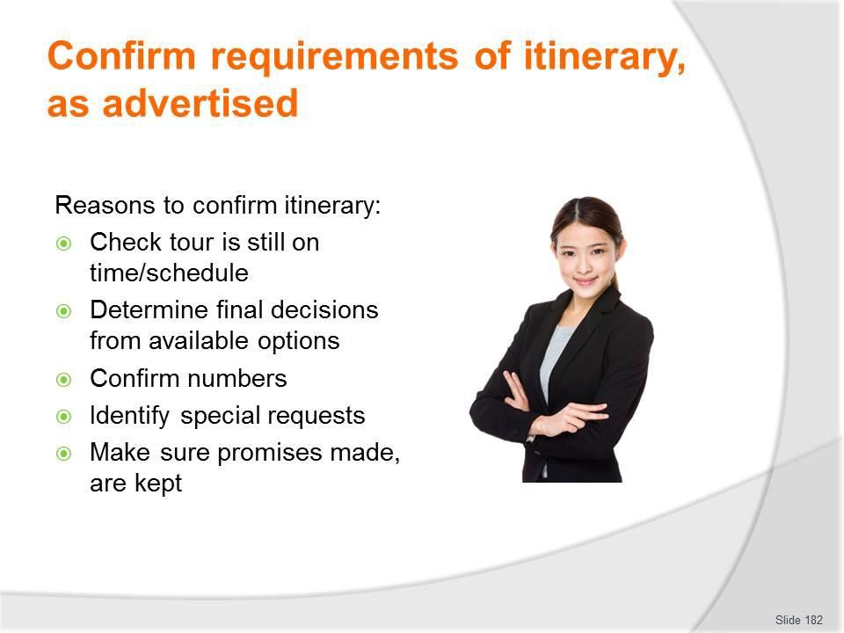
Slide No | Trainer Notes
182. | Trainer presents reasons to confirm itinerary include to:  - Check the tour is still running according the planned itinerary – and to finalise service times  - There is always the possibility the tour is running early or late and so the catering may need to be adjusted to accommodate this change in timing  - Determine final decisions about tour options – some tours may feature inclusions where tour group members can select some catering choices (menu items, service styles, eating indoors or out) as the tour proceeds  - In these cases, the catering crew needs to find out what the tour group has decided  - Confirm tour group numbers – there may be cases where the tour group has grown or reduced in number and the camp crew need to know exact numbers they are catering for  - Identify special requests which may have emerged within the tour group – as tours progress it can become apparent certain tour group members have needs or preferences not known when the tour was planned/departed but which can be/need to be accommodated to optimise their satisfaction with the tour  - Ensure promises made are kept – for example:  - Advertised items and meals are provided when and in the quantities advertised  - Special event meals are served at the times and in the styles advertised.

Slide
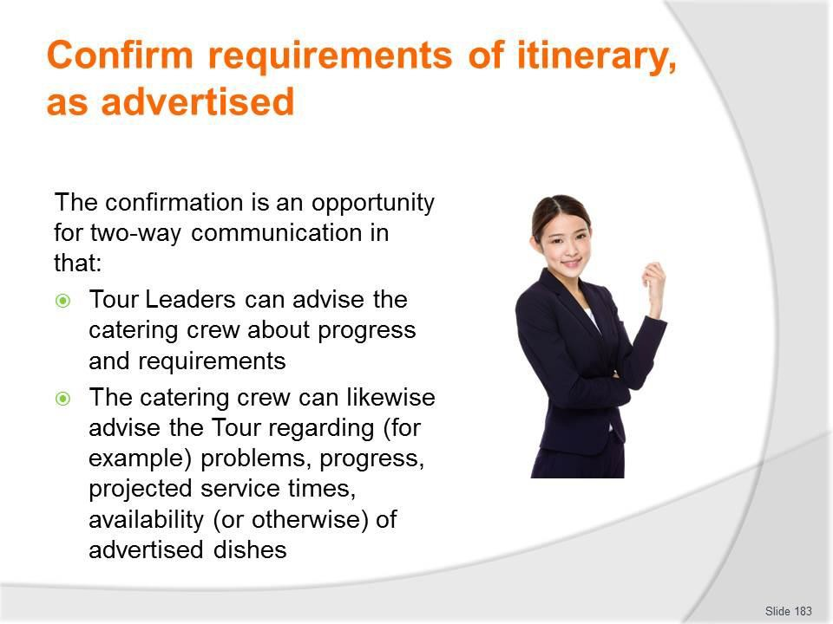
Slide No | Trainer Notes
183. | Trainer highlights the two-way nature of this communication highlighting:  - This confirmation can become a two-way process – that is, the catering crew can use this opportunity to notify the tour/Tour Leader of expected arrangements which cannot be accommodated  - For example, food for planned dishes/meals may have perished/become unfit for consumption during transportation and be unavailable for service, or critical cooking equipment may have been lost or damaged  - This notification allows the Tour Leader to pre-warn the tour group, explain the reasons and prepare them for revised circumstances on arrival at the camp site saving the catering crew having to explain things and deal with the disappointments/complaints which may arise  - The Catering crew will always carry a Tour Folder for every tour group containing:  - Contact detail for the Tour Leader and other tour staff  - Copies of the itinerary and inclusions  - Copy of contract- for private tours  - Copy of terms and Conditions of the tour  - Tour operators policy manual  - Standard recipes for planned meals  - Relevant SOPs for camp catering

- Plans developed for the tour and/or camp or destination
- Site information – for the camp.

Slide
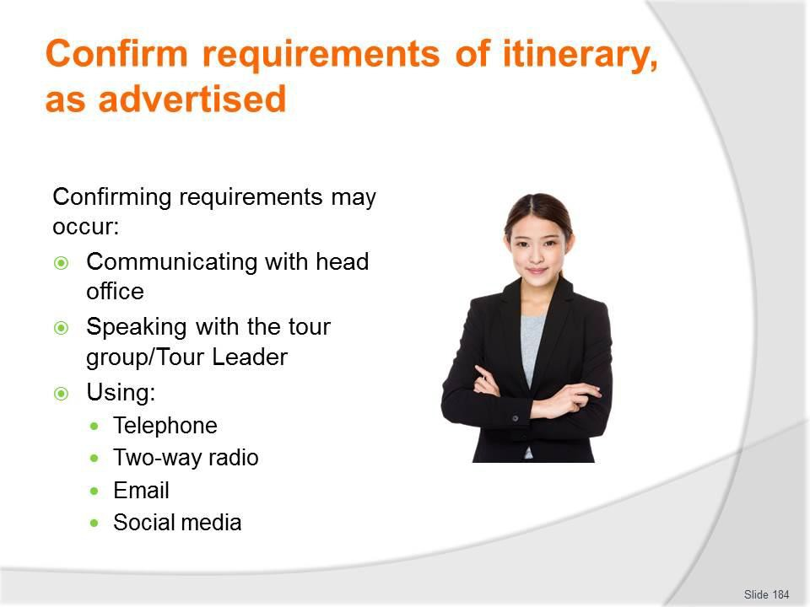
Slide No | Trainer Notes
184. | Trainer identifies ways to confirm requirements explaining:  - There are a variety of ways in which requirements can be checked. They may involve:  - Communicating with head office/the tour operator  - Speaking with the tour group – usually in the form of the Tour Leader or, in some cases, the catering crew who are currently with that group  - Communication options may be:  - Via telephone – landline, cell, satellite  - Two-way radio  - Email exchanges.

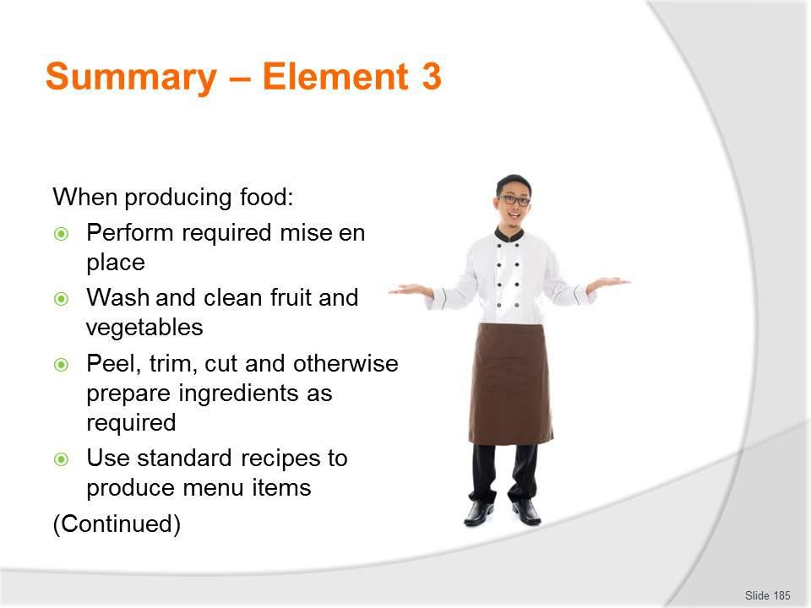
Slide
Slide No
Trainer Notes
185.
Trainer provides a recap of the Element asking questions to check trainee understanding and responding to questions from trainees, as required.

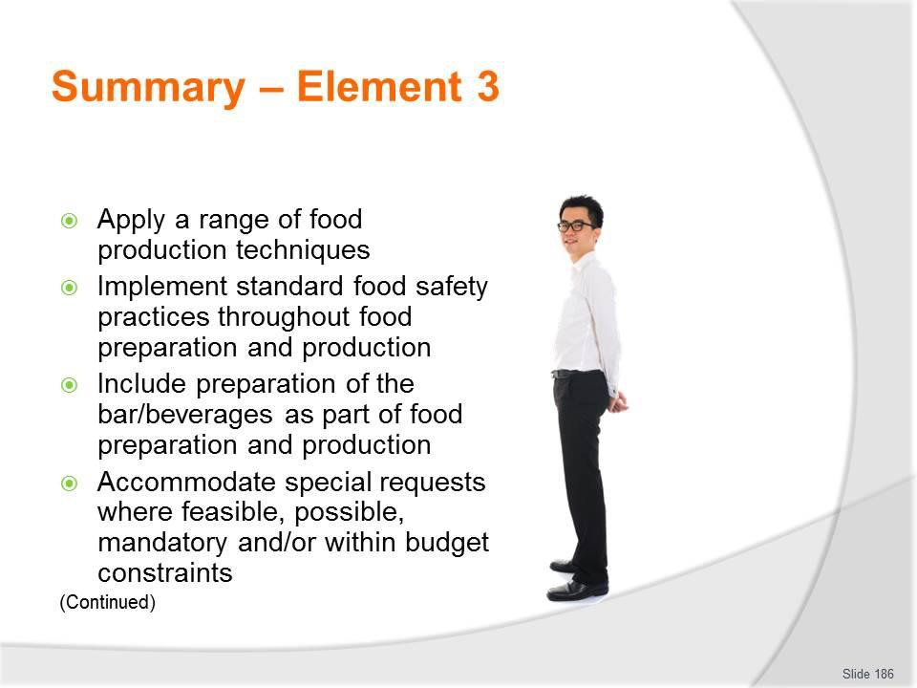
Slide
Slide No
Trainer Notes
186.
Trainer provides a recap of the Element asking questions to check trainee understanding and responding to questions from trainees, as required.

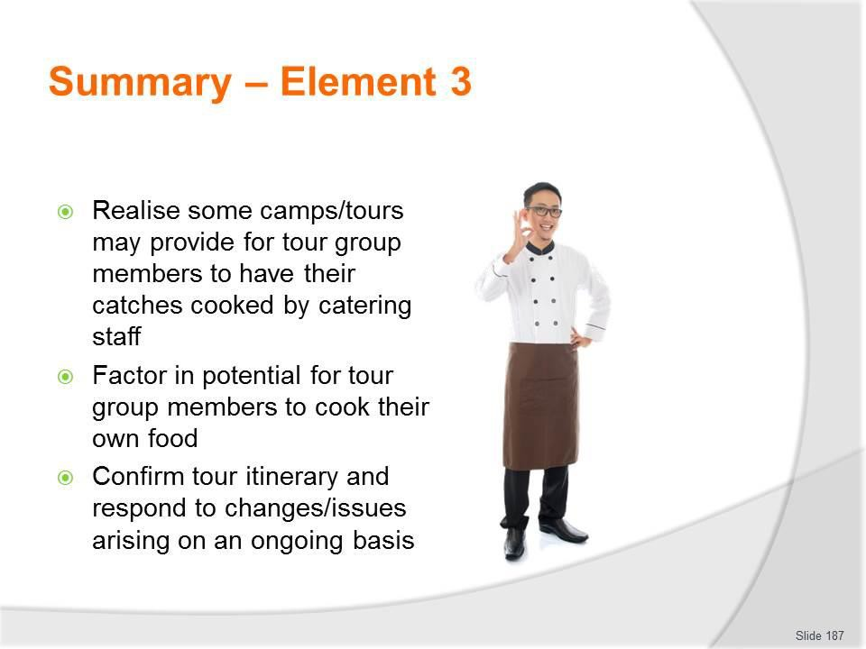
Slide
Slide No
Trainer Notes
187.
Trainer provides a recap of the Element asking questions to check trainee understanding and responding to questions from trainees, as required.

Slide
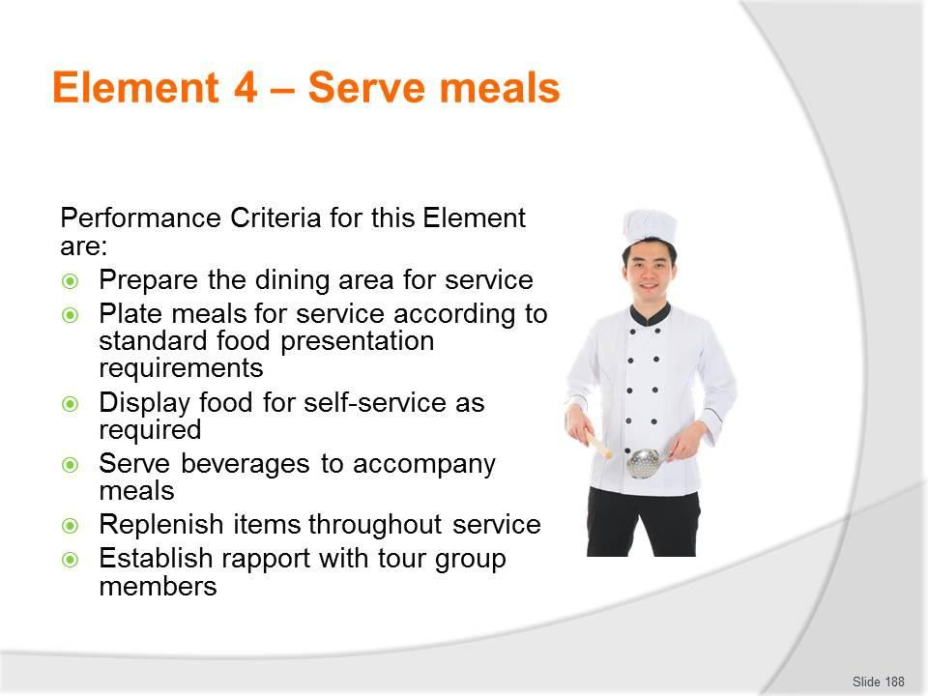
Slide No | Trainer Notes
188. | Trainer identifies for trainees the Performance Criteria for this Element, as listed on the slide.  Class Activity – General Discussion  Trainer leads a general class discussion by asking questions such as:  - What is the importance of correctly and efficiently serving food at camps to tour group members?  - What is ‘portion control’ and why is it important when serving meals?  - How can required portion control be achieved?  - What self-service might occur as part of the camp site catering experience for tour group members?

Slide
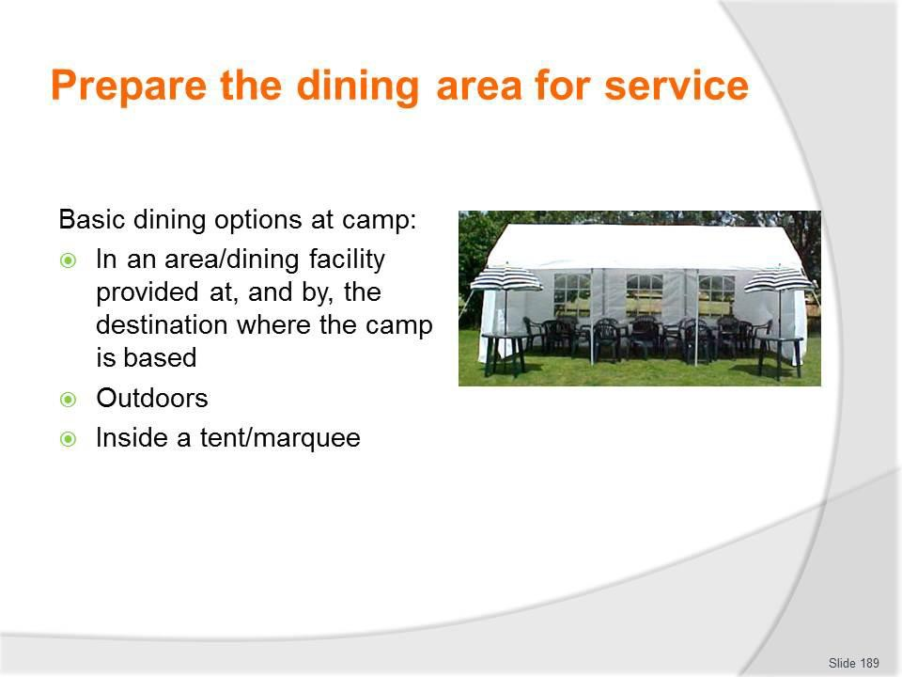
Slide No | Trainer Notes
189. | Trainer identifies basic dining option:  - In an area/dining facility provided at and by the destination where the camp is based – using those facilities and moving furniture (if possible) to suit tour group and individual mean requirements  - Outdoors – in the fresh air, where tour group members choose where they sit and take their meals where they want and select who they want to sit with  - Inside a tent/marquee – and are seated at tables and chairs to reflect group numbers and any required seating arrangements.

Slide
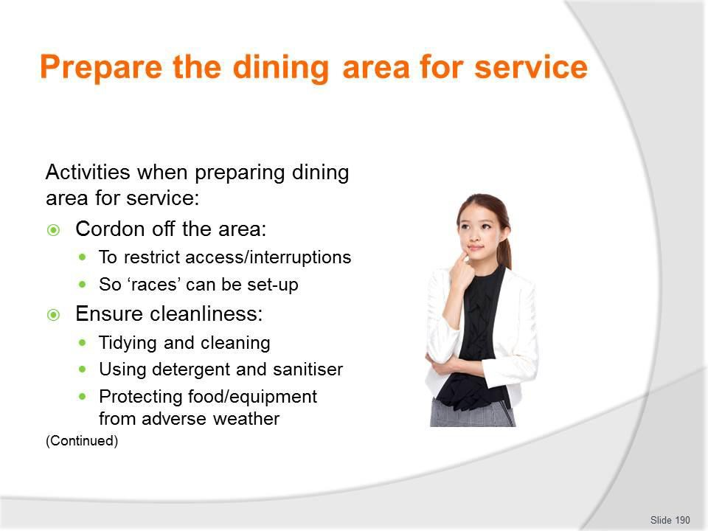
Slide No | Trainer Notes
190. | Trainer discusses preparing the dining area for meal service highlighting there is/may be a need to:  - Cordon off the area – to:  - Restrict access to the area during preparation so:  - Set-up can occur without interruption  - Tour group member safety is optimised  - ‘Races’ can be created to control tour group access to food during self-service  - Ensure the cleanliness of the dining and service areas – this means:  - Tidying and cleaning the area so it looks presentable – for example:  - Putting things away  - Removing litter  - Taking action to make sure the area and facilities are hygienic - for example:  - Using detergent to remove dirt  - Applying sanitiser to remove bacteria  - Protecting food/equipment from adverse weather.

Slide
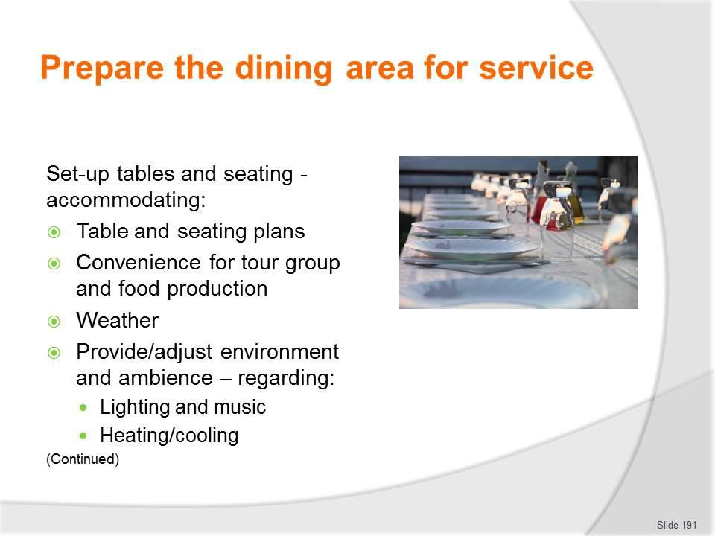
Slide No | Trainer Notes
191. | Trainer continues discussing requirements when setting up dining area:  - Set-up tables and seating – taking into account:  - Table plans/seating plans provided for the group  - Accommodation for required numbers  - Provision of sufficient seating  - Convenience for tour group members  - Location of/proximity to catering/food production area  - Creating of, where necessary, a wind screen/other weather-related protection for diners  - Provide and/or adjust environmental elements to create suitable ambience where/if applicable – with reference to things such as:  - Lighting  - Heating/cooling  - Music.

Slide
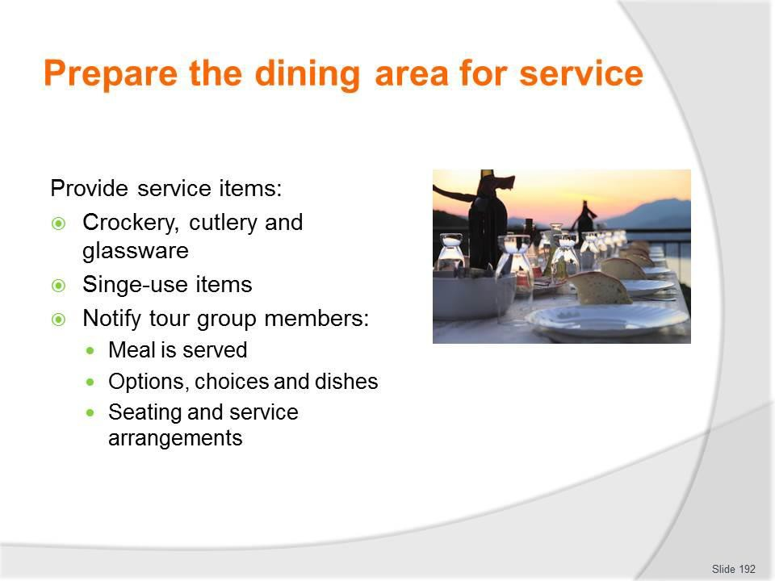
Slide No | Trainer Notes
192. | Trainer continues discussing requirements when setting up dining area:  - Provide required service items – which need to reflect the menu to be served and may necessitate laying/supplying clean and sufficient:  - Cutlery; Crockery; Glassware; Single-use items; Serviettes  - Notify tour group members – in relation to:  - The fact the meal is served; Options and choices available; Explanations of menu items and beverages;  - Seating and service arrangements.  Classroom Activity – Demonstration and Practical  Trainer demonstrates setting-up of a dining area to meet requirements of a nominated tour and provides opportunity for students to do the same.

Slide
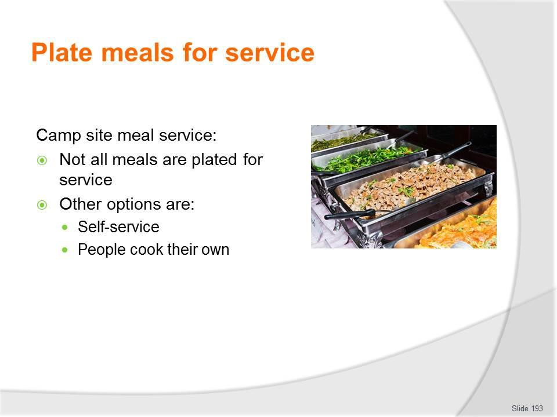
Slide No | Trainer Notes
193. | Trainer discusses meal service observing:  - It must be remembered not all food served to tour group members at camps will be plated  - Other options are:  - Food presented in food display and presentation equipment – for people to serve themselves  - Tour group members cook their own food – over a camp fire or using specialised cooking equipment/utensils.

Slide
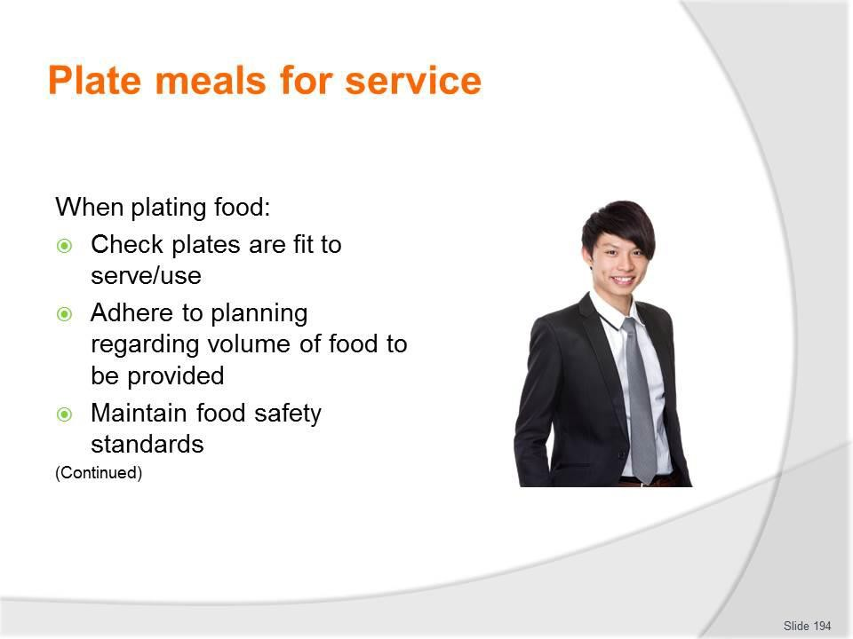
Slide No | Trainer Notes
194. | Trainer presents points to implement when plating food:  - Check service plates prior to use – to ensure they are:  - Clean; Free of chips and cracks; Correct type and size  - Adhere to planning tour standards regarding the quantity of food supplied – this volume of food may/will be:  - Related to general tour standards established by the tour operator as being normal for general camp site catering  - Specified via the individual contract agreed with the group in the case of custom tours  - Directly linked to the number of people on the tour and expected at the meal service session  - Maintain food safety – throughout the entire process in terms of:  - Food handling protocols; Personal hygiene practices; Food holding and presentation procedures; Utensils and equipment used for service; Crockery onto which food is plated.

Slide
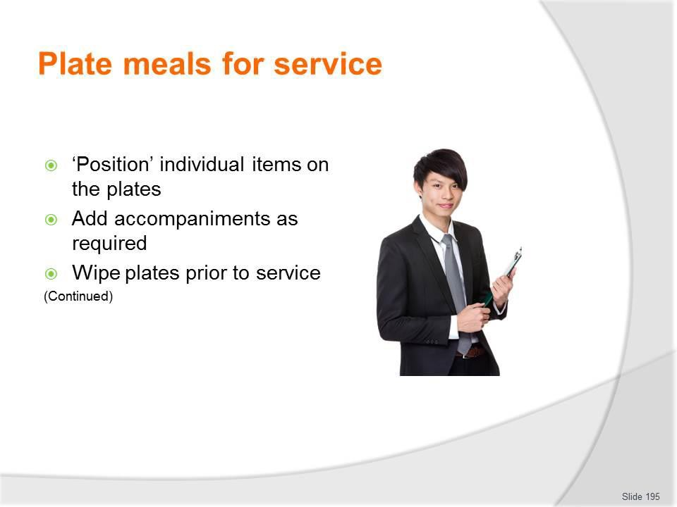
Slide No | Trainer Notes
195. | Trainer continues presenting points to implement when plating food:  - Position food on plates – in a pre-arranged manner, such that:  - Presentation is standardised across all meals of the same type which are served – so all meals look identical  - The final/finished product looks attractive, appealing and enticing – because people first ‘eat with their eyes’  - Colours are separated/contrasted on the plate  - Add accompaniments to each plate – as required, in terms of:  - Garnishes  - Sauces  - Wipe plates prior to service – in order to:  - Meet customer expectations  - Enhance presentation  - Demonstrate professionalism  - Remove smudges, drips, spills and finger marks.

Slide
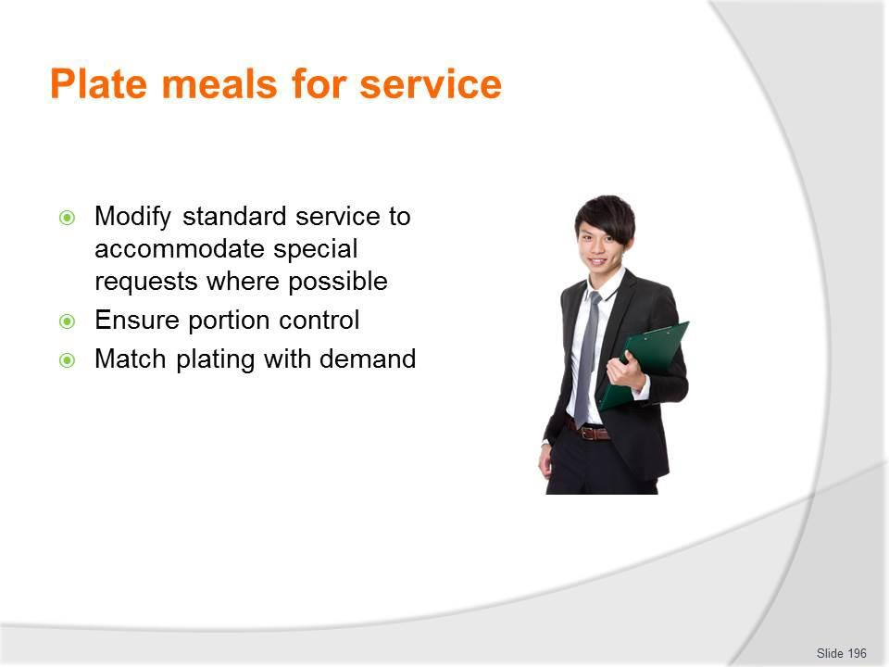
Slide No | Trainer Notes
196. | Trainer continues presenting points to implement when plating food:  - Modify standard serve requirements – on the basis of:  - Special requests made by tour group members – such as:  - For ‘more’ or ‘less’ of an item  - Not wanting certain food items  - Common sense – with reference, for example to:  - Serving less to children  - Cutting back on serve sizes where an item is running out  - Ensure equality in serve sizes so each person has meal of the same size unless otherwise requested – which can require:  - Using the designated type/size of plate  - Using nominated slotted/service spoons to serve items onto the plate  - Counting items – individual units of (say) potatoes, slices of meat, pieces of fish  - Match plating with demand – to:  - Enhance food quality – by serving, to the best extent possible, ‘to order’ so food is served immediately as opposed to losing quality/temperature by awaiting service  - Meet immediate demand – as this may vary throughout the service session.

Classroom Activity – Demonstration and Practical
Trainer demonstrates range of plating practices and provides opportunity for students to do the same.

Slide
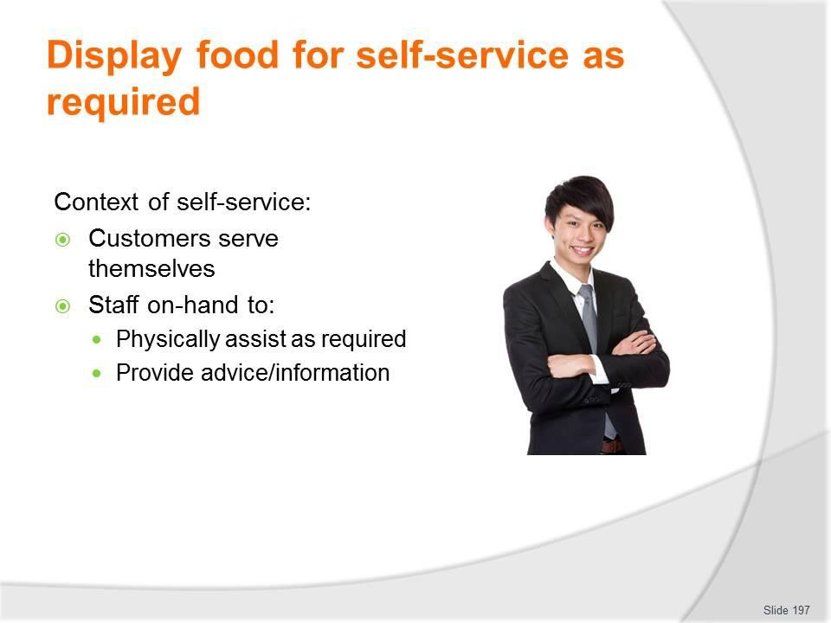
Slide No | Trainer Notes
197. | Trainer gives context self service stating:  - Self-service is a service style where customers ‘help themselves’ to the food that has been prepared  - Catering staff are usually present and available to:  - Assist customers as required – with:  - The service of food  - Carrying meals to tables  - Extra items as required – such as:  o More/different condiments; Items to replace those which have been dropped on the ground  - Advise customers – about:  - Recipes; Ingredients; Taste of the food.

Slide
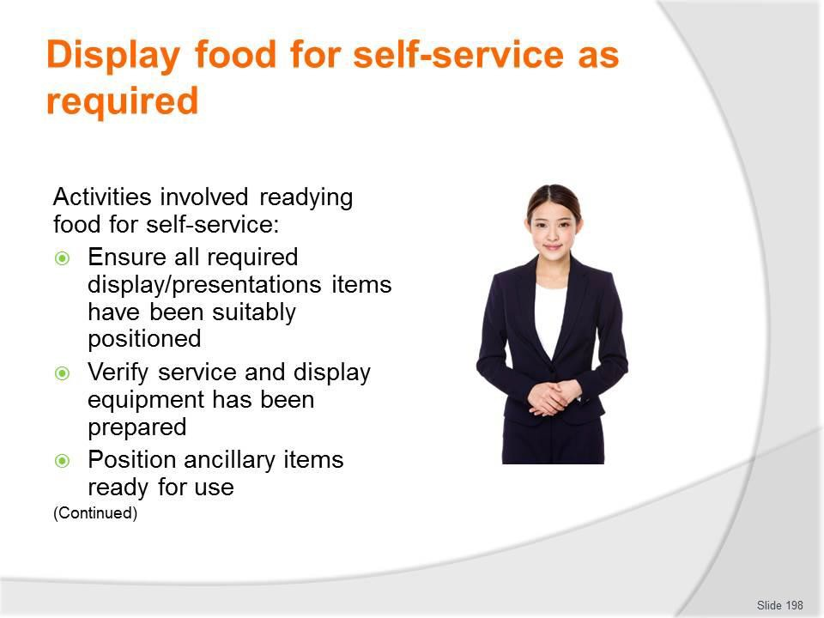
Slide No | Trainer Notes
198. | Trainer presents activities involved in readying food for self-service stating it can be/is necessary to:  - Ensure all required display/presentations items have been suitably positioned – to:  - Minimise travel of food from production area to service location  - Facilitate self-service access by tour group members  - Verify service and display equipment has been prepared for service – that is:  - Items are cleaned and sanitised  - Bain maries for hot food have been pre-heated ready for use  - Refrigerated service and display items need to be pre-chilled – so cold food is placed into cold equipment  - Position ancillary items ready for use – these may include:  - Bread/rolls; Butter; Optional garnishes; Side dishes; Condiments; PC packs.

Slide
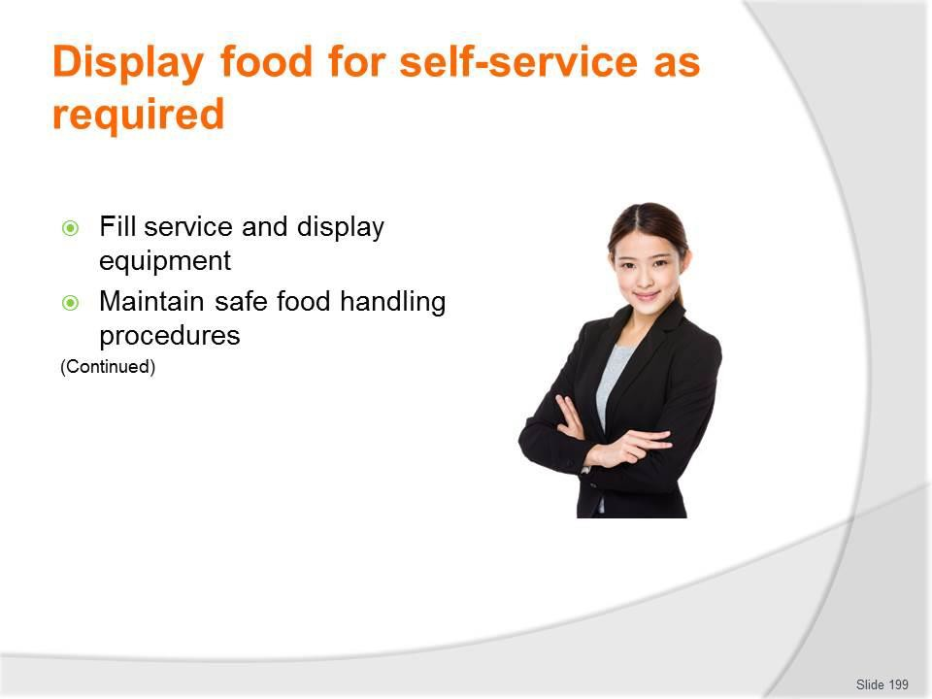
Slide No | Trainer Notes
199. | Trainer continues presenting activities involved in readying food for self-service stating it can be/is necessary to:  - Fill service and display equipment – this:  - Usually requires loading the prepared food into bain marie trays or onto service platters and taking the food to the display units where it is placed into the unit  - Necessitates careful handling of the food – to maintain/retain the best possible appearance  - Should happen as close to expected service time as possible – to minimise the holding time of the food  - Maintain safe food temperatures – which may require (depending on the FSP for the operation):  - Recording final cooking temperature of prepared food in the kitchen area  - Taking and recording the temperature of the display/presentation units into which the prepared food is placed  - Noting the time the food is placed in the refrigeration unit  - Monitoring temperature of the food that is on display on an ongoing basis – to ensure food remains not only hot or cold (as required) but safe to consume.

Slide
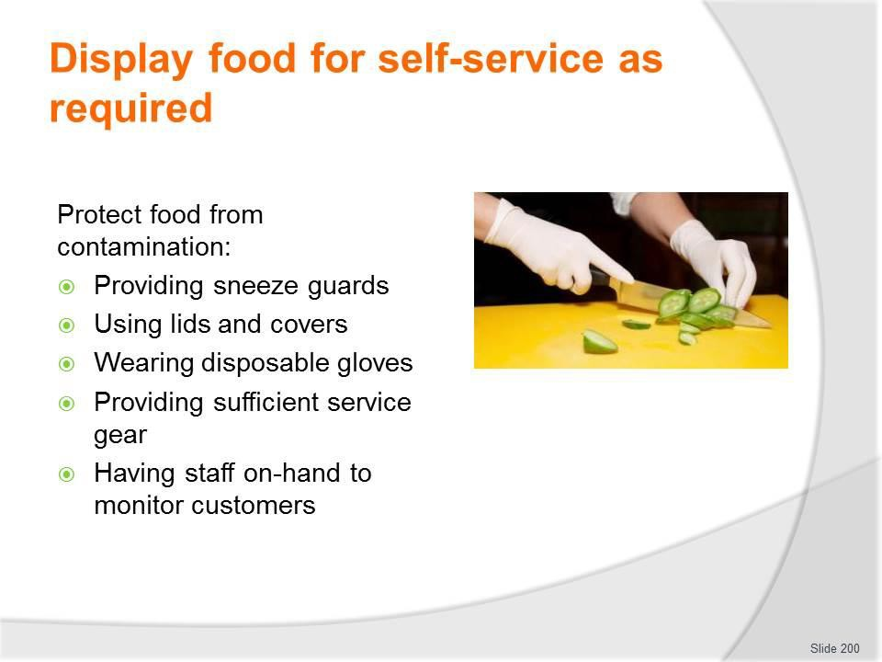
Slide No | Trainer Notes
200. | Trainer continues presenting activities involved in readying food for self-service stating it can be/is necessary to:  - Protect food from contamination – by following standard practices such as:  - Checking/ensuring integrity of food displayed during production and when it is transferred to the display units  - Covering food whenever possible – while on display and during actual service  - Not touching food with bare hands – to prevent contamination  - Wearing disposable gloves when serving/handling food  - Eliminating pests/flies from the service area as best as can be achieved  - Using sneeze guards, where practicable – to protect food from coughs and sneezes of users  - Never using service gear which have been dropped on the floor/ground  - Not using service utensils which have been used by customers to eat/taste food  - Providing sufficient and suitable food service implements to facilitate self- service of food  - Tasking staff with monitoring customer activity – so they might, as the need arises:  - Remove contaminated food from display  - Replace contaminated service gear  - Provide help/advice to younger customers.

Classroom Activity – Practical Group Exercise
Trainer presents students with required resources and a tour/camp site catering scenario and works with them to set-up a suitable self-service area to accommodate a given meal/menu.

Slide
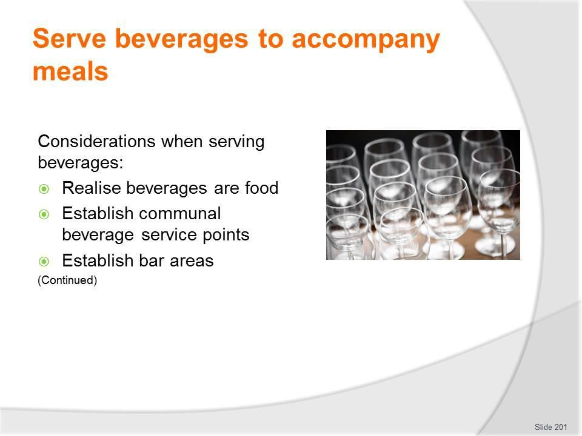
Slide No | Trainer Notes
201. | Trainer presents considerations when serving beverages as part of camp site catering:  - Realise from the viewpoint of food safety that beverages are food – so all the safe food hygiene protocols which apply to food need to apply to drinks  - Establish communal beverage service points – for self-service of hot and cold drinks. Locate these so they:  - Avoid crowding at food service areas  - Separate cold from hot drinks – to reduce congestion at each point  - Establish bar areas – for staff service of drinks:  - Direct to customers  - Using table service.

Slide
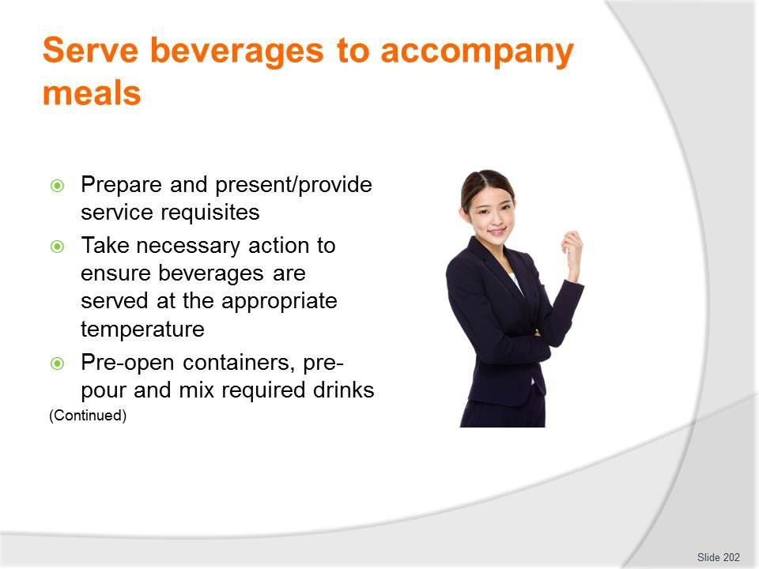
Slide No | Trainer Notes
202. | Trainer continues presenting considerations when serving beverages:  - Prepare and present/provide service requisites – such as:  - Glassware; Cups; Spoons; Milk; Tea and coffee; Drink garnishes and/or decorations  - Take necessary action to ensure beverages are served at the appropriate temperature – that is:  - Hot drinks should be hot; Cold drinks should be cold  - Pre-open containers – in advance of service sessions as identified by pre-arranged beverage lists/requirements, and:  - Mix drinks and decant bulk beverages into jugs and/or glasses ready for service and/or use by customers  - Pre-pour beverages from containers – ready for:  - Communal service points; Table service;  - Direct customer service.

Slide
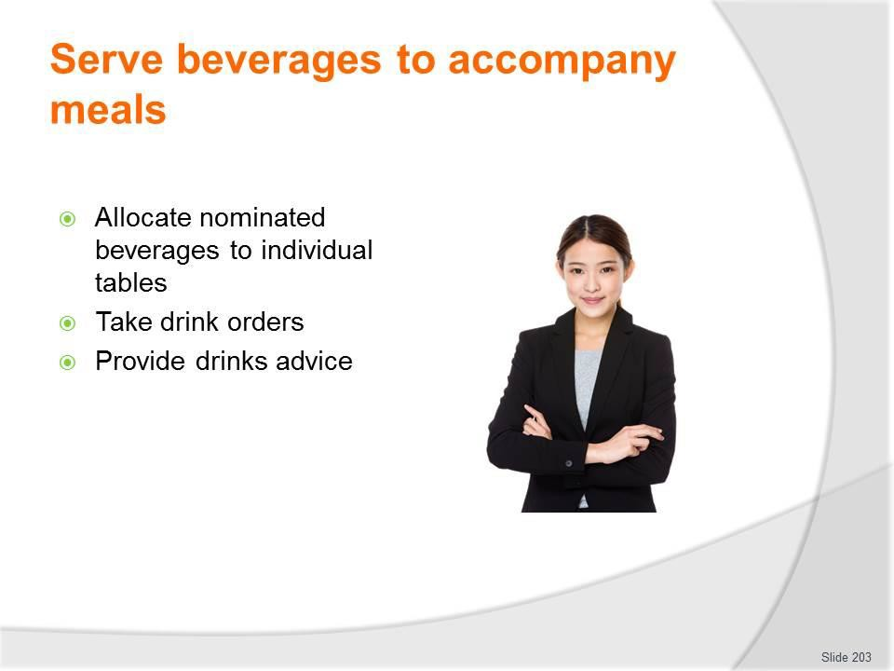
Slide No | Trainer Notes
203. | Trainer continues presenting considerations when serving beverages:  - Allocate nominated beverages to individual tables – in accordance with meal plan, by:  - Type  - Quantity  - Take drink orders – where:  - Customers pay for each drink they order  - A range of drink options is provided as part of the set menu  - Provide drinks advice – in terms of:  - Making recommendations  - Matching wine/s to food  - Giving information on available beverages  - Notifying tour group members about contents of pre-mixed drinks.

Slide
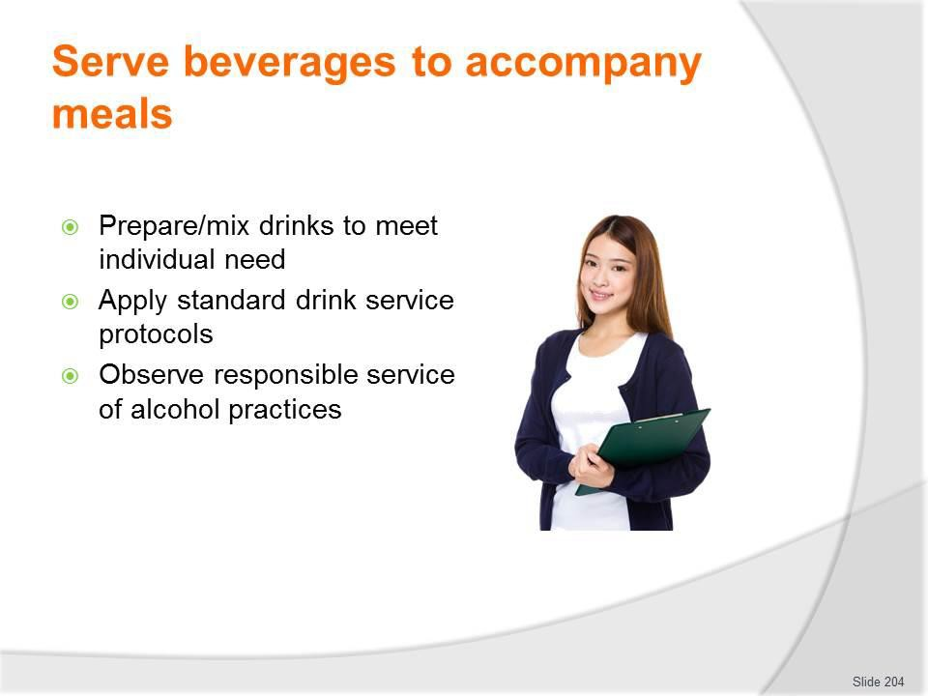
Slide No | Trainer Notes
204. | Trainer continues presenting considerations when serving beverages:  - Prepare/mix drinks to meet individual need – ensuring:  - A comprehensive knowledge of the beverages available – as there is always a restricted range of drinks and always a need to recommend alternatives  - Standard portion control practices are observed – to:  - Protect financial performance of the catering  - Help drinkers control/monitor their alcohol intake  - Apply standard drink service protocols – including:  - Not handling glasses by the top/rim of the glass  - Washing/cleaning and drying glasses between uses  - Observe responsible service of alcohol practices – which (may) mean:  - Complying with local liquor laws  - Not serving minors  - Not serving drunks  - Only serving liquor to accompany meals  - Not serving those who are not part of the tour group.

Classroom Activity – Practical Group Exercise
Trainer presents students with required resources and a tour/camp site catering scenario and works with them to set-up a suitable self-service area to accommodate a given meal/menu.

Slide
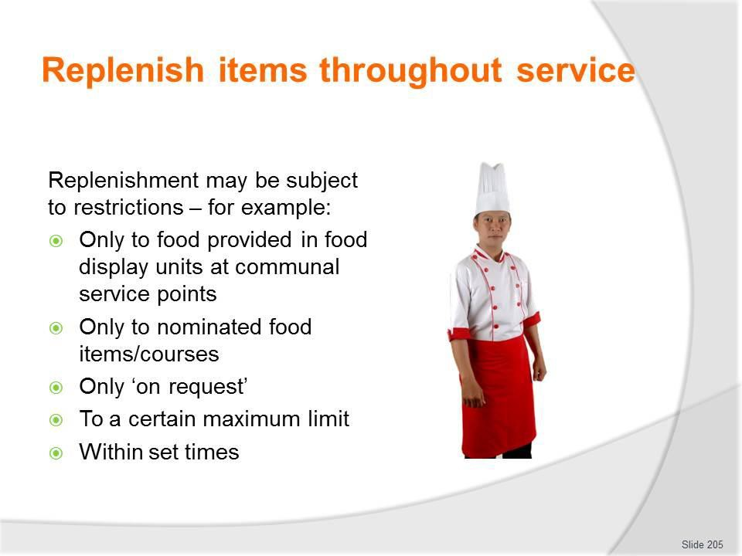
Slide No | Trainer Notes
205. | Trainer discusses replenishment of items stating:  - For many camp site meal times there can be a need to replenish items during service  - In most cases this requirement may apply:  - Only to food provided in food display units at communal service points – and not to direct service to customers ‘at the table’  - Only to nominated food items – such as:  - Bread/rolls and butter and/or vegetables and salad but not to central/protein elements of the meal  - Certain courses of the meal – for example, entrees and desserts may be replenished but not main courses  - Only ‘on request’ – meaning additional items may not be offered but can be provided if asked for  - To a certain maximum limit – there is never/rarely unlimited amounts of food/beverages which can be provided  - Within set times – meaning there may be a time after which additional items will not be provided.

Slide
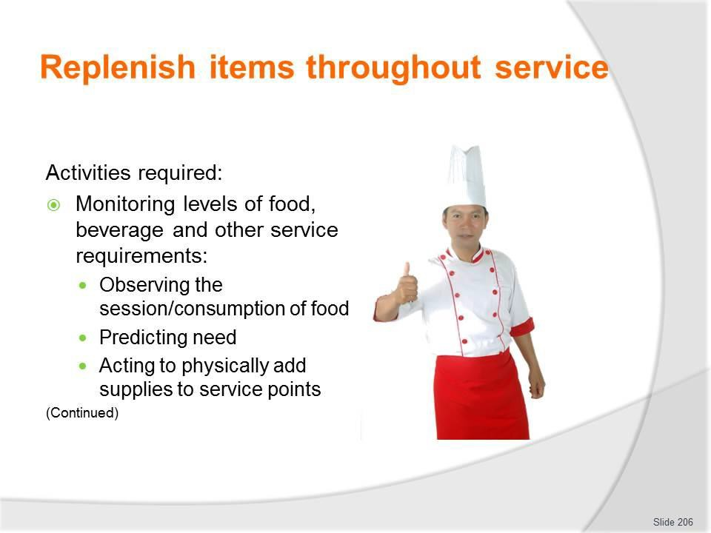
Slide No | Trainer Notes
206. | Trainer explains activities inherent in replenishment can include:  - Monitoring levels of food, beverage and other service requirements – by:  - Observing the service session  - Being alert to signals from customers they want service/need attention  - Predicting need to re-supply items based on usage rates and numbers already served/numbers remaining  - Factoring in relevant factors as they apply to each service session – which may include:  - Arrival patterns of customers  - Profiles of customers  - Customer satisfaction with/enjoyment of food and beverage items  - Taking action to physically add supplies to service points – as required in accordance with:  - Actual usage levels  - Estimated future usage  - Amounts remaining/available to be served.

Slide
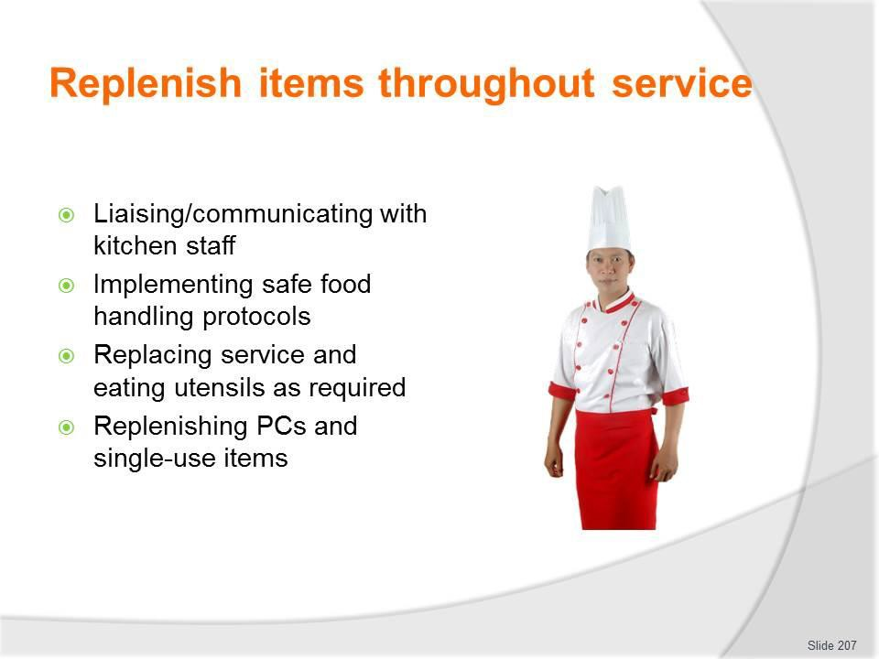
Slide No | Trainer Notes
207. | Trainer continues explaining activities inherent in replenishment can include:  - Advising kitchen staff/catering crew regarding usage – so they may, as appropriate to the tour (by type and budget):  - Prepare more of the same food that is being used  - Prepare different food items  - Implementing safe food hygiene practices – which can include:  - Rotating stock and serving food that was prepared first, first – that is, applying FIFO stock rotation principles  - Not mixing food batches  - Applying safe food handling procedures when providing additional/extra items  - Replacing service and eating utensils – as required  - Replacing amounts of PC packs and single-use items – to prevent them running out.

Slide
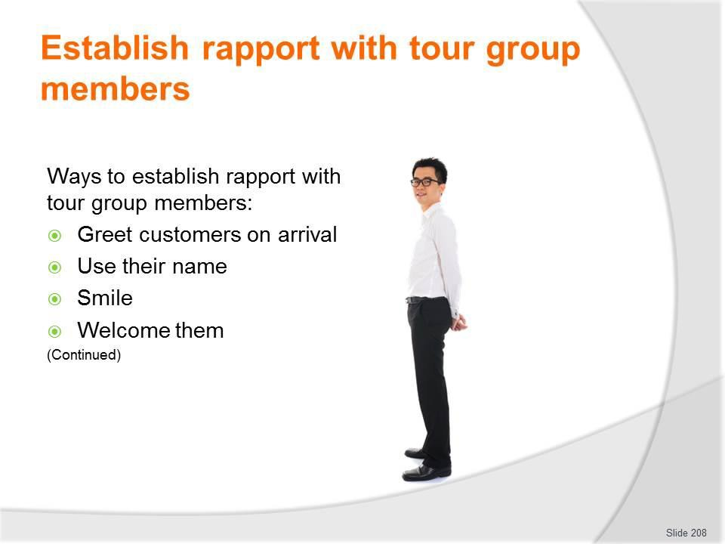
Slide No | Trainer Notes
208. | Trainer explains importance of serving staff establishing and maintaining a positive relationship with tour group members identifying techniques to do so:  - Greet customers – on their arrival at the food service area  - Use their name when talking to them – many will be wearing a name tag  - Smile when talking to them/serving them – it is truly a universal language understood by people from all countries  - Welcome them – to the food area and the meal/service session.

Slide
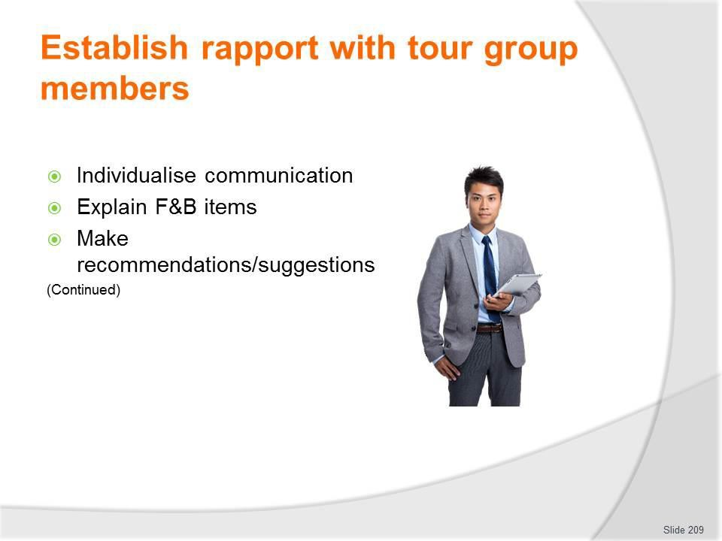
Slide No | Trainer Notes
209. | Trainer continues explaining actions to establish rapport with diners/tour group members:  - Individualise the communication – so it does not appear disinterested or robotic  - Explain food and beverage items – with attention to:  - Describing ingredients, recipes and tastes  - Highlighting what is included in the tour and what has to be paid for as an extra  - Detailing any limits/restrictions which might apply to food, drinks, time, dining area, service  - Recommending beverages (from the available list) to accompany meals  - Making food and beverage recommendations/suggestions – based on:  - Asking questions to determine customers needs/preferences  - Advising them based on personal experience  - Availability of items including knowledge about stock levels and/or items which the bar/kitchen wants to ‘push’  - Encouraging individuals to try something new or different.

Slide
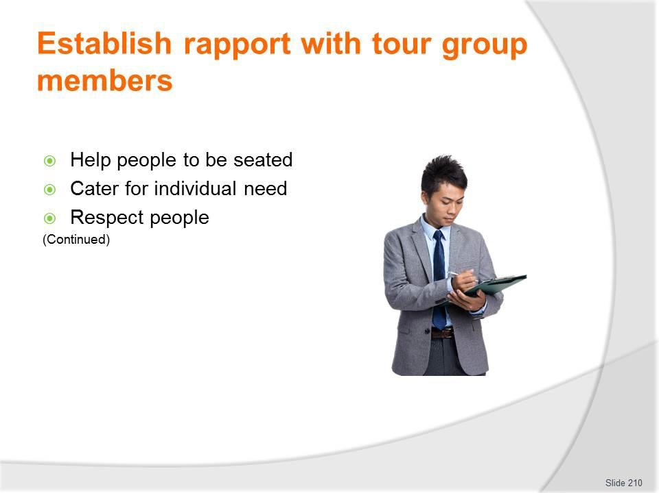
Slide No | Trainer Notes
210. | Trainer continues explaining actions to establish rapport with diners/tour group members:  - Individualise the communication – so it does not appear disinterested or robotic  - Explain food and beverage items – with attention to:  - Describing ingredients, recipes and tastes  - Highlighting what is included in the tour and what has to be paid for as an extra  - Detailing any limits/restrictions which might apply to food, drinks, time, dining area, service  - Recommending beverages (from the available list) to accompany meals  - Making food and beverage recommendations/suggestions – based on:  - Asking questions to determine customers needs/preferences  - Advising them based on personal experience  - Availability of items including knowledge about stock levels and/or items which the bar/kitchen wants to ‘push’  - Encouraging individuals to try something new or different.

Slide
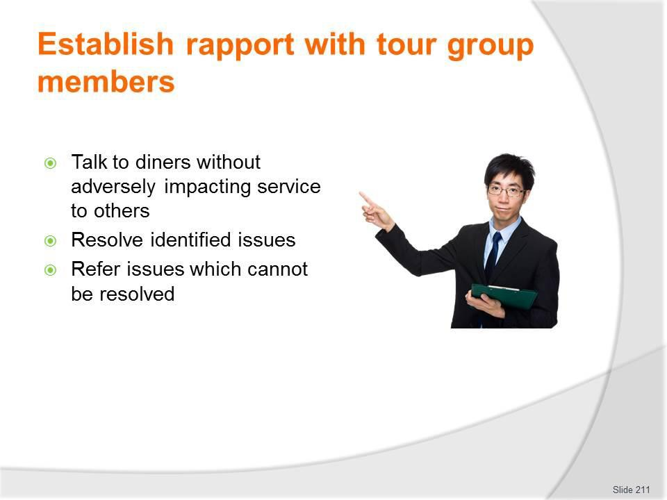
Slide No | Trainer Notes
211. | Trainer continues explaining actions to establish rapport with diners/tour group members:  - Communicate with individuals when time exists to do so without adversely impacting service delivery – and:  - Sharing their experiences of the tour  - Seeking their feedback on the tour, food, beverages and service  - Providing information – such as:  - Giving details on history, communities, facilities and similar  - Reminding tour group members not to feed local fauna  - Advising on local laws and customs  - Resolve identified problems – within individual scope of authority  - Refer issues which cannot be successfully resolved – to Supervisor so they can take appropriate action.  Classroom Activity – Demonstration and Role Plays  Trainer creates simulated service situation and demonstrates how to establish rapport with tour group members providing role play opportunities for students to do the same.

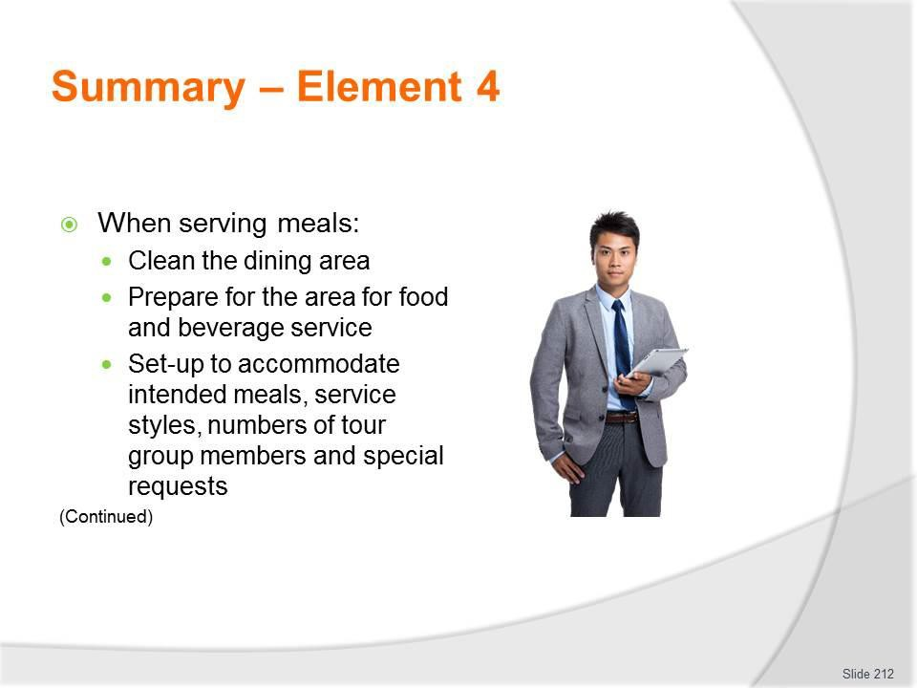
Slide
Slide No
Trainer Notes
212.
Trainer provides a recap of the Element asking questions to check trainee understanding and responding to questions from trainees, as required.

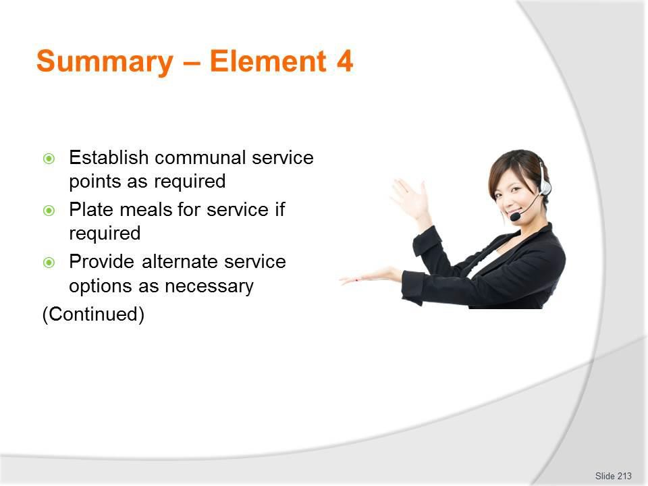
Slide
Slide No
Trainer Notes
213.
Trainer provides a recap of the Element asking questions to check trainee understanding and responding to questions from trainees, as required.

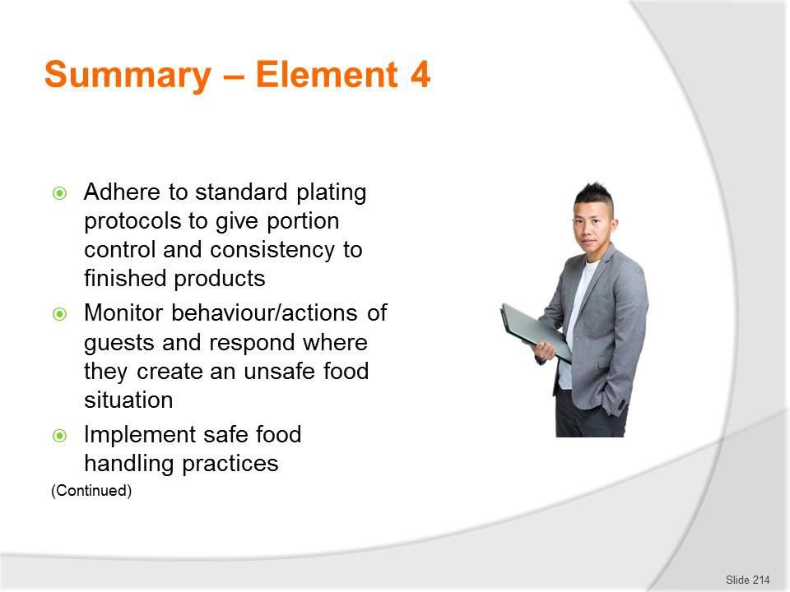
Slide
Slide No
Trainer Notes
214.
Trainer provides a recap of the Element asking questions to check trainee understanding and responding to questions from trainees, as required.

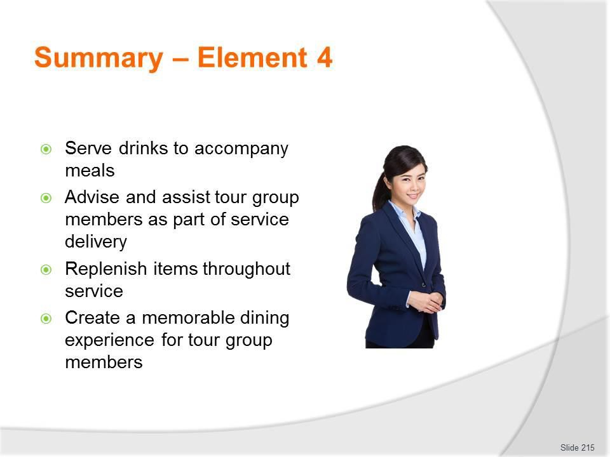
Slide
Slide No
Trainer Notes
215.
Trainer provides a recap of the Element asking questions to check trainee understanding and responding to questions from trainees, as required.

Slide
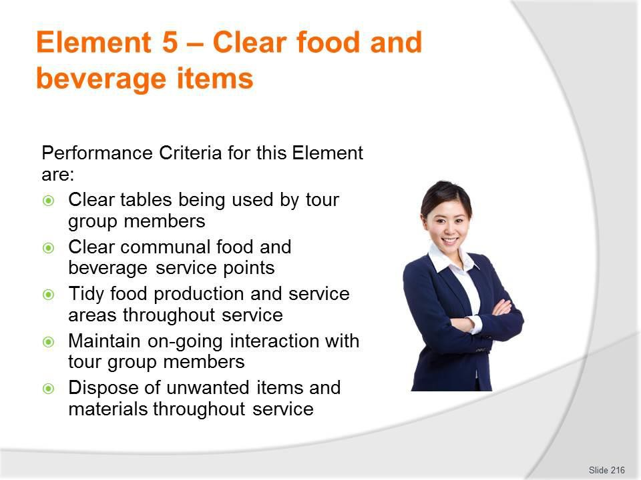
Slide No | Trainer Notes
216. | Trainer identifies for trainees the Performance Criteria for this Element, as listed on the slide.  Class Activity – General Discussion  Trainer leads a general class discussion by asking questions such as:  - What is meant be by ‘clearing’ food and beverage items?  - How is it done?  - When?  - What are important points to observe when doing it?

Slide
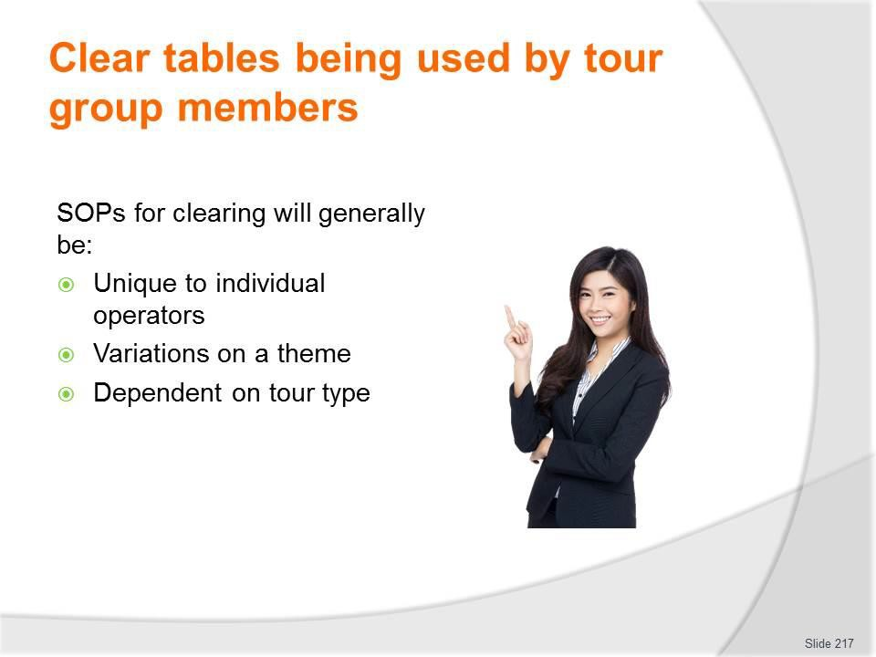
Slide No | Trainer Notes
217. | Trainer gives background to clearing tables stating every tour operator/catering crew will have their own individual protocols for clearing camp site tables but their SOPs will generally:  - Be variations on a theme – meaning they are all essentially the same  - Depend on the tour type – in that:  - Actions for scheduled tours will stay the same for each type of standard tour  - Special, one-off requirements can often apply to custom tours – in terms of things such as:  - Timing of clearing of courses  - Number of staff to be used  - Items to be cleared from, and items to remain on, the tables.

Slide
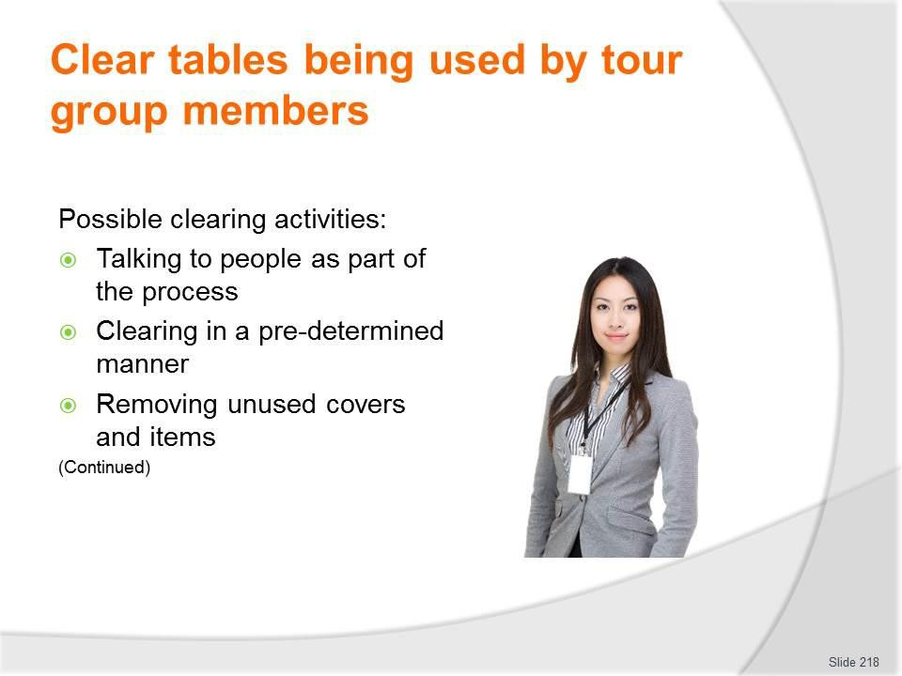
Slide No | Trainer Notes
218. | Trainer indicates activities possibly required when clearing meal tables used by tour group members:  - Talking to diners as part of the clearing process – to:  - Ask people for permission to clear their plates – as opposed to simply taking them  - Develop/maintain rapport  - Clearing in a pre-determined manner – for example:  - As individuals finish their meal  - When a full table has completed their meal  - At a set time  - Removing unused covers and items – from tables:  - After first course has been started  - On an ongoing basis on a course-by-course basis.  Classroom Activity – Demonstration and Practical  Trainer demonstrates activities identified on the slide and provides opportunity for students to do the same.

Slide
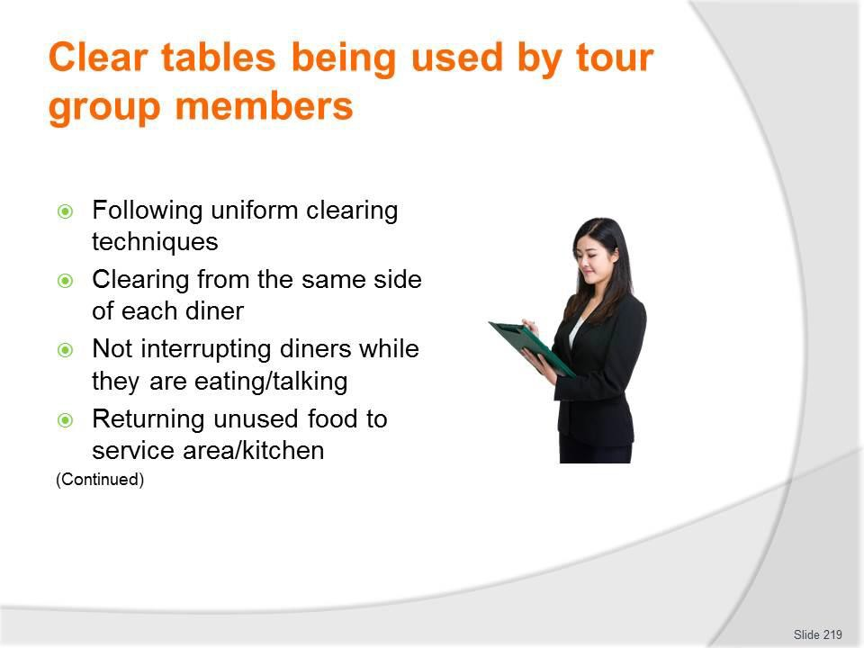
Slide No | Trainer Notes
219. | Trainer continues indicating activities possibly required when clearing meal tables:  - Following a uniform clearing method for all tables – such as:  - Clearing to trays – and carrying trays to clearance points or the kitchen/dishwashing area  - Using designated plate carrying protocols to remove items – such as the 2-plate carry, 3-plate carry or other  - Clearing all used food plates and cutlery from the same side of the diner – as determined by the service protocols of the tour operator/catering crew  - Not interrupting guests – if they are talking or still eating  - Returning unused food to the service area or kitchen – for:  - Disposal – where SOP or FSP requires all left-over food is discarded  - Storage for later use – where safe to do so.  Classroom Activity – Demonstration and Practical  Trainer demonstrates activities identified on the slide and provides opportunity for students to do the same.

Slide
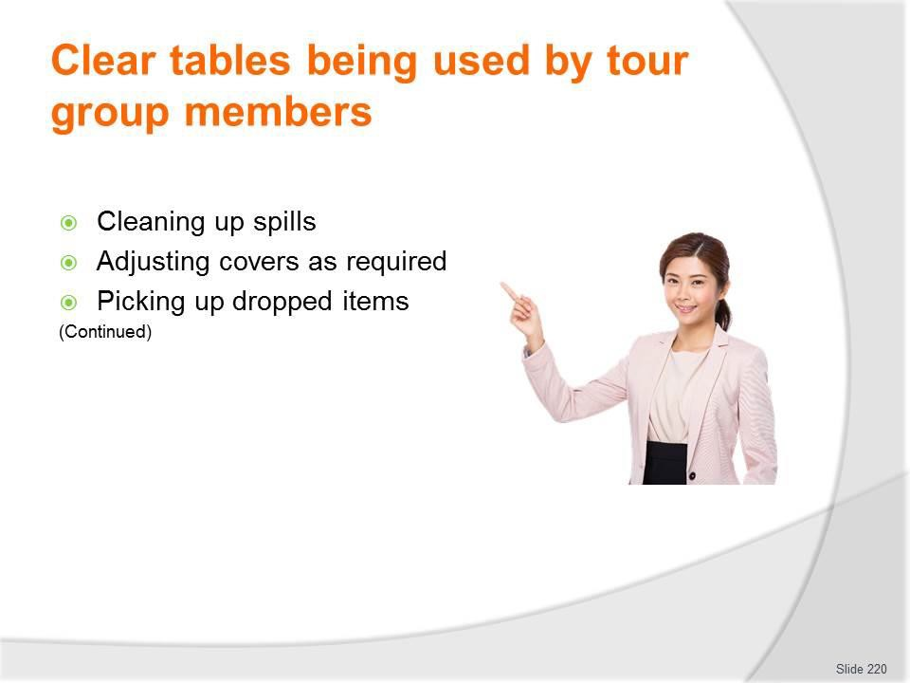
Slide No | Trainer Notes
220. | Trainer continues indicating activities possibly required when clearing meal tables:  - Cleaning up spills – as they may occur during clearing  - Adjusting the cover as required – where, for example:  - Have dropped an item on the ground; Have used the wrong item before its intended use; The next course requires additional/different items  - Picking up dropped items – including:  - Food; Cutlery and other service items; Serviettes and other single-use items; Personal items of the diners;  - Waste/rubbish.  Classroom Activity – Demonstration and Practical  Trainer demonstrates activities identified on the slide and provides opportunity for students to do the same.

Slide
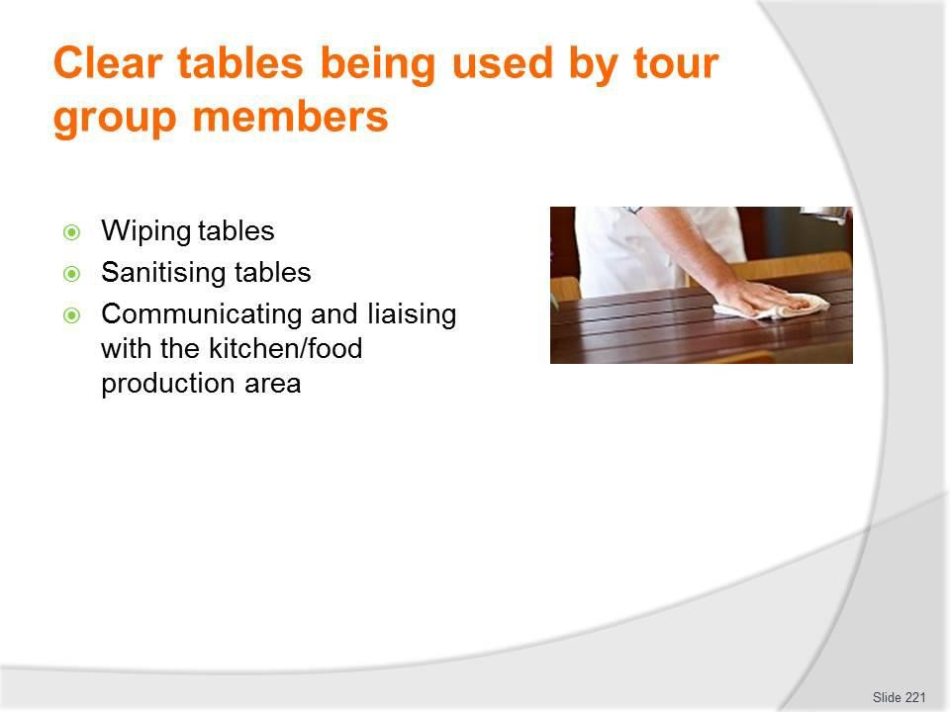
Slide No | Trainer Notes
221. | Trainer continues indicating activities possibly required when clearing meal tables:  - Wiping down and sanitising tables – which may be required:  - In between courses; At the end of meals  - Communicating with the kitchen – to:  - Advise of clearing progress; Give an indication of service time for next course; Pass on feedback received;  - Identify issues for future/next session.  Classroom Activity – Demonstration and Practical  Trainer demonstrates activities identified on the slide and provides opportunity for students to do the same.

Slide
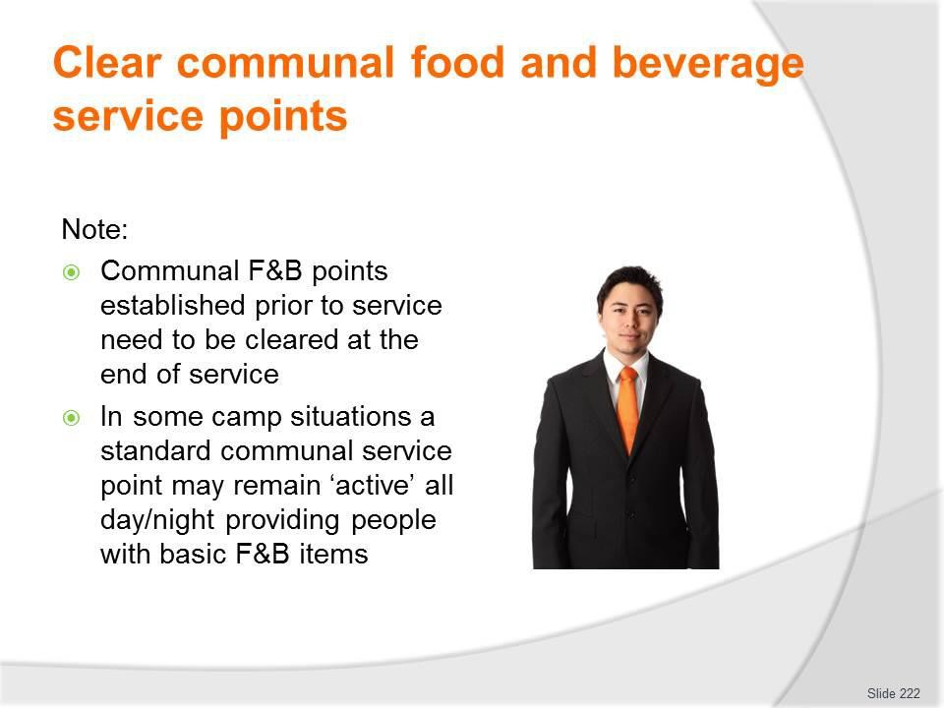
Slide No | Trainer Notes
222. | Trainer indicates:  - Communal F&B service points which were established prior to service need to be cleared at the end of service  - In some camp situations a standard communal service point may remain ‘active’ all day/night providing people with water, tea and coffee, juice and a limited range of PC sweet biscuits, sliced cake or cheese and crackers.)

Slide
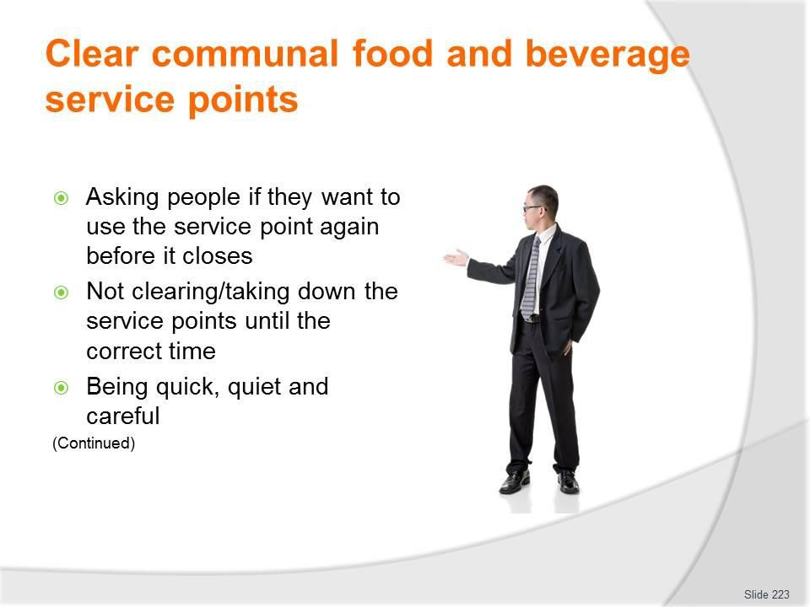
Slide No | Trainer Notes
223. | Trainer presents requirements when clearing these communal service points may include:  - Asking people if they want to use the service point again – as it is about to close/be cleared, so they have a chance to get themself another drink/item  - Not clearing/taking down the service points until the correct time – this may be:  - A pre-determined time  - When all diners have left  - As directed by the Supervisor  - Being quick, quiet and careful - so as to:  - Minimise time spent on this activity  - Avoid adverse impact of tour group  - Prevent damage to equipment  - Protect food/beverages which are safe to re-use/serve again.

Slide
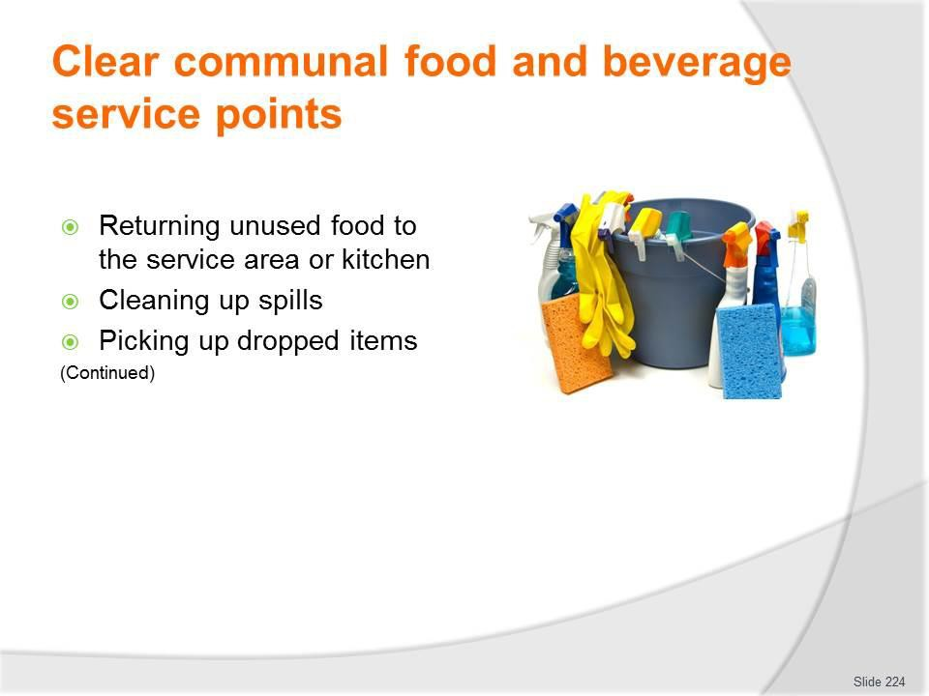
Slide No | Trainer Notes
224. | Trainer continues presenting activities when clearing communal F&B points:  - Returning unused food to the service area or kitchen – for:  - Disposal – where SOP or FSP requires all left-over food is discarded  - Storage for later use – where safe to do so  - Cleaning up spills – as they:  - Have occurred during service  - Occur during clearing  - Picking up dropped items – including:  - Food  - Cutlery and other service items  - Serviettes and other single-use items  - Personal items of the diners  - Waste/rubbish.  Classroom Activity – Demonstration and Practical  Trainer demonstrates activities identified on the slide and provides opportunity for students to do the same.

Slide
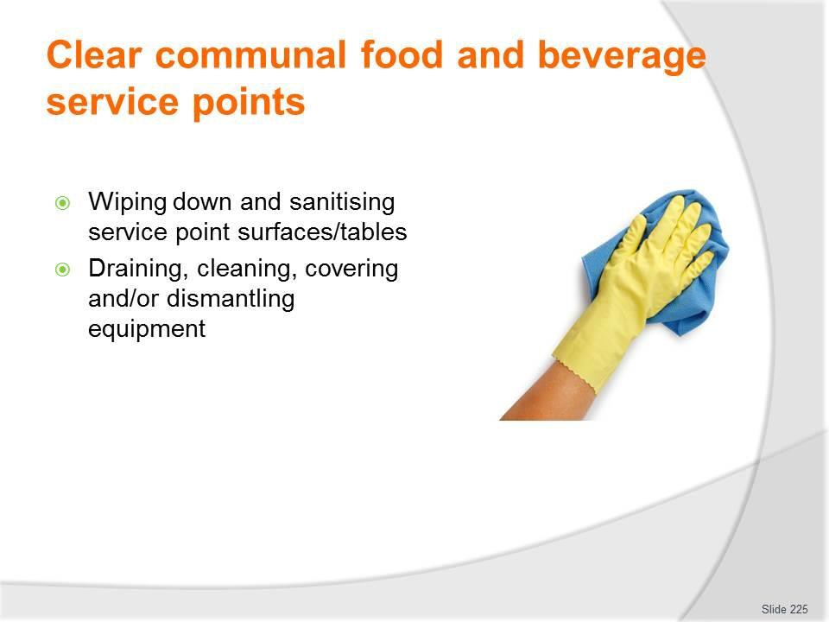
Slide No | Trainer Notes
225. | Trainer continues presenting activities when clearing communal F&B points:  - Wiping down and sanitising service point surfaces/tables – which may be required:  - In between courses  - At the end of meals  - Draining equipment – such as urns and wet bain maries, and:  - Cleaning and drying them  - Covering them and leaving them in place for next session  - Removing them for bump out, as required.  Classroom Activity – Demonstration and Practical  Trainer demonstrates activities identified on the slide and provides opportunity for students to do the same.

Slide
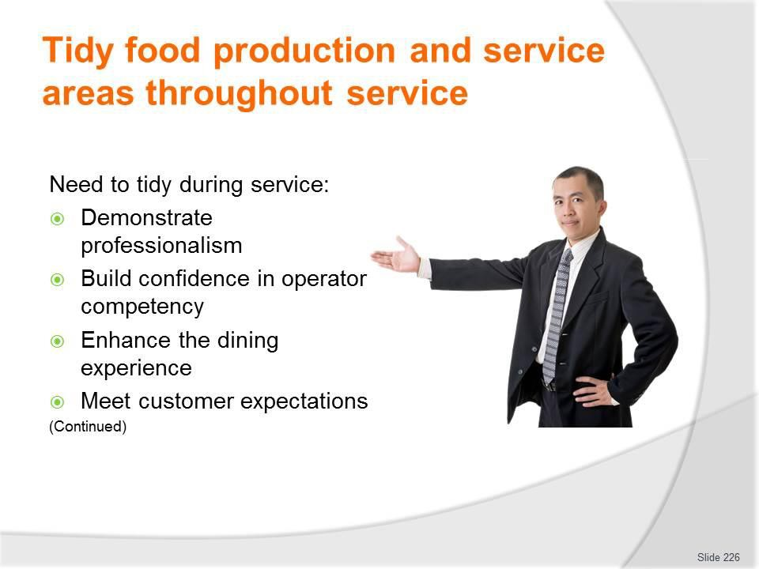
Slide No | Trainer Notes
226. | Trainer continues presenting activities when clearing communal F&B points:  - Wiping down and sanitising service point surfaces/tables – which may be required:  - In between courses  - At the end of meals  - Draining equipment – such as urns and wet bain maries, and:  - Cleaning and drying them  - Covering them and leaving them in place for next session  - Removing them for bump out, as required.  Classroom Activity – Demonstration and Practical  Trainer demonstrates activities identified on the slide and provides opportunity for students to do the same.

Slide
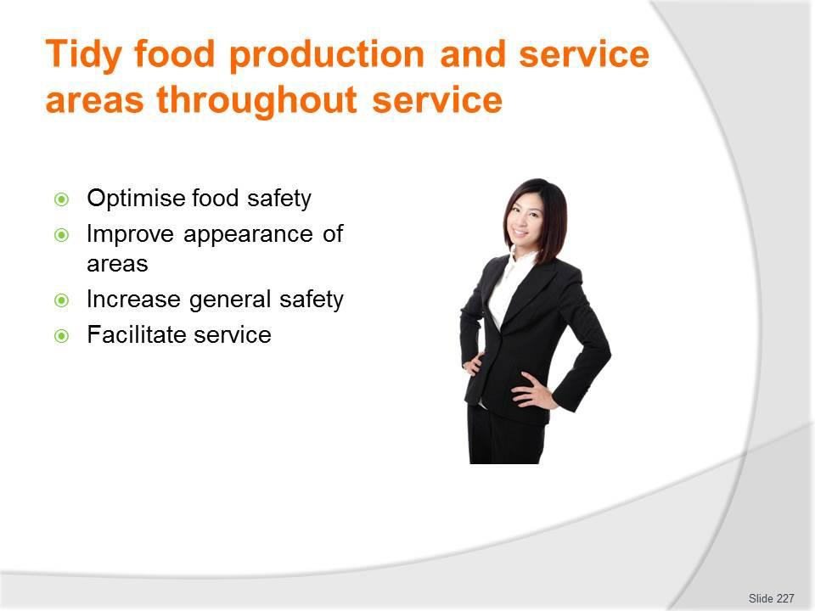
Slide No | Trainer Notes
227. | Trainer continues discusses need to tidy during service:  - Optimise food safety – through removal of materials which may cause contamination  - Improve the appearance of the areas – so the areas look more attractive  - Increase general safety – removal of rubbish can mean removal of risk  - Facilitate service – as things are replaced/put where they should be and everyone knows where to find them when they need them.

Slide
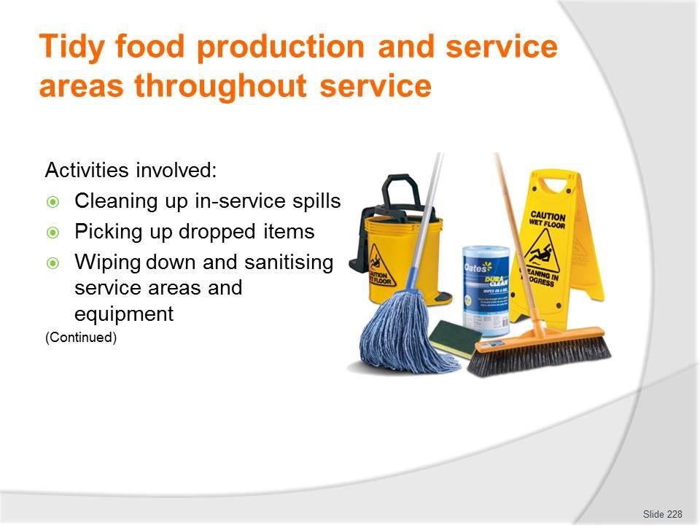
Slide No | Trainer Notes
228. | Trainer presents activities involved in tidying the food production and service area:  - Cleaning up in-service spills – to:  - Facilitate later/full cleaning – making the final cleaning of the areas quicker/easier  - Enhance the immediate operational safety of the area – by getting rid of potential causes of ‘slips and trips’  - Remove food sources which may attract pests  - Picking up dropped items – including:  - Food – and disposing of all food that has been dropped on the floor  - Cutlery – and replacing same for diners where required  - Serviettes – to keep the service area neat, replacing them for people as necessary  - Personal items accidentally dropped by customers – as a professional service and courteous act  - Wiping down and sanitising service areas and equipment – as planned, which may mean:  - Cleaning with a nominated cloth and using a nominated chemical to sanitise after the clearing of identified courses  - Cleaning at a given time of the day – such as every four hours, regardless.

Classroom Activity – Demonstration and Practical
Trainer demonstrates activities identified on the slide and provides opportunity for students to do the same.

Slide
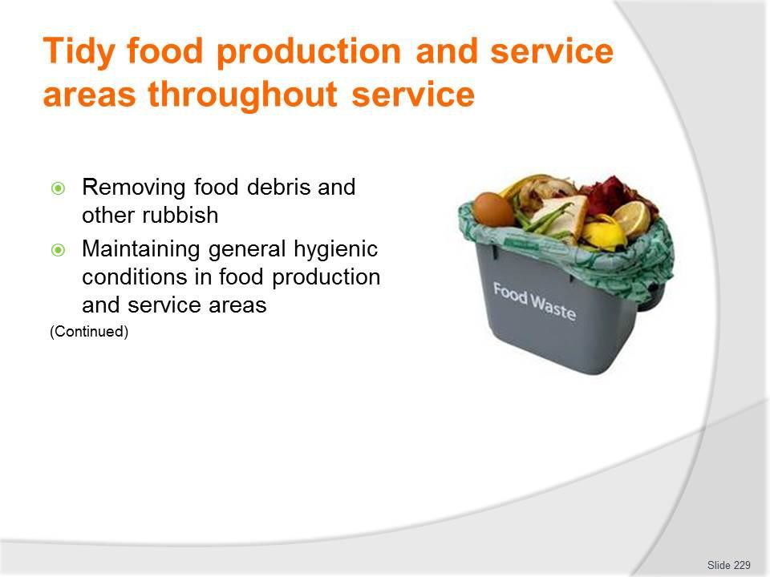
Slide No | Trainer Notes
229. | Trainer continues presenting activities involved in tidying the food production and service area:  - Removing food debris and other rubbish – to:  - Designated rubbish containers – in the service area and/or the kitchen area, which may require separation of:  - Food waste  - General waste  - Recyclable materials  - Designated areas – which may be:  - Specified by the camp site owners/operators  - Created by the camp catering crew especially for the tour  - Maintaining general hygienic conditions in food production and service areas – which can involve:  - Undertaking pest management/control – to limit flies, insects and other pests/rodents  - Monitoring food – to ensure it remains fit for human consumption or is thrown out  - Protecting and/or covering food – from flies, dust and other contamination  - Checking temperature and condition of food – as part of other service-related and tidying duties

- Making sure food handlers wash their hands after handling rubbish/undertaking cleaning and before handing food/food items again.
Classroom Activity – Demonstration and Practical
Trainer demonstrates activities identified on the slide and provides opportunity for students to do the same.

Slide
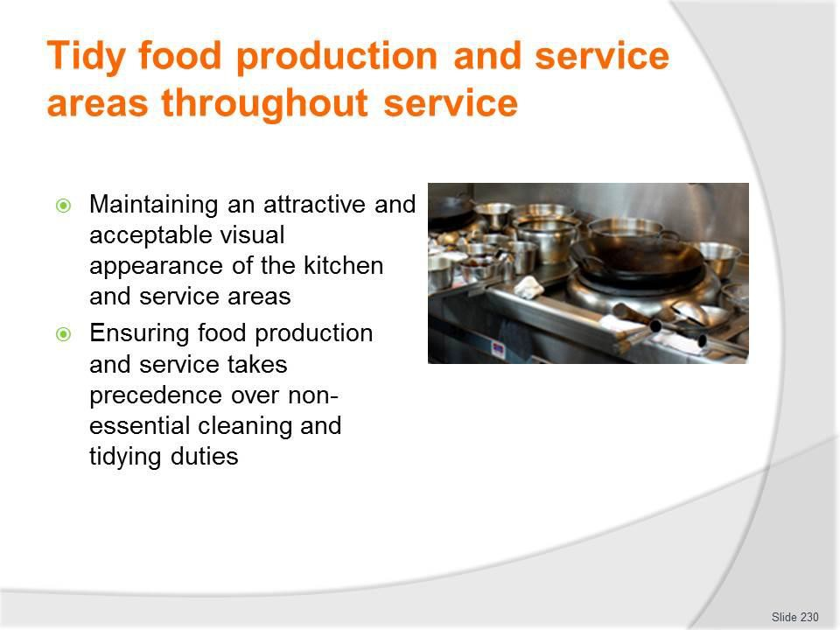
Slide No | Trainer Notes
230. | Trainer continues presenting activities involved in tidying the food production and service area:  - Maintaining an attractive and acceptable visual appearance of the kitchen and service areas – which must involve:  - Seeing things through the eyes of the customers/tour group members  - Realising a tidy/professional appearance is a legitimate and important element of the total service experience  - Understanding the strong and direct link which often occurs between tidiness and cleanliness – that is, areas which are tidy are often also areas which are clean  - Ensuring food production and service takes precedence over non-essential cleaning and tidying duties – such that:  - Making and serving food takes priority over tidying and cleaning  - Customers should never be forced to wait while cleaning and tidying occurs  - Workers should:  - Use the ‘small change’ of time to clean and tidy  - Try to do two things at once – for example, tidy a table as they clear it  - Try to take something out of the service area when they leave it – and not leave empty-handed.

Classroom Activity – Demonstration and Practical
Trainer demonstrates activities identified on the slide and provides opportunity for students to do the same.

Slide
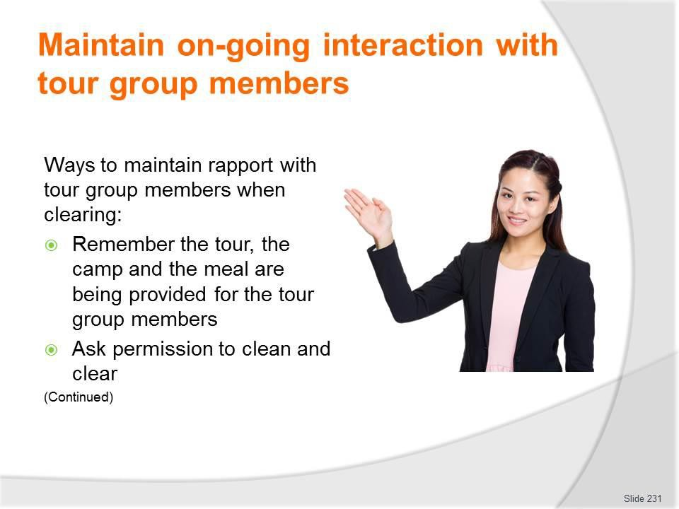
Slide No | Trainer Notes
231. | Trainer presents techniques to maintain rapport with tour group members when clearing:  - Remember the tour, the camp and the meal are being provided for the tour group members – so:  - Give tour group members right-of-way – let them ‘go first’: do not get in their way or push through them  - Do not interrupt them  - Never do work to annoy them or distract from their enjoyment or experience’  - Take care – not to bump into people or knock them or their belongings  - Ask permission – to:  - Clear and clean  - Take items, plates and glasses  - Never assume things can be done/taken.  Classroom Activity – Demonstration and Practical  Trainer demonstrates activities identified on the slide and provides opportunity for students to do the same.

Slide
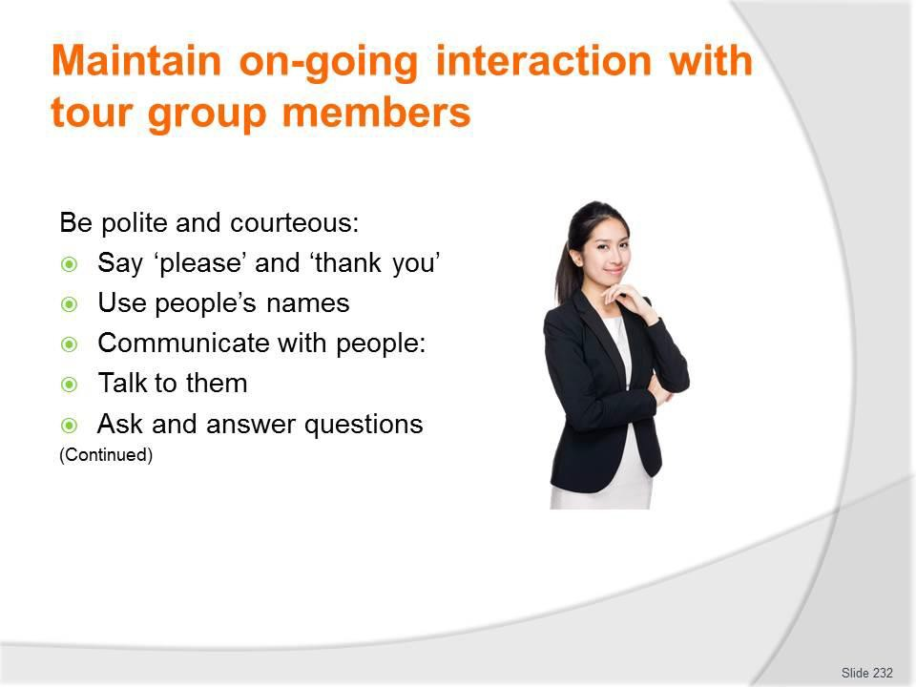
Slide No | Trainer Notes
232. | Trainer continues presenting techniques to maintain rapport with tour group members when clearing:  - Be polite and courteous – which means:  - Saying ‘please’ and ‘thank you  - Using people’s names  - Knowing when to engage with people – and when to keep quiet and leave people alone  - Refraining from complaining to customers – about the supervisor, work, conditions, pay  - Communicate with people – which may involve:  - Asking how they enjoyed their meal and seeking feedback on the service  - Seeking suggestions for change/improvement  - Identifying and resolving complaints  - Providing local information  - Using positive body language – and smiling  - Monitoring/reading the non-verbal communication of diners – to help detect if there is a problem/issue which needs to be addressed.

Classroom Activity – Demonstration and Practical
Trainer demonstrates activities identified on the slide and provides opportunity for students to do the same.

Slide
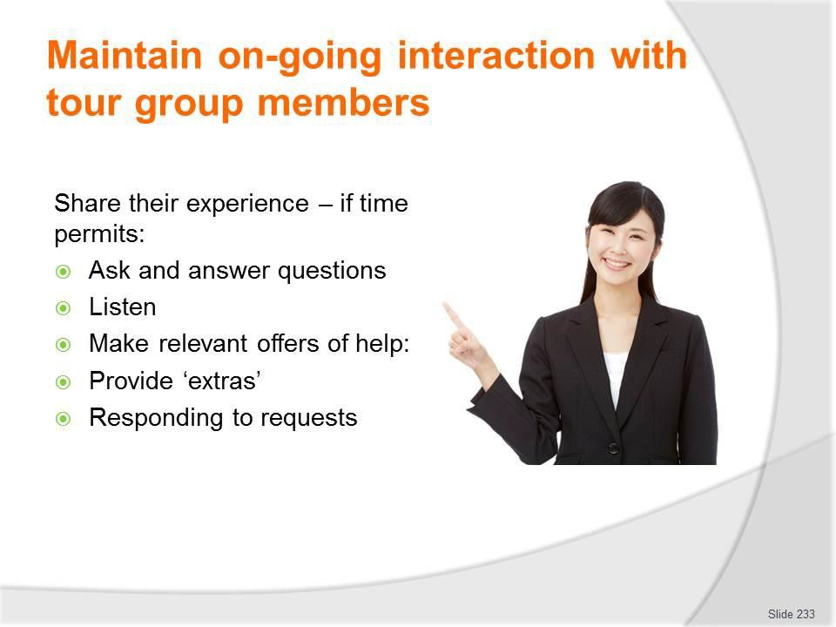
Slide No | Trainer Notes
233. | Trainer continues presenting techniques to maintain rapport with tour group members when clearing:  - Share their experience (but not allowing this to dominate the work that needs to be done and not allowing one customer to feel others are receiving preferential treatment) – which can be done by:  - Following-up on previous conversations – in which tour group members have indicated where they are going and what they are going to do  - Asking where they have already been and what they have already done  - Enquiring what they are doing next/tomorrow  - Listening to their tales/anecdotes  - Giving tips/advice on up-coming activities and destinations – so they get the most from them  - Make relevant offers of help – such as:  - Providing ‘extras’ where possible/within scope of authority or budget – such as:  - Another drink  - A snack to take away  - Promising to find out if a special request can be accommodated  - Finding out what is on the menu tomorrow/next meal  - Notifying Supervisor where tour group members require their attention to deal with an issue.

Classroom Activity – Demonstration and Practical
Trainer demonstrates activities identified on the slide and provides opportunity for students to do the same.

Slide
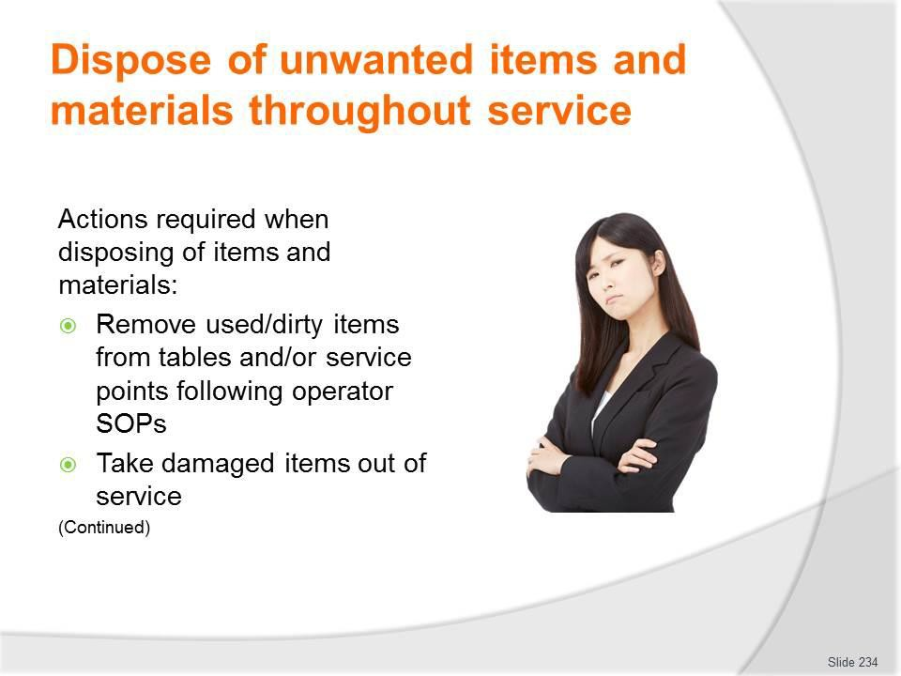
Slide No | Trainer Notes
234. | Trainer discusses actions required when disposing of items and materials:  - Remove used/dirty items from tables and/or service points – for:  - Clearance to washing areas  - Disposal as appropriate  - House/tour operator specifications will determine how this is done – options include:  - By hand/carrying items in hands  - By tray/carrying items on a (service) tray  - Take damaged items out of service – and remove them, as relevant, to:  - An area for later repairs/maintenance  - To a waste area where the item needs to be disposed of – note there can be a need to transport some damaged items back to head office for disposal there as suitable disposal areas do not always exist at every camp site.  Classroom Activity – Demonstration and Practical  Trainer demonstrates activities identified on the slide and provides opportunity for students to do the same.

Slide
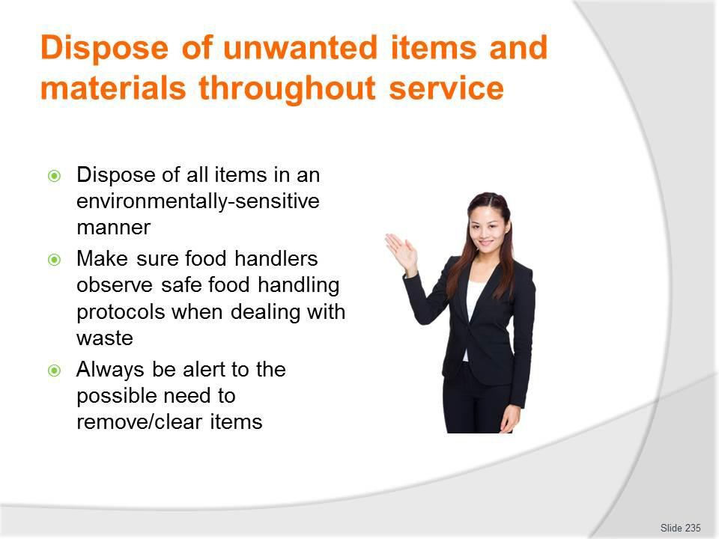
Slide No | Trainer Notes
235. | Trainer continues discussing actions required when disposing of items and materials:  - Dispose of all items in an environmentally-sensitive manner – see later slides  - Make sure food handlers observe safe food handling protocols when dealing with waste – which may require/include:  - Washing their hands after handling waste/rubbish and before handling food/food items again  - Wearing protective gloves when handling rubbish  - Protecting food from contamination by waste:  - Through physical separation  - By covering food, food surfaces and food items  - Always be alert to the possible need to remove/clear items – whenever leaving the service area in order to:  - Never leave the dining area empty-handed  - Reduce time required for clearing at other times during service  - Make room/space for fresh items to be brought in to the dining areas/placed on tables and at communal service points.  Classroom Activity – Demonstration and Practical  Trainer demonstrates activities identified on the slide and provides opportunity for students to do the same.

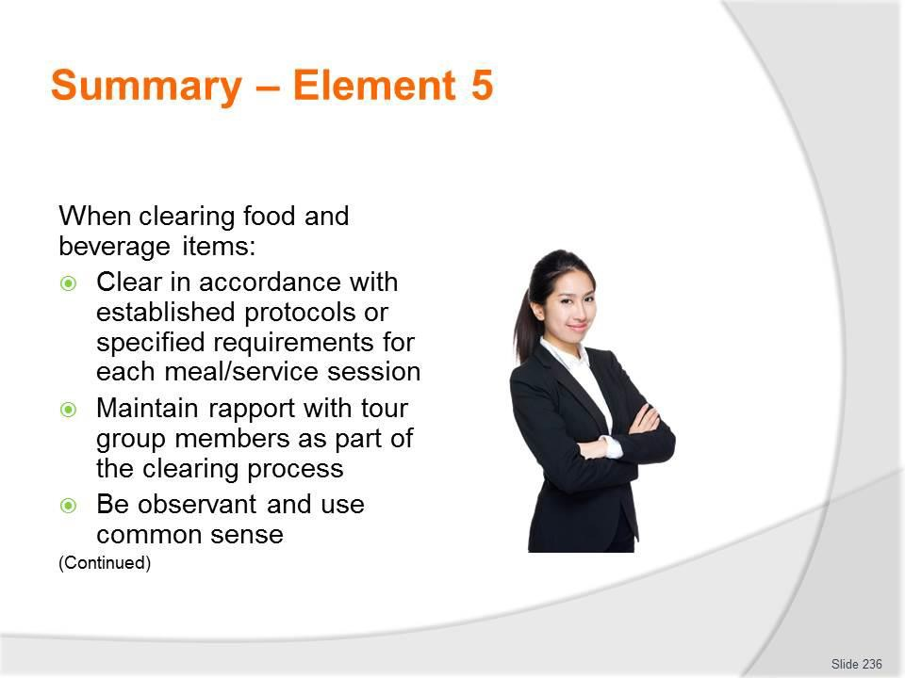
Slide
Slide No
Trainer Notes
236.
Trainer provides a recap of the Element asking questions to check trainee understanding and responding to questions from trainees, as required.

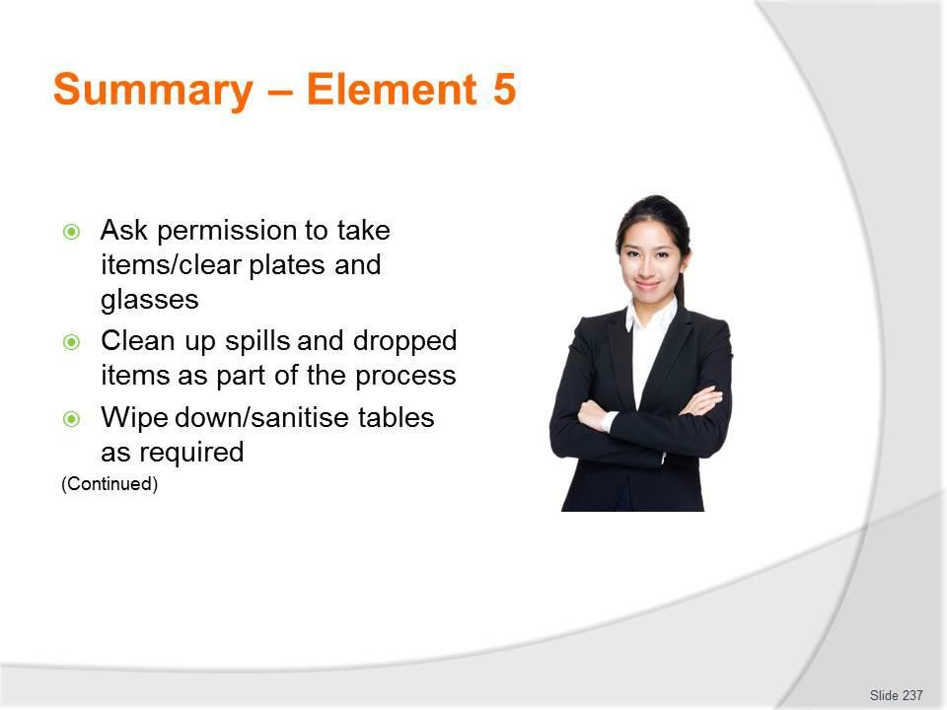
Slide
Slide No
Trainer Notes
237.
Trainer provides a recap of the Element asking questions to check trainee understanding and responding to questions from trainees, as required.

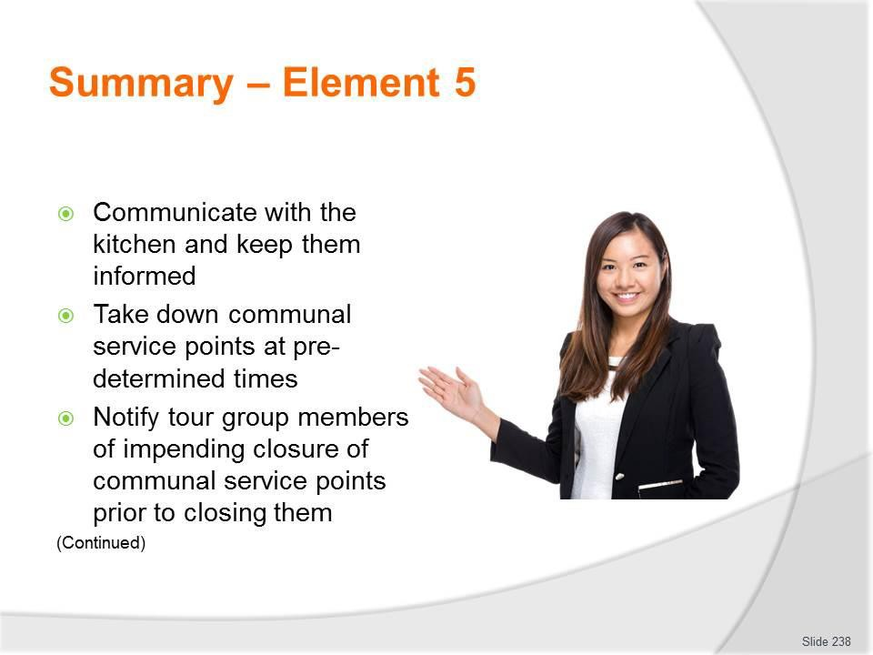
Slide
Slide No
Trainer Notes
238.
Trainer provides a recap of the Element asking questions to check trainee understanding and responding to questions from trainees, as required.

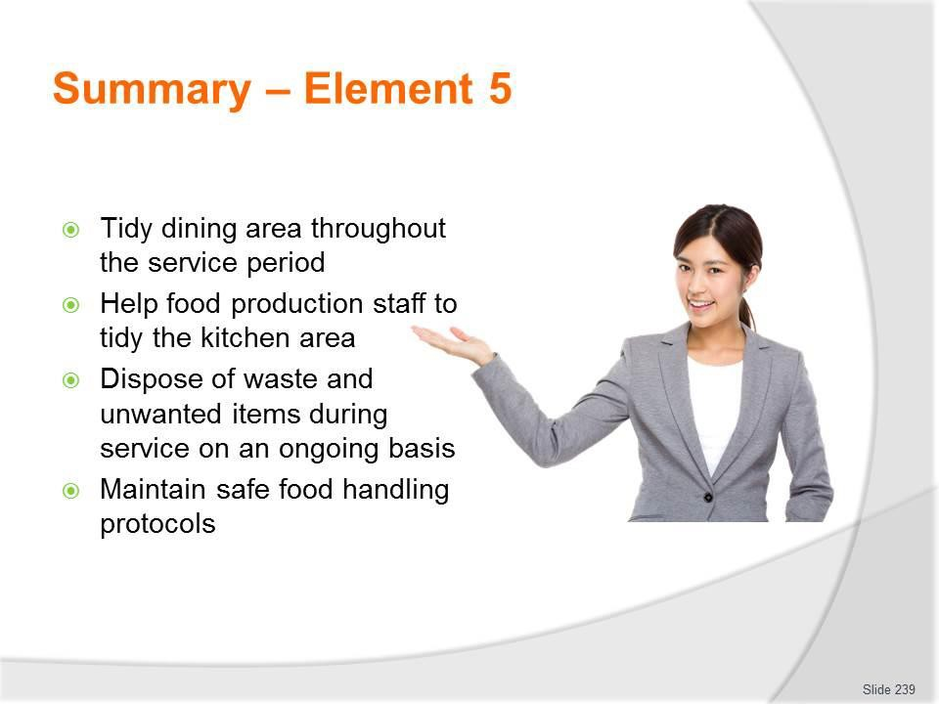
Slide
Slide No
Trainer Notes
239.
Trainer provides a recap of the Element asking questions to check trainee understanding and responding to questions from trainees, as required.

Slide
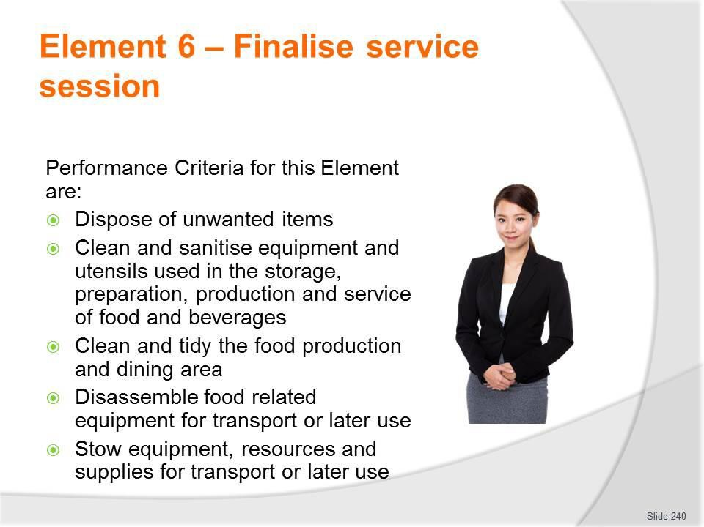
Slide No | Trainer Notes
240. | Trainer identifies for trainees the Performance Criteria for this Element, as listed on the slide.  Class Activity – General Discussion  Trainer leads a general class discussion by asking questions such as:  - What activities are involved in finalising a service session?  - Why is this an important part of camp site catering?  - What difficulties can you foresee in this stage of procedures?

Slide
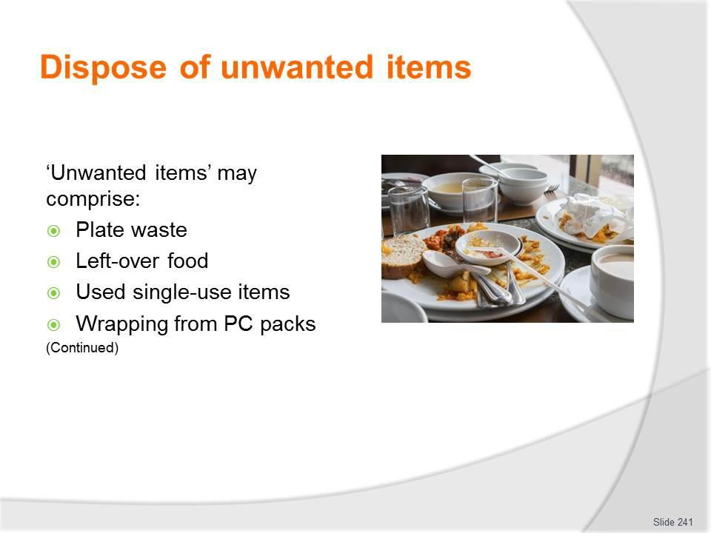
Slide No | Trainer Notes
241. | Trainer defines unwanted items as:  - Plate waste – which is food left on the plates by diners when they finish a meal  - Left-over food – as produced by the catering crew and:  - Not consumed/served to tour group members; Not suitable for storage for later use; Unable to be safely stored for future use; Banned from storage under the FSP in operation for the camp  - Used single-use items – such as:  - Plastic cutlery; Foam cups; Disposable food and drink containers; Drinking straws and hot drink stirrers  - Paper serviettes/napkins  - These items will be dirty and must be disposed of and cannot be cleaned (washed/sanitised) for re-use as they are designed and intended to be used only once  - Wrapping from the range of portion-control packs served to/used by the tour group members – which may need to be separated into general waste or recyclable materials.

Slide
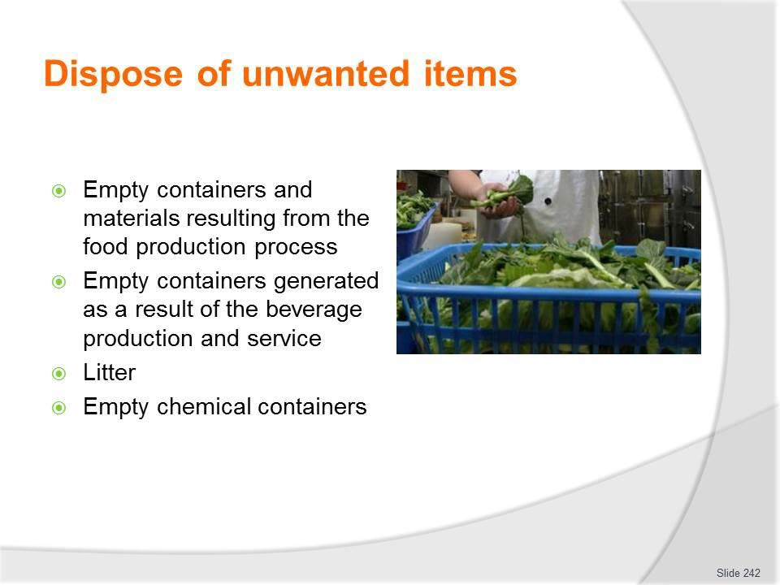
Slide No | Trainer Notes
242. | Trainer continues identifying unwanted items:  - Empty containers and materials resulting from the food production process – such as:  - Tins/cans; Cardboard cartons; Glass and jars; Food wrapping and packaging materials  - Aluminium foil and cling wrap  - Empty containers generated as a result of the beverage production and service process – such as:  - Bottles; Cans; Drink cartons  - Litter – this is general waste and rubbish:  - Produced by tour group members while in camp/in the dining area  - Generated by the crew as a consequence of their work and/or social activities  - Empty chemical containers – generated as a result of cleaning activities  - These containers may be ‘deposit paid’ containers and, if so, will need to be returned to head office so they can be returned to collect the deposit.

Slide
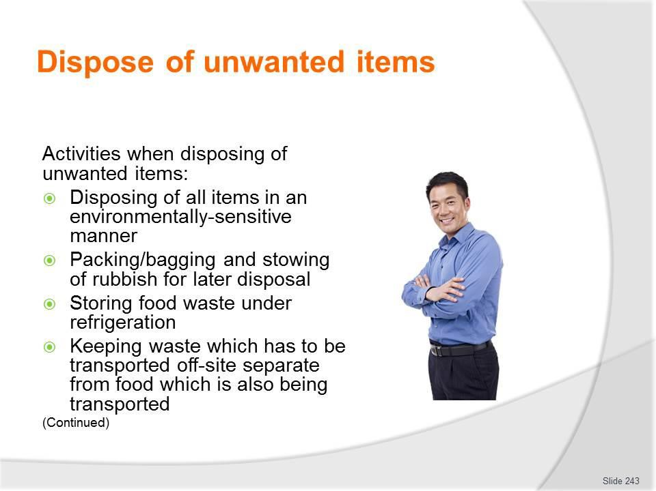
Slide No | Trainer Notes
243. | Trainer identifies activities possibly required when disposing of unwanted items might include:  - Disposing of all items in an environmentally-sensitive manner – in accordance with:  - Site requirements; Contracted arrangements; Agreements with local communities; Local legislation  - Packing/bagging and stowing of rubbish – for:  - Carrying away when leaving the camp/returning to base  - Later disposal at an approved waste disposal area, where no facilities exist on- site  - Storing food waste under refrigeration – to:  - Help reduce spoilage and odour  - Provide protection against access by pests/animals  - Keeping waste which has to be transported off-site separate from food which is also being transported – this:  - Is to prevent contamination  - May require storage of waste in a separate vehicle to ‘food’ transport vehicles.

Slide
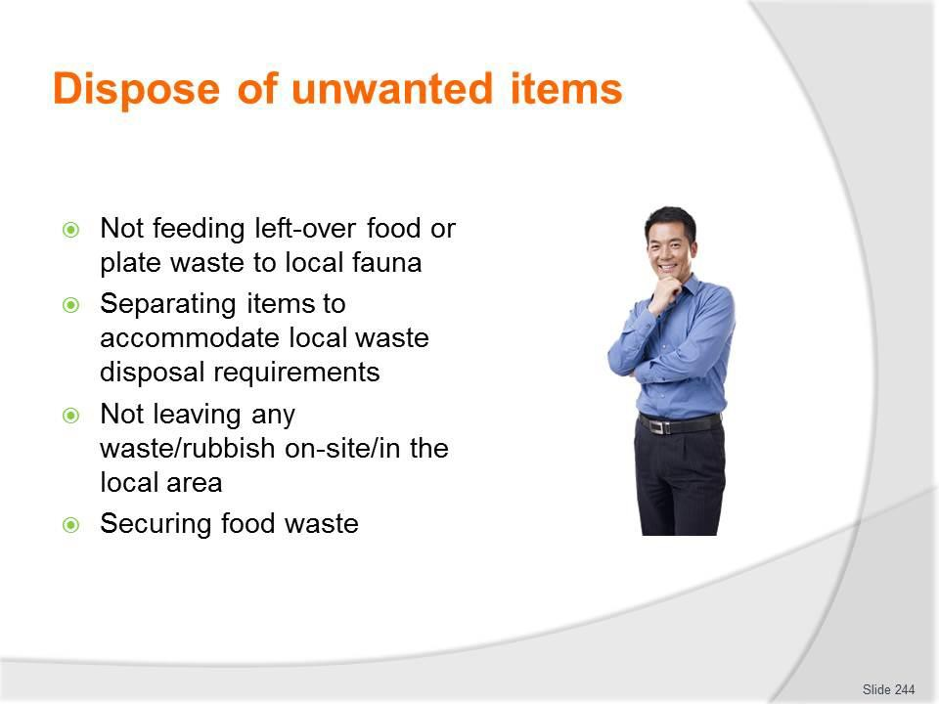
Slide No | Trainer Notes
244. | Trainer continues identifying activities possibly required when disposing of unwanted items might include:  - Not feeding left-over food or plate waste to local fauna – which can involve:  - Informing tour group members not to feed the wildlife; Training staff not to do so;  - Monitoring tour group members to ensure they comply  - Separating items to accommodate local waste disposal requirements – which may require separation of waste into:  - General waste, rubbish and litter; Food waste; Recyclable materials; Oil – from fryers/cooking  - Not leaving any waste/rubbish on-site/in the local area – which may involve:  - An inspection by a local person to confirm all waste/rubbish has been removed  - Not burying waste on-site – as animals can dig it up  - Forfeiting a deposit if the area is not properly cleaned  - The tour operator:  - Having to pay a charge if the site has to be cleaned by others after the tour has departed  - Being refused future access to the site if it is not left as required

- Securing food waste – in metal containers with tight lids so that:
- It does not attract pests and local wildlife; It cannot be accessed by animals, birds and pests.

Slide
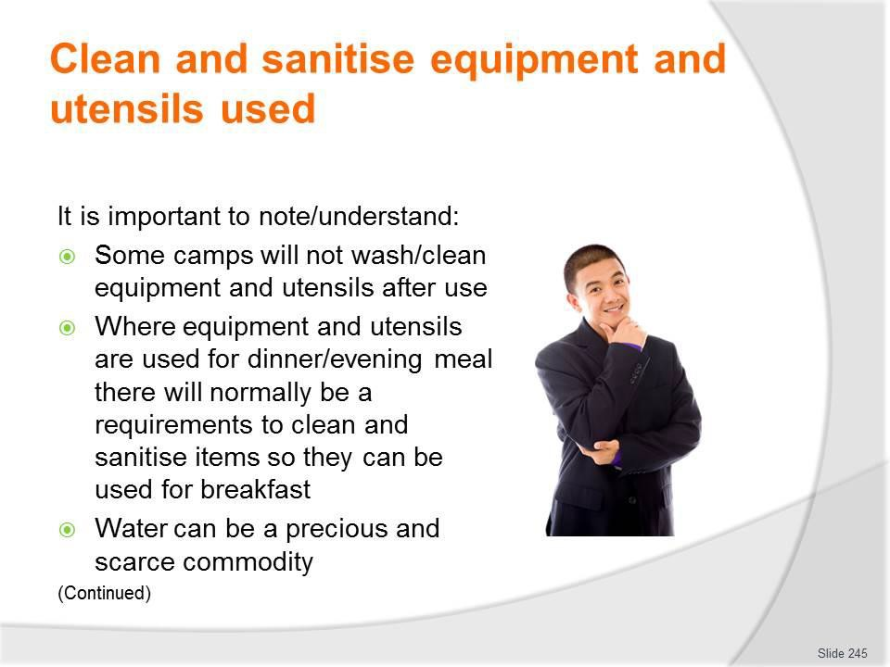
Slide No | Trainer Notes
245. | Trainer presents important points which need to be understood in this regard stating:  - Some camps will not wash/clean equipment and utensils after use – they may decide to:  - Load the used/dirty items for transport back to the head office  - Clean and sanitise items on return  - Where equipment and utensils are used for dinner/evening meal there will normally be a requirements to clean and sanitise items so they can be used for breakfast – unless sufficient additional items have been loaded/are available  - Water can be a precious and scarce commodity in some areas – so:  - It needs to be used wisely  - Limits may apply to quantities available  - Hand sanitiser may be provided for tour group members and staff.

Slide
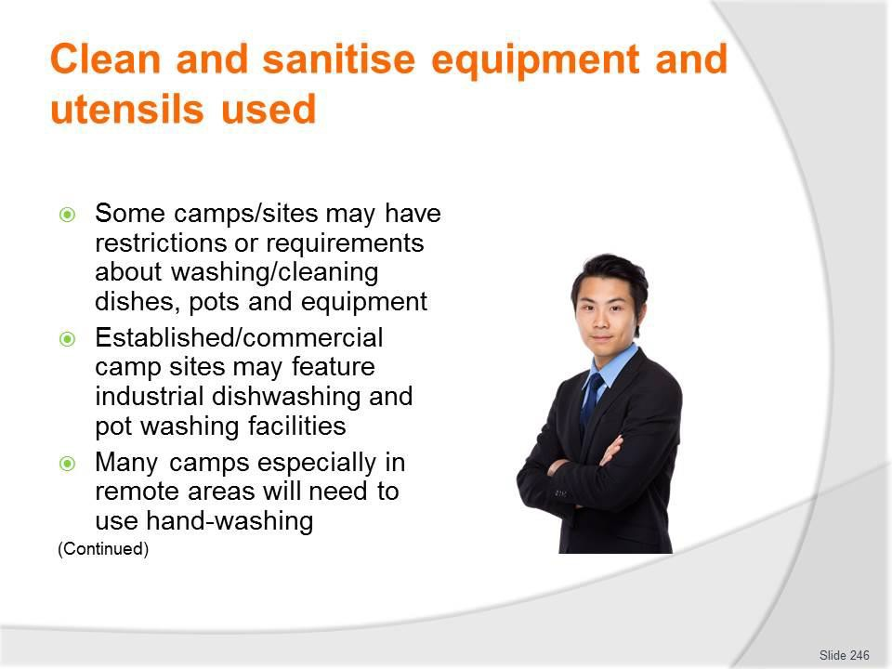
Slide No | Trainer Notes
246. | Trainer continues presenting important points which need to be understood in this regard stating:  - Some camps/sites may have restrictions or requirements about:  - Cleaning activities that can be undertaken  - Chemicals that can be used  - Management/control and disposal of waste water generated as a result of washing and cleaning activities  - Established/commercial camp sites may feature industrial dishwashing and pot washing facilities – with:  - Pre-wash sprays  - Pot wash and soaking sinks  - Dishwashing machines  - Many camps especially in remote areas will need to use hand-washing – to clean glasses, dishes, equipment and utensils  - The use of hand-washing is effective and safe providing a two-bowl approach is used as described on following slides.

Slide
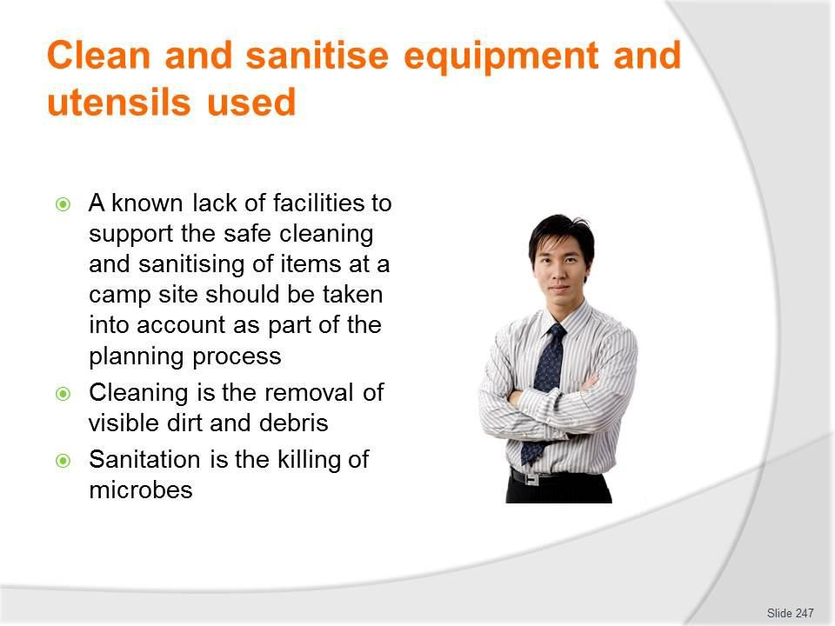
Slide No | Trainer Notes
247. | Trainer continues presenting important points which need to be understood in this regard stating:  - A known lack of facilities to support the safe cleaning and sanitising of items at a camp site should be taken into account as part of the planning process – in terms of:  - Serving menu items which can be prepared in advance and transported to the site ready for service – or re-heating and service (rather than cooking/production)  - Using disposable service wear – plates, cutlery, plastic glasses  - Cleaning is the removal of visible dirt and debris (including objectionable odour) – from crockery, cutlery, glasses, equipment, utensils or fixtures and fittings  - Sanitation is the killing of microbes using either hot water and/or chemicals  - Cleaning is performed before sanitation and where chemicals are used, the manufacturer's instructions in relation to dilution rates, contact time and temperature must be adhered to.

Slide
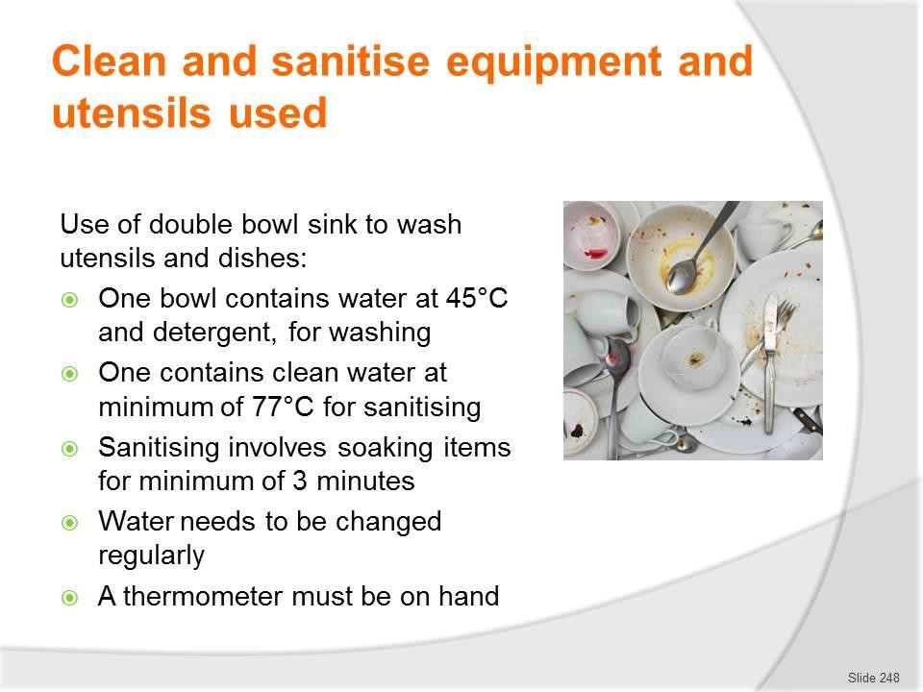
Slide No | Trainer Notes
248. | Trainer presents technique for using a double bowl sink to wash eating utensils and dishes:  - One bowl must contain water at 45°C and detergent, for washing  - One bowl must contain clean water at a minimum of 77°C for sanitising  - Sanitising must involve soaking the items for a minimum of three minutes – it is not acceptable to just pour hot water over items to remove the suds  - Water needs to be changed regularly to keep it clean  - A thermometer must be on hand to check water temperature.

Slide
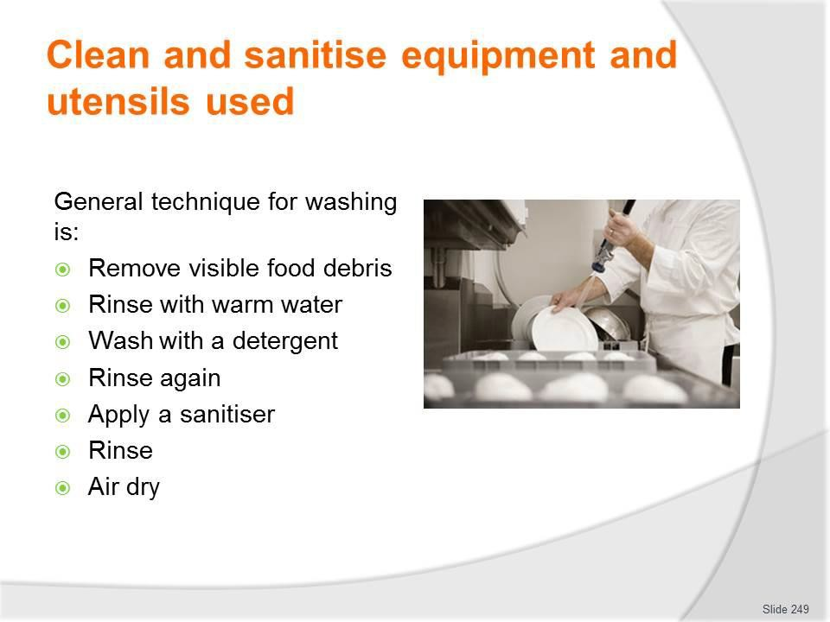
Slide No | Trainer Notes
249. | Trainer identifies in general terms, the following sequence is suitable for cleaning crockery and cutlery:  - Remove visible food debris – for example, scrape the plates  - Rinse with warm water – to remove loose dirt  - Wash with a detergent  - Rinse again – to remove the detergent and debris  - Apply a sanitiser – sanitisers are chemicals designed to kill bacteria  - Rinse – to remove the sanitiser  - Allow to air dry  - Air drying is the preferred option as it eliminates using a cloth to dry surfaces, which may inadvertently introduce bacteria to the surface that has just been cleaned and sanitised.  Classroom Activity – Demonstration and Small Group Exercise  Trainer shows class how to use facilities to hand-wash dishes and provides opportunity for students to do the same.

Slide
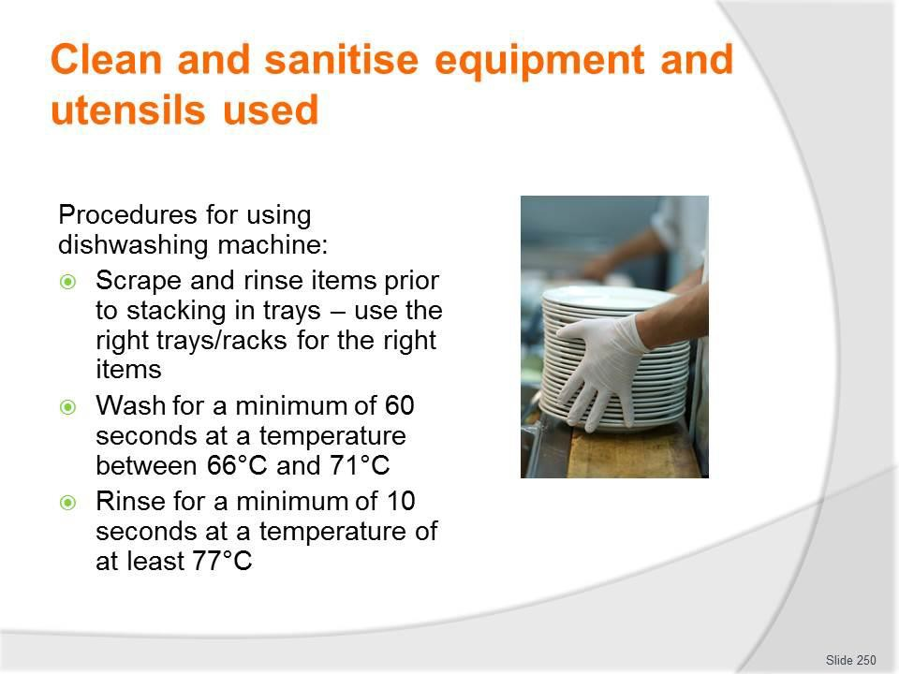
Slide No | Trainer Notes
250. | Trainer indicates procedure for washing eating utensils and dishes by machine is as follows:  - Scrape and rinse items prior to stacking in trays – use the right trays/racks for the right items  - Wash for a minimum of 60 seconds at a temperature between 66°C and 71°C  - Rinse for a minimum of 10 seconds at a temperature of at least 77°C.

Slide
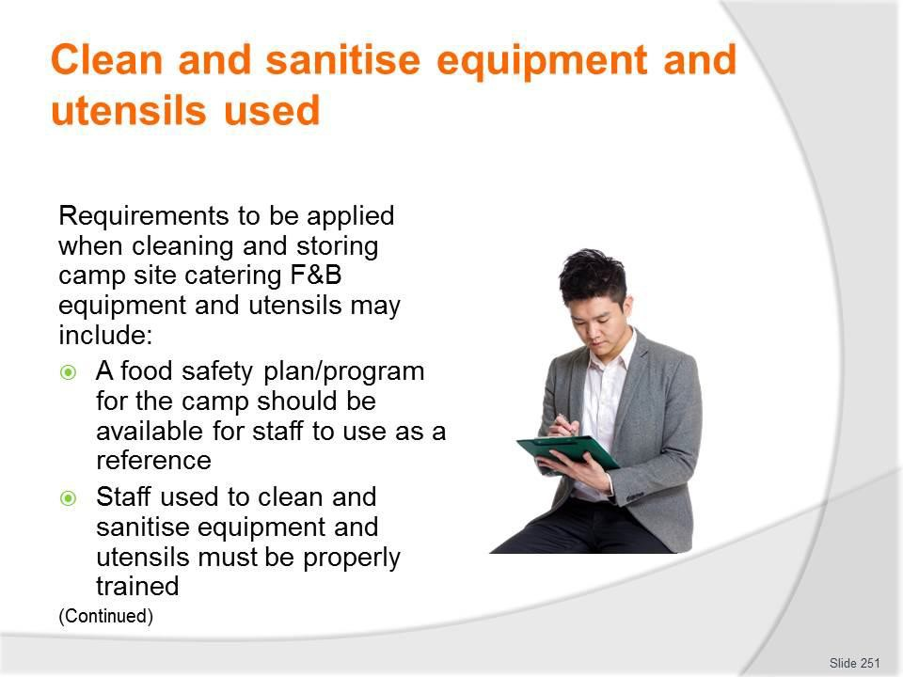
Slide No | Trainer Notes
251. | Trainer presents standard requirements which may need to be applied when cleaning and storing camp site catering F&B equipment and utensils:  - A food safety plan/program for the camp should be available – in order:  - To provide guidance and direction for employees as/if required  - To optimise likelihood of maintaining food safety for the tour  - To provide specific cleaning and sanitation instructions for individual items of equipment and utensils  - Staff used to clean and sanitise equipment and utensils must be properly trained – which can mean:  - They may need to hold a recognised food handling qualification  - They should have received practical training (demonstration and drill/practice) in the cleaning and sanitising of items under simulated camp situations.

Slide
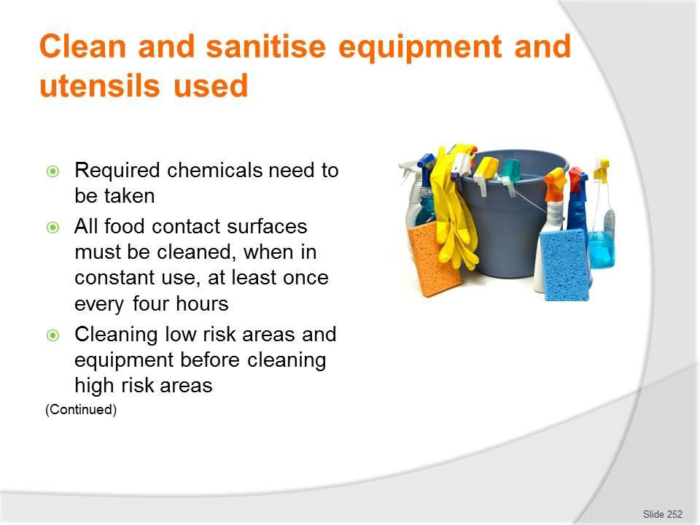
Slide No | Trainer Notes
252. | Trainer continues presenting standard requirements when cleaning and storing camp site catering F&B equipment and utensils:  - Required chemicals need to be taken – as part of standard tour/catering resources, in terms of (for example):  - De-greaser – for cutting/removing heavy grease  - Suitable detergents – of required types and strengths/active ingredients to cope with expected need as indicated by menu planning  - Sanitiser  - Glass washing detergent  - General purpose cleaners  - Stainless steel clean cleaners –where portable/mobile equipment of this type is used, or it is known to exist as part of the available kitchen area/facilities  - All food contact surfaces must be cleaned, when in constant use, at least once every four hours – to help prevent contamination  - Cleaning low risk areas and equipment before cleaning high risk areas – when the same cleaning items/equipment have to be used.

Classroom Activity – Guest Speaker
Trainer arranges for representative from a chemical cleaning supply company to attend and:
- Discuss and differentiate range of available chemicals which may be carried, needed or used as part of camp site catering
- Demonstrate use of same
- Supervise students as they practice using chemicals/cleaning agents for cleaning items.

Slide
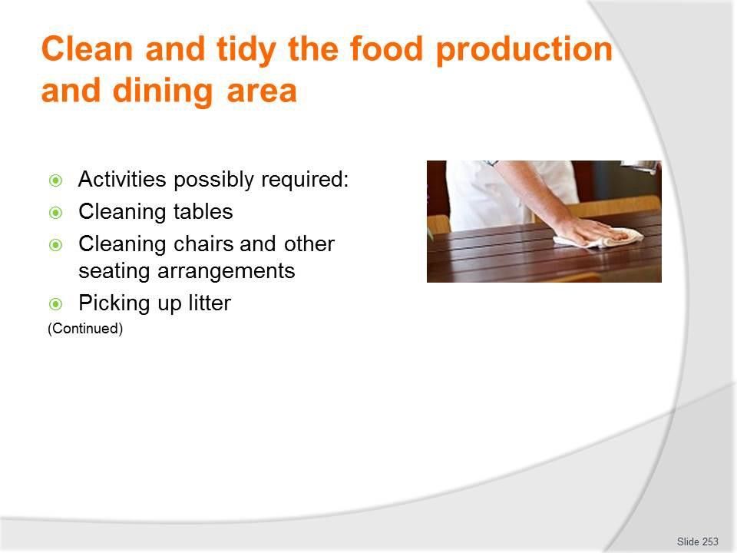
Slide No | Trainer Notes
253. | Trainer indicates the following may be required when finalising cleanliness of food production and dining areas:  - Cleaning tables – this applies to:  - Portable tables which will be returned to head office – which will commonly not be sanitised at this stage  - Tables provided by camp administration/owners on-site in the camp – which will also be sanitised  - Cleaning chairs and other seating arrangements – as above  - Picking up litter – left/generated by the tour group from rooms, areas and equipment, fixtures and fittings.

Slide
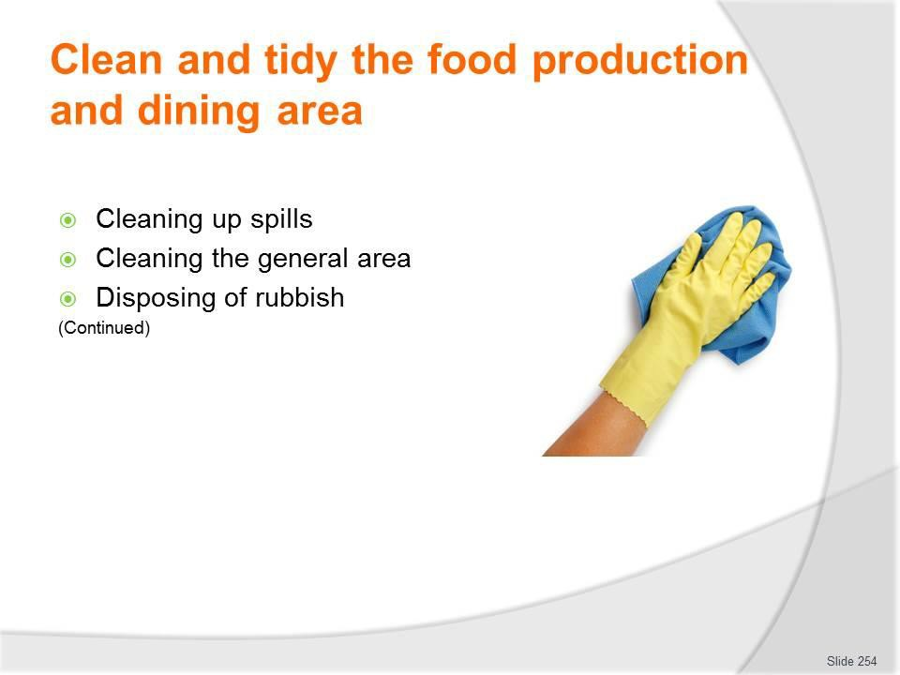
Slide No | Trainer Notes
254. | Trainer continues presenting possible relevant activities:  - Cleaning up spills – which may have occurred:  - In the kitchen area during the food production process – and which may have been cleaned up quickly on-the-spot at the time of the spill happened, but still require a final/proper/more comprehensive cleaning  - On the ground – in the dining/service area as a result of spills or food dropped by tour group members  - On furniture and/or equipment  - Cleaning the general area – which may entail:  - Returning the areas to the original condition in which they were provided  - Improving the condition of areas beyond that in which they were found to the greatest extent possible  - Disposing of rubbish and litter:  - In an environmentally-sensitive manner – as identified in earlier notes  - By removing it for disposal in an alternate location  - In compliance with all relevant laws.

Slide
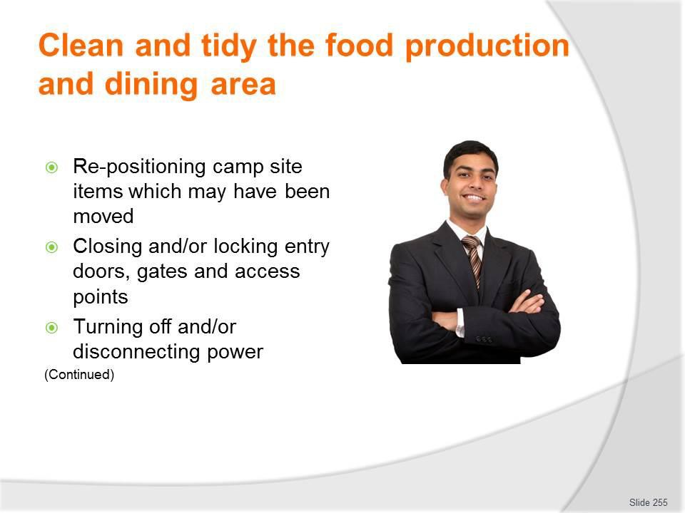
Slide No | Trainer Notes
255. | Trainer continues presenting possible relevant activities:  - Re-positioning camp site items which may have been moved – by:  - Tour group members  - Tour staff for the purposes of activities/recreation  - Food production and service staff  - Closing and/or locking entry doors, gates and access points – to things such as:  - Ablution blocks/facilities  - Cupboards and cabinets in food production and service areas  - Food production and dining areas  - Sites  - Turning off and/or disconnecting:  - Electrical power  - Gas  - Water  - Nominated items.

Slide
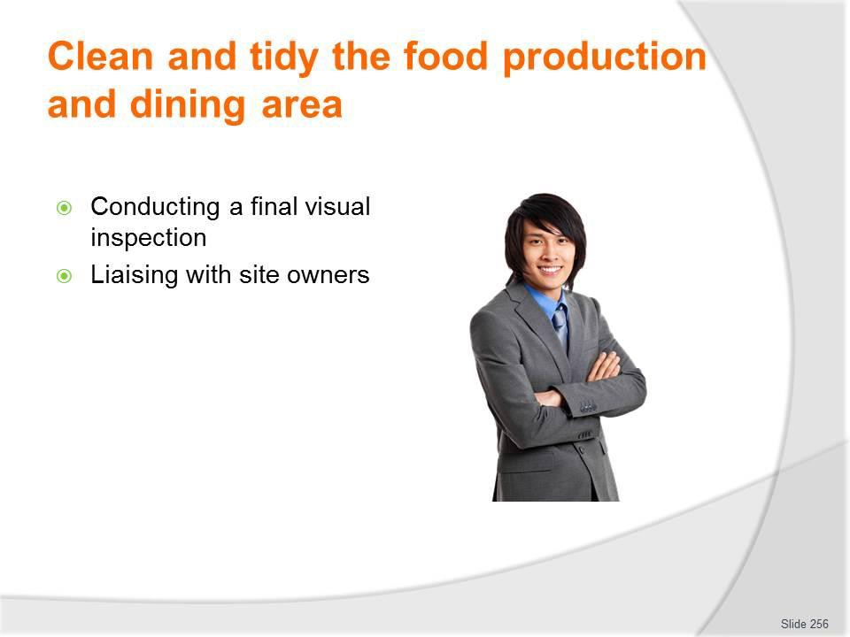
Slide No | Trainer Notes
256. | Trainer continues presenting possible relevant activities:  - Conducting a final visual inspection – which:  - Is done to find items which may have been dropped, forgotten or overlooked by the crew and/or tour group members  - May be done in partnership with site representative  - Could require completion of ‘On departure’ checklist to provide evidence of the inspection and form a basis for recording issues  - Often forms the basis of reimbursement of bonds paid and/or extra charges levied  - Liaising with site owners, where applicable – to:  - Confirm that the areas have been cleaned to their satisfaction  - Identify areas requiring further attention  - Negotiating payment/recompense in accordance with identified issues.

Slide
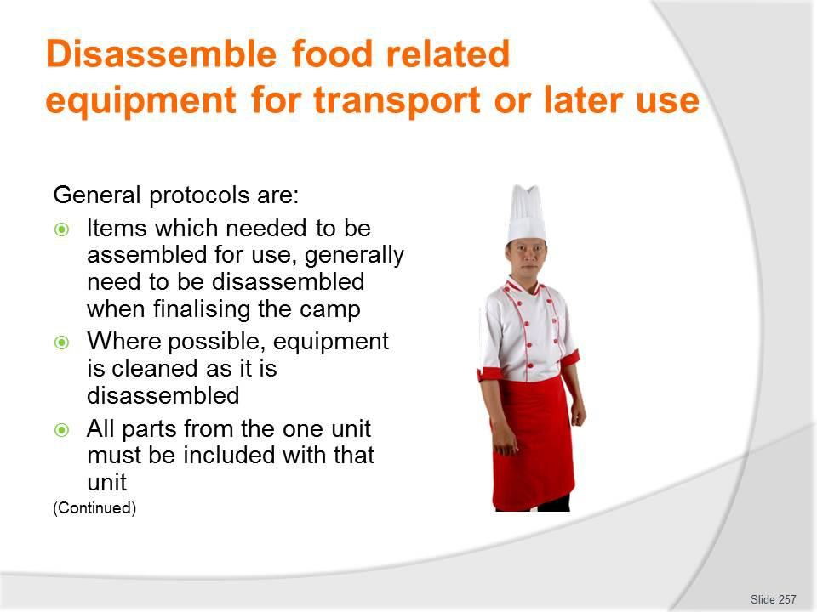
Slide No | Trainer Notes
257. | Trainer continues presenting possible relevant activities:  - Conducting a final visual inspection – which:  - Is done to find items which may have been dropped, forgotten or overlooked by the crew and/or tour group members  - May be done in partnership with site representative  - Could require completion of ‘On departure’ checklist to provide evidence of the inspection and form a basis for recording issues  - Often forms the basis of reimbursement of bonds paid and/or extra charges levied  - Liaising with site owners, where applicable – to:  - Confirm that the areas have been cleaned to their satisfaction  - Identify areas requiring further attention  - Negotiating payment/recompense in accordance with identified issues.

Slide
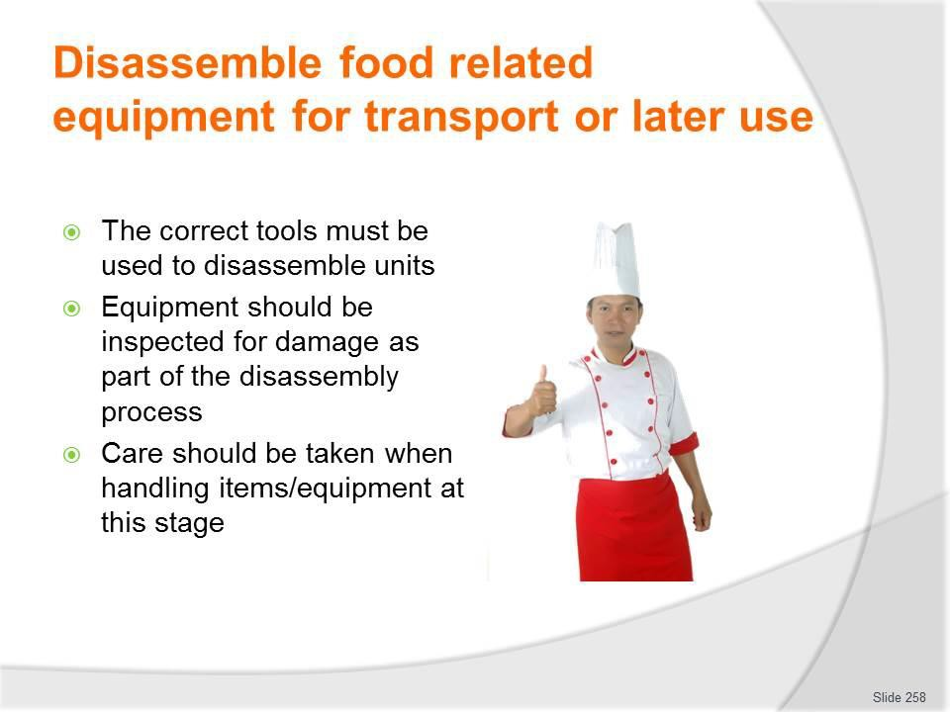
Slide No | Trainer Notes
258. | Trainer continues presenting possible activities required when disassembling items:  - The correct tools must be used to disassemble units – to avoid damage to nuts, bolts. connections and hoses  - Equipment should be inspected for damage as part of the disassembly process – and supervisors advised of identified problems so appropriate remedial action relating (for example) to repairs or securing substitute equipment can be taken  - Care should be taken when handling items/equipment at this stage – to:  - Avoid damage to equipment  - Avoid personal injury  - Maintain cleanliness of items after disassembly.  Classroom Activity – Demonstration and Practical  Trainer demonstrates dismantling/disassembly of sample camp site catering equipment and provides opportunity for students to do the same.

Slide
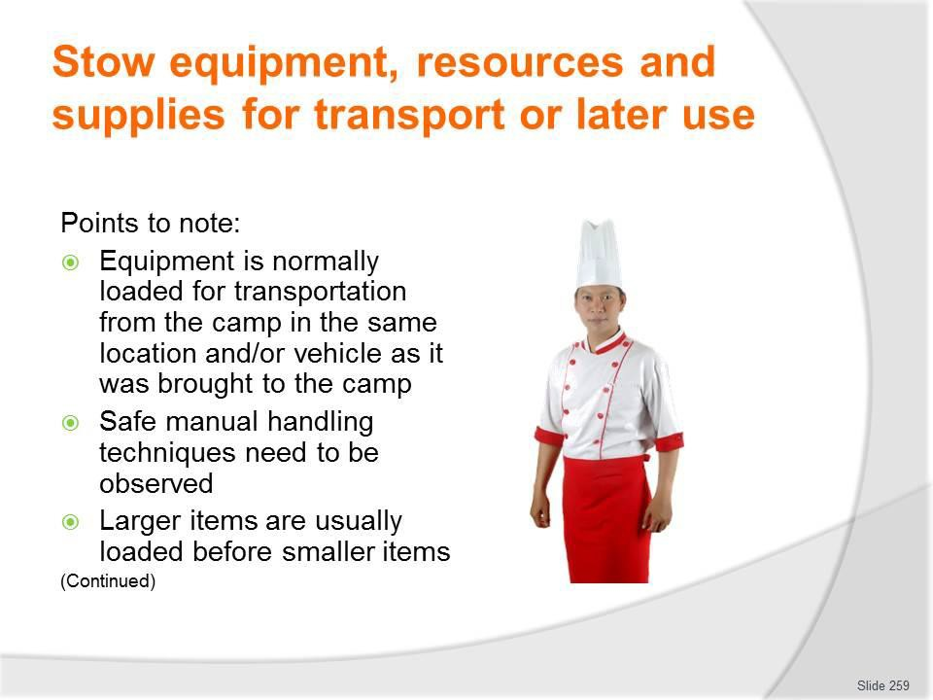
Slide No | Trainer Notes
259. | Trainer suggests points which need to be taken into account when stowing equipment, resources and supplies for transport or later use:  - Equipment is normally loaded for transportation from the camp in the same location and/or vehicle as it was brought to the camp – this standardised pattern/location of equipment:  - Speeds up the loading process  - Ensures all items can be accommodated  - Safe manual handling techniques need to be observed – which frequently indicates need for a team lift as many pieces of food equipment are large, awkward and/or heavy  - Larger items are usually loaded before smaller items – and the smaller items are loaded:  - ‘In and around’ the bigger ones  - Last.

Slide
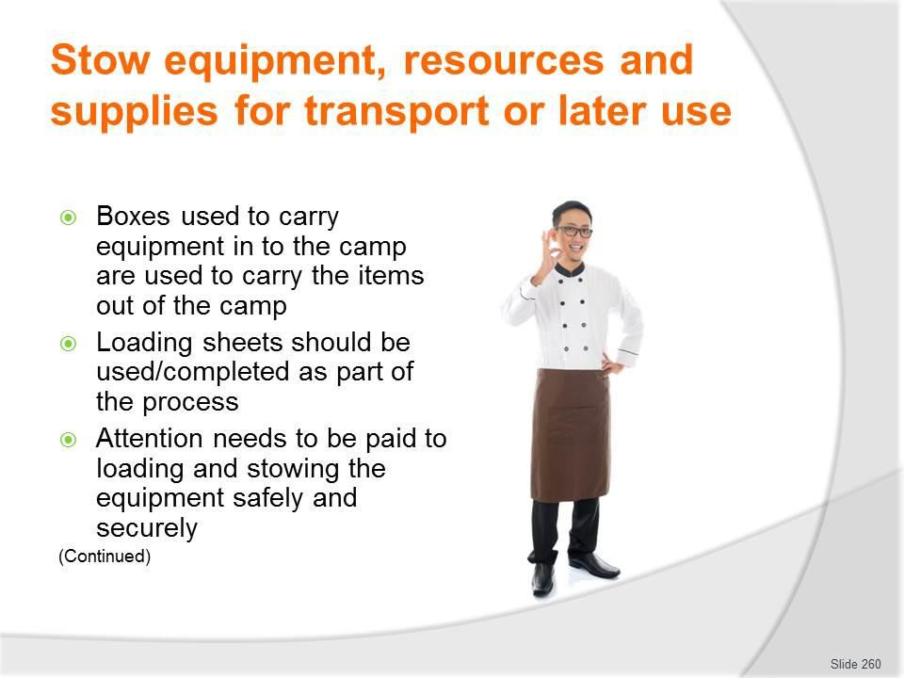
Slide No | Trainer Notes
260. | Trainer continues discussing points which need to be taken into account when stowing equipment, resources and supplies for transport or later use:  - Boxes used to carry equipment in to the camp are used to carry the items out of the camp – in particular:  - These crates and cartons are often purpose-built to suit individual items of equipment and will safely house and properly protect sensitive/fragile aspects such as knobs, dials, gauges, connections and linkages  - Loading smaller items into boxes speeds up the loading process by reducing the number of trips which have to be made to the transport vehicle  - Stowing boxes (which are usually of a rectangular-shape) is easier and more secure than trying to stow lots of smaller items  - Loading sheets should be used/completed as part of the process – to verify all items carried in were, in fact, taken out/back  - Attention needs to be paid to loading and stowing the equipment safely and securely – to:  - Prevent movement during travel  - Avoid damage in transit  - Deter unauthorised access/theft.

Slide
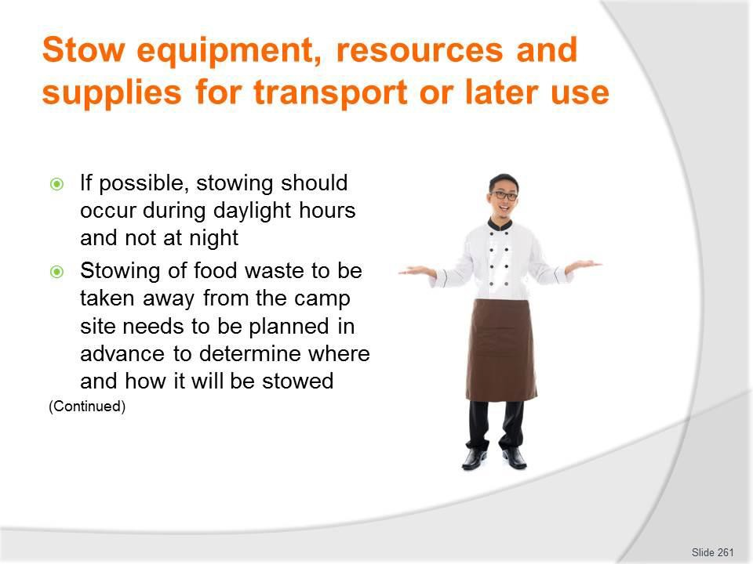
Slide No | Trainer Notes
261. | Trainer continues discussing points which need to be taken into account when stowing equipment, resources and supplies for transport or later use:  - If possible, stowing should occur during daylight hours and not at night  - Even with artificial lighting, it is often still too difficult to see clearly and there is too much potential for accident, damage and for smaller items to be overlooked, forgotten and lost  - It is generally much better for equipment and supplies to be stowed ‘next day’ – not only is there better light but staff are generally better rested  - Stowing of food waste to be taken away from the camp site needs to be planned in advance – so that:  - It is separated from and unable to contaminate foodstuffs  - It does not present an odour problem to tour group members travelling in the vehicles  - It is secured/contained in such a way there is no leakage.

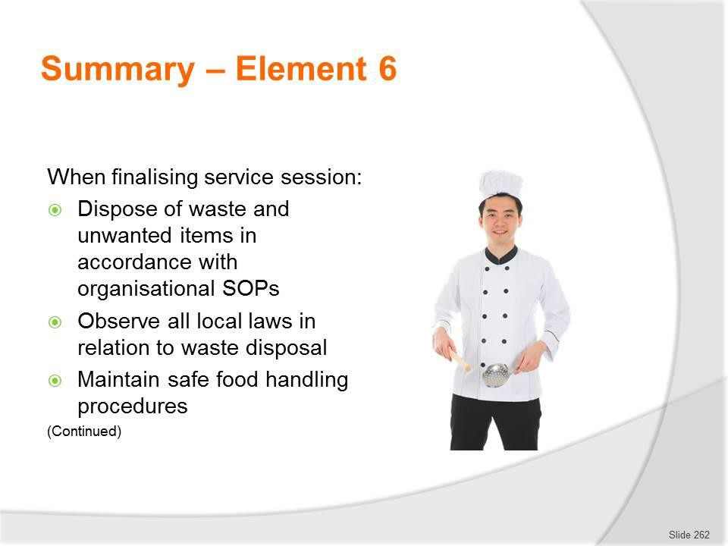
Slide
Slide No
Trainer Notes
262.
Trainer provides a recap of the Element asking questions to check trainee understanding and responding to questions from trainees, as required.

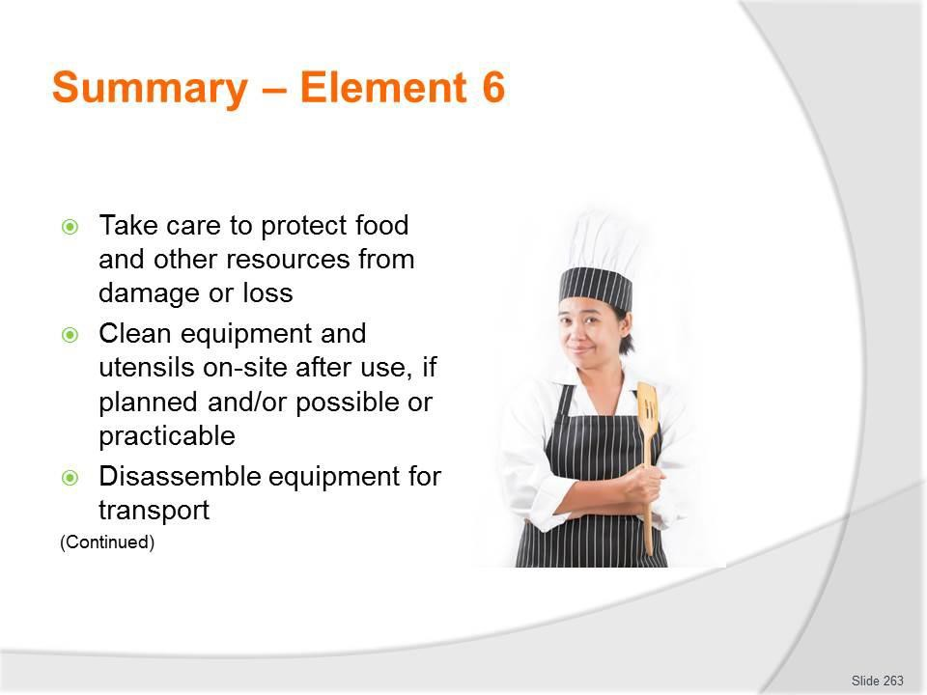
Slide
Slide No
Trainer Notes
263.
Trainer provides a recap of the Element asking questions to check trainee understanding and responding to questions from trainees, as required.

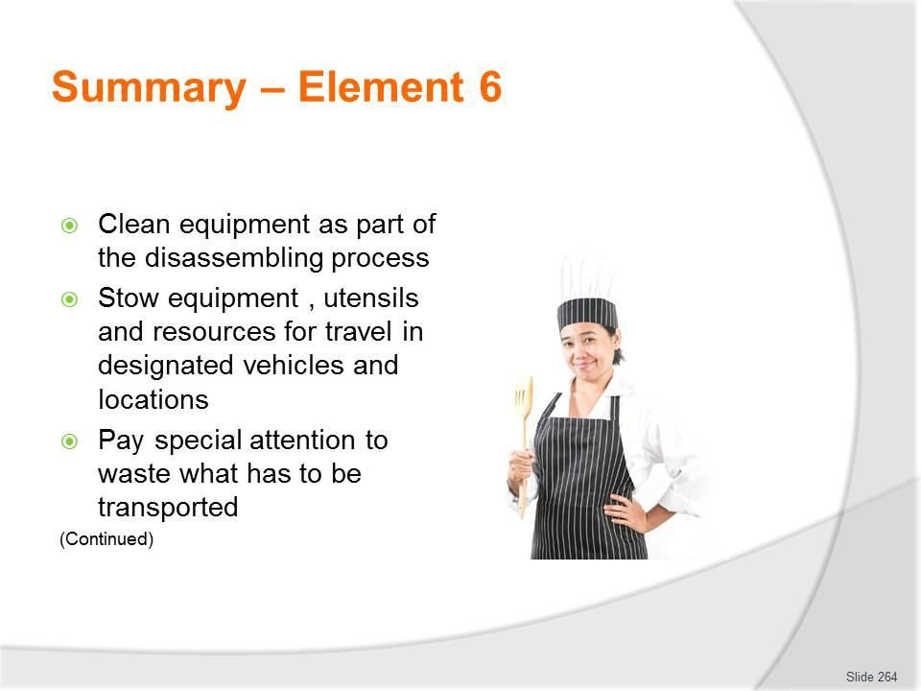
Slide
Slide No
Trainer Notes
264.
Trainer provides a recap of the Element asking questions to check trainee understanding and responding to questions from trainees, as required.

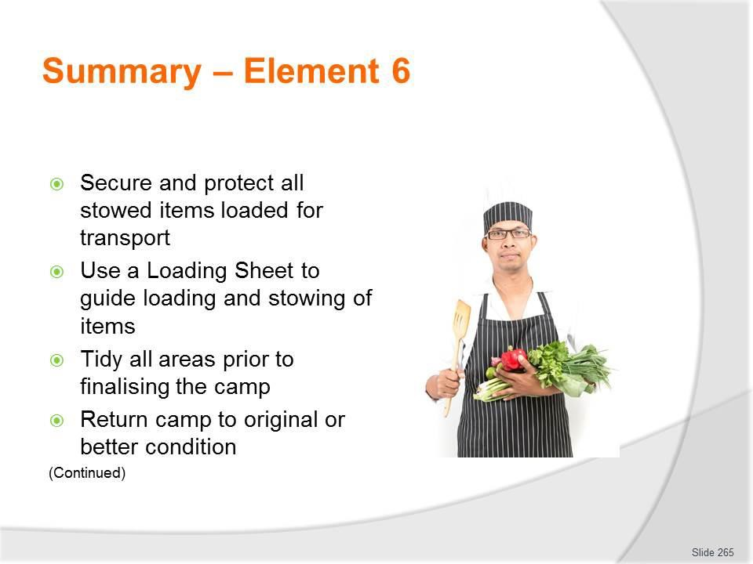
Slide
Slide No
Trainer Notes
265.
Trainer provides a recap of the Element asking questions to check trainee understanding and responding to questions from trainees, as required.

Slide
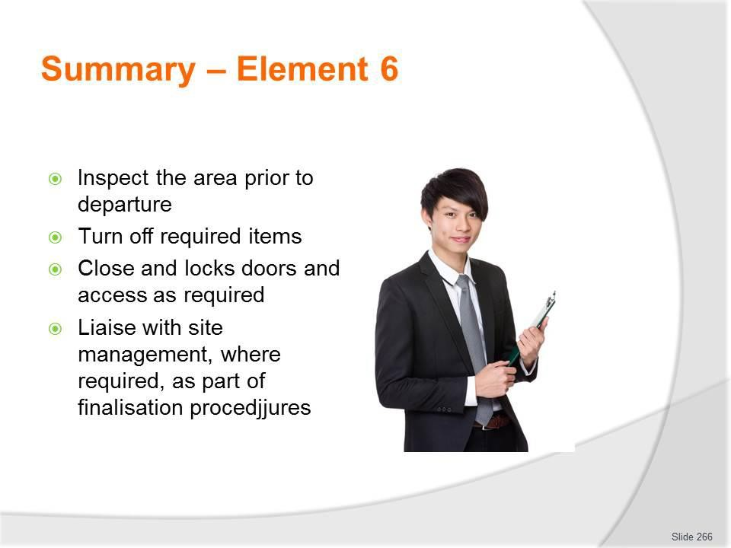
Slide No | Trainer Notes
266. | Trainer provides a recap of the Element asking questions to check trainee understanding and responding to questions from trainees, as required.  Trainer thanks trainees for their attention and encourages them to apply course content as required in their workplace activities.

Recommended training equipment
- SOPs for operation of camp catering and cooking
- Sample contracts for private/custom tours
- Sample camp site menus for:
  - Breakfasts
  - Morning and afternoon teas
  - Lunches
  - Dinners
  - Suppers
  - Special occasions
- Examples of standard recipe cards
- Examples of job descriptions for tour catering staff
- Nutrition guidelines
- Samples of:
  - Itineraries
  - Advertisements and promotional material for standard and custom tours
  - Tour briefs
  - Tour Reports
  - Tour-specific catering checklists and loading sheets
  - Budgets
  - Tour Reports
  - Catering loading sheets
  - Tour group profiles
- Catering equipment and utensils to support/enable the preparation and cooking of a range of different menu items – such as:
  - A range of knives (or knife kits) – such as:
    - Chef’s knife
    - Utility knife
    - Paring knife
    - Boning knife
    - Slicing knife
    - Serrated knife
    - Butcher’s knife
    - Cleaver

    - Palette knives
    - Steel
  - Mouli
  - Ladle
  - Chinois
  - Selection/range of bowls
  - Measuring bowls, cups, spoons and scales
  - Cutting boards
  - Whisk
  - Bain-marie
  - Braiser
  - Double boiler
  - Inserts/hotel pans
  - Roasting pan
  - Sauce pot
  - Sauté pans (sauteuse and sautoir)
  - Stock pot
  - Wok
  - Frying pan
  - Ricer
  - Dutch ovens
  - Skewers and sticks
  - Aluminium foil
  - Mixers
  - Slicers
  - Food processor
  - Stoves
  - Salamanders
  - Steamers
  - Bain maries
  - Bowl cutter
  - Mincer or grinder
  - Deep fryers
  - Rotisserie
  - Bratt pans

- Ovens.
- Foodstuffs/ingredient to prepare and cook required menu items
- A range of beverages and beverage preparation and service equipment and utensils
- Dining-related items:
  - Cutlery – which may include knives (main and entree), forks (main and entree), spoons (tea, soup, dessert)
  - Crockery – which may include main course plates, side plates, soup bowls, dessert bowls, cups and saucers, serving platters
  - Glassware – which may include a variety of types of glasses appropriate to the beverages being served (beer glasses, wine glasses, highballs, old fashioned plus others as needed), jugs
  - Single use items – such as paper serviettes, drinking straws, stirrers, plastic/disposable cutlery, doilies
  - Portion control packs – such as condiments, proprietary sauces, sugar, sweetener, jams, tea and coffee, biscuits.
- Food thermometer
- Bins and bin liners including portable trash/rubbish items for containment and transportation of general and food waste from camp sites to disposal areas
- Food safety plans/programs – for food transport vehicles, and camps/remote sites
- Generators to power cooking/catering equipment
- Cleaning chemicals, detergents, de-greasers and sanitisers
- Brooms, mops, cleaning cloths and equipment/utensils
- Portable gas cylinders and connections
- Range of tools for assembling/disassembling equipment and connecting hoses to power source/s
- Electrical extension leads
- Power boards
- Residual Current Devices
- Equipment and materials/chemicals for purifying water
- Food transport and catering vehicles (vans, refrigerated vehicles, trucks, trailers).

Instructions for Trainers for using PowerPoint – Presenter View
Connect your laptop or computer to your projector equipment as per manufacturers’ instructions.
In PowerPoint, on the Slide Show menu, click Setup Show.
Under Multiple monitors, select the Show Presenter View check box.
In the Display slide show on list, click the monitor you want the slide show presentation to appear on.
Source: http://office.microsoft.com

Note:

In Presenter View:
You see your notes and have full control of the presentation Your trainees only see the slide projected on to the screen

More Information

You can obtain more information on how to use PowerPoint from the Microsoft Online Help Centre, available at: http://office.microsoft.com/training/training.aspx?AssetID=RC011298761033

Note Regarding Currency of URLs

Please note that where references have been made to URLs in these training resources trainers will need to verify that the resource or document referred to is still current on the internet. Trainers should endeavour, where possible, to source similar alternative examples of material where it is found that either the website or the document in question is no longer available online.

Appendix – ASEAN acronyms

AADCP | ASEAN – Australia Development Cooperation Program
ACCSTP | ASEAN Common Competency Standards for Tourism Professionals
AEC | ASEAN Economic Community
AMS | ASEAN Member States
ASEAN | Association of Southeast Asian Nations
ASEC | ASEAN Secretariat
ATM | ASEAN Tourism Ministers
ATPMC | ASEAN Tourism Professionals Monitoring Committee
ATPRS | ASEAN Tourism Professional Registration System
ATFTMD | ASEAN Task Force on Tourism Manpower Development
CATC | Common ASEAN Tourism Curriculum
MRA | Mutual Recognition Arrangement
MTCO | Mekong Tourism Coordinating office
NTO | National Tourism Organisation
NTPB | National Tourism Professional Board
RQFSRS | Regional Qualifications Framework and Skills Recognition System
TPCB | Tourism Professional Certification Board



